ENTERPRISE — ORACLE CLOUD PROGRAM — MASTER DOCUMENT
Master Architecture Document
Solution · Technical & Infrastructure · Landing Zone · Workloads · Integration · FDI · MDM/ETL · Security · Observability · FinOps · IaC (Azure DevOps + GitHub) · DR · Multi-Cloud
The single consolidated reference for the organization's Oracle Cloud estate — tenancy <tenancy>, Fusion (ERP · EPM · HCM · CX/SCM) + OCI (OIC · ATP · FDI · VBS). Consolidates Volumes 1–9 and diagrams D1–D15 into one document, and adds the full OCI security service catalog, the MDM/ETL architecture, and the Azure DevOps + GitHub delivery model. Where a domain has a deep-dive volume, this document is authoritative for the WHAT and the volume for the HOW.
Status: v1.0 DRAFT | Author: Enterprise Cloud Architect (OCI) | August 2026 | Classification: Internal

Document Map
Section | Domain | Diagrams | Deep-dive volume
1 | Solution architecture (business + logical) | D1, D9 | Vol. 1, Vol. 6
2 | Technical & infrastructure architecture | D10, D3 | Vol. 2, Vol. 6
3 | Landing zone & governance | D2, D8 | Vol. 3 (Standard v1.1), Vol. 5
4 | Workload architecture & environments | — | Vol. 5
5 | Integration architecture (OIC) | D5 | Vol. 2 §6, Vol. 7
6 | Analytics (FDI) | D7 | Vol. 2 §8
7 | MDM / ETL & data migration | D6 | Vol. 2 §7 (new consolidated section)
8 | Security architecture (full OCI catalog) | D4, D11, D12 | Vols 3, 7 (+ new catalog here)
9 | Observability & management | — | Vol. 5 §12
10 | FinOps | — | Vol. 3 §10
11 | IaC & CI/CD — Azure DevOps + GitHub | — | New authoritative section
12 | Disaster recovery (both options) | D13, D14 | Vol. 8
13 | Multi-cloud extension | D15 | Vol. 9

1. Solution Architecture
Greenfield Oracle Fusion adoption: ERP, EPM, HCM and the fourth pillar (CX/SCM per subscription confirmation R-01) become the system of record; the legacy ERP retires at cutover with master data + opening balances migrated and history retained only in analytics. One tenancy carries two control planes — Oracle-managed Fusion SaaS reached over the Oracle Services Network, and the customer-managed OCI estate (integration, custom data, analytics, network, security). Identity is singular: Microsoft Entra ID (fed by on-prem AD and HCM joiner/mover/leaver events) provides one SSO with Conditional Access + MFA across Fusion, OIC, FDI, and the OCI Console.
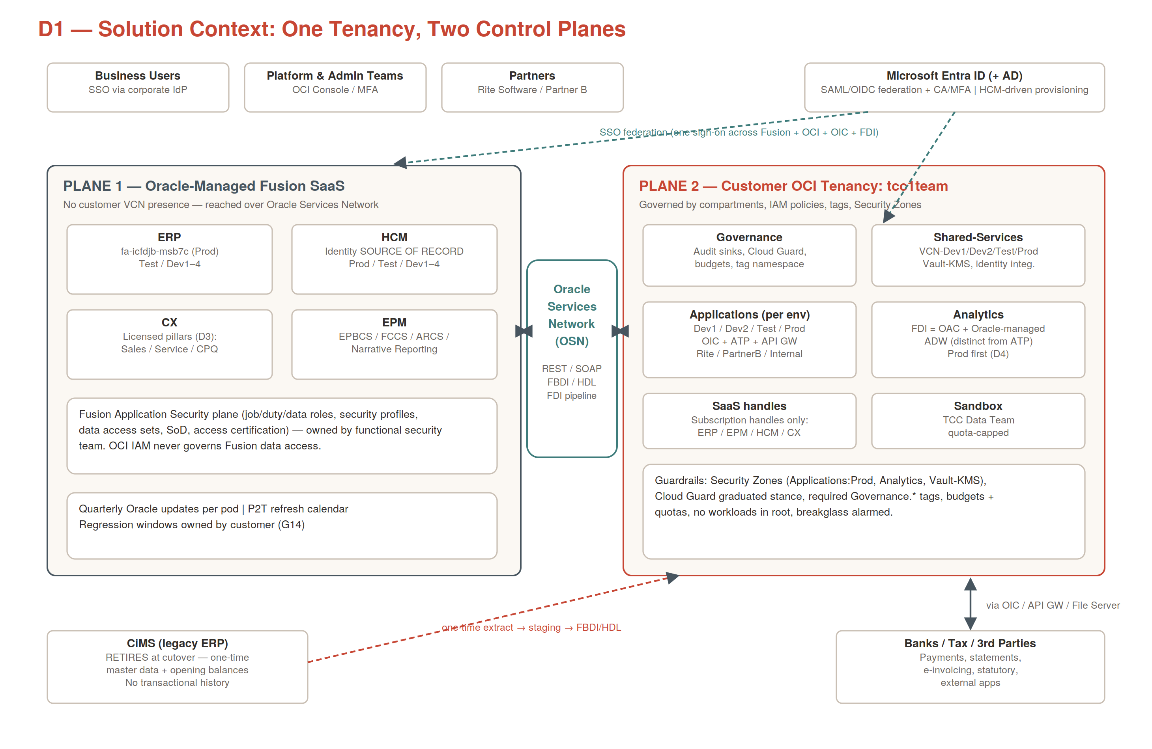
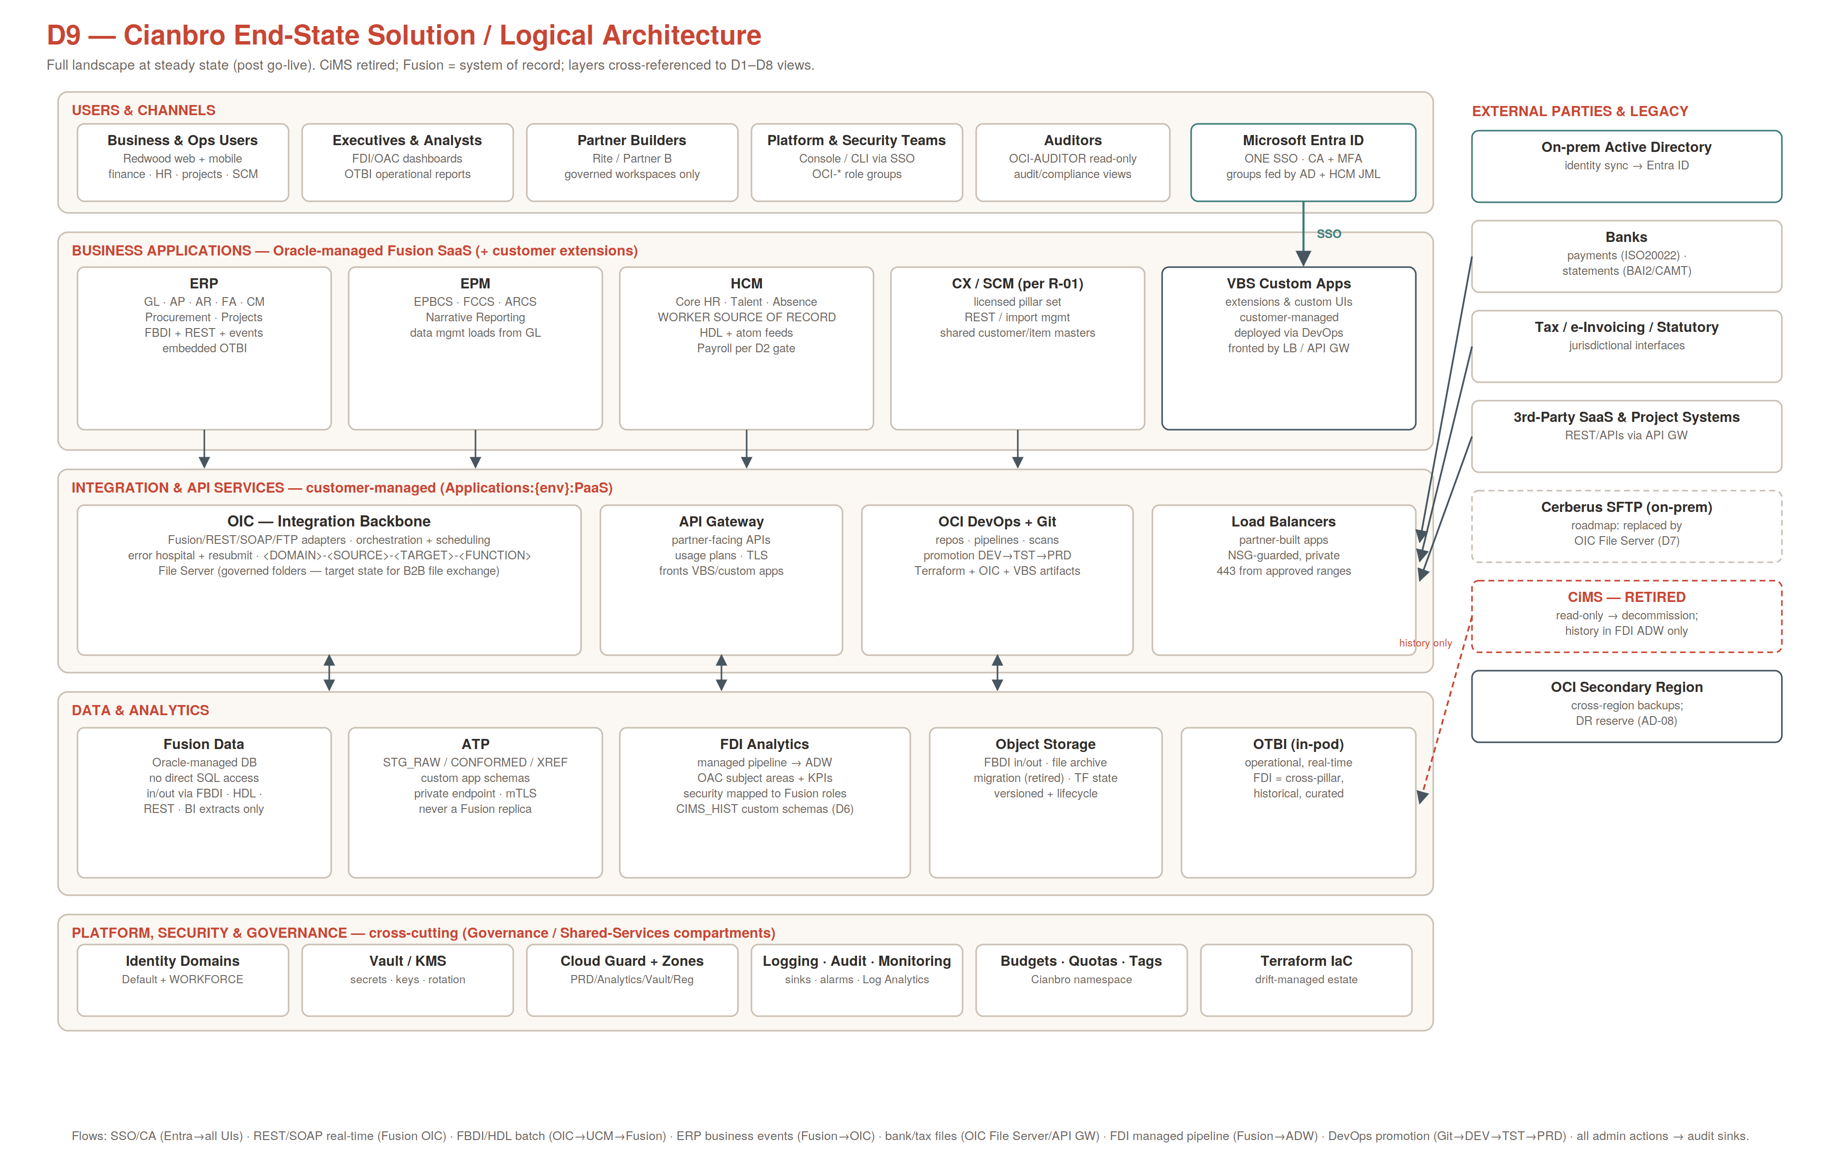
The end state reads in five layers: users/channels, business applications (+VBS custom extensions), integration & API services, data & analytics, and the cross-cutting platform/governance plane — with external counterparties (banks, tax, third-party SaaS) integrating only through governed edges (API Gateway, OIC File Server, load balancers), and eight catalogued logical flows (F1–F8, Vol. 6 §2) covering every data movement.

2. Technical & Infrastructure Architecture
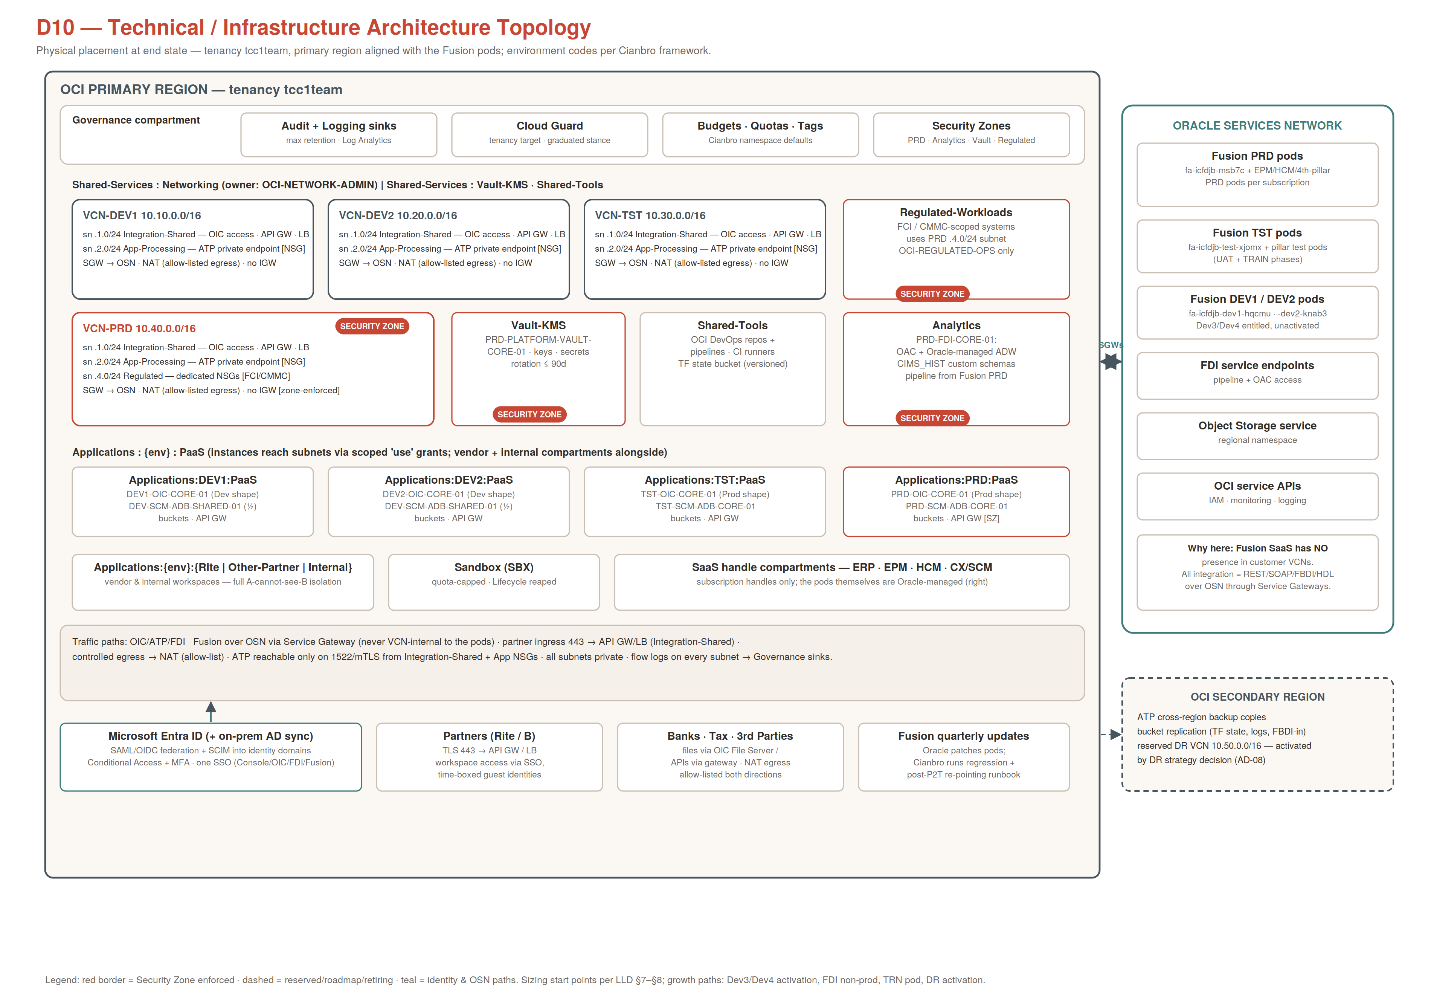
Physical placement: primary region aligned with the Fusion pods; four environment VCNs (DEV1 10.10/16, DEV2 10.20/16, TST 10.30/16, PRD 10.40/16 + Regulated subnet .4.0/24) in Shared-Services; per-environment PaaS compartments consume subnets via scoped 'use' grants; Security Zones on PRD, Analytics, Vault-KMS, Regulated-Workloads; secondary region carries backup copies and the DR footprint (§12). Fusion pods sit on the OSN — no customer VCN path to them exists, by design.

Network pattern (per environment)
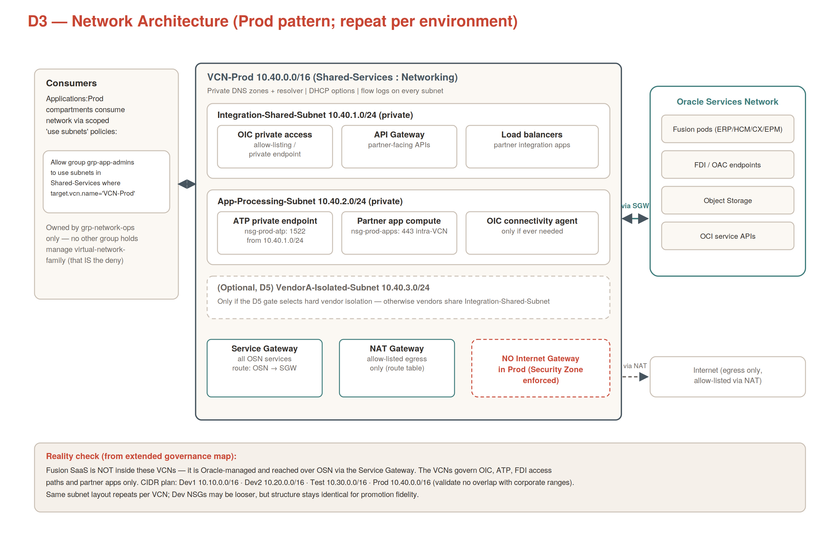
- All subnets private; Service Gateway for OSN traffic, NAT with egress allow-list, no Internet Gateway in TST/PRD; NSG default-deny micro-segmentation; ATP private endpoints on 1522/mTLS; DNS via per-VCN private zones. The complete flow registers (external E1–E6, internal I1–I7) live in Vol. 7 and are the authoritative list of permitted paths.

3. Landing Zone & Governance
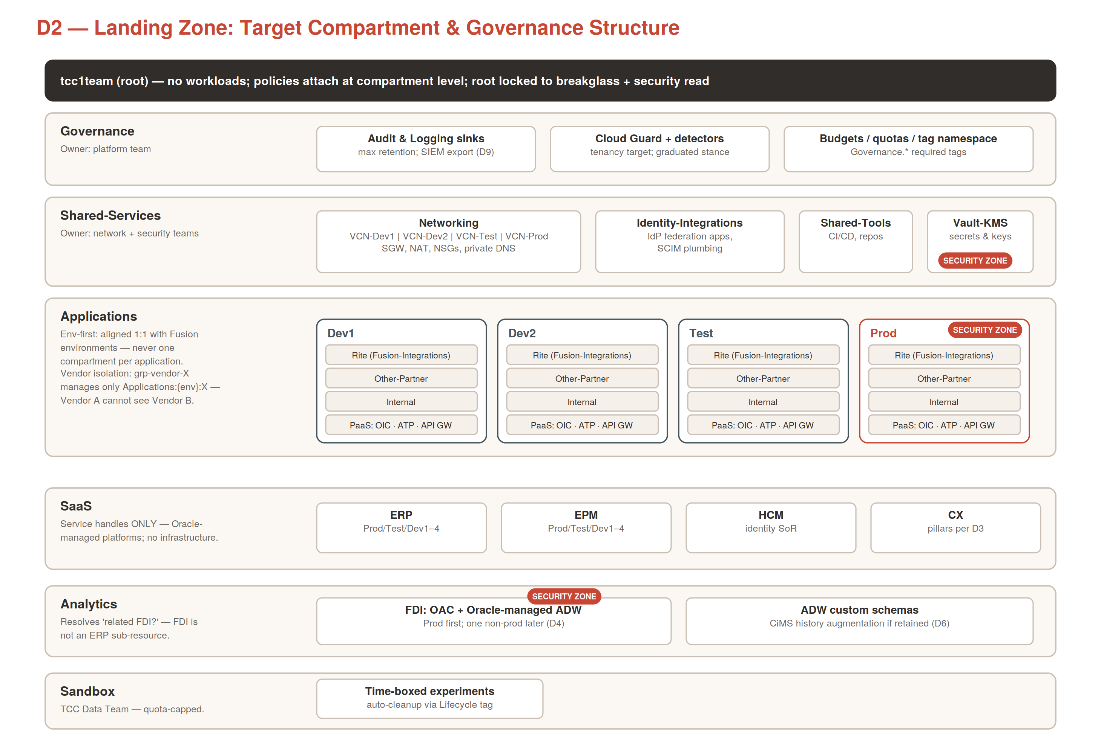
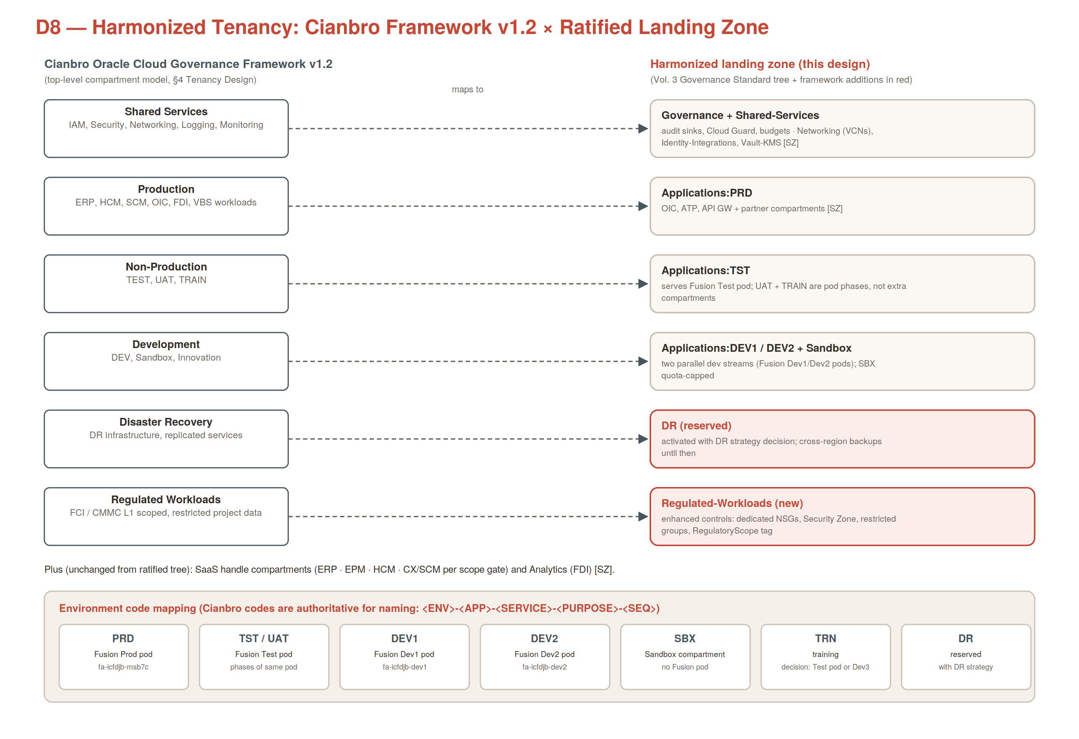
- Compartment model: Governance · Shared-Services (Networking / Identity-Integrations / Shared-Tools / Vault-KMS) · Applications {DEV1, DEV2, TST, PRD} × {Partner-A, Partner-B, Internal, PaaS} · SaaS handles · Analytics · Regulated-Workloads · Sandbox · DR. Environment codes follow the standard environment framework (PRD/UAT/TST/DEV/SBX/TRN/DR); UAT and TRAIN are Fusion Test-pod phases.
- Guardrails: no workloads in root; default-deny IAM (no Deny keyword — absence-of-allow + Security Zones); group-based access only (OCI-* groups federated from Entra); 15-key governance tag namespace with locked defaults; budgets + quotas per compartment; everything Terraform-managed with weekly drift reconciliation ≤ 48h.
- Authority: OCI Governance Standard v1.1 (GOV-* control IDs) under the Oracle Cloud Governance Framework v1.2 and Responsibility Matrix; Cloud Governance Board ratifies; 8-step CAB change workflow for all governed change.

4. Workload Architecture & Environment Matrix
Env | Fusion pods served | OIC | Data | VCN | Analytics
DEV1 | fa-<realm>-dev1 + pillar dev1 pods | DEV1-OIC-CORE-01 | shared ADB (schema-isolated) | VCN-DEV1 | —
DEV2 | fa-<realm>-dev2 + pillar dev2 pods | DEV2-OIC-CORE-01 | shared ADB | VCN-DEV2 | —
TST (SIT/UAT/TRN) | fa-<realm>-test + pillar test pods | TST-OIC-CORE-01 | TST-SCM-ADB-CORE-01 | VCN-TST | FDI non-prod (later, D4)
PRD | fa-<realm>-prod + pillar PRD pods | PRD-OIC-CORE-01 | PRD-SCM-ADB-CORE-01 | VCN-PRD | PRD-FDI-CORE-01
- Workload classes: OIC integrations (the backbone); ATP schemas (staging/x-ref/custom apps — never a Fusion replica); VBS custom apps and partner-built apps (LB/API-GW fronted compute in App-Processing); FDI analytics; object storage estates (FBDI in/out, archives, TF state). Vendor workloads live in per-partner compartments with full A-cannot-see-B isolation. Promotion: DEV1/DEV2 (parallel streams) → TST → PRD via pipeline only (§11); Dev3/Dev4 pod entitlement extends this matrix without redesign.

5. Integration Architecture (OIC)
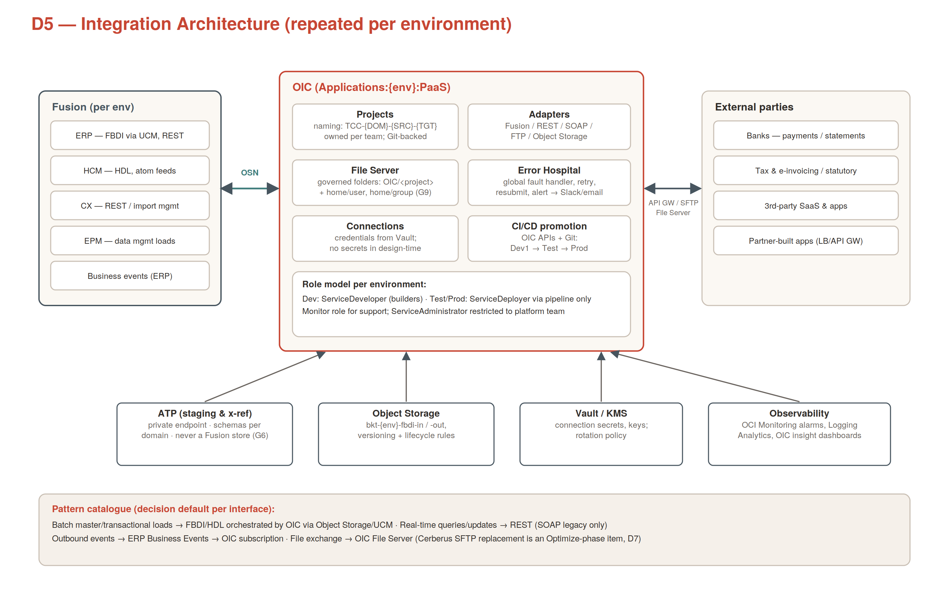
- Patterns: real-time REST/SOAP over OSN (Fusion↔OIC); batch FBDI/HDL via Object Storage/UCM; ERP Business Events outbound; B2B files via OIC File Server (legacy MFT/SFTP replacement per roadmap) and APIs via API Gateway with per-consumer usage plans.
- Governance annex: integrations named <DOMAIN>-<SOURCE>-<TARGET>-<FUNCTION>; connections use Vault-held service accounts only; global fault handler + error hospital mandatory; ServiceDeveloper role exists only in DEV — TST/PRD receive artifacts via the pipeline identity (ServiceDeployer); File Server folders OIC/<project>/{in,out,archive,error} with group grants.
- Service accounts (per environment): svc-oic-{env}-fusion (Fusion integration roles), svc-oic-{env}-atp-stg (staging schemas), svc-oic-{env}-osbucket (object storage), svc-devops-{env}-oicdeploy (pipeline) — all Vault-held, 90-day rotation, certified quarterly.

6. Analytics — Fusion Data Intelligence
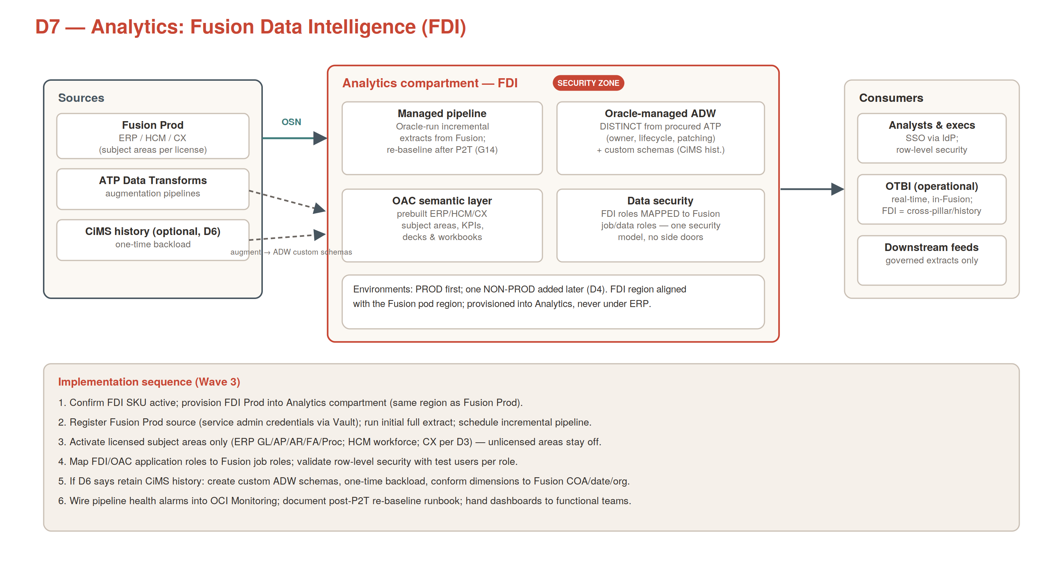
- FDI (OAC + Oracle-managed ADW) lives in the Analytics compartment — PRD first, non-prod later; subject areas limited to licensed pillars; FDI application roles mapped 1:1 to Fusion job roles with row-level security from Fusion data security (no side-door reporting access); pipeline re-baselined after every P2T refresh; LEGACY_HIST custom schemas hold retained legacy history (decision D6); certified reporting, documented lineage, and quarterly data-quality reviews per framework §14. OTBI stays the in-pod operational reporting layer; FDI is cross-pillar, historical, curated.

7. MDM / ETL & Data Migration
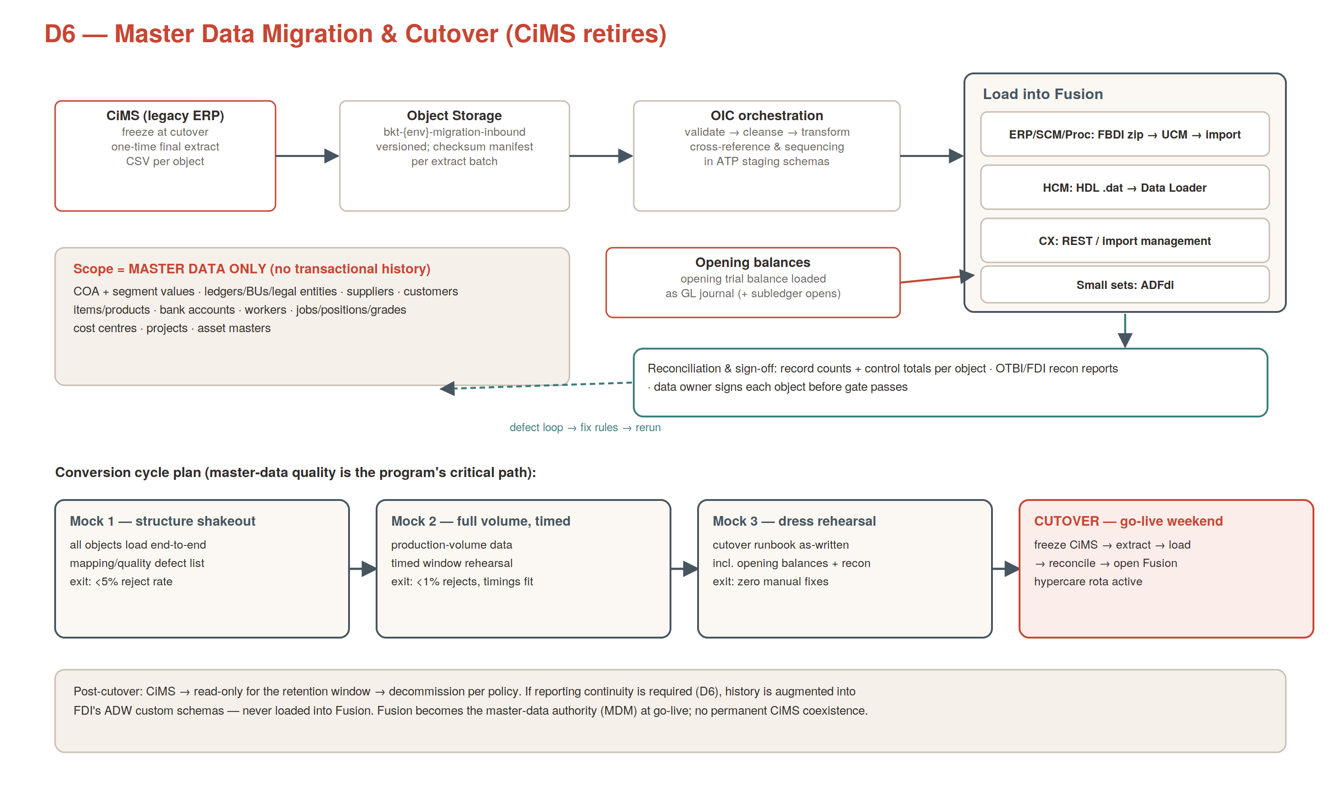

7.1 Master Data Management (MDM)
- Authority model: at go-live Fusion becomes the single master-data authority (GOV-DA-03) — there is no separate MDM hub, and none is needed at this footprint: master changes are made only in Fusion, and every downstream consumer receives them via governed paths (business events, REST reads, FDI extracts). The legacy ERP goes read-only then decommissions; no permanent coexistence.
Master data domain | Mastered in | Steward (accountable)
Chart of accounts, segment values, ledgers/LE/BUs | Fusion GL/Enterprise Structures | Finance (Controller)
Suppliers (+sites, bank details) | Fusion Procurement/AP | Procurement / AP
Customers | Fusion AR / CX (shared party model) | AR / Sales ops
Items / products | Fusion SCM Product Hub | SCM lead
Workers, jobs, positions, grades | Fusion HCM (also identity source of record) | HR lead
Projects, assets, cost centres | Fusion PPM / FA / GL | PPM / Assets / Finance
Bank accounts | Fusion Cash Management | Treasury
- Change governance: supplier-bank-detail and similar high-risk master changes ride Fusion approval workflows + SoD; downstream systems never write master data back; data-quality KPIs (duplicate rate, completeness) reported at the quarterly data review.

7.2 ETL architecture
- One-time conversion (D6): the legacy ERP extract (CSV + checksum manifests) → Object Storage inbound → OIC validate/cleanse/transform with ATP staging (STG_RAW → STG_CONFORMED → XREF) → FBDI zips / HDL files / REST imports in the strict 10-step load sequence → machine-readable reconciliation per object → data-owner sign-off; 3 mock cycles then cutover; migration artifacts Confidential with lifecycle deletion.
- Steady-state ETL/ELT: scheduled OIC batch (FBDI/HDL) for recurring bulk interfaces; FDI managed pipeline is the ONLY bulk extract path from Fusion (ELT into ADW); ATP Data Transforms handles augmentation modeling in Analytics; every job has error-hospital handling, alerting via SupportGroup tag, and registered flows. Rule: no new point-to-point extract from Fusion, ever — analytics consumers read from FDI/ADW curated layers.

8. Security Architecture
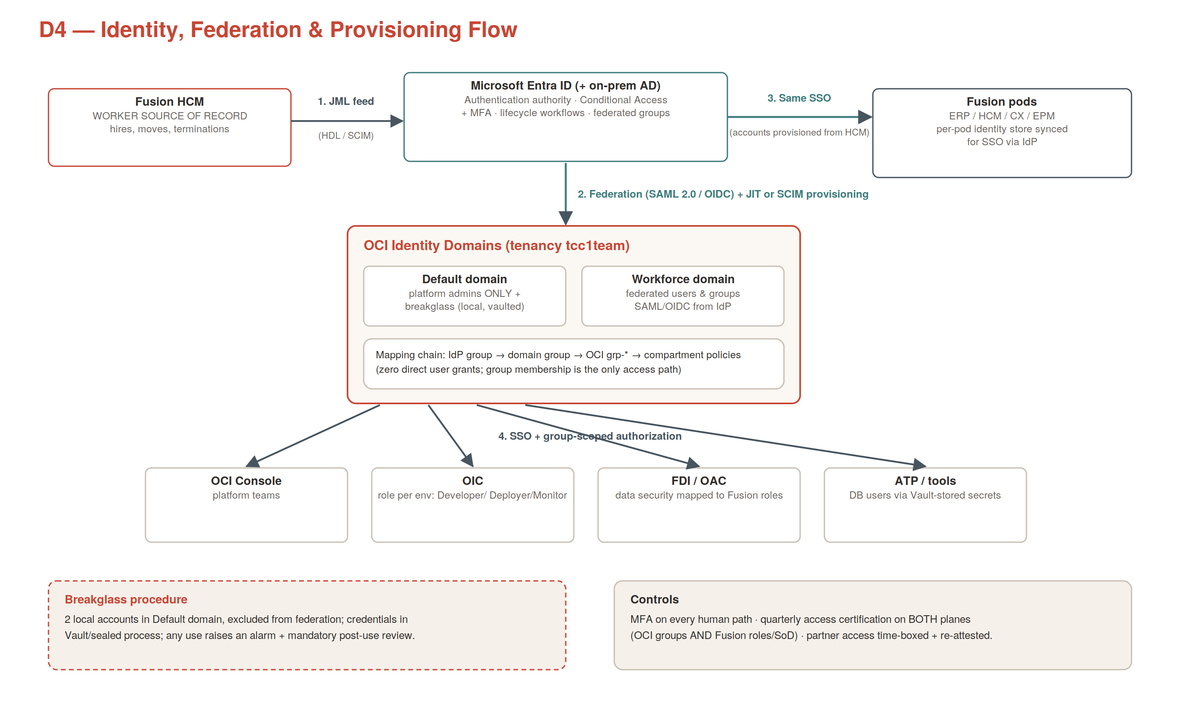

8.1 Identity & access (IAM + Entra ID federation)
- Entra ID is the sole IdP: SAML 2.0/OIDC federation into OCI identity domains (Default = platform admins + 2 alarmed break-glass accounts only; WORKFORCE = all federated humans incl. time-boxed vendor B2B guests); Conditional Access + MFA on every interactive path; SCIM provisioning; HCM drives joiner/mover/leaver. Authorization is group-only: Entra groups → OCI-* groups → compartment-scoped policies (default-deny, no wildcard admin outside break-glass); service accounts are per-system-per-environment with Vault-held credentials rotated ≤ 90 days; quarterly access certification covers both OCI groups and Fusion roles. Access flows A–F are specified in Vol. 7 §5 (D12).

8.2 OCI security service catalog (what runs, where, why)
Service | Role in this design | Scope | Wave | Owner
IAM + Identity Domains | Federation, groups, policies, break-glass — §8.1 | Tenancy | W0 | IAM team
Compartments + policies | Structural least privilege; absence-of-allow IS the deny | Tenancy | W0–W1 | Infra Ops (Security A)
Security Zones | Preventive guardrails: no public buckets/IPs, no IGW, encryption required — violations impossible | PRD · Analytics · Vault-KMS · Regulated | W1 | Security
Cloud Guard | CSPM: detectors + graduated responders (auto-remediate DEV → alert-only PRD); posture score KPI | Tenancy target | W0 | Security
Vault / KMS | Secrets (OIC connections, svc accounts, SFTP keys, wallets) + master keys; 90d rotation; customer-managed keys for PRD/Analytics/Regulated storage | Shared-Services:Vault-KMS [SZ] | W0 | Security
Encryption | At rest: AES-256 everywhere, ATP TDE, CMK where supported. In transit: TLS 1.2+ all paths, mTLS 1522 to ATP, signed SAML assertions | Everywhere — non-negotiable | Always | Security
Certificates | TLS certificate lifecycle for LB / API GW listeners; renewal alarms | Integration-Shared endpoints | W2 | Infra Ops
Data Safe | For ATP/ADW: security + user assessments, sensitive-data discovery, MASKING for non-prod copies (Confidential never lands unmasked in DEV/TST — enforces GOV-DA-01), activity auditing → SIEM | ATP all envs + FDI ADW | W2–W3 | Security + DBA
Vulnerability Scanning (VSS) | Host + container-image scanning for any compute (partner/VBS app VMs, ADO agents); findings → Cloud Guard | App-Processing compute | W2 | Security (App Dev remediates)
OS Management Hub | OS patch + compliance management for all compute instances; patch windows per ChangeWindow tag | All compute (incl. ADO agent pool) | W2 | Infra Ops
Bastion | Session-managed admin access to private compute/ATP — no jump hosts, no SSH from internet, sessions time-boxed + recorded in audit | App-Processing / Regulated | W1 | Infra Ops
WAF | OCI WAF policies on public-facing LB + API Gateway: OWASP protections, rate limiting, geo/IP controls — hardens flows E1/E2/E4 | Integration-Shared public edges | W2 | Security + Network
NSGs | Micro-segmentation, default-deny both directions; rule matrix in Vol. 5 §6.3 | All subnets | W1 | Network (Security A on rules)
Audit + Logging + Log Analytics | Tenancy audit at max retention; service + flow logs to Governance sinks; deletion not grantable to operational groups | Tenancy → Governance | W0 | Security
Threat Intelligence | Feeds Cloud Guard detectors with Oracle threat intel for indicator matching | Tenancy | W0 (with Cloud Guard) | Security
SIEM — Microsoft Sentinel | Single pane: OCI audit/flow/Cloud Guard findings stream via Service Connector Hub → Sentinel connectors, severity-mapped with Defender/M365 signals — closes gate D9; multi-cloud ready (Vol. 9) | Cross-cloud | W2 | Security (SOC)
Oracle Access Governance | OPTIONAL roadmap: automates the quarterly access certification across OCI + Fusion roles | Roadmap (Optimize) | post-go-live | IAM team
Network and access flow enforcement (D11/D12, Vol. 7) is the runtime complement to this catalog: six-layer defense in depth — routing, NSG, Security Zone, service allow-lists, identity/secrets, detection — with the standing rule that an unregistered flow does not exist.

9. Observability & Management
Layer | Implementation | Consumer
Metrics & alarms | OCI Monitoring: ALM-BREAKGLASS-LOGIN (critical, paged) · ALM-OIC-ERRORS-{env} · ALM-ATP-CPU/STORAGE · ALM-BUDGET-* (70/90/100) · ALM-CLOUDGUARD-CRITICAL · ALM-FDI-PIPELINE · ALM-TAG-COMPLIANCE · DR alarms per §12 option | Routed by SupportGroup tag; critical → paged
Logs | Audit + service + VCN flow logs → Governance sinks → Log Analytics group LOGA-PLATFORM-01; dashboards for platform, security, integration health | Platform ops + SOC
Integration observability | OIC monitoring + error hospital (single front door for integration incidents); resubmission with audit trail | Integration support
Events & notifications | OCI Events → Notifications topics per team; announcements monitored for Oracle maintenance | All teams
Operational calendar | Fusion quarterly updates + P2T refreshes + OIC patching windows + drill schedule + freeze windows — one calendar | Change management
Runbooks & registers | Environment register, flow register, service-account register, exception register — versioned with the LLD | Everyone; audited quarterly

10. FinOps
- Attribution: every resource carries BusinessUnit / CostCenter / Partner / Service tags (locked defaults) — ≥98% tag-compliance KPI makes cost data trustworthy; vendor spend shows back per partner.
- Guardrails: budgets per top-level compartment with 70% forecast / 90% / 100% actual alerts; compartment quotas zero-out GPU/HPC/Exadata in DEV and Sandbox; Sandbox reaped monthly via Lifecycle tag.
- Cadence: monthly cost review (variance, budget breaches, Cloud Advisor recommendations, ATP auto-scale bounds, storage lifecycle tiering); renewal negotiations armed with real consumption; inter-cloud egress gets its own line once multi-cloud phases begin (§13); FOCUS-based consolidated reporting at multi-cloud P4.

11. IaC & CI/CD — Azure DevOps Pipelines + GitHub Repositories
Delivery model: GitHub is the source of truth (repos, branch protection, pull requests, CODEOWNERS); Azure DevOps Pipelines is the execution engine (YAML pipelines, Environments with approval gates, agent pools). This pairing keeps developer workflow in GitHub while using ADO's environment-approval model to implement the CAB gate — and it aligns with the Entra-centric identity plane.

11.1 Repositories (GitHub)
Repo | Contents | Branch model
oci-platform | Terraform: global/ (IAM, governance, compartments) · modules/ (network-vcn, oic-instance, atp, bucket, security-zone) · envs/ (dev1, dev2, tst, prd) · state in versioned OCI Object Storage per stack | main / develop / feature/* / hotfix/* · PR + review mandatory
oic-integrations | OIC design-time exports (nightly job) + configuration plans per environment + DR config plan | same
vbs-apps | VBS application sources, build definitions | same
cloud-core | Shared: tag schema data, naming validators, policy-as-code tests, CIDR registry, pipeline templates | same
- Branch protection on main: required PR reviews, required status checks (fmt/validate/tflint/checkov), CODEOWNERS routes IAM/network/zone paths to Security for mandatory review (implements GOV-PO-04); no direct pushes; secrets scanning enabled.

11.2 Pipelines (Azure DevOps)
- ADO project 'OCI-Platform'; GitHub connected via the Azure Pipelines GitHub App (service connection) — pipelines trigger on PR and merge events in GitHub.
- Each repo carries azure-pipelines.yml extending shared templates from cloud-core: stages = validate (fmt/lint/scan) → plan (publish plan artifact to the PR) → apply-DEV (auto on merge) → apply-TST (ADO Environment 'TST' approval: platform lead) → apply-PRD (ADO Environment 'PRD' approval: CAB — implements change-workflow step 6).
- Agent strategy — the zero-stored-keys rule: SELF-HOSTED ADO agent pool on OCI compute in Shared-Services:Shared-Tools, authenticating to OCI via instance principals (dynamic group DG-ADO-AGENTS → policy-scoped) — no OCI API keys exist anywhere in ADO. Agents are patched by OS Management Hub and scanned by VSS (§8.2). Microsoft-hosted agents are the fallback for non-OCI jobs only.
- Secrets: pipeline-consumed secrets resolve at runtime from OCI Vault via the agent's instance principal; ADO Library holds no long-lived cloud credentials; OIC deploys use the OAuth client (SEC-DEVOPS-{ENV}-OICDEPLOY) fetched from Vault.
- Non-Terraform artifacts ride the same pipelines: OIC design-time import with config-plan substitution per environment; VBS build + deploy; both gated identically (DEV auto → TST approval → PRD CAB).
- Drift job: scheduled ADO pipeline runs terraform plan nightly per env; any diff raises a work item + alarm — unreconciled > 48h breaches GOV-CH-01 and appears in the governance KPI pack.
- Migration note: earlier volumes referenced 'GitHub/ADO or OCI DevOps' — this section is now authoritative: GitHub repos + ADO pipelines. OCI DevOps is not used; Vol. 5 §10 is superseded accordingly.

12. Disaster Recovery — Full Stack DR and Manual DR

12.1 Option 1 — OCI Full Stack DR (service-orchestrated, warm standby)
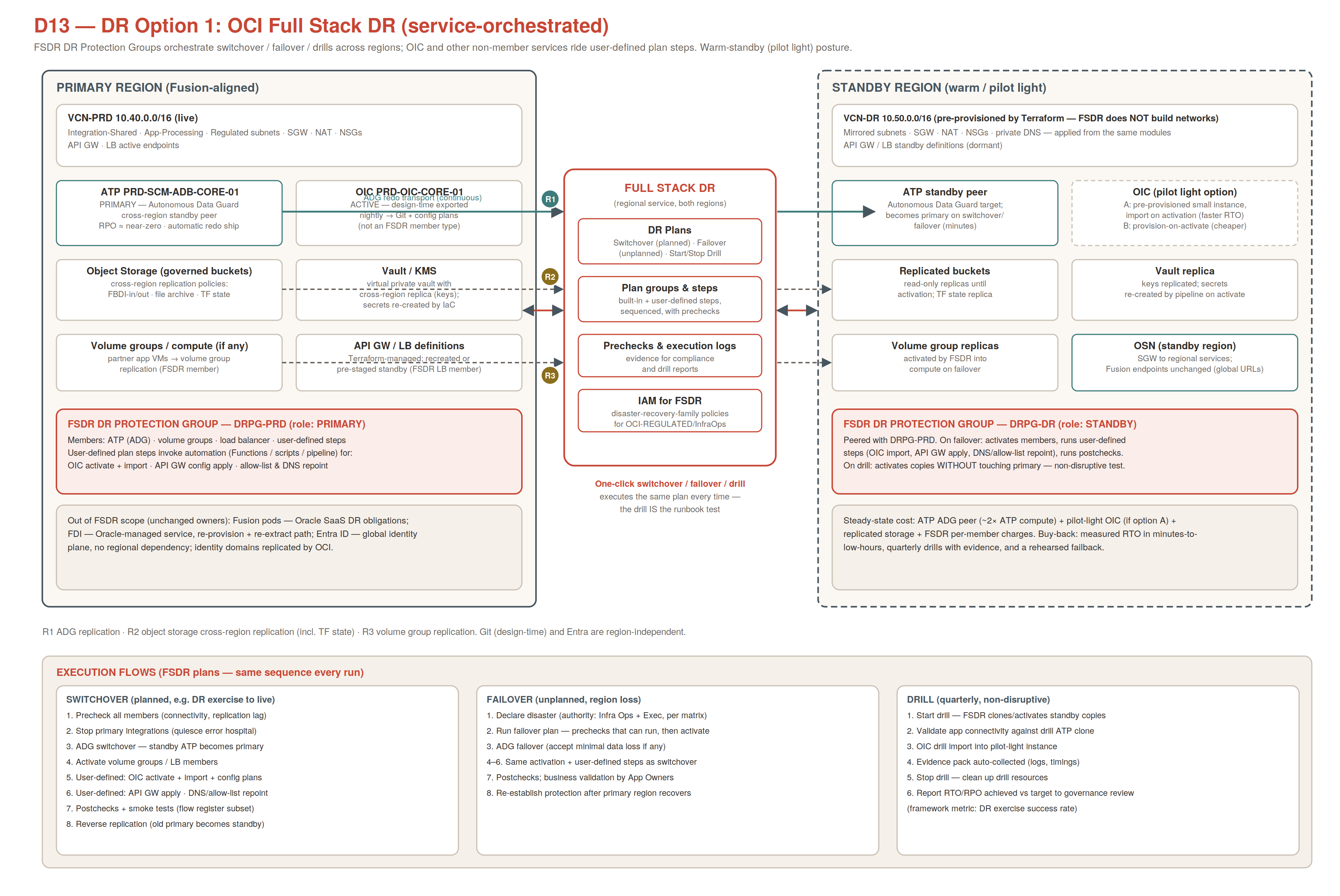

12.2 Option 2 — Manual / IaC-driven DR (backup-and-rebuild, cold standby)
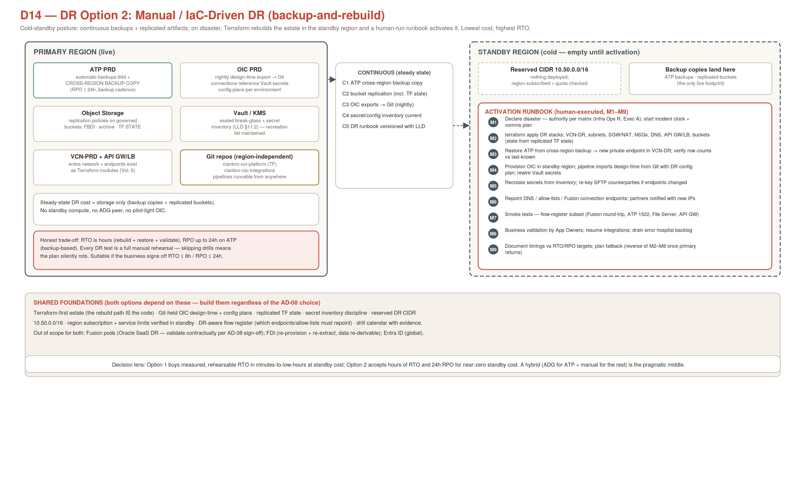

12.3 Summary and recommendation
Dimension | Option 1 — Full Stack DR | Option 2 — Manual / IaC
RTO / RPO | ≈1–2h / near-zero (ATP via Autonomous Data Guard) | ≈6–8h / ≤24h (cross-region backup based)
Steady-state cost | ADG peer + optional pilot-light OIC + replicated storage + FSDR member charges | Storage only
Execution | Versioned DR plans (switchover/failover/drill) with prechecks; OIC via user-defined steps calling the ADO pipeline | Human-run M1–M9 runbook; Terraform rebuild + restore + repoint
Drills | Quarterly non-disruptive; evidence auto-collected | Annual full rehearsal minimum
Recommendation | Adopt for PRD, phased: shared foundations → ADG (measure cost 1 month) → FSDR + first drill | The graceful fallback — Option 1 minus ADG/pilot-light/orchestration; nothing wasted either way
- Both options share the same foundations (build regardless): Terraform-rebuildable estate, Git-held OIC design-time + DR config plan, replicated TF state, secret inventory, reserved 10.50.0.0/16, verified standby-region service limits. Out of scope for both: Fusion pods (Oracle SaaS DR — file the contractual terms), FDI (re-provision + re-extract), Entra (global). Full detail: Vol. 8.

13. Multi-Cloud Extension (OCI → AWS · Azure · GCP)
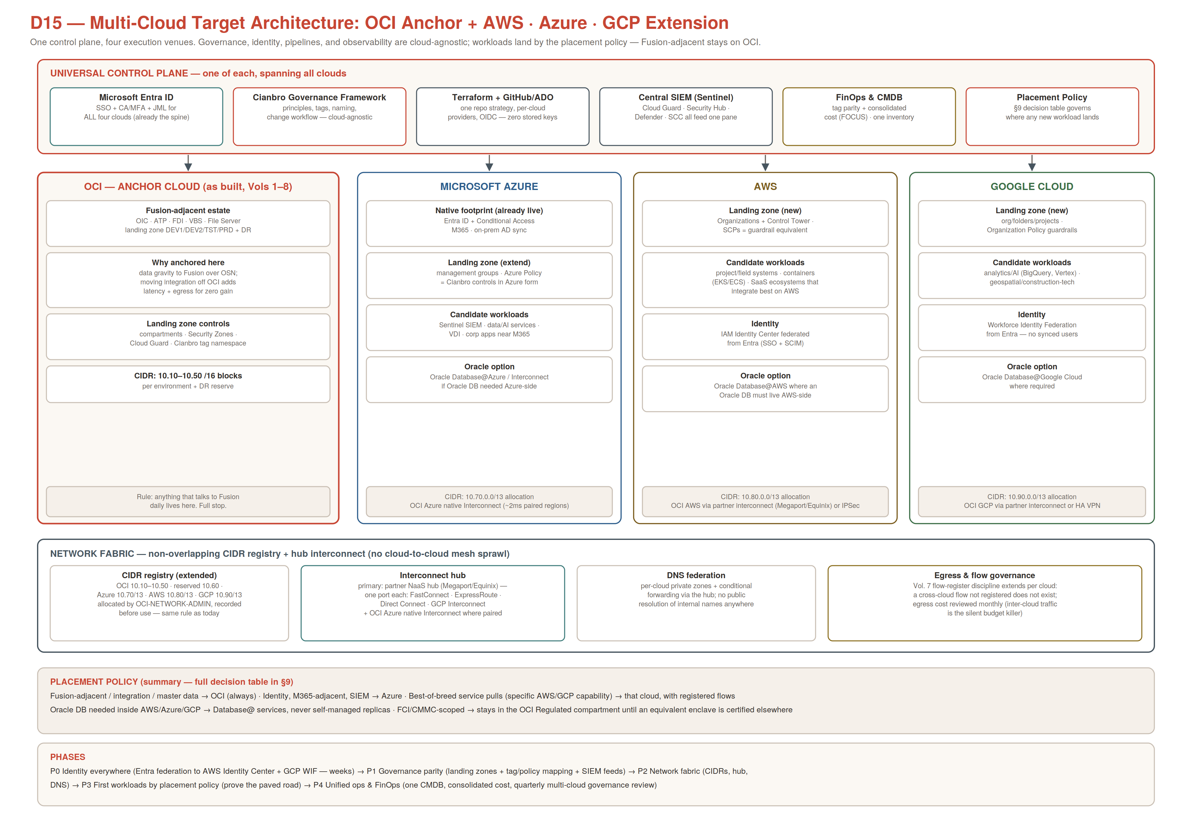
- Principles (MC-01..05): extend-never-fork the governance framework (per-cloud Landing Zone Annexes with the same GOV-* IDs); one identity plane (Entra federates AWS Identity Center, GCP Workforce Identity Federation — no cloud-local users); OCI stays the anchor for anything Fusion-adjacent (data gravity over OSN); placement by the §9 decision table of Vol. 9, recorded in the decision log; paved roads only — a cloud opens when its landing zone, tag/policy mapping, SIEM feed, pipeline identity, and CIDR allocation exist.
- Fabric: extended CIDR registry (Azure 10.70/13, AWS 10.80/13, GCP 10.90/13); NaaS hub interconnect (one circuit per cloud, not a peering mesh) + OCI↔Azure native Interconnect; DNS conditional forwarding at the hub; every cross-cloud flow registered before build; inter-cloud egress on the monthly cost review.
- Operations: Sentinel remains the one SIEM pane (Cloud Guard, Security Hub/GuardDuty, Defender, SCC all feed it); the ADO+GitHub delivery model (§11) extends per cloud with per-provider repos and OIDC/workload-identity federation; CMMC/FCI scope stays in the OCI Regulated compartment until an equivalent enclave is certified elsewhere. Phases P0–P4 and the full parity matrix: Vol. 9.

Appendix — diagram index: D1 solution context · D2 landing zone · D3 network · D4 identity · D5 integration · D6 migration/ETL · D7 FDI · D8 harmonized tenancy · D9 end-state logical · D10 infrastructure topology · D11 network flows · D12 access flows · D13 Full Stack DR · D14 Manual DR · D15 multi-cloud. All available as editable SVG in the delivered diagram packs.

