ORACLE CLOUD INFRASTRUCTURE · ENTERPRISE REFERENCE

Production Disaster Recovery
Design & Implementation Document
Hybrid FastConnect Connectivity · IPSec VPN Backup · On-Prem Global Load Balancer · Identity Replication · Hot/Warm/Cold Standby
Primary: Ashburn (us-ashburn-1) · Secondary / DR: Phoenix (us-phoenix-1)
Version 1.0 · 13 October 2026 · Classification: Internal
Generic reference design — no organization-specific identifiers

Document control
Field | Value | Notes
Title | Production DR Design & Implementation Document | Hybrid-connected; Ashburn primary / Phoenix secondary
Version | 1.0 | Generic reference baseline
Date | 13 October 2026
Classification | Internal | De-identified; safe for broad internal circulation
Scope | Production DR for OCI + external Fusion SaaS | Hybrid FastConnect connectivity, identity replication, hot/warm/cold
Connectivity posture | Hybrid: redundant FastConnect + IPSec VPN backup | On-prem ↔ OCI (both regions); Azure via ExpressRoute
Design basis | Provided production topology + MAA best practice | Reference implementation pending reconciliation with live inventory

Reading guide
§1–§2 set scope and principles. §3 is the end-to-end architecture. §4 is the hybrid connectivity design (FastConnect redundancy, public/private virtual circuits, IPSec VPN, DRG routing, ExpressRoute, on-prem GSLB).
§5 covers identity (Entra ID federation + IAM Identity Domain replication). §6 defines the hot/warm/cold standby model with per-service recommendations. §7–§10 are service recovery, RTO/RPO, delivery and runbooks. §11–§14 are the implementation plan, gates, decisions and references.

Contents

1. Executive summary
This document defines the production Disaster Recovery (DR) design and implementation approach for an Oracle Cloud Infrastructure (OCI) estate with Ashburn (us-ashburn-1) as the primary region and Phoenix (us-phoenix-1) as the secondary / DR region. Unlike a cloud-isolated model, this design establishes hybrid connectivity between the on-premises data centre and both OCI regions using redundant FastConnect circuits with an IPSec VPN backup, so production and recovery workloads are reachable from the enterprise network over private, resilient paths.
Client traffic is steered by an on-premises DNS-based Global Load Balancer (GSLB) in an active-standby configuration: users resolve to Ashburn in steady state and are failed over to Phoenix on a declared disaster. Workforce identity is provided by Microsoft Entra ID; OCI IAM Identity Domains federate to it, and the primary Ashburn domain is replicated to Phoenix so a regional failover needs no re-federation and no new enterprise application.
Recovery is engineered per service against a hot / warm / cold standby model, with a recommended default tier for each service that balances RTO/RPO against steady-state cost. Oracle Fusion Cloud Applications remain an external Oracle-operated SaaS consumed by both regions and are never deployed inside OCI.

Design pillars
- Resilient hybrid connectivity. Two diverse FastConnect circuits per region, each carrying a private and a public virtual circuit, with a two-tunnel IPSec VPN as an automatic BGP backup.
- Active-standby traffic steering. On-prem DNS GSLB resolves to the primary region and fails over to Phoenix; Azure reaches OCI through an ExpressRoute interconnect.
- Replicated identity. Entra ID federation plus OCI IAM Identity Domain cross-region replication (Ashburn → Phoenix) for seamless identity failover; machine identity stays on OAuth2/mTLS with secrets in Vault.
- Per-service standby tiers. Hot (near-real-time), warm (pre-provisioned) and cold (backup/rebuild) options, each with a documented recommendation.
Key assumptions carried into this design
FastConnect connectivity to both regions is approved (this supersedes any prior no-on-prem-connectivity constraint).
The enterprise holds (or will procure) two diverse FastConnect circuits per region and internet capacity for the IPSec VPN backup.
OCI IAM Identity Domain cross-region replication is available for the domains in DR scope.
Per-service RTO/RPO targets and the standby cost budget are ratified before build (see §13).

2. Scope and design principles

2.1 In scope
- Two-region OCI production DR: Ashburn (primary) and Phoenix (secondary).
- Hybrid connectivity: redundant FastConnect (public + private virtual circuits), IPSec VPN backup, Azure ExpressRoute interconnect, on-prem GSLB.
- Identity: Entra ID federation and IAM Identity Domain replication Ashburn → Phoenix.
- Per-service recovery: Autonomous DB (ADW/ATP), OIC Gen3, FDI/analytics, Object Storage, compute/agents, network/edge.
- Delivery via ADO/Terraform with region-isolated state; failure runbooks and a phased implementation plan.

2.2 Out of scope
- Deploying Oracle Fusion SaaS inside OCI (it remains an external managed service).
- Non-production environment DR beyond what is explicitly included; a third region or active-active multi-region.
- Application-internal data-consistency logic beyond the platform recovery mechanisms described here.

2.3 Design principles
- Resilience by diversity. No single shared-fate path: two FastConnect circuits in diverse locations, dual CPE, dual VPN tunnels, dual regions.
- Private-first connectivity. Private virtual circuits for VCN traffic; public virtual circuits for Oracle Services and Fusion SaaS public endpoints; internet used only for the encrypted VPN backup and ExpressRoute hand-off.
- Region isolation. Phoenix is an independent build with non-overlapping CIDRs, region-specific OCIDs and its own Terraform state.
- Identity continuity. Replicate identity domains so recovery does not depend on re-federating or re-provisioning users.
- Right-sized standby. Choose hot/warm/cold per service on business value, not a blanket tier.

3. End-to-end target architecture
Figure 1 is the consolidated, de-identified topology. The on-premises data centre connects to each OCI region over redundant FastConnect with IPSec VPN backup; the on-prem GSLB steers active-standby; Entra ID federates the IAM domains which replicate Ashburn → Phoenix; and Fusion SaaS is consumed externally by both regions.
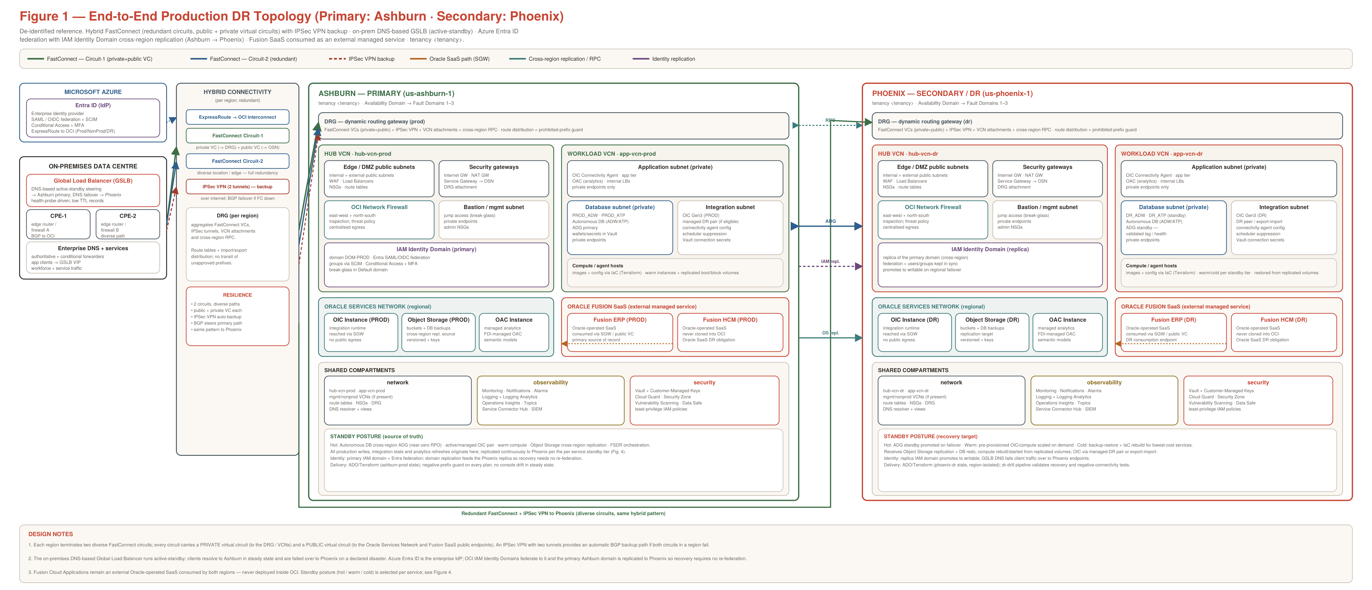
Figure 1 — End-to-end production DR topology (primary: Ashburn; secondary: Phoenix).

Building blocks per region
- Hub VCN. Edge/DMZ public subnets (WAF, load balancers), security gateways (Internet GW, NAT GW, Service Gateway), OCI Network Firewall, bastion/management, and the regional IAM Identity Domain.
- Workload VCN. Application subnet (OIC connectivity agent, OAC, internal load balancers), database subnet (Autonomous DB with private endpoints), integration subnet (OIC Gen3), and compute/agent hosts delivered by IaC.
- DRG. Aggregates the FastConnect virtual circuits, IPSec VPN attachment, VCN attachments and cross-region RPC, with route distribution and a prohibited-prefix guard.
- Oracle Services Network & SaaS. OIC, Object Storage and OAC reached via the Service Gateway; Fusion ERP/HCM consumed as an external managed service.
- Shared compartments. network, observability and security compartments provide routing/DNS, monitoring/logging/SIEM, and Vault/Cloud Guard/Security Zone across the region.

4. Hybrid network connectivity
Figure 2 details the connectivity design for one region; the same pattern is built independently in Ashburn and Phoenix.
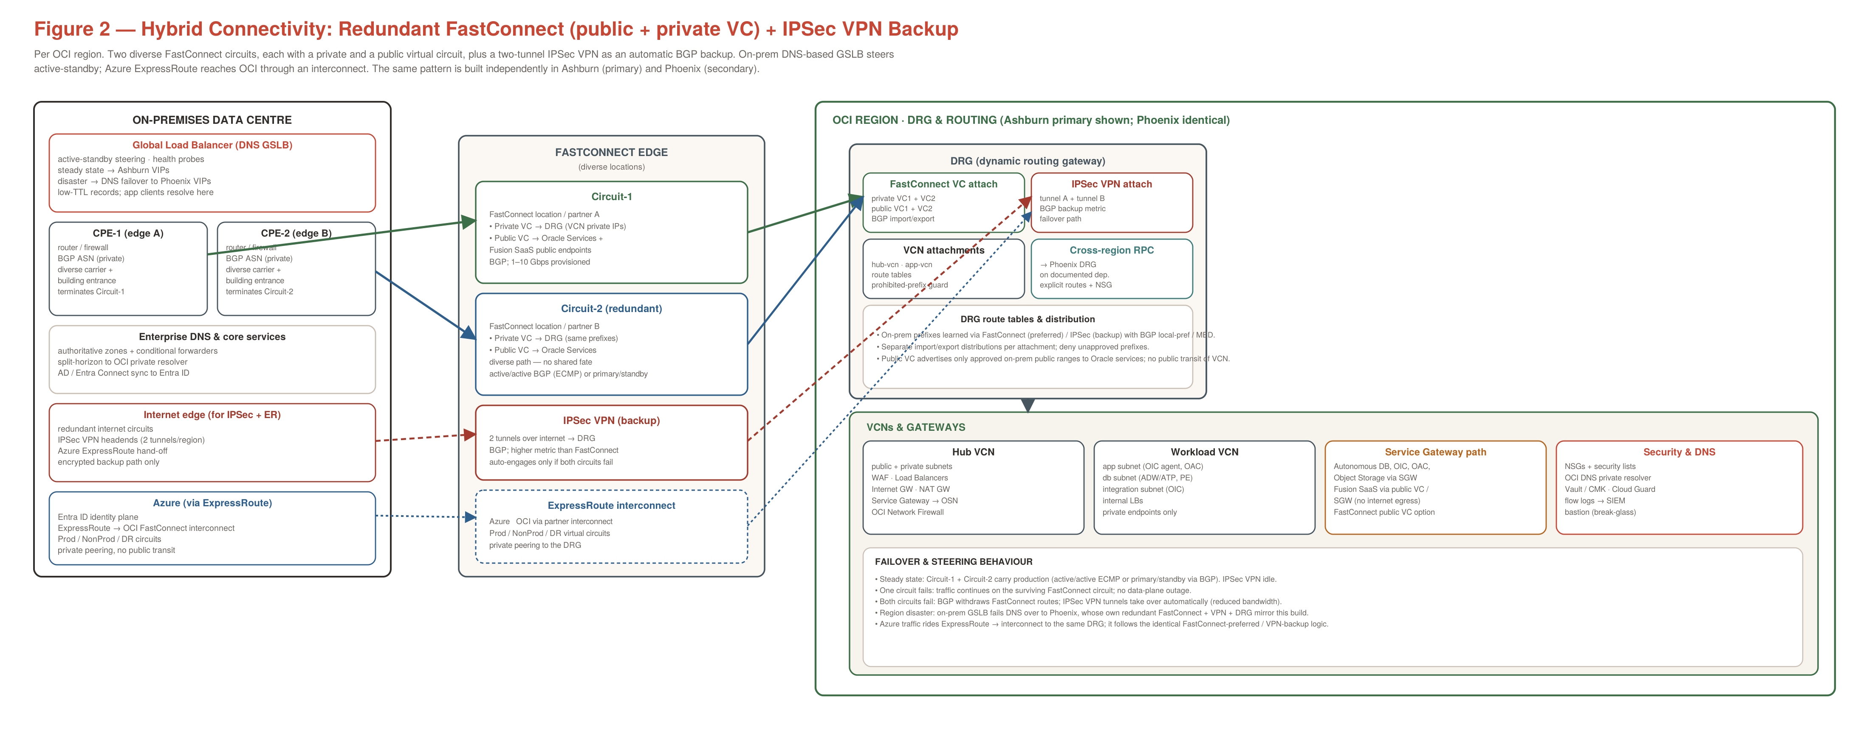
Figure 2 — Redundant FastConnect (public + private virtual circuits) with IPSec VPN backup.

4.1 Redundant FastConnect circuits
Each region terminates two diverse FastConnect circuits (Circuit-1 and Circuit-2) in different FastConnect locations / edges, terminated on two separate customer premises equipment (CPE-1 and CPE-2) for full path and device diversity. Every circuit provisions both a private and a public virtual circuit:
Virtual circuit | Purpose
Private virtual circuit | Carries private-IP traffic between the on-premises network and OCI VCNs via the DRG. Used for application, database and integration access over private address space.
Public virtual circuit | Reaches Oracle public service endpoints (Object Storage, OCI APIs) and Fusion SaaS public endpoints over FastConnect instead of the internet. Advertises only approved on-prem public ranges; no public transit of VCN traffic.
Both circuits run BGP. They operate active/active with ECMP where the enterprise routing supports it, or primary/standby via BGP local-preference / MED. Losing one circuit leaves production on the surviving circuit with no data-plane outage.

4.2 IPSec VPN backup
A two-tunnel IPSec VPN over the internet attaches to the same DRG as an automatic backup. Its BGP routes carry a higher metric than FastConnect, so the VPN is idle in steady state and engages only if both FastConnect circuits in a region fail. Bandwidth is lower than FastConnect, so the VPN is a continuity path, not a capacity equal.

4.3 DRG routing and failover behaviour
- Route learning. On-prem prefixes are learned via FastConnect (preferred) and IPSec VPN (backup); BGP local-preference / MED enforces the preference order.
- Distribution control. Separate import/export route distributions per attachment; unapproved prefixes are denied (prohibited-prefix guard).
- Public advertisement. The public virtual circuit advertises only approved on-prem public ranges to Oracle services; VCN traffic is never publicly transited.
Failover sequence
Steady state: Circuit-1 + Circuit-2 carry production; IPSec VPN idle.
One circuit fails: traffic continues on the surviving FastConnect circuit; no outage.
Both circuits fail: BGP withdraws FastConnect routes; IPSec VPN tunnels take over automatically (reduced bandwidth).
Region disaster: the on-prem GSLB fails DNS over to Phoenix, whose own redundant FastConnect + VPN + DRG mirror this build.

4.4 Azure connectivity via ExpressRoute
Microsoft Azure reaches OCI through an ExpressRoute → OCI FastConnect interconnect with private peering to the DRG (Prod / NonProd / DR virtual circuits). Azure traffic follows the identical FastConnect-preferred / VPN-backup logic. Azure also hosts the Entra ID identity plane (§5). No public transit between Azure and OCI is assumed; any such path is independently reviewed.

4.5 On-premises Global Load Balancer (DNS GSLB)
An on-premises DNS-based Global Load Balancer (for example an F5 GTM / BIG-IP DNS or equivalent GSLB) provides active-standby steering. In steady state it resolves application names to Ashburn VIPs; on a declared disaster it fails DNS over to Phoenix VIPs. Health probes drive the decision and records use low TTLs so failover propagates quickly. Clients and services always resolve through the GSLB rather than pinning a regional endpoint.

4.6 Connectivity build steps
- Provision two FastConnect circuits per region in diverse locations; terminate on CPE-1 and CPE-2.
- On each circuit, create a private virtual circuit (to the DRG) and a public virtual circuit (to Oracle services); configure BGP sessions and route filters.
- Create the DRG per region; attach FastConnect VCs, the IPSec VPN (two tunnels), VCN attachments and the cross-region RPC; set route distributions and the prohibited-prefix guard.
- Stand up the IPSec VPN with higher BGP metric than FastConnect; verify it only engages on dual-circuit failure.
- Establish the Azure ExpressRoute interconnect with private peering to the DRG for Prod/NonProd/DR.
- Configure the on-prem GSLB with health probes, Ashburn-primary resolution and Phoenix failover; set low TTLs.
- Validate: failover drills for single-circuit loss, dual-circuit loss (VPN engages) and regional failover (GSLB cutover); confirm no unapproved prefixes are advertised.

5. Identity: Entra ID federation + IAM domain replication
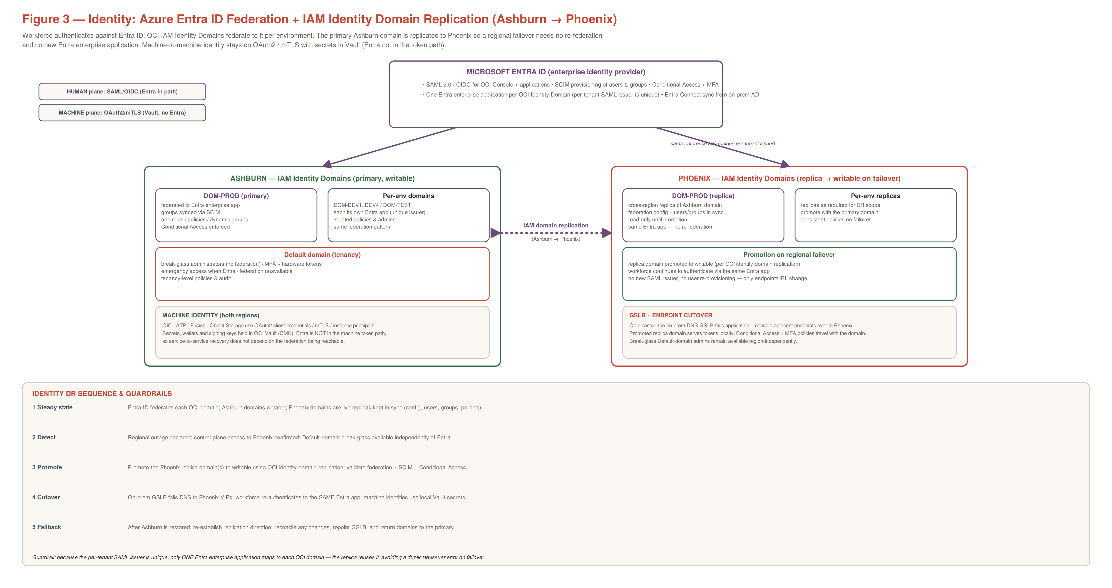
Figure 3 — Entra ID federation with IAM Identity Domain replication (Ashburn → Phoenix).

5.1 Federation model
Microsoft Entra ID is the enterprise identity provider. OCI IAM Identity Domains federate to Entra via SAML 2.0 / OIDC, with users and groups provisioned through SCIM and Conditional Access + MFA enforced. One Entra enterprise application maps to each OCI Identity Domain, because the per-tenant SAML issuer is unique — a single application cannot be reused across domains without an issuer collision.

5.2 IAM Identity Domain replication (Ashburn → Phoenix)
The primary Ashburn domains are replicated to Phoenix using OCI identity-domain cross-region replication. The replica carries the federation configuration, users, groups and policies and stays read-only until promotion. On a regional failover the replica is promoted to writable; because it reuses the same Entra enterprise application, no re-federation and no user re-provisioning are required — only the endpoint/URL changes, driven by the GSLB cutover.

5.3 Machine identity
Service-to-service identity (OIC ↔ ATP ↔ Fusion ↔ Object Storage) uses OAuth2 client-credentials, mTLS and instance principals, with secrets, wallets and signing keys held in OCI Vault (customer-managed keys). Entra is not in the machine token path, so service recovery does not depend on the federation being reachable.

5.4 Identity DR sequence
- Steady state — Entra federates each OCI domain; Ashburn domains writable; Phoenix domains are live replicas kept in sync.
- Detect — regional outage declared; confirm control-plane access to Phoenix; Default-domain break-glass available independently of Entra.
- Promote — promote the Phoenix replica domain(s) to writable; validate federation, SCIM and Conditional Access.
- Cutover — on-prem GSLB fails DNS to Phoenix VIPs; workforce re-authenticates to the same Entra app; machine identities use local Vault secrets.
- Failback — re-establish replication direction, reconcile changes, repoint GSLB, and return domains to the primary.
Guardrail
Because the per-tenant SAML issuer is unique, only one Entra enterprise application maps to each OCI domain. The replica reuses it, which avoids the “Provider ID already exists” duplicate-issuer error on failover.

6. Hot / warm / cold standby model

6.1 Tier definitions
Tier | Mechanism | Indicative RTO | Indicative RPO
Hot | Active / near-real-time replication; standby ready to promote | ~1–2 hours | Near zero
Warm | Pre-provisioned, periodically synchronized; scaled on demand | Hours | Minutes–hours
Cold | Backup + rebuild via IaC at disaster time | 6–8 hours+ | ≤ 24 hours
Figure 4 maps each service to its hot/warm/cold options and the recommended default.
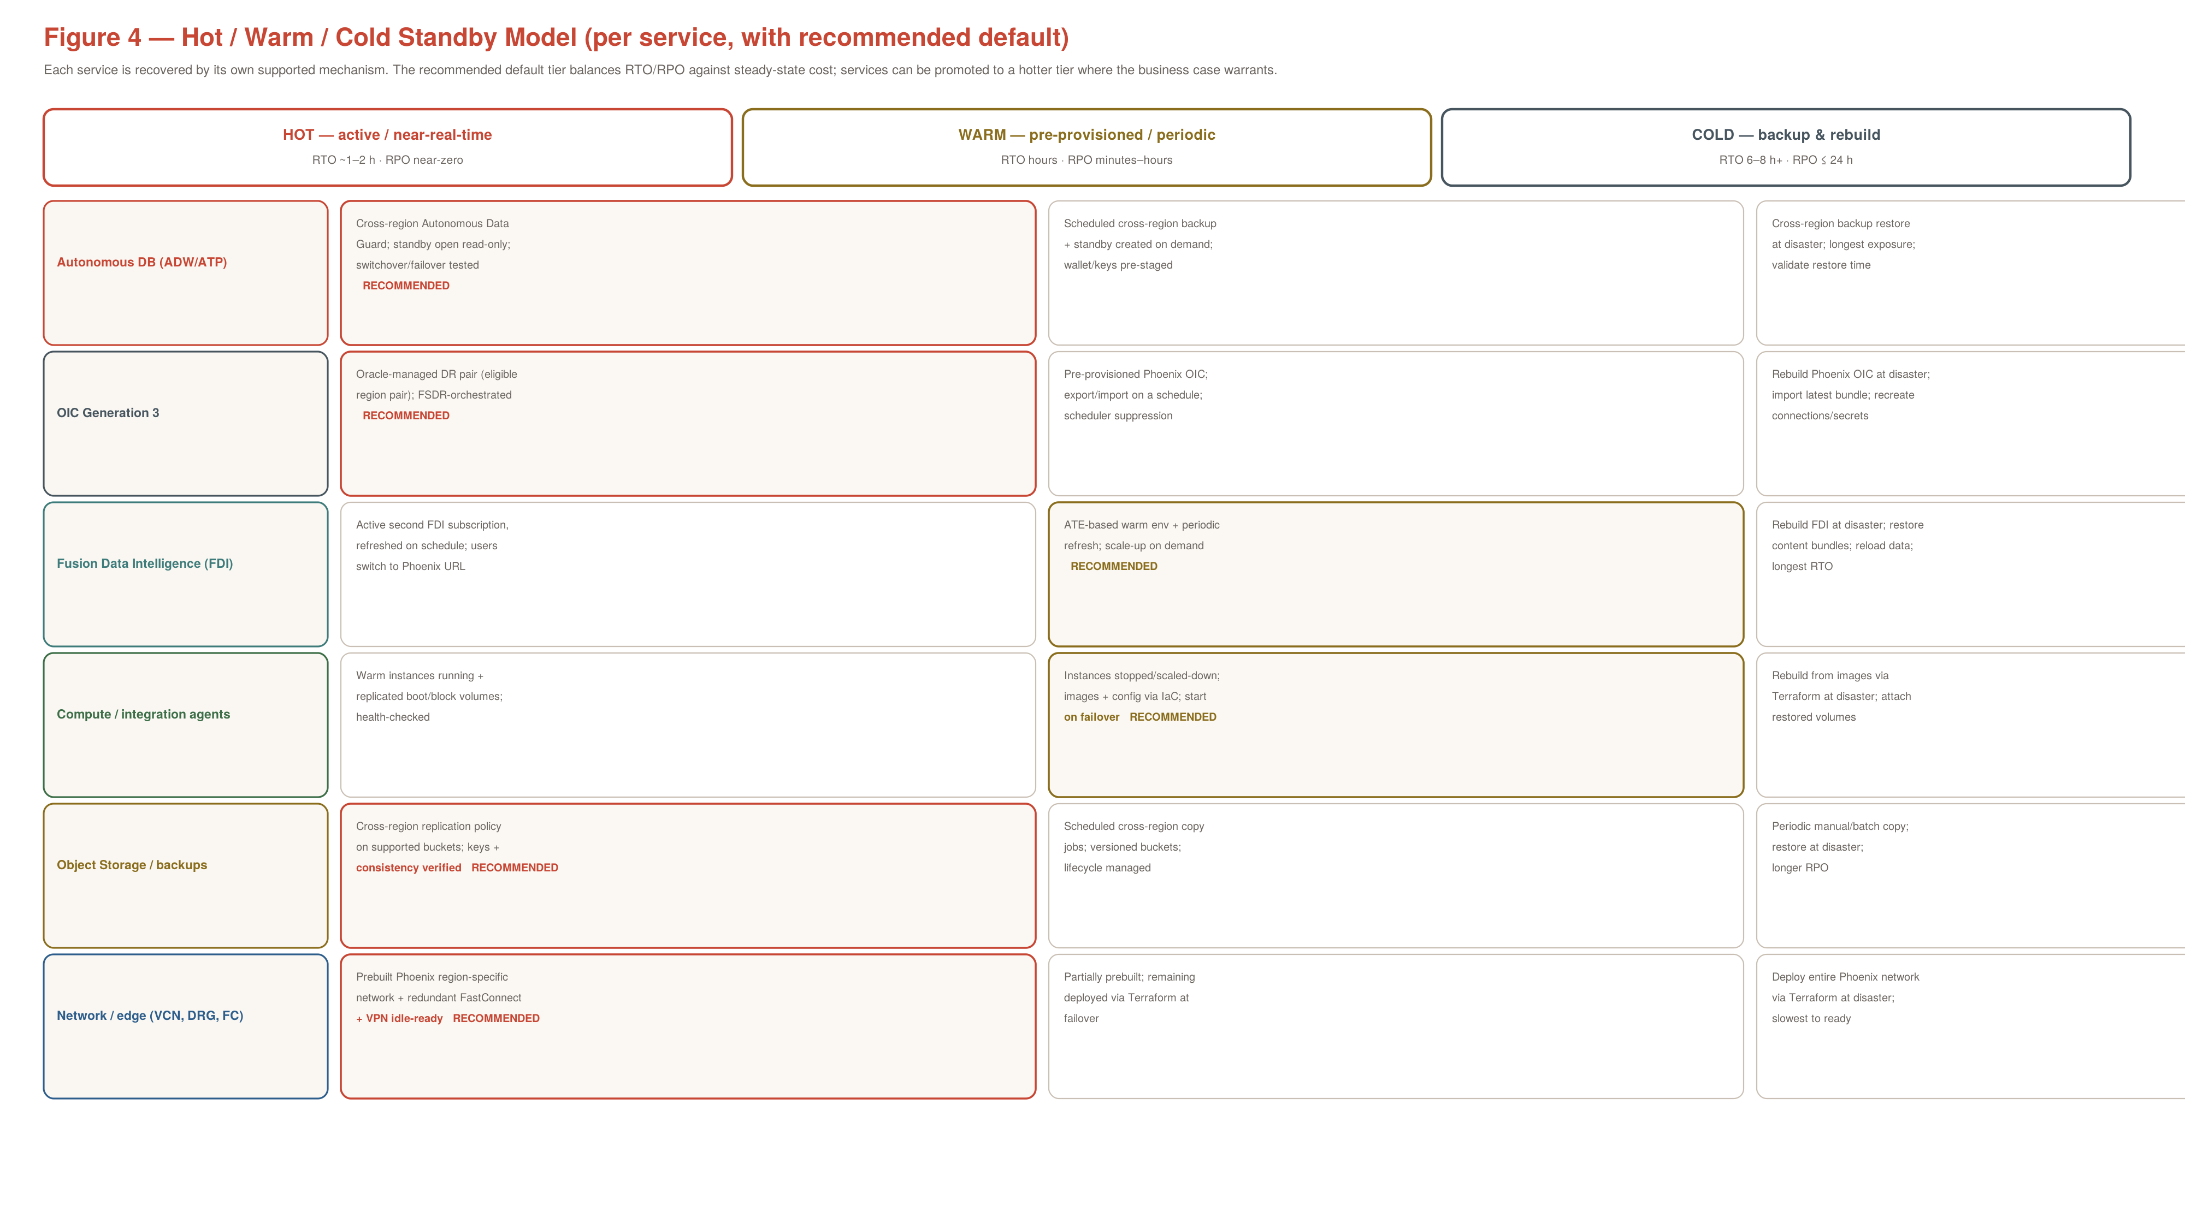
Figure 4 — Hot/warm/cold standby model per service, with recommended default.

6.2 Per-service recommendation
Service | Recommended tier | Rationale
Autonomous DB (ADW/ATP) | Hot — cross-region ADG | Near-zero RPO and tested switchover justify the standby cost for the system of record.
OIC Gen3 | Hot — managed DR pair (if eligible) | Oracle-managed DR pair gives low RTO and FSDR orchestration; fall back to warm export/import if not eligible.
FDI / analytics | Warm — ATE + periodic refresh | No native FDI failover/ADG; ATE warm with scale-up balances cost and recovery; active subscription if analytics is business-critical.
Compute / agents | Warm — IaC start on failover | Images + config via IaC with replicated volumes recover quickly at lower steady-state cost than always-on warm instances.
Object Storage / backups | Hot — cross-region replication | Replication is inexpensive and underpins every other recovery; keep it hot.
Network / edge | Hot — prebuilt + FC/VPN idle-ready | Prebuilt Phoenix network with redundant FastConnect and idle VPN removes the slowest step from the recovery path.

7. Service recovery design

7.1 Autonomous Database (ATP / ADW)
- Configure cross-region Autonomous Data Guard; keep the Phoenix standby open read-only with validated lag and service mapping.
- Synchronize wallets, Vault keys, secrets and application connect strings securely.
- Switchover/failover using documented OCI procedures; run SQL and application smoke tests on promotion. Use backup restore only for cold-tier databases where longer RTO/RPO is acceptable.

7.2 OIC Generation 3
- Preferred: an Oracle-managed DR pair in a supported region pair, orchestrated by Full Stack DR where eligible.
- Alternative: pre-provisioned Phoenix OIC with scheduled export/import of integrations, connections, lookups, certificates and activation settings; re-create secrets and connectivity-agent config; define duplicate-event and scheduler-suppression controls.
- Inventory PROD, TEST and DEV instances; confirm which are in DR scope.

7.3 FDI / analytics
- FDI has no automatic regional failover and no ADG/cloning of its managed data store. Recovery is a separately subscribed FDI or an Additional Test Environment (ATE) in Phoenix.
- Export FDI content bundles (semantic models, reports, extensions) at each release to versioned Object Storage; import and validate in Phoenix. Do not rely on generic OAC snapshots.
- Schedule independent Phoenix refresh per the target RPO; reconcile dimensions, fact counts and KPIs; pre-document ATE scale-up.

7.4 Object Storage
- Enable cross-region replication on supported buckets (application data, DB backups, release/bundle store); verify object consistency and key availability in Phoenix.

7.5 Compute and integration agents
- Deliver images and configuration via Terraform; replicate boot/block volumes. Warm tier keeps instances pre-provisioned and started on failover; cold tier rebuilds from images at disaster time.

8. Consolidated RTO / RPO targets
Planning targets — to be ratified (§13)
These are planning bands for sizing and cost, not contractual commitments until ratified per service with application owners.
Fusion SaaS RTO/RPO is Oracle's obligation under the subscription and is confirmed against contractual terms, not set here.
Service | Tier | Target RTO | Target RPO | Basis / dependency
Network / edge | Hot | < 1 hr | n/a | Prebuilt Phoenix network + redundant FastConnect + idle VPN
Autonomous DB (hot) | Hot | 1–2 hr | Near zero | Cross-region ADG; validated lag; switchover tested
Autonomous DB (cold) | Cold | 6–8 hr | ≤ 24 hr | Cross-region backup restore
OIC Gen3 (managed) | Hot | 1–2 hr | Low | Oracle-managed pair; FSDR-orchestrated
OIC Gen3 (customer) | Warm | 4–8 hr | Sync-cadence bound | Pre-provisioned Phoenix OIC; export/import
Object Storage | Hot | Minutes–hours | Replication lag | Cross-region replication on supported buckets
Compute / agents | Warm | Hours | Volume replication lag | IaC start + replicated volumes
FDI / analytics | Warm | Hours–1 day | Last refresh | ATE scale-up + bundle import + refresh
Identity | Hot | Minutes | Replication lag | IAM domain replication + promotion; GSLB cutover

9. ADO / Terraform delivery model
Infrastructure is delivered through Azure DevOps pipelines and Terraform modules with region-isolated state. FastConnect, DRG, VPN, VCNs and security are codified; FDI/SaaS provisioning is a separate Oracle-managed workstream orchestrated through ADO approvals.
infra/modules/{network-hub, network-spoke, drg, fastconnect, vpn,
network-security, dns, observability, autonomous-db}
infra/env/{ashburn-prod, phoenix-dr}
pipelines/{validate, plan, deploy-phoenix, connectivity-test, dr-drill}.yml
- Stage 1 — validate. fmt / validate / lint, security + policy checks, prohibited-prefix and forbidden-CIDR scans.
- Stage 2 — plan. Terraform plan artifact + change-control approval; production drift report.
- Stage 3 — deploy Phoenix. Foundation network, DRG, FastConnect/VPN attachments, security, DNS, observability.
- Stage 4 — replicate. ADG, Object Storage replication, OIC pairing, identity-domain replication.
- Stage 5 — orchestrate & drill. Full Stack DR recovery plans (eligible members), runbook registration, connectivity and DR drills.

10. Failure scenarios and runbooks

10.1 Planned switchover
- Confirm change ticket, backups, resource health, standby sync and connectivity (FastConnect + VPN) status.
- Pause duplicate OIC schedulers; quiesce writable transactions / integration ingress if required.
- Run Full Stack DR switchover for eligible components, or manually switch Autonomous DB and approved workloads.
- Promote the Phoenix IAM replica domain; validate federation and machine identities.
- Fail the on-prem GSLB over to Phoenix VIPs; retarget client endpoints; validate FastConnect/VPN reachability to Phoenix.
- Activate FDI/analytics recovery; reconcile dashboards and records; obtain application-owner approval.

10.2 Unplanned primary (Ashburn) outage
- Declare disaster; establish control-plane access, IAM (promote replica domain) and Phoenix health.
- Assess cross-region standby consistency; identify possible data loss before promoting Autonomous DB.
- Execute Full Stack DR failover or customer-managed ATP/OIC recovery.
- Start/scale warm compute; recover FDI from the Phoenix ATE/subscription.
- Fail GSLB DNS to Phoenix; verify user access over FastConnect/VPN, dashboard freshness and no duplicate scheduling.
- Publish actual RTO/RPO and application-level status.

10.3 Return to Ashburn (failback)
- Complete remediation; document all writes, integration schedules and FDI content changes.
- Resynchronize Autonomous DB; reverse OIC roles or redeploy application exports; re-establish identity-domain replication direction.
- Reconcile FDI bundles and reload primary if necessary.
- Perform approved switchover, GSLB/DNS cutover back to Ashburn, smoke tests and sign-off; retain Phoenix readiness.

11. Phased implementation plan
Phase | Objective | Key activities | Exit gate
0 | Reconcile & decide | Inventory primary estate; confirm FastConnect procurement (2 circuits/region); ratify RTO/RPO + standby budget; confirm IAM replication eligibility | Inventory + ratified targets + approved connectivity
1 | Connectivity foundation | Provision FastConnect (public+private VC) + IPSec VPN + DRG per region; ExpressRoute interconnect; on-prem GSLB | Dual-circuit + VPN failover drills pass; prefix guard verified
2 | Phoenix platform | Non-overlapping CIDRs; hub/workload VCNs; firewall, DNS, security, observability via Terraform (phoenix-dr state) | Foundation deployed; security baseline verified
3 | Data, integration & identity | ADG standby; Object Storage replication; OIC pair/export-import; IAM Identity Domain replication Ashburn→Phoenix | Standby health validated; replica domain in sync
4 | Analytics & compute | FDI/ATE build + refresh; warm/cold compute per tier; FDI bundle export/import + reconciliation | Bundle restoration + KPI reconciliation; compute recovery tested
5 | Orchestrate & drill | Full Stack DR plans; GSLB failover test; planned-switchover + unplanned-outage drills; failback test | Timed drill results; signed RTO/RPO; approved failback

Guardrails across all phases
- Connectivity tested, not assumed. Every connectivity change is proven by failover drills (single circuit, dual circuit, regional) before sign-off.
- Region-isolated state. ashburn-prod and phoenix-dr remain separate Terraform states.
- Identity continuity first. Stand up identity-domain replication early so later DR drills exercise real promotion, not a manual workaround.
- Evidence as you go. Capture the §12 gate evidence into the ADO release record at each phase.

12. Acceptance gates / evidence
Gate | Required evidence
Connectivity | Dual-circuit + dual-tunnel VPN failover drills; BGP preference verified; no unapproved prefixes advertised
Topology | As-is vs to-be inventory and actual Terraform plan per region
Identity | IAM domain replication in sync; replica promotion tested; Entra federation + SCIM + Conditional Access validated
Autonomous DB | ADG standby health/lag; controlled switchover + restore tests
OIC | DR mode verified; scheduler + callback validation
FDI / analytics | Bundle restoration; independent refresh; KPI reconciliation
GSLB | DNS failover test to Phoenix and back; TTL + health-probe behaviour verified
Security | IAM/NSG/firewall/DNS logs; Vault/CMK; no unauthorized external dependencies
Operations | Timed drill results; signed RTO/RPO per service; approved failback

13. Open decisions and assumptions
- FastConnect procurement. Confirm two diverse FastConnect circuits per region (locations/partners) and the commercial model.
- Azure path scope. Confirm the ExpressRoute → OCI interconnect design and whether NonProd/DR circuits are required at go-live.
- Identity replication. Confirm which IAM Identity Domains are in DR scope for cross-region replication.
- GSLB platform. Confirm the on-prem GSLB product and health-probe design; agree DNS TTLs.
- Targets & budget. Ratify RTO/RPO per service and the hot/warm/cold cost budget.
- FDI entitlement. Confirm Phoenix FDI subscription or ATE rights, capacity and source-connectivity permission.

14. Oracle implementation references
- OCI FastConnect overview — https://docs.oracle.com/en-us/iaas/Content/Network/Concepts/fastconnect.htm
- FastConnect redundancy best practices — https://docs.oracle.com/en-us/iaas/Content/Network/Concepts/fastconnectresiliency.htm
- Site-to-Site VPN (IPSec) — https://docs.oracle.com/en-us/iaas/Content/Network/Tasks/managingIPsec.htm
- Dynamic Routing Gateway (DRG) — https://docs.oracle.com/en-us/iaas/Content/Network/Tasks/managingDRGs.htm
- IAM Identity Domains — cross-region replication — https://docs.oracle.com/en-us/iaas/Content/Identity/domains/to-set-up-replication.htm
- OCI Full Stack Disaster Recovery — https://docs.oracle.com/en-us/iaas/disaster-recovery/index.html
- Autonomous Data Guard (cross-region) — https://docs.oracle.com/en-us/iaas/autonomous-database-serverless/doc/autonomous-data-guard.html
- OIC 3 Oracle-managed DR — https://docs.oracle.com/en/cloud/paas/application-integration/oracle-disaster-recovery/configuring-oracle-managed-disaster-recovery-solution-oracle-integration-3.pdf

A. Appendix A — Naming and addressing conventions (generic)
Generic placeholders used throughout this document. Replace with the actual tenancy, compartments and CIDRs during reconciliation (§13, Phase 0).
Element | Ashburn (primary) | Phoenix (secondary)
Tenancy | <tenancy> | <tenancy> (same)
Hub VCN | hub-vcn-prod | hub-vcn-dr (non-overlapping CIDR)
Workload VCN | app-vcn-prod | app-vcn-dr (non-overlapping CIDR)
Autonomous DB | PROD_ADW / PROD_ATP | DR_ADW / DR_ATP
IAM domain | DOM-PROD (primary) | DOM-PROD (replica)
Terraform state | ashburn-prod | phoenix-dr
Fusion SaaS | Fusion ERP/HCM (PROD) — external | Fusion ERP/HCM (DR consumption) — external

