ENTERPRISE — ORACLE CLOUD PROGRAM — VOLUME 9
Multi-Cloud Extension Strategy
Extending the OCI Anchor Estate to AWS, Azure and Google Cloud (D15)
How the organization's Oracle Cloud platform (Vols 1–8) becomes one venue in a governed multi-cloud estate — without forking the governance model, duplicating the identity plane, or letting workloads land by accident. Core thesis: the organization is already bi-cloud in the control plane (Entra ID and M365 live in Azure); the extension is a governance-parity exercise, not a rebuild.
Status: v1.0 DRAFT for Cloud Governance Board | Author: Enterprise Cloud Architect (OCI) | August 2026 | Classification: Internal

1. Drivers and Extension Principles
- Legitimate drivers (test every initiative against these): a workload needs a capability that genuinely lives in one cloud (e.g., BigQuery/Vertex analytics, an AWS-native SaaS ecosystem, Sentinel/M365-adjacent security ops); an acquisition arrives with an existing estate; a vendor delivers only on a specific cloud; or contractual/resilience requirements demand venue diversity. 'Avoiding lock-in' alone is not a driver — undirected multi-cloud buys lock-in to complexity instead.
- MC-01 — Extend, never fork: the Governance Framework v1.2, Responsibility Matrix, tag schema, naming standard, change workflow, and KPI set apply verbatim to every cloud; each cloud gets an implementation mapping (§5), not its own governance.
- MC-02 — One identity plane: Entra ID is the only IdP for all four clouds. No cloud-local users beyond break-glass equivalents; JML remains HCM → Entra → everywhere.
- MC-03 — OCI stays the anchor for Fusion-adjacent workloads: anything that talks to Fusion daily (integration, master data, staging, FDI) stays on OCI — data gravity over OSN makes any other placement strictly worse. Multi-cloud is for net-new workload classes, not for relocating the ERP platform.
- MC-04 — Placement by policy, not preference: every new workload passes the §9 decision table; the answer is recorded in the decision log. 'The team knows AWS' is an input, not a verdict.
- MC-05 — Paved roads only: a cloud is 'open for business' only when its landing zone, tag/policy mapping, SIEM feed, pipeline identity, and network allocation exist — the same rule that kept OCI clean (guardrails before builders).

2. Target Architecture (D15)
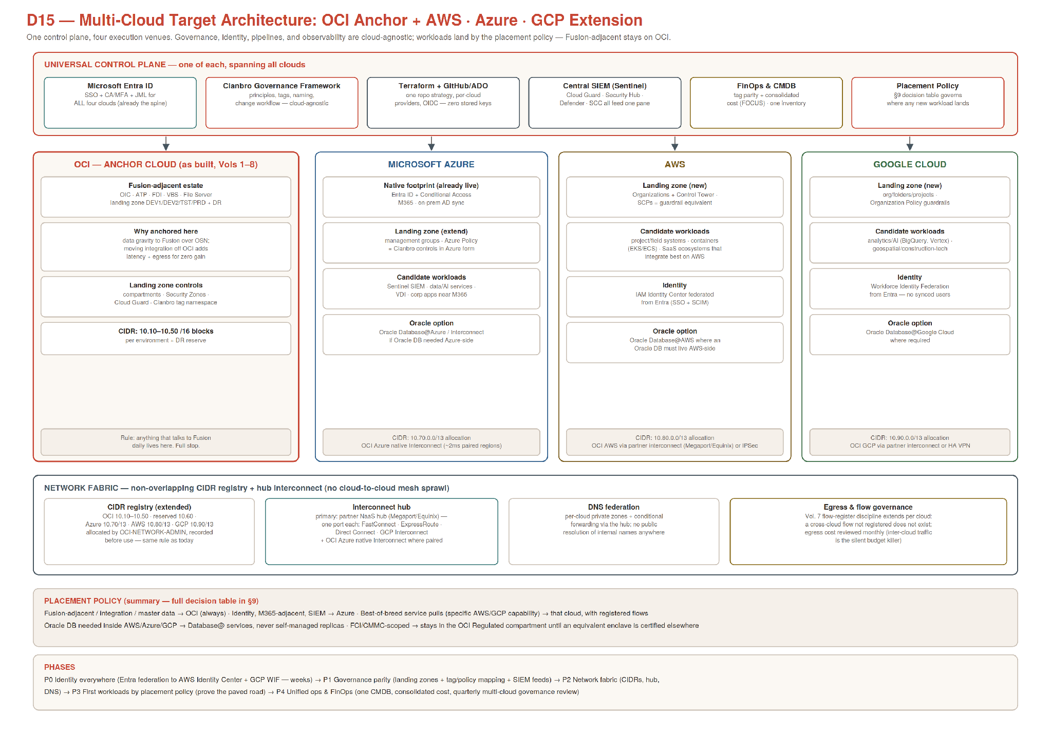

3. Identity Extension (Phase 0 — weeks, not months)
Cloud | Federation mechanism | Authorization model | Pipeline identity (no stored keys)
OCI (done) | Entra → identity domains (SAML/SCIM), Vol. 4 §5 | Entra groups → OCI-* groups → IAM policies | Resource principals (DG-TERRAFORM-CI)
Azure | Native — Entra IS the directory | Entra groups → Azure RBAC roles on management groups/subscriptions | GitHub/ADO OIDC → Entra workload identity federation
AWS | Entra → IAM Identity Center (SAML + SCIM provisioning) | Entra groups → Identity Center permission sets → account assignments | GitHub/ADO OIDC → IAM role trust policy (web identity)
GCP | Entra → Workforce Identity Federation (no synced users at all) | Entra groups → IAM role bindings on org/folders/projects | GitHub/ADO OIDC → Workload Identity Federation → service account impersonation
Naming extends the existing standard: Entra groups CORP-AWS-*, CORP-AZ-*, CORP-GCP-* mirror the CORP-OCI-* pattern; every cloud gets the same role archetypes (admin per domain, developer, support/read, auditor, break-glass equivalent) so the quarterly certification reads identically across venues. Break-glass: one documented emergency path per cloud (AWS root + hardware MFA sealed; Azure emergency access accounts; GCP org-admin recovery), all alarmed like ALM-BREAKGLASS-LOGIN.

4. Network Fabric and CIDR Plan (Phase 2)
Allocation | Block | Notes
OCI (as built) | 10.10–10.50 /16s | Environments + DR reserve, unchanged
Reserved buffer | 10.60.0.0/13 | Future OCI growth / second tenancy
Azure | 10.70.0.0/13 | Hub VNet 10.70.0.0/16 first; spokes per landing-zone subscription
AWS | 10.80.0.0/13 | Network account TGW hub 10.80.0.0/16; spokes per account
GCP | 10.90.0.0/13 | Shared VPC host project 10.90.0.0/16
- Interconnect strategy — hub, not mesh: one NaaS partner hub (Megaport/Equinix class) terminates FastConnect, ExpressRoute, Direct Connect, and GCP Partner Interconnect on a single virtual router; every cloud pair routes through the hub. Add the OCI↔Azure native Interconnect where paired regions exist (lowest latency for any future Database@Azure or Sentinel log shipping). IPSec VPN is the interim/DR path per pair. No direct cloud-to-cloud peering sprawl — 4 clouds meshed directly is 6 relationships to secure and audit; the hub is 4.
- DNS: each cloud keeps private zones ({cloud}.corp.internal pattern); conditional forwarding rules meet at the hub resolver. The Vol. 7 rule extends: no public resolution of internal names, and every cross-cloud flow lands in the flow register with hop-by-hop controls before it is built.
- Egress economics: inter-cloud traffic is billed both directions and is the silent budget killer of multi-cloud; the monthly cost review gains an inter-cloud egress line, and chatty cross-cloud designs (e.g., an AWS app hitting ATP per-request) fail placement review — replicate read models instead, or co-locate.

5. Governance Parity Matrix (Phase 1 — the heart of the extension)
Governance control (OCI as-built) | Azure equivalent | AWS equivalent | GCP equivalent | Parity check
Compartment tree (Vol. 3 §5) | Management groups + subscriptions | OUs + accounts (Control Tower) | Folders + projects | Same env-first shape: PRD/TST/DEV isolation
IAM policies, default-deny (GOV-PO) | Azure RBAC + deny via Policy | SCPs + permission boundaries + IAM | IAM + Organization Policy | Least privilege; no wildcard admin outside break-glass
Security Zones (preventive) | Azure Policy deny effects | SCPs + Control Tower guardrails | Organization Policy constraints | Public-exposure impossible in PRD-class scopes
Cloud Guard (detective) | Defender for Cloud | Security Hub + GuardDuty | Security Command Center | All findings → Sentinel, severity-mapped
governance tag namespace (15 keys) | Azure tags + tag policy | AWS tags + tag policies | GCP labels (lowercase mapping table) | ≥ 98% compliance KPI measured per cloud
Budgets/quotas (GOV-CG) | Cost Mgmt budgets + Policy | AWS Budgets + SCP guardrails | Budgets + quota caps | 70/90/100 alerts to same cost review
Audit/log sinks, deletion-proof | Log Analytics + immutable storage | CloudTrail (org) + S3 object lock | Cloud Audit Logs + locked bucket | Retention parity; feeds Sentinel
Change workflow + drift (GOV-CH) | same 8-step CAB + TF drift job | same | same | One CAB, per-cloud pipelines
Vendor isolation (GP-06) | Partner subscriptions/RGs | Partner accounts | Partner projects | A-cannot-see-B test quarterly, per cloud
Deliverable per cloud: a Landing Zone Annex (10–15 pages) to the Governance Standard — same GOV-* control IDs, cloud-specific implementation column. Accelerators: Azure landing zone reference, AWS Control Tower, GCP foundation blueprint — adopted the way the OCI CIS modules were: adapted to the organization's compartment tree, never wholesale.

6. IaC and CI/CD Extension
- Repo strategy: oci-platform stays; add azure-platform, aws-platform, gcp-platform — same layout (global/ modules/ envs/ pipelines/), same branch model, same plan-on-PR / apply-on-merge / CAB-gated-PRD pipeline pattern. A small cloud-core repo holds what is genuinely shared: tag-schema definitions, naming validators, policy-as-code tests, the CIDR registry as data.
- Providers & state: per-cloud Terraform providers, state stays in each cloud's native backend (OCI Object Storage as-built; Azure Storage; S3+DynamoDB; GCS) — cross-cloud state hostage-taking is an anti-pattern. All pipeline auth via OIDC federation (§3 table) — the zero-stored-keys rule becomes tenancy-wide law.
- Guardrail tests travel: the same checkov/tflint gates run per cloud with per-provider rule packs; a PR that weakens a parity control (§5) requires Security review exactly as IAM/network PRs do today.

7. Security Operations and Compliance
- SIEM decision: Microsoft Sentinel is the natural single pane (Entra/M365 gravity, Defender native, mature OCI/AWS/GCP connectors): Cloud Guard problems, Security Hub/GuardDuty findings, SCC findings, and all audit trails ship to Sentinel with a common severity mapping; the monthly security review reads one queue. This also finally closes gate D9 (SIEM export) from the OCI design.
- Secrets: per-cloud native vaults (OCI Vault as-built, Azure Key Vault, AWS Secrets Manager, GCP Secret Manager) with the same rules — 90-day rotation, owner recorded, no cross-cloud secret sharing; a workload reads secrets only from its own cloud's vault.
- CMMC/FCI: the Regulated-Workloads enclave stays OCI-only until an equivalent enclave (e.g., AWS GovCloud-pattern or Azure Government assessment) is explicitly certified — regulated scope never spreads by accident; RegulatoryScope tagging extends to all clouds so the boundary is queryable.

8. Data and Integration Rules
- OIC remains the integration hub for anything touching Fusion; cross-cloud app-to-app integration that never touches Fusion may use cloud-native eventing, but must register its flows (Vol. 7 discipline). API Gateway per cloud fronts that cloud's services; no service calls another cloud's private endpoints directly — through gateways, with registered flows.
- Data gravity rules: master data authority stays Fusion; FDI stays OCI; an enterprise analytics lake, if built (e.g., BigQuery), consumes governed extracts from FDI/ADW — never a second extract path from Fusion. Oracle databases needed inside AWS/Azure/GCP use the Database@ services rather than self-managed replicas (keeps Oracle support posture and avoids licensing archaeology).

9. Workload Placement Policy (decision table)
If the workload … | Then it lands in | Because
Integrates with Fusion daily / holds master or staging data | OCI (always) | MC-03 data gravity; OSN adjacency; existing guardrails
Is identity, M365-adjacent, security ops, or corp IT tooling | Azure | Entra/M365/Sentinel gravity
Needs a capability materially better on one cloud (named service, not vibes) | That cloud | Best-of-breed with registered flows + egress review
Is an acquired estate | Stays put initially | Wrap in governance parity first; migrate only with a business case
Needs an Oracle DB inside AWS/Azure/GCP | Database@ service there | MC rules §8; support + licensing posture
Is FCI/CMMC-scoped | OCI Regulated compartment | Until an equivalent enclave is certified (§7)
Has no forcing function | OCI, then Azure | Fewest new moving parts; anchor-first default

10. Phased Roadmap and Exit Criteria
Phase | Work | Exit criteria
P0 — Identity (weeks 1–4) | Entra federation to AWS Identity Center + GCP WIF; role-archetype groups; break-glass per cloud; pipeline OIDC everywhere | One SSO demo across 4 consoles; zero stored pipeline keys; certification covers all clouds
P1 — Governance parity (weeks 3–10) | Landing zone annexes per cloud; tag/policy mapping; SIEM feeds live; budgets/quotas; drift jobs | Parity matrix (§5) all green; findings from 4 clouds in one Sentinel queue
P2 — Network fabric (weeks 8–14) | CIDR allocations; NaaS hub + first two circuits (Azure native Interconnect + AWS); DNS federation; flow-register extension | Cross-cloud test flow registered, built, observed in logs both ends
P3 — First workloads (from week 12) | One pilot per business-driven cloud through the full paved road (placement review → LZ → pipeline → flows) | Pilot live with zero exceptions; egress cost within estimate
P4 — Unified ops (ongoing) | One CMDB; consolidated FinOps (FOCUS-based); quarterly multi-cloud governance review; DR posture per cloud reviewed | KPIs reported per cloud in one pack; no unmanaged estate

11. Risks and Anti-Patterns
- Complexity tax: every cloud added multiplies audits, skills, patching literacy, and incident paths; the placement policy exists to make each addition earn its keep. Staff for it or don't do it — the JD pattern from the DevOps hire extends (per-cloud depth, shared IaC discipline).
- Anti-patterns to refuse: lift-and-shift of Fusion-adjacent workloads off OCI (MC-03); cloud-local IdPs or synced service accounts; direct cross-cloud private peering sprawl; a second extract pipeline from Fusion; per-cloud governance dialects ('AWS does it differently' is a mapping problem, not an exemption); unregistered cross-cloud flows; 'temporary' stored access keys in pipelines.
- Cost honesty: multi-cloud rarely saves money; it buys capability and leverage. Model egress + duplicated platform overhead (LZ upkeep, SIEM ingestion, interconnect ports) into every placement business case.
Document impact on the pack: Governance Standard gains per-cloud Landing Zone Annexes (same GOV-* IDs); Vol. 6 D9/D10 gain the multi-cloud context frame (D15); Vol. 7 flow register gains cross-cloud sections; HLD decision register gains MC-01..05 and the SIEM closure of D9. The OCI volumes themselves do not change — that is the point of extend-not-fork.

