OCI IAM with Okta
SSO, Lifecycle Management and JIT Provisioning Tutorials
Step-by-step instructions for integrating Oracle Cloud Infrastructure Identity and Access Management (identity domains) with Okta for single sign-on, SCIM-based identity lifecycle management and Just-In-Time provisioning.
Service provider | OCI IAM with Identity Domains
Identity provider | Okta (Oracle Cloud Infrastructure IAM catalog app)
Protocols | SAML 2.0 with single logout (SSO, JIT); SCIM (provisioning)
Tutorials | SSO; Identity Lifecycle Management; JIT Provisioning
Source | Oracle Cloud Infrastructure documentation
Table of Contents
1. Introduction 4
1.1 Tutorials in This Document 4
1.2 Solution Architecture 4
2. SSO With OCI and Okta 6
2.1 Overview 6
2.2 Before You Begin 6
2.3 Task 1: Get the OCI Identity Provider Metadata and the Domain URL 7
2.4 Task 2: Create an App in Okta 8
2.5 Task 3: Create Okta as an IdP in OCI IAM 9
2.6 Task 4: Configure Okta 12
2.7 Task 5: Test Single Sign-On 12
2.8 What's Next 13
3. Identity Lifecycle Management Between OCI and Okta 14
3.1 Overview 14
3.2 Before You Begin 15
3.3 Task 1: Create a Confidential Application in OCI 15
3.4 Task 2: Find the OCI IAM GUID and Generate a Secret Token 17
3.5 Task 3: Create an App in Okta 19
3.6 Task 4: Change Okta Settings 19
3.7 Task 5: Test User and Group Provisioning 20
3.8 Additional Configurations for Federated Users 21
3.8.1 Setting Users' Federated Status 21
3.8.2 Disable Notifications for Account Creation or Updates 24
3.9 What's Next 26
4. JIT Provisioning from Okta to OCI IAM 27
4.1 Overview 27
4.2 Before You Begin 28
4.3 Task 1: Configure JIT Attributes in OCI IAM 28
4.4 Task 2: Configure SAML Attributes Sent by Okta 32
4.5 Task 3: Test JIT Provisioning Between Okta and OCI 33
4.6 What's Next 35
Appendix A. References 36
A.1 Key Endpoints and Values 36
List of Figures
Figure 1: Integration architecture between OCI IAM and Okta 5
Figure 2: SSO configuration workflow across OCI IAM and Okta 6
Figure 3: Export SAML metadata 7
Figure 4: Download the XML metadata file 8
Figure 5: Domain information showing the Domain URL 8
Figure 6: Configuration values exchanged between Okta and OCI IAM 9
Figure 7: Exchange metadata page of Create SAML identity provider 10
Figure 8: Additional configuration for global logout 11
Figure 9: SP-initiated SSO and single logout message sequence 12
Figure 10: Provisioning set-up from the OCI confidential app to the Okta app 14
Figure 11: Add a confidential application 16
Figure 12: Configure the application as a client with client credentials 16
Figure 13: Add app roles 17
Figure 14: Domain information showing the Domain URL 17
Figure 15: Client ID and client secret 18
Figure 16: Enable API integration 20
Figure 17: Add Attribute page (isFederatedUser) 22
Figure 18: Attribute page expression for isFederatedUser 23
Figure 19: Attribute values showing isFederatedUser mapped 23
Figure 20: User information showing that the user is federated 24
Figure 21: Add Attribute page (bypassNotification) 25
Figure 22: Attribute page expression for bypassNotification 25
Figure 23: Attribute values showing bypassNotification mapped 26
Figure 24: JIT provisioning decision flow at sign-in 27
Figure 25: JIT attribute and group mapping from Okta to OCI IAM 28
Figure 26: Configuration page for the Okta identity provider in IAM 29
Figure 27: Enable Just-In-Time provisioning 29
Figure 28: Assign group mappings 31
Figure 29: Mapping of attributes between Okta and OCI IAM 31
Figure 30: Setting assignment rules 31
Figure 31: Okta attribute statements 32
Figure 32: Okta group attribute statements 33
Figure 33: User in Okta 34
Figure 34: My Profile in OCI IAM for the new user 34
Figure 35: Check user properties in OCI IAM 35

1. Introduction
This set of tutorials provides step-by-step instructions to get you working with Okta and OCI IAM.
A common requirement for OCI customers is to enable Single Sign-On (SSO) between multiple cloud providers. Cloud administrators and application users don't want to have to re-authenticate as they move from one cloud platform to another, which is something they may do multiple times throughout a typical day.
These tutorials cover the details on how to enable Single Sign-On (SSO) between OCI IAM and Okta. To enable a fully seamless experience, these tutorials also cover configuration of identity Lifecycle Management (LCM), which includes provisioning and deprovisioning of accounts using SCIM APIs, as well as Just-In-Time (JIT) provisioning using SAML.
Be sure to read the Before You Begin sections in each tutorial so that you have everything you need to complete them successfully. You can perform the tutorials in any order.

1.1 Tutorials in This Document
Chapter | Tutorial | Purpose | Source
2 | SSO With OCI and Okta | Federate sign-in with SAML 2.0 and single logout: Okta as identity provider (IdP), OCI IAM as service provider (SP). About 15 minutes. | Oracle docs
3 | Identity Lifecycle Management Between OCI and Okta | Provision users and groups from Okta to OCI IAM over SCIM. About 30 minutes. | Oracle docs
4 | JIT Provisioning from Okta to OCI IAM | Create or update OCI IAM users and group memberships at sign-in from SAML attributes. | Oracle docs

NOTE
These tutorials are specific to IAM with Identity Domains.

1.2 Solution Architecture
OCI IAM (identity domain) trusts Okta as a SAML identity provider for SSO, single logout and JIT provisioning. Separately, Okta pushes users and groups to OCI IAM through the identity domain's SCIM API, authenticated with a token generated from an OCI confidential application.
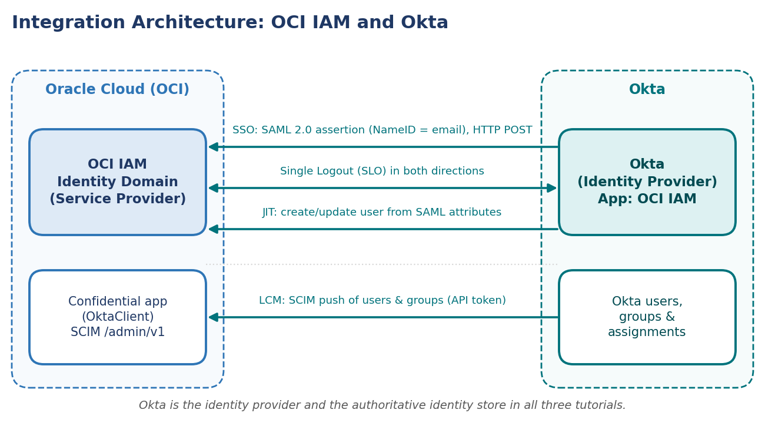
Figure 1: Integration architecture between OCI IAM and Okta
Component | Role in this integration
OCI IAM identity domain | SAML 2.0 service provider; hosts the Okta SAML IdP, the IdP policy, JIT settings and the OktaClient confidential application used for SCIM provisioning.
Okta | SAML 2.0 identity provider through the Oracle Cloud Infrastructure IAM catalog app; authoritative identity store that pushes users and groups to OCI IAM.
User / browser | Initiates sign-in to the OCI Console and is redirected to the Okta sign-in page.

2. SSO With OCI and Okta

2.1 Overview
In this tutorial, you set up Single Sign-On between OCI and Okta, where Okta acts as the identity provider (IdP) and OCI IAM is the service provider (SP).
This 15 minute tutorial shows you how to set up Okta as an IdP, with OCI IAM acting as SP. By setting up federation between Okta and OCI IAM, you enable users' access to services and applications in OCI IAM using user credentials that Okta authenticates. The high-level workflow is:
- First, gather the information needed from OCI IAM.
- Configure Okta as an IdP for OCI IAM.
- Configure OCI IAM so Okta acts as IdP.
- Create IdP policies in OCI IAM.
- Test that federated authentication works between OCI IAM and Okta.
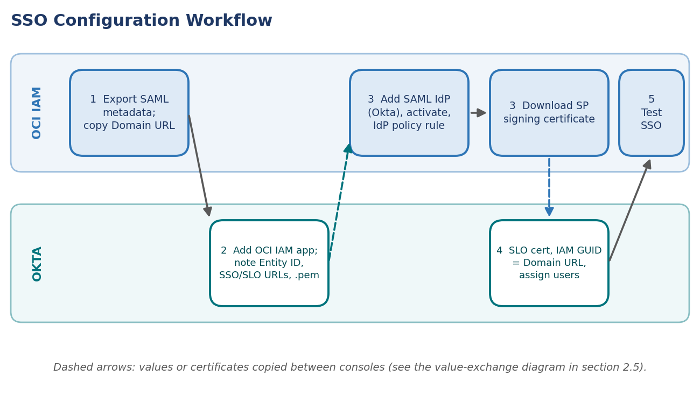
Figure 2: SSO configuration workflow across OCI IAM and Okta

2.2 Before You Begin
To perform this tutorial, you must have the following:
Prerequisite | Details
OCI account | A paid Oracle Cloud Infrastructure (OCI) account, or an OCI trial account. See Oracle Cloud Infrastructure Free Tier.
OCI administrator role | Identity domain administrator role for the OCI IAM identity domain. See Understanding Administrator Roles.
Okta account | An Okta account with administrator privileges to configure provisioning.

You gather the additional information you need from the steps of the tutorial: the OCI IdP metadata, the domain URL, and the identity domain's signing certificate.

2.3 Task 1: Get the OCI Identity Provider Metadata and the Domain URL
You need the SAML metadata from your OCI IAM identity domain to import into the Okta application you create. OCI IAM provides a direct URL to download the metadata of the identity domain you're using. Okta uses the OCI domain URL to connect to OCI IAM.
- Open a supported browser and enter the Console URL:
https://cloud.oracle.com

- Enter your Cloud Account Name, also referred to as your tenancy name, and select Next.
- Select the identity domain to sign in to. This is the identity domain that's used to configure SSO, for example Default.
- Sign in with your username and password.
- Open the navigation menu and select Identity & Security. Under Identity, select Domains.
- Select the name of the identity domain that you want to work in. You might need to change the compartment to find the domain that you want. Then, select Security and then Identity providers.
- Select Export SAML metadata.
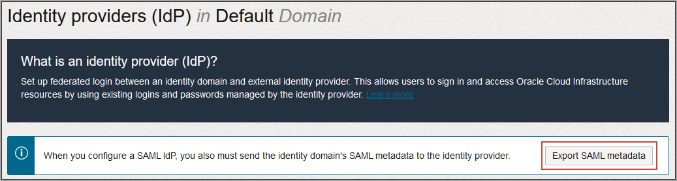
Figure 3: Export SAML metadata
- Select the Metadata file option, and select Download XML.
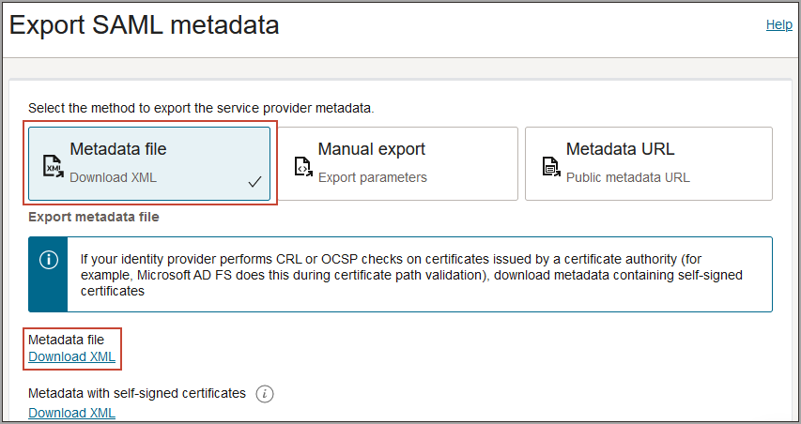
Figure 4: Download the XML metadata file
- Rename the downloaded XML file to OCIMetadata.xml.
- Return to the identity domain overview by selecting the identity domain name in the breadcrumb navigation trail. Select Copy next to the Domain URL in Domain information and save the URL. This is the OCI IAM domain URL which you will use later.
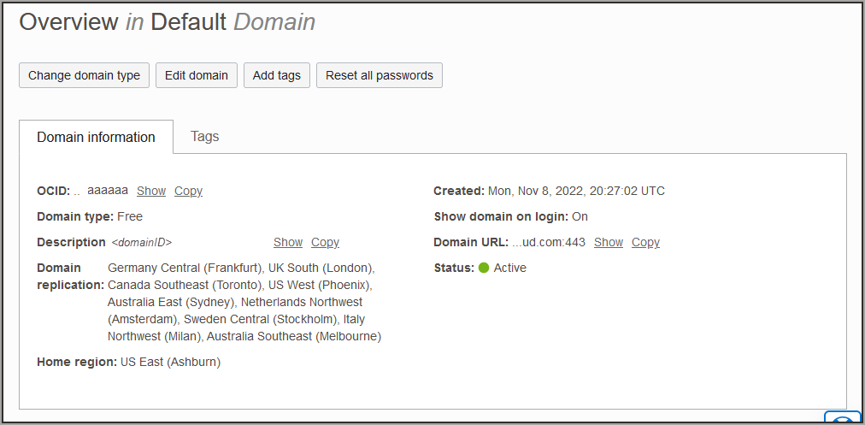
Figure 5: Domain information showing the Domain URL

2.4 Task 2: Create an App in Okta
Create an app in Okta, and make a note of values you'll need later.
- In the browser, sign in to Okta using the URL below, where <OktaOrg> is the prefix for your organization with Okta:
https://<OktaOrg>-admin.okta.com

- In the left menu, select Security and select Applications and then select Browse App Catalog.
- Search for Oracle Cloud and select Oracle Cloud Infrastructure IAM from the options available.
- Select Add Integration.
- Under General settings, enter a name for the application, for example OCI IAM, and select Done.
- In the application details page for your new application, select the Sign On tab, and under SAML Signing Certificates select View SAML setup instructions.
- On the View SAML setup instructions page, make a note of the following values:
Okta value | Used in OCI IAM for
Entity ID | Identity provider issuer URI
SingleSignOnService URL | SSO service URL
SingleLogoutService URL | IdP Logout Request URL and IdP Logout Response URL

- Download and save the certificate, with a file extension of .pem.

2.5 Task 3: Create Okta as an IdP in OCI IAM
Create an IdP for Okta in the OCI Console using the values you noted in section 2.4. The diagram below summarizes every value that is copied between the two consoles during this task and the next.
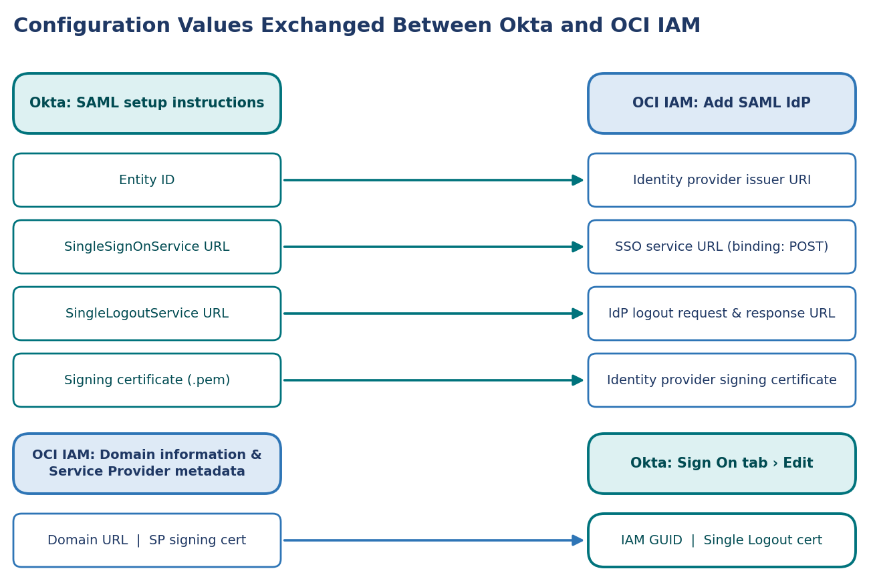
Figure 6: Configuration values exchanged between Okta and OCI IAM
- In the OCI Console in the domain you're working in, select Security and then Identity providers.
- Select Add IdP, then select Add SAML IdP.
- Enter a name for the SAML IdP, for example Okta. Select Next.
- On the Exchange metadata page, ensure that Enter IdP metadata is selected.
- Enter the following values from section 2.4:
OCI IAM field | Value
Identity provider issuer URI | The Okta Entity ID
SSO service URL | The Okta SingleSignOnService URL
SSO service binding | POST
Upload identity provider signing certificate | The Okta certificate .pem file

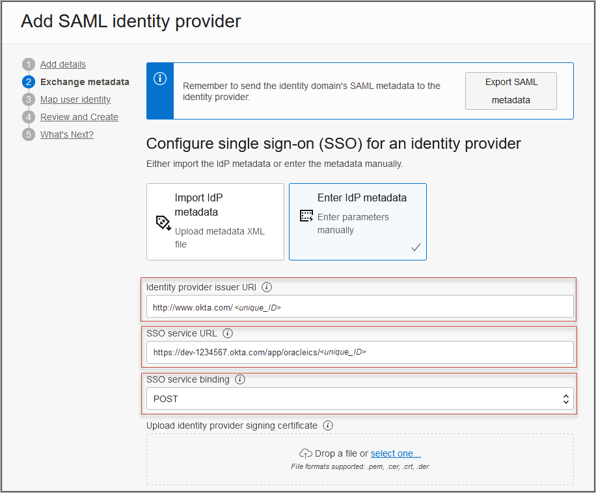
Figure 7: Exchange metadata page of Create SAML identity provider
- Further down the page, ensure that Enable Global logout is selected, and enter the following:
OCI IAM field | Value
IDP Logout Request URL | The Okta SingleLogoutService URL
IDP Logout Response URL | The Okta SingleLogoutService URL
Logout binding | POST

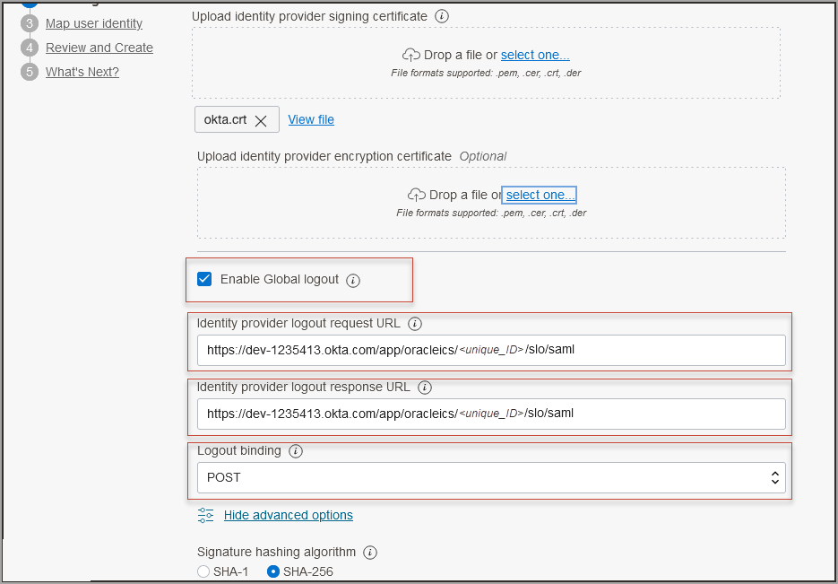
Figure 8: Additional configuration for global logout
- Select Next.
- On the Map attributes page, set the following:
Field | Value
Requested NameId format | Email address
Identity provider user attribute | SAML assertion Name ID
Identity Domain user attribute | Primary email address

- Select Next.
- Review, and select Create IDP.
- On the What's Next page, select Activate, then select Add to IdP policy.
- Select Default Identity Provider Policy to open it, then select the Actions menu (three dots) for the rule and select Edit IdP rule.
- Select in Assign identity providers and then select Okta to add it to the list.
- Select Save changes.
- Download the SP certificate:
  - In the OCI Console in the domain you're working in, select Security and then Identity providers.
  - Select Okta.
  - On the Okta IdP page, select Service Provider metadata.
  - Select Download next to Service Provider signing certificate to download the SP signing certificate and save it.

2.6 Task 4: Configure Okta
- In the Okta console, select Applications then select the new application OCI IAM.
- Go to the Sign On tab and select Edit.
- Select Enable Single Logout.
- Browse to the certificate you downloaded from the OCI IAM Console in the previous step, and select Upload.
- Scroll down to Advanced Sign-on Settings.
- Enter the following:
Okta field | Value
Oracle Cloud Infrastructure IAM GUID | The OCI IAM domain URL from section 2.3
Application username format | Email

- Select Save.
- Go to the Assignments tab and assign users who you want to have access to this application.
- Select Next.

2.7 Task 5: Test Single Sign-On
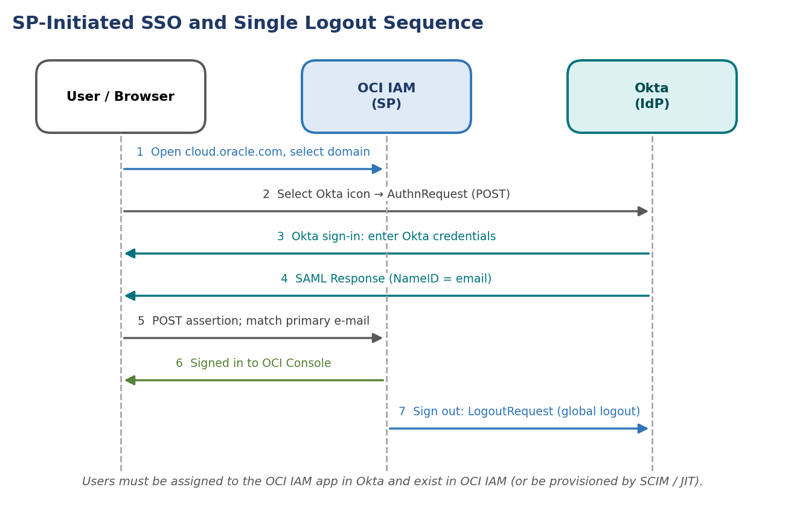
Figure 9: SP-initiated SSO and single logout message sequence
- Enter the Console URL:
https://cloud.oracle.com

- Enter your Cloud Account Name, also referred to as your tenancy name, and select Next.
- Sign in with your username and password.
- Select the domain that you configured the Okta IdP for.
- On the sign-in page, select the Okta icon.
- Enter your Okta credentials. You're signed in to the OCI Console.

2.8 What's Next
Congratulations! You have successfully set up SSO between Okta and OCI IAM.
To explore more information about development with Oracle products, check out the Oracle Developers Portal and Oracle Cloud Infrastructure.

3. Identity Lifecycle Management Between OCI and Okta

3.1 Overview
In this tutorial, you configure user lifecycle management between Okta and OCI IAM, where Okta acts as the authoritative identity store. This 30 minute tutorial shows you how to provision users and groups from Okta to OCI IAM.
- Create a confidential application in OCI IAM.
- Get the identity domain URL and generate a secret token.
- Create an app in Okta.
- Update Okta's settings.
- Test that provisioning works between OCI IAM and Okta.
In addition, there are instructions on how to set users' federated status so that they're authenticated by the external identity provider, and how to stop users getting notification emails when their account is created or updated.
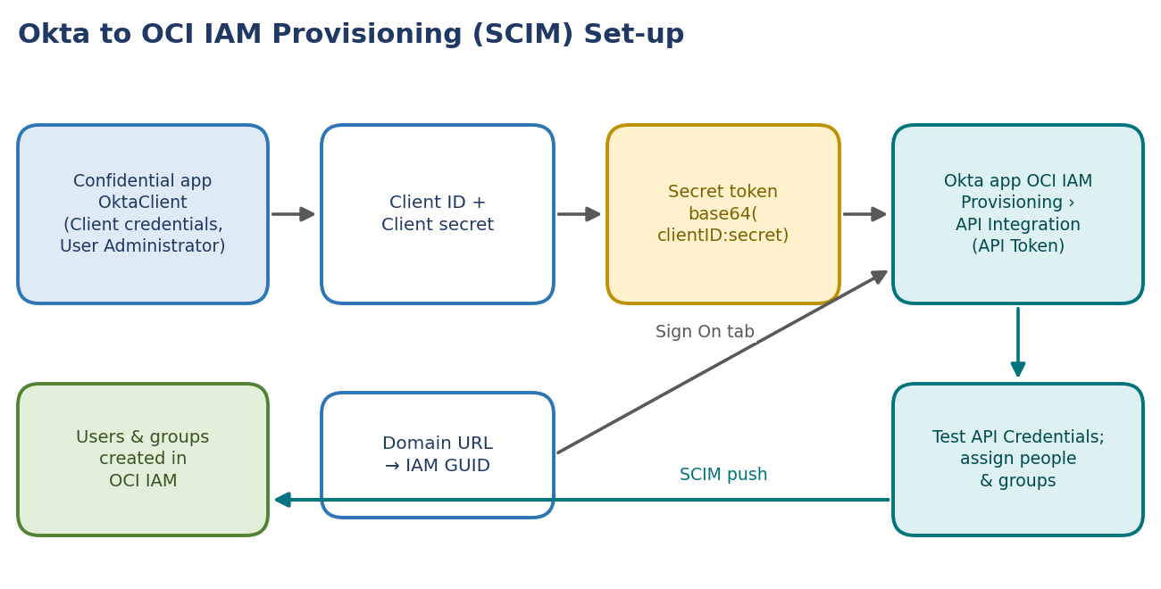
Figure 10: Provisioning set-up from the OCI confidential app to the Okta app
NOTE
This tutorial is specific to IAM with Identity Domains.

3.2 Before You Begin
To perform this tutorial, you must have the following:
Prerequisite | Details
OCI account | A paid Oracle Cloud Infrastructure (OCI) account, or an OCI trial account. See Oracle Cloud Infrastructure Free Tier.
OCI administrator role | Identity domain administrator role for the OCI IAM identity domain. See Understanding Administrator Roles.
Okta account | An Okta account with administrator privileges to configure provisioning.

You gather the additional information you need from the steps of the tutorial: the OCI IAM domain URL, and the OCI IAM client ID and client secret.

3.3 Task 1: Create a Confidential Application in OCI
Create a confidential application in OCI IAM and activate it.
- Open a supported browser and enter the Console URL:
https://cloud.oracle.com

- Enter your Cloud Account Name, also referred to as your tenancy name, and select Next.
- Sign in with your username and password.
- Open the navigation menu and select Identity & Security. Under Identity, select Domains.
- Select the identity domain in which you want to configure Okta provisioning and select Applications.
- Select Add Application, choose Confidential Application and select Launch workflow.
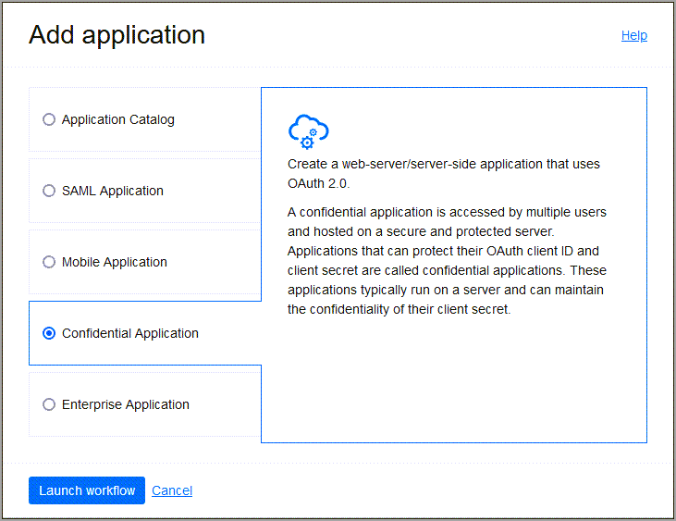
Figure 11: Add a confidential application
- Enter a name for the confidential application, for example OktaClient. Select Next.
- Under Client configuration, select Configure this application as a client now.
- Under Authorization, select Client Credentials.
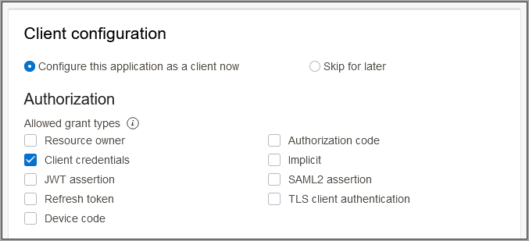
Figure 12: Configure the application as a client with client credentials
- Scroll to the bottom, and select Add app roles.
- Under App roles select Add roles, and in the Add app roles page select User Administrator and select Add.
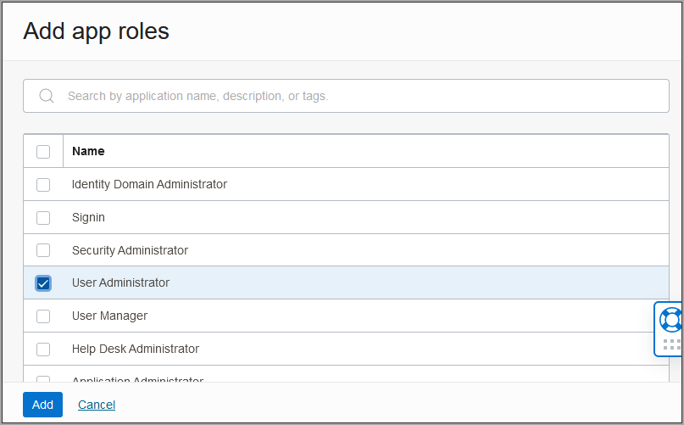
Figure 13: Add app roles
- Select Next, then select Finish.
- In the application details page select Activate and confirm that you want to activate the new application.

3.4 Task 2: Find the OCI IAM GUID and Generate a Secret Token
You need two pieces of information to use as part of the connection settings for the Okta app you create later.
- Return to the identity domain overview by selecting the identity domain name in the breadcrumbs. Select Copy next to the Domain URL in Domain information and save the URL to an app where you can edit it.
Figure 14: Domain information showing the Domain URL
The OCI IAM GUID is part of the domain URL, for example idcs-9ca4f92e3fba2a4f95a4c9772ff3278 in:
https://<IdentityDomainID>.identity.oraclecloud.com:443/fed/v1/idp/sso

- In the confidential app in OCI IAM, select OAuth configuration under Resources.
- Scroll down, and find the Client ID and Client secret under General Information.
- Copy the client ID and store it.
- Select Show secret and copy the secret and store it.
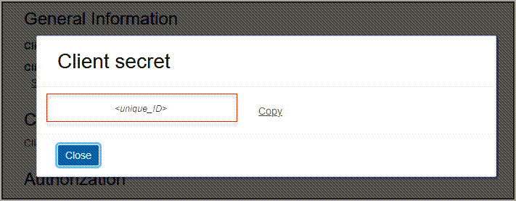
Figure 15: Client ID and client secret
The secret token is the base64 encoding of <clientID>:<clientsecret>, that is base64(<clientID>:<clientsecret>). These examples show how to generate the secret token on Windows and macOS:
Platform | Command
Windows (PowerShell) | [Convert]::ToBase64String([System.Text.Encoding]::Unicode.GetBytes('client_id:secret'))
macOS | echo -n <clientID>:<clientsecret> | base64

The secret token is returned. For example:
$ echo -n 392357752347523923457437:3454-9853-7843-3554 | base64
Nk0NzUyMzcyMzQ1NzMTc0NzUyMzMtNTQzNC05ODc4LTUzNQ==

IMPORTANT
Make a note of the secret token value. Treat it as a credential: anyone holding it can call the identity domain with the OktaClient app's User Administrator role.

3.5 Task 3: Create an App in Okta
Create an application in Okta.
- In the browser, sign in to Okta using the URL below, where <OktaOrg> is the prefix for your organization with Okta:
https://<OktaOrg>-admin.okta.com

- In the menu on the left, select Applications.
NOTE
If you already have an application which you created when you went through SSO With OCI and Okta (chapter 2), you can use it. Select it to open and edit it, and go to section 3.6.

- Select Browse App Catalog and search for Oracle Cloud. Select Oracle Cloud Infrastructure IAM from the options available.
- Select Add Integration.
- Under General settings, enter a name for the application, for example OCI IAM, and select Done.

3.6 Task 4: Change Okta Settings
Connect the Okta app to the OCI IAM confidential app using the domain URL and secret token from an earlier step.
- In the newly created application page, select the Sign On tab.
- In Settings, select Edit.
- Scroll down to Advanced Sign-on Settings.
- Enter the domain URL in Oracle Cloud Infrastructure IAM GUID.
- Select Save.
- Near the top of the page, select the Provisioning tab.
- Select Configure API Integration.
- Select Enable API Integration.
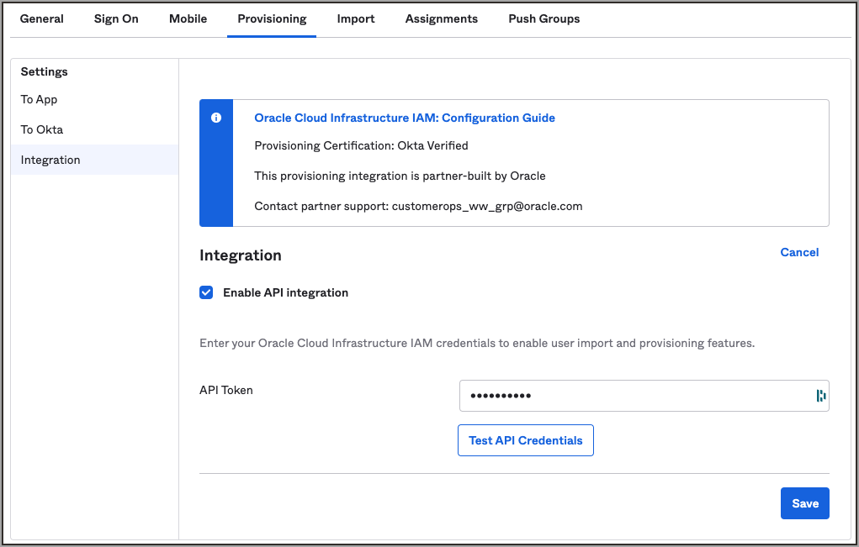
Figure 16: Enable API integration
- Enter the secret token value you copied earlier in API Token.
- Select Test API Credentials. If you get an error message, check the values that you have entered and try again. When you get the following message, Okta has successfully connected to the OCI IAM SCIM endpoint:
Oracle Cloud Infrastructure IAM was verified successfully!

- Select Save.
The Provisioning to App page opens, where you can create users, update user attributes, and map attributes between OCI IAM and Okta.

3.7 Task 5: Test User and Group Provisioning
To test user and group provisioning for Okta:
- In the newly created application, choose the Assignments tab.
- Select Assign and select Assign to People.
- Search for the user to provision from Okta to OCI IAM. Select Assign next to the user.
- Select Save, and then Go Back.
- Now provision Okta groups into OCI IAM. In the Assignments tab, select Assign and select Assign to Groups.
- Search for the groups to be provisioned to OCI IAM. Next to the group name, select Assign.
- Select Done.
- Now sign in to OCI:
  - Open a supported browser and enter the OCI Console URL https://cloud.oracle.com.
  - Enter your Cloud Account Name, also referred to as your tenancy name, and select Next.
  - Select the identity domain in which Okta has been configured.
- Select Users. The user which was assigned to the OCI IAM application in Okta is now present in OCI IAM.
- Select Groups. The group which was assigned to the OCI IAM application in Okta is now present in OCI IAM.

3.8 Additional Configurations for Federated Users
You can set users' federated status so that they're authenticated by the external identity provider, and you can disable notification emails being sent to the user when their account is created or updated. Both use a custom Boolean attribute in Okta mapped with an expression:
Setting | Okta attribute (variable name) | Expression | Apply on
Federated status | isFederatedUser | true | Create and update
Bypass notification | bypassNotification | true | Create and update

External namespace for both attributes: urn:ietf:params:scim:schemas:oracle:idcs:extension:user:User.

3.8.1 Setting Users' Federated Status
Federated users don't have credentials to sign in directly to OCI. Instead they're authenticated by the external identity provider. If you want users to use their federated accounts to sign in to OCI, set the federated attribute to true for those users. To set the user's federated status:
- In the browser, sign in to Okta using the URL below, where <OktaOrg> is the prefix for your organization with Okta:
https://<OktaOrg>-admin.okta.com

- In the menu on the left, select Applications.
- Select the application you created earlier, OCI IAM.
- Scroll down to the Attribute Mappings section.
- Select Go to Profile Editor.
- Under Attributes, select Add Attributes.
- In the Add Attribute page, enter the following:
Field | Value
Data Type | Boolean
Display Name | isFederatedUser
Variable Name | isFederatedUser
External namespace | urn:ietf:params:scim:schemas:oracle:idcs:extension:user:User
Scope | Check User personal

NOTE
The external name is automatically populated by the value of the variable name.

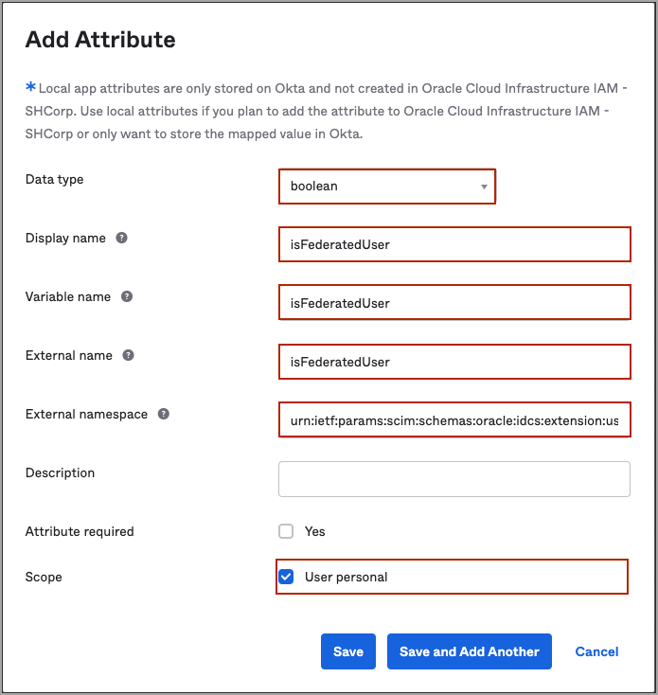
Figure 17: Add Attribute page (isFederatedUser)
- Navigate back to Okta's Application page and select the OCI IAM application.
- Select Provisioning.
- Scroll down to Attributes Mapping and select Show Unmapped Attributes.
- Locate the isFederatedUser attribute and select the edit button next to it.
- In the attribute page:
  - For Attribute value choose Expression.
  - In the box below, enter true.
  - For Apply on, choose Create and update.
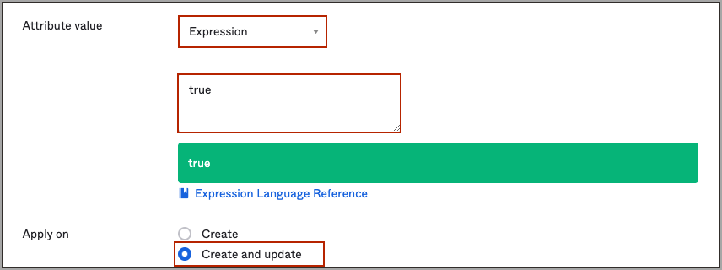
Figure 18: Attribute page expression for isFederatedUser
- Select Save.
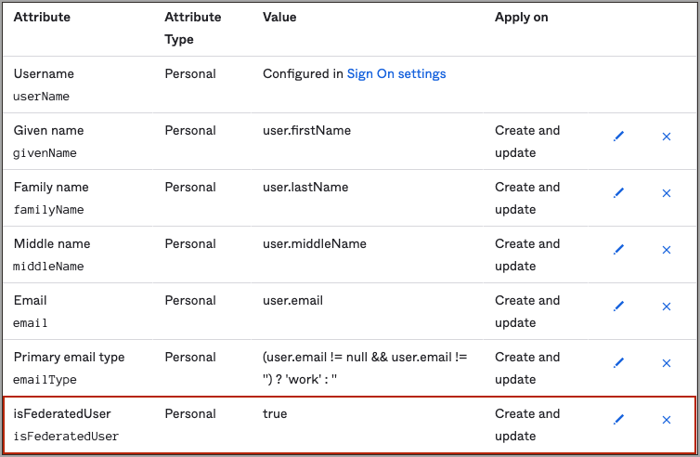
Figure 19: Attribute values showing isFederatedUser mapped
Now, when the users are provisioned from Okta to OCI, their federated status is set to true. You can see this in the user's profile page in OCI: navigate to the identity domain you are using, select Users, and select the user to show the user information. Federated is shown as Yes.
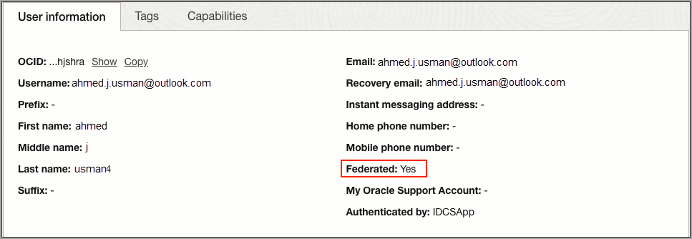
Figure 20: User information showing that the user is federated

3.8.2 Disable Notifications for Account Creation or Updates
The bypass notification flag controls whether an email notification is sent after creating or updating a user account in OCI. If you don't want users to be notified that accounts have been created for them, then set the bypass notification flag to true. To set the bypass notification flag:
- In the browser, sign in to Okta using the URL below, where <OktaOrg> is the prefix for your organization with Okta:
https://<OktaOrg>-admin.okta.com

- In the menu on the left, select Applications.
- Select the application you created earlier, OCI IAM.
- Scroll down to the Attribute Mappings section.
- Under Attributes, select Add Attributes.
- In the Add Attribute page, enter the following:
Field | Value
Data Type | Boolean
Display Name | bypassNotification
Variable Name | bypassNotification
External namespace | urn:ietf:params:scim:schemas:oracle:idcs:extension:user:User
Scope | Check User personal

NOTE
The external name is automatically populated by the value of the variable name.

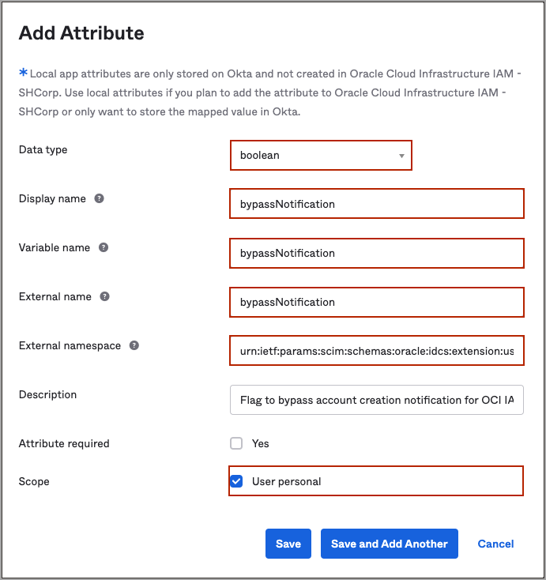
Figure 21: Add Attribute page (bypassNotification)
- Navigate back to Okta's Application page and select the OCI IAM application.
- Select Provisioning.
- Scroll down to Attributes Mapping and select Show Unmapped Attributes.
- Locate the bypassNotification attribute and select the edit button next to it.
- In the attribute page:
  - For Attribute value choose Expression.
  - In the box below, enter true.
  - For Apply on, choose Create and update.
Figure 22: Attribute page expression for bypassNotification
- Select Save.
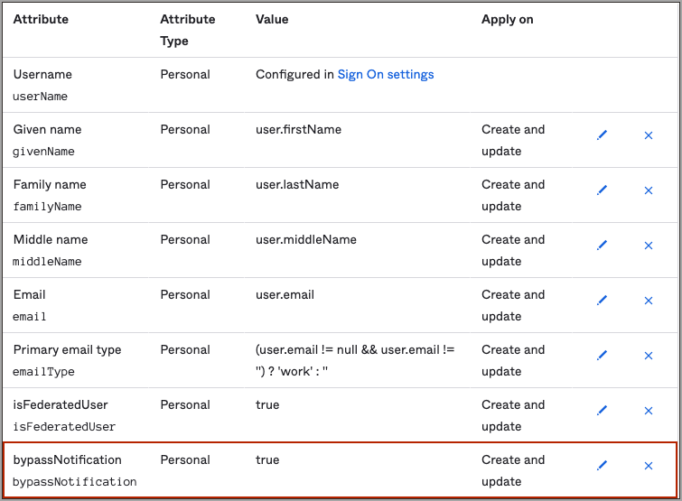
Figure 23: Attribute values showing bypassNotification mapped

3.9 What's Next
Congratulations! You have successfully set up user lifecycle management between Okta and OCI.
To explore more information about development with Oracle products, check out the Oracle Developers Portal and Oracle Cloud Infrastructure.

4. JIT Provisioning from Okta to OCI IAM

4.1 Overview
In this tutorial, you configure Just-In-Time (JIT) provisioning between the OCI Console and Okta, using Okta as the identity provider (IdP).
You can set up JIT provisioning so that identities can be created in the target system at the time that they make a request to access the target system. This can be easier to set up than having all users created in advance. This tutorial covers the following steps:
- Configure JIT attributes in OCI IAM.
- Configure SAML attributes sent by Okta.
- Test JIT provisioning between OCI IAM and Okta.
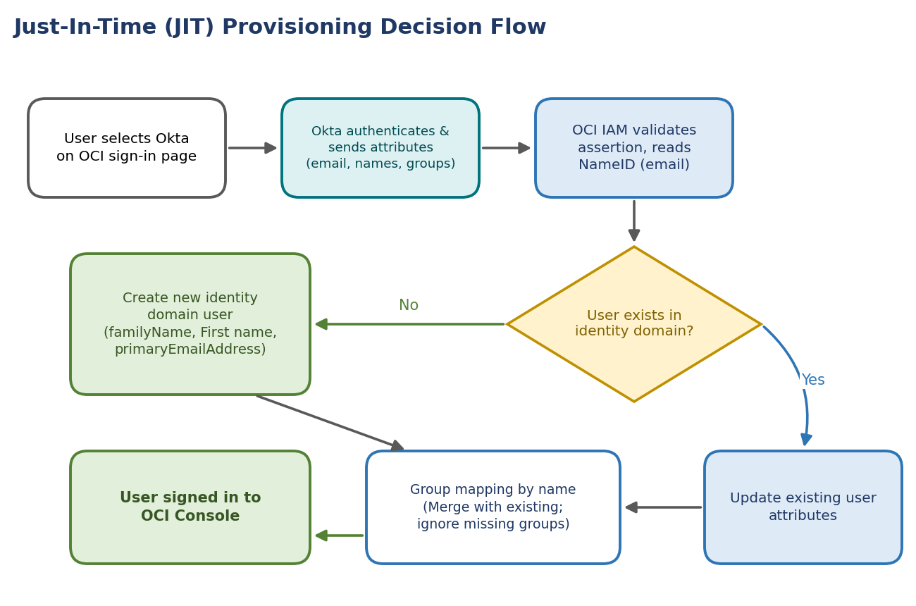
Figure 24: JIT provisioning decision flow at sign-in
NOTE
This tutorial is specific to IAM with Identity Domains.

4.2 Before You Begin
To perform this tutorial, you must have the following:
Prerequisite | Details
OCI account | A paid Oracle Cloud Infrastructure (OCI) account, or an OCI trial account. See Oracle Cloud Infrastructure Free Tier.
OCI administrator role | Identity domain administrator role for the OCI IAM identity domain. See Understanding Administrator Roles.
Okta role | An Okta account with one of the following Okta roles: Global Administrator, Cloud Application Administrator, or Application Administrator.
Completed SSO setup | You must have completed the tutorial SSO With OCI and Okta (chapter 2).
Groups | The groups which you are going to use for JIT provisioning.

4.3 Task 1: Configure JIT Attributes in OCI IAM
In OCI IAM, update the Okta IdP for JIT.
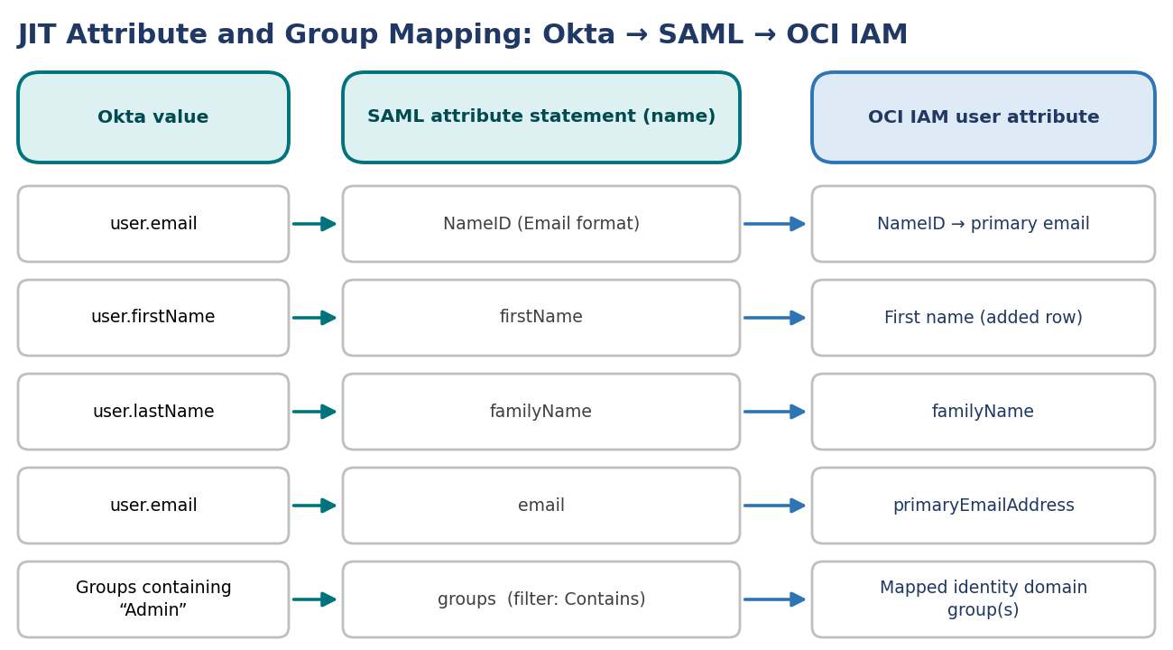
Figure 25: JIT attribute and group mapping from Okta to OCI IAM
- Open a supported browser and enter the Console URL:
https://cloud.oracle.com

- Enter your Cloud Account Name, also referred to as your tenancy name, and select Next.
- Select the identity domain which will be used to configure SSO.
- Sign in with your username and password.
- Open the navigation menu and select Identity & Security.
- Under Identity, select Domains.
- Select the identity domain in which you had configured Okta as IdP.
- Select Security in the left menu, and then Identity providers.
- Select the Okta IdP.
- Select Configure JIT.
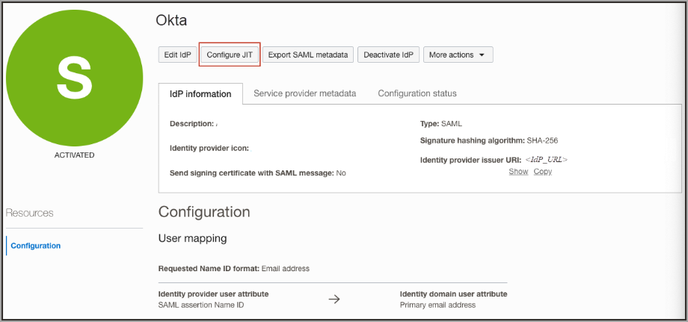
Figure 26: Configuration page for the Okta identity provider in IAM
- On the Configure Just-in-time (JIT) provisioning page:
  - Select Just-In-Time (JIT) provisioning.
  - Select Create a new identity domain user.
  - Select Update the existing identity domain user.
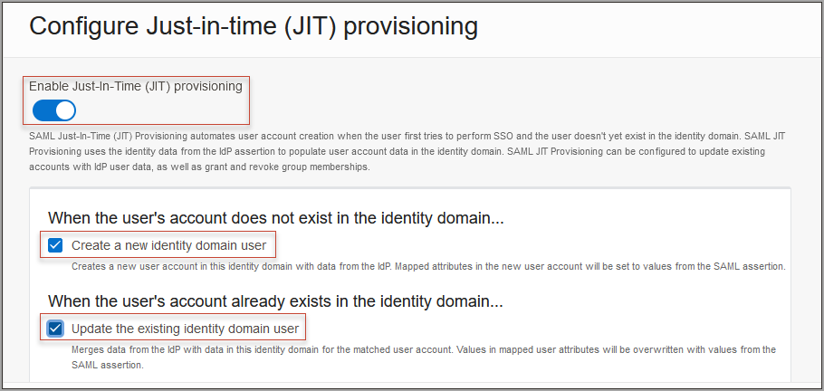
Figure 27: Enable Just-In-Time provisioning
- Under Map user attributes:
  - Leave the first row for NameID unchanged.
  - For other attributes, under IdP user attribute select Attribute.
  - Provide the IdP user attribute name as shown in the table below.
  - Select Add Row and enter firstName. For the identity domain user attribute, choose First name.
Identity domain attribute | IdP user attribute | IdP user attribute name
NameID (first row) | (unchanged) | (unchanged)
familyName | Attribute | familyName
primaryEmailAddress | Attribute | email
First name (added row) | Attribute | firstName

NOTE
If you configured additional user attributes to be sent as part of the user assertion from Okta, you can map them to identity domain user attributes by adding additional rows.

- Select Assign group mapping.
- Enter the Group membership attribute name. In this tutorial, use groups.
NOTE
Make a note of the group membership attribute name, because you'll use it in the next section.

- Select Define explicit group membership mappings.
- Under IdP group name maps to identity domain group name, do the following:
  - In IdP Group name, provide the name of the group in Okta.
  - In Identity domain group name, select the group in OCI IAM to map the Okta group to.
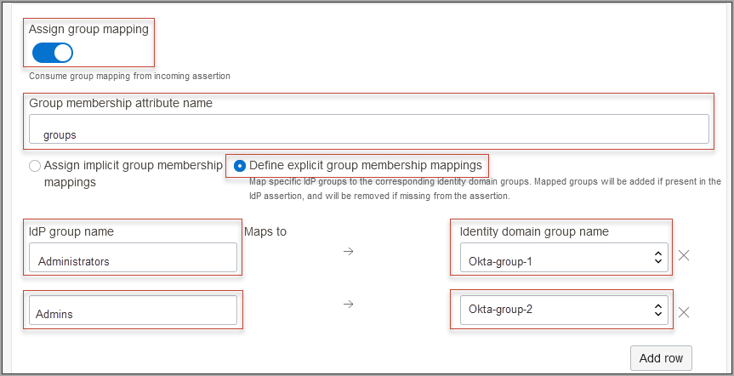
Figure 28: Assign group mappings
NOTE
Additional groups can be mapped by selecting Add Row.

The following shows the attributes configured in Okta on the left, and attributes mapped in OCI IAM on the right.
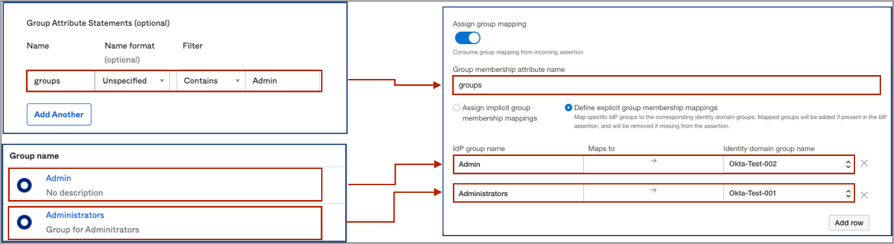
Figure 29: Mapping of attributes between Okta and OCI IAM
- Under Assignment rules, select the following:
Assignment rule | Selection
When assigning group memberships | Merge with existing group memberships
When a group is not found | Ignore the missing group

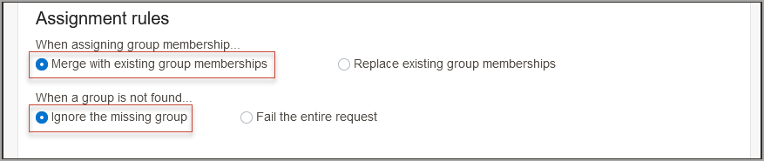
Figure 30: Setting assignment rules
NOTE
Select options based on your organization's requirements.

- Select Save changes.

4.4 Task 2: Configure SAML Attributes Sent by Okta
In Okta, update the OCI IAM app configuration to send user attributes and the group name in the SAML assertion.
- In Okta, in the application you created for OCI IAM, select the Sign On tab.
- Select Edit next to Settings.
- Under SAML 2.0, select > next to Attributes (Optional).
- Provide the following values:
Name | Name format | Value
firstName | Unspecified | user.firstName
familyName | Unspecified | user.lastName
email | Unspecified | user.email

You can add additional attributes to suit your business requirements, but you only need these for this tutorial.
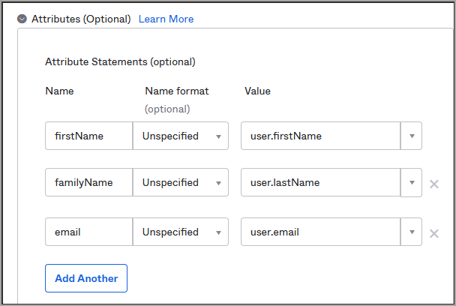
Figure 31: Okta attribute statements
- Under Group Attribute Statements, enter these values:
Name | Name format | Filter | Value
groups | Unspecified | Contains | Admin

NOTE
Okta provides a mechanism for filtering groups which can be sent in the SAML assertion. The filter has options including Starts with, Equals, Contains, and Matches regex. In this tutorial, we use the Contains filter, which means that Okta only sends those groups which are associated with the user and which contain the specified string. In this example, we have specified Admin as the string, so all the groups which contain the string Admin and are associated with the user are sent in the SAML assertion.

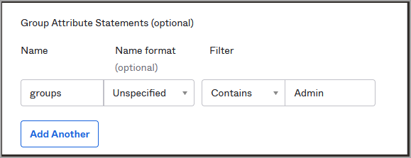
Figure 32: Okta group attribute statements
- Select Save.

4.5 Task 3: Test JIT Provisioning Between Okta and OCI
In this section, you test that JIT provisioning works between Okta and OCI IAM.
- In the Okta console, create a new user with an email ID which is not present in OCI IAM.
- Assign the user to the required groups, for example, Administrators and Admins.
- Log out of Okta.
- Assign the user to the OCI IAM app in Okta.
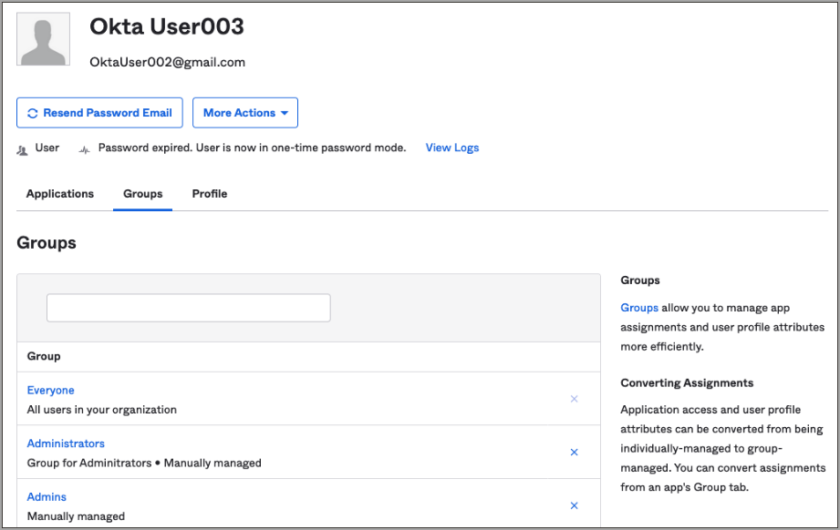
Figure 33: User in Okta
- In the browser, open the OCI Console.
- Select the identity domain in which JIT configuration has been enabled.
- From the sign in options, select Okta.
- On the Okta login page, provide the newly created user id.
- On successful authentication from Okta, the user account is created in OCI IAM and the user is logged into the OCI Console.
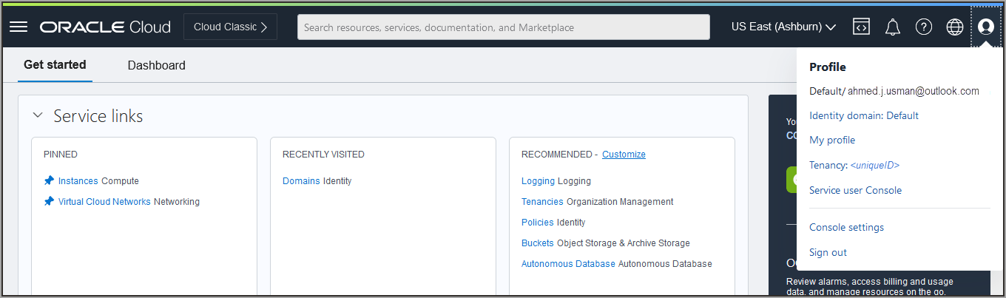
Figure 34: My Profile in OCI IAM for the new user
- In the navigation menu, select the Profile menu (user avatar icon) and then select User settings. Check the user properties such as email id, first name, last name, and associated groups.
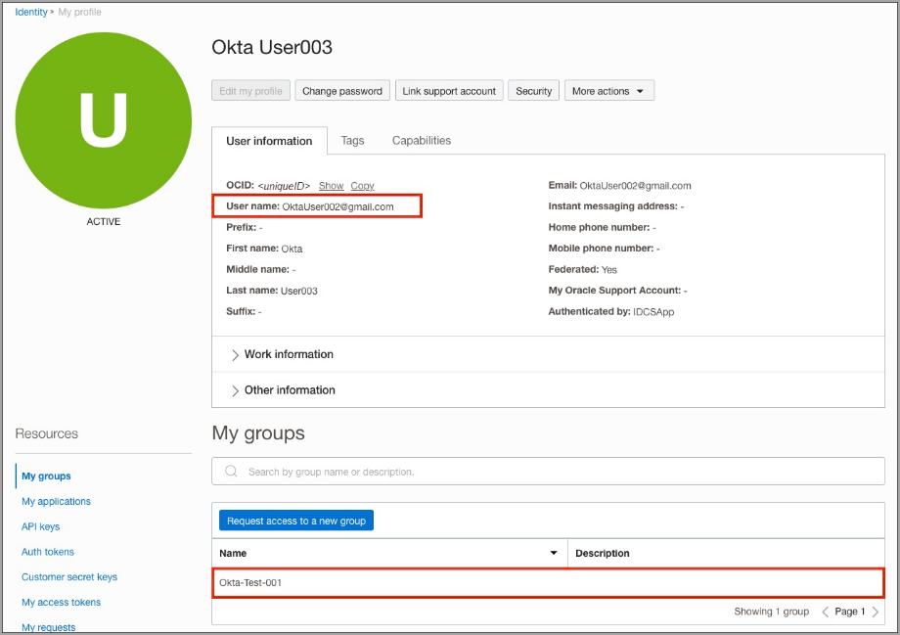
Figure 35: Check user properties in OCI IAM

4.6 What's Next
Congratulations! You have successfully set up JIT provisioning between Okta and IAM.

Appendix A. References
Reference | Link
SSO With OCI and Okta | https://docs.oracle.com/en-us/iaas/Content/Identity/tutorials/okta/sso_okta/sso_okta.htm
Identity Lifecycle Management Between OCI and Okta | https://docs.oracle.com/en-us/iaas/Content/Identity/tutorials/okta/lifecycle_okta/okta-lifecycle.htm
JIT Provisioning from Okta to OCI IAM | https://docs.oracle.com/en-us/iaas/Content/Identity/tutorials/okta/jit_okta/okta_jit.htm
Oracle Cloud Infrastructure Free Tier | https://docs.oracle.com/iaas/Content/FreeTier/freetier.htm
Understanding Administrator Roles | https://docs.oracle.com/en-us/iaas/Content/Identity/roles/understand-administrator-roles.htm
Signing in to the Console (supported browsers) | https://docs.oracle.com/iaas/Content/GSG/Tasks/signingin.htm

A.1 Key Endpoints and Values
Item | Value
OCI Console | https://cloud.oracle.com
Okta admin console | https://<OktaOrg>-admin.okta.com
OCI SAML metadata file | OCIMetadata.xml (Security › Identity providers › Export SAML metadata)
OCI IAM GUID (Okta field) | OCI IAM domain URL, e.g. idcs-<id>.identity.oraclecloud.com
Okta catalog app | Oracle Cloud Infrastructure IAM
SSO / logout binding | POST
SCIM API token | base64(<clientID>:<clientsecret>)
Successful API test message | Oracle Cloud Infrastructure IAM was verified successfully!
JIT group attribute | groups (filter: Contains Admin)

