OCI SECURITY ARCHITECTURE — IDENTITY
Bridging Microsoft Entra ID with OCI Identity Domains, Oracle Fusion, OIC and ATP
Best-practice recommendations for a six-environment Fusion estate (Dev1–Dev4, Test, Prod), each with dedicated OIC + ATP.
Author's note on naming: “OCI IDCS” is the legacy name for what Oracle now calls OCI IAM Identity Domains. This document uses the current term; where you see “identity domain” read it as the successor to IDCS. Each Oracle Fusion pod ships with its own identity domain, and OIC/ATP live in OCI identity domains too — so “bridging Entra to Fusion IDCS and to OIC+ATP” is really about how one corporate IdP federates a set of identity domains.
Prepared by: OCI Enterprise / Security Architect | v1.0 Draft | Classification: Internal

Contents
1. Executive advice (read this first)
2. The two identity planes — the core model
3. Target federation topology (6 environments)
4. Bridge 1 — Entra ID to the OCI Identity Domain (human SSO)
5. Bridge 2 — Identity Domain to Oracle Fusion
6. Bridge 3 — OIC (console SSO + OAuth2 to Fusion)
7. Bridge 4 — ATP (human DB auth + service credentials)
8. Environment isolation and blast-radius model
9. Security controls and guardrails
10. Recommendations summary (do / avoid)
11. Build sequence (high level)
Appendix A — Naming conventions
Appendix B — OAuth scopes and group model

1. Executive Advice (Read This First)
Ten recommendations, in priority order, for federating Microsoft Entra ID across your six Fusion environments and their dedicated OIC + ATP:
- Separate the two planes. Human sign-in (SAML/OIDC, Entra in the path) and machine-to-machine (OAuth2/mTLS, Entra NOT in the path) are different problems. Design and operate them independently. This is the single most important decision — see §2.
- One identity domain per environment. Federate Dev1, Dev2, Dev3, Dev4, Test and Prod as six separate identity domains. Separate blast radius, separate Conditional Access, separate certificate rotation, per-environment audit.
- One Entra enterprise app per domain. The Entra SAML issuer (https://sts.windows.net/<tenant>/) is the same for every app in your tenant, and OCI requires that issuer to be unique within a domain. So a domain holds exactly ONE Entra IdP; give each domain its own enterprise app. Never add a second Entra IdP to one domain.
- Keep the Default domain out of federation. Use it only for two vaulted, MFA-enrolled, alarmed break-glass admins. Every federated login goes to the workforce/per-environment domains.
- Provision with SCIM; source workers from HCM. Turn JIT off; let SCIM push only assigned users/groups. For workers, HCM is the source of record → Entra → SCIM → domain. Machine identities are provisioned directly as confidential apps, not from HCM.
- OIC→Fusion is OAuth2, not a password. Register a confidential OAuth2 application in the same domain and call Fusion REST/SOAP with client-credentials (or JWT for user context). No basic-auth service users where OAuth is available.
- ATP: IAM database authentication for humans, Vault for services. Human DBAs authenticate to ATP through the federated identity domain (IAM DB auth); application/OIC access uses an mTLS wallet + least-privileged DB account with the wallet and credential in OCI Vault.
- Secrets live in OCI Vault with customer-managed keys. OAuth client secrets, signing keys, ATP wallets and TLS certs — all in Vault, 90-day rotation, read at runtime via resource principal / dynamic group. Nothing in cleartext in OIC connections.
- Harden Prod differently from Dev. Strict Conditional Access (compliant device + MFA, block legacy auth) and PIM-eligible admin roles on Prod and any platform domain; baseline MFA on non-prod.
- Remember what federation does NOT do. Entra/OCI federation governs who can SIGN IN. It never controls who can see a Fusion invoice, worker record or ledger — that is Fusion application security (job/duty/data roles, SoD), a separate plane with a separate owner.

2. The Two Identity Planes — The Core Model
Everything in this design follows from one distinction. When you “bridge Entra to Fusion, OIC and ATP” you are really building two separate bridges that happen to share an environment.
Aspect | Human plane (SAML / OIDC) | Machine plane (OAuth2 / mTLS)
Who / what | Employees, partners, admins signing in interactively | OIC integrations, batch jobs, service accounts
Protocol | SAML 2.0 (or OIDC) via the identity domain's IdP | OAuth2 client-credentials / JWT; mTLS for DB
Is Entra in the path? | Yes — Entra is the IdP; MFA/CA/PIM apply | No — tokens are issued by the domain / DB; Entra is not called at runtime
Reaches | Fusion UI, OIC console, OAC, OCI Console, ATP admin | Fusion REST/SOAP APIs, ATP data (1522)
Credential store | Entra (federated); domain groups → roles | OCI Vault (client secret, wallet, keys)
Failure behaviour | If Entra/federation down, SSO pauses (break-glass still works) | Keeps running — does not depend on Entra
Owner | Identity / platform team | Integration + platform team
Consequence. Because the machine plane does not depend on Entra, an Entra outage or a federation change never stops your integrations — provided you did not shortcut OIC→Fusion with a human federated account. That is why service-to-service must be OAuth2/mTLS, never a person's SSO identity.

3. Target Federation Topology (6 Environments)
One Entra enterprise app per OCI identity domain; one identity domain per Fusion environment. Human SSO flows over SAML; users/groups arrive by SCIM. The machine plane (OAuth2/mTLS) sits underneath, per environment, with secrets in Vault.
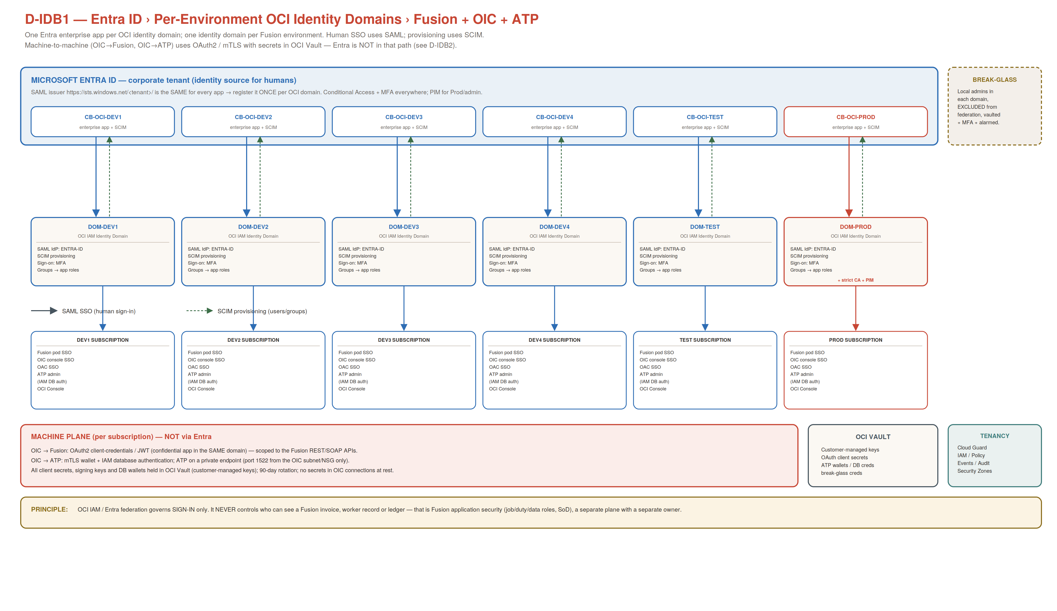
Diagram D-IDB1 — macro topology. Each of the six subscriptions (Dev1–Dev4, Test, Prod) is federated in its own domain; Prod additionally carries strict Conditional Access and PIM. Break-glass is local and excluded from federation.

4. Bridge 1 — Entra ID to the OCI Identity Domain (Human SSO)

4.1 SAML federation, per domain
- In each domain (DOM-DEV1 … DOM-PROD): Security ▸ Identity providers ▸ Add SAML IdP; import the metadata of that domain's own Entra enterprise app (CB-OCI-<ENV>). Enable signed requests + assertions (SHA-256); NameID = userPrincipalName (email format).
- Set the domain sign-on policy default rule to delegate to the Entra IdP and require MFA.
- Confirm the issuer registers cleanly. If OCI reports “Provider ID already exists”, a domain already has an Entra IdP with that issuer — UPDATE it, do not add a second (the issuer is per-tenant, identical across apps).

4.2 SCIM provisioning and source of record
- Enable automatic provisioning on the same Entra enterprise app; tenant URL = the domain SCIM endpoint; secret token stored in Vault. Scope = sync only assigned users and groups; JIT off.
- Source of record: HCM (workers) → Entra → SCIM → domain. Joiner/mover/leaver is driven from HCM/Entra; a test de-provision must deactivate in the domain within one cycle.
- Map Entra security groups to domain groups (arrive as OCI-*), then to application roles (OIC ServiceInvoker/ServiceAdministrator, OAC, Console).

4.3 Conditional Access, MFA, PIM
- MFA everywhere. Non-prod = baseline CA (MFA). Prod + any platform domain = strict CA (MFA + compliant/hybrid-joined device, block legacy auth) and PIM-eligible admin groups (activation with approval + justification).
- Assignment required = Yes on every enterprise app; only that environment's groups are assigned — an unassigned user is refused at Entra before reaching OCI.

4.4 Break-glass
- Two local admins in the Default domain (or a dedicated break-glass domain), excluded from federation, ≥24-char vaulted passwords, MFA, and an alarm on every successful login (see §9). Proven working before and after any federation change.

5. Bridge 2 — Identity Domain to Oracle Fusion
Each Fusion pod is associated with an identity domain. Once that domain is federated to Entra (Bridge 1), Fusion SSO for humans follows automatically: a user hits the Fusion URL, is redirected to the domain, which delegates to Entra, MFA is enforced, and the user lands in Fusion with the roles their groups grant.
- Human SSO. Fusion UI sign-in uses the domain's SAML IdP (Entra). No separate Fusion-side IdP configuration beyond associating the pod with the federated domain and confirming NameID = userPrincipalName.
- Fusion application security stays separate. OCI/Entra decide IF a person can sign in; Fusion job/duty/data roles, security profiles, data access sets and SoD decide WHAT they can do. Keep this workstream and its owner distinct from the platform identity work.
- Provisioning to Fusion. Worker accounts originate in HCM; do not double-provision the same humans into Fusion by a second path. For non-worker/partner access, provision through the same Entra→SCIM chain into the environment's groups.
Pod ↔ domain binding. The exact mechanism to associate a Fusion pod with a specific (federated) identity domain varies by pod generation. Confirm with Oracle Support for your pods before cutover, and treat re-pointing a pod's SSO as a change with a fall-back to the previously working IdP metadata.

6. Bridge 3 — OIC (Console SSO + OAuth2 to Fusion)
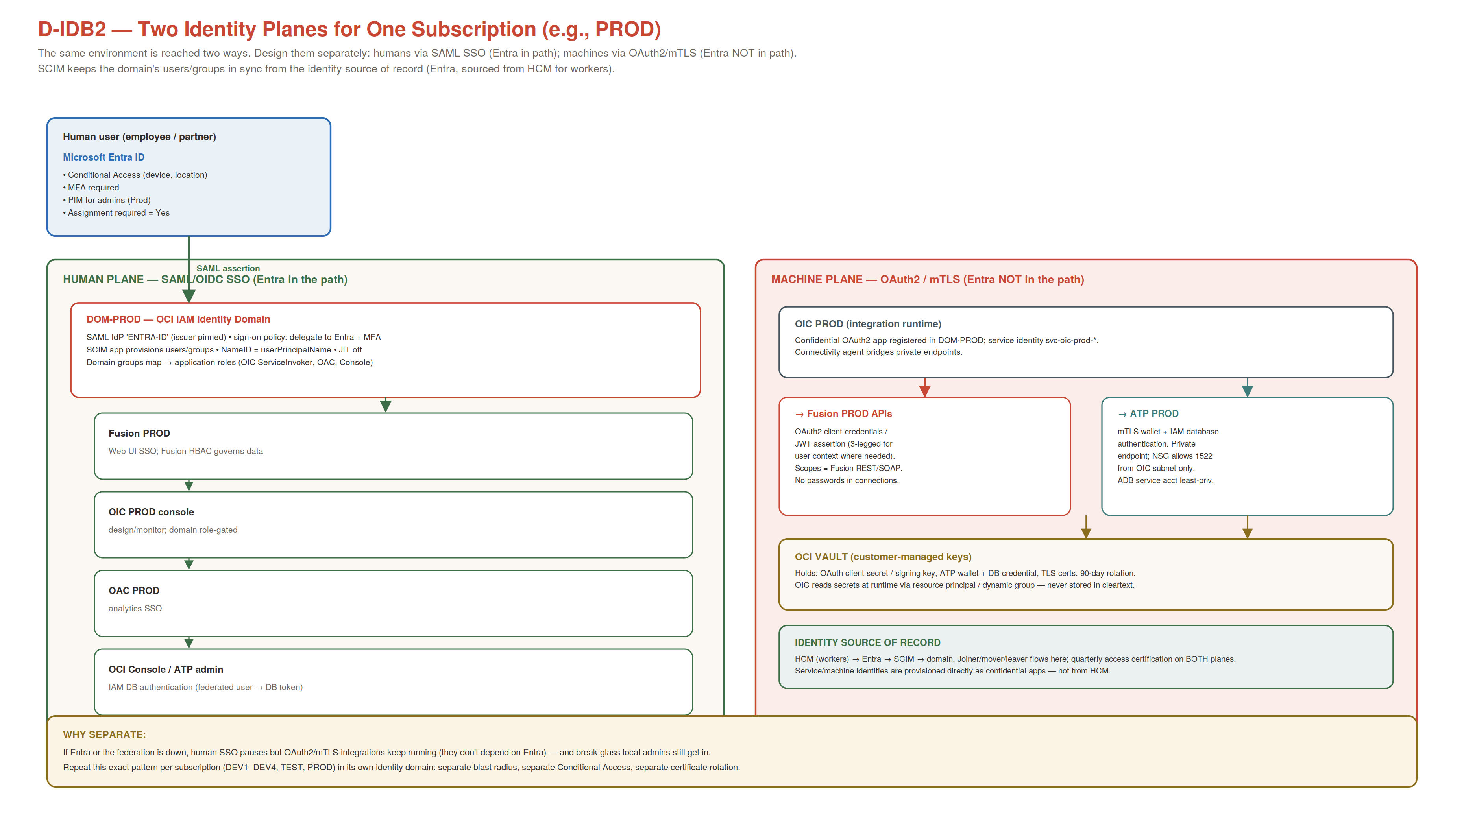
Diagram D-IDB2 — the two planes for one subscription. Repeat per environment.

6.1 OIC console (human plane)
- OIC console sign-in uses the environment's identity domain (Entra-federated). Gate OIC roles by domain group: ServiceDeveloper in Dev, ServiceAdministrator/Deployer promotion in Test/Prod.

6.2 OIC to Fusion (machine plane) — the important one
- Register a confidential OAuth2 application in the same identity domain as the environment; create a service identity svc-oic-<env>-fusion.
- OIC calls Fusion REST/SOAP with OAuth2 client-credentials (2-legged) for system-to-system, or JWT/3-legged where a specific user context is required. Grant only the Fusion scopes needed (Appendix B).
- Store the client secret / signing key in OCI Vault; OIC reads it at runtime via resource principal / dynamic group. Rotate every 90 days. Avoid basic-auth service accounts unless a specific API has no OAuth option (document as an exception).

6.3 OIC connectivity and files
- The OIC connectivity agent bridges private endpoints; SFTP/file exchange uses SSH keys pinned to named counterparties. These are machine-plane credentials — also in Vault, also rotated.

7. Bridge 4 — ATP (Human DB Auth + Service Credentials)

7.1 Human database access
- Use IAM database authentication: human DBAs authenticate to ATP with their federated OCI identity (from the Entra-federated domain) and a short-lived DB token — no shared local DB passwords. Map OCI groups to ATP DB roles.
- This gives you one identity lifecycle (Entra → domain → ATP) and one place to revoke: disable the person in Entra and their DB access follows.

7.2 Application / OIC access
- Applications and OIC connect with an mTLS wallet and a least-privileged DB service account; the wallet and credential live in OCI Vault. Do not embed wallets in images or repos.
- ATP on a private endpoint in the app-processing subnet; NSG allows 1522 only from the OIC/app subnet. The database initiates nothing outbound.

7.3 Encryption and keys
- TDE with customer-managed keys from the environment's Vault; restrict key/vault administration to the security group; key deletion is irreversible and board-approved.
Guard-rail. ATP here is for OIC staging, custom/partner persistence and integration cross-reference data — never a Fusion backing store, and no bulk replication of Fusion transactional data outside FDI.

8. Environment Isolation and Blast-Radius Model
Six domains, six enterprise apps, six OAuth trust boundaries. The table shows what stays independent per environment.
Dimension | Per-environment (isolated) | Why it matters
Identity domain + Entra app | DOM-DEV1..PROD, each with CB-OCI-<ENV> | A change/mistake in one env cannot break another's SSO
SAML signing certificate | Per app; rotate staggered | No estate-wide simultaneous cert outage
Conditional Access / PIM | Baseline in Dev; strict + PIM in Prod | Prod gets tighter controls than Dev
OAuth confidential app (OIC) | svc-oic-<env>-* per domain | Compromise of a Dev secret does not reach Prod Fusion
ATP wallet / DB accounts | Per env, in that env's Vault | Blast radius of a leaked wallet is one environment
Sign-in audit | Per domain | Clean per-environment attribution and certification

9. Security Controls and Guardrails
- MFA + Conditional Access. Enforced at Entra for every human sign-in; strict policy on Prod/platform.
- PIM. Admin roles (domain admin, OIC ServiceAdministrator, ATP admin) are PIM-eligible with just-in-time activation and approval on Prod.
- Break-glass alarm. An Events rule on successful sign-in by the break-glass accounts pages Security within 5 minutes; tested.
- Secrets & keys. OCI Vault, customer-managed keys; 90-day rotation; no cleartext secrets in OIC connections; wallets never in repos/images.
- Certificate rotation. Track all six SAML signing-cert expiries; rotate staggered, never all-at-once.
- Logging & SIEM. Audit retention maximised; domain sign-in logs and Cloud Guard problems streamed via Service Connector Hub to the SOC/SIEM.
- Cloud Guard & Security Zones. Detect-only baseline graduating to alert/respond; Security Zones on Prod, Vault and Analytics.
- Access certification. Quarterly, on BOTH planes — OCI/domain groups AND Fusion roles/SoD; partner access time-boxed and re-attested.

10. Recommendations Summary (Do / Avoid)
Do | Avoid
One identity domain + one Entra app per environment | A single shared domain/app federating all six pods
Separate human (SAML) and machine (OAuth2/mTLS) planes | Using a person's federated login for OIC→Fusion
OAuth2 client-credentials/JWT for OIC→Fusion | Basic-auth service accounts where OAuth exists
IAM DB auth for human ATP access; wallet+Vault for apps | Shared local DB passwords; wallets in repos/images
SCIM provisioning, JIT off, HCM as worker source | Manual/duplicate provisioning; JIT sprawl
Break-glass local, excluded from federation, alarmed | Federating the Default domain / no backdoor
Strict CA + PIM on Prod; staggered cert rotation | One CA policy and one cert for the whole estate
Secrets in Vault, 90-day rotation, resource-principal reads | Secrets pasted into OIC connections at rest

11. Build Sequence (High Level)
- Stand up break-glass in the Default domain; prove login + MFA; vault the credentials.
- Create the six identity domains (or confirm the Fusion pod domains) and, per domain, one Entra enterprise app; register the SAML IdP; enable SCIM; verify the IdP-group → SCIM → domain-group → role chain.
- Apply Conditional Access + PIM (strict on Prod); confirm unassigned users are refused.
- Per environment: register the OIC confidential OAuth2 app; wire OIC→Fusion with client-credentials; store secrets in Vault.
- Per environment: configure ATP IAM DB auth for humans and mTLS wallet + service account for OIC; lock NSG 1522 to the OIC subnet.
- Enable logging/SIEM export, Cloud Guard, Security Zones; schedule quarterly access certification and staggered cert rotation.
Pathfinder. Prove the whole pattern on Dev1 first (federate, SCIM, OIC OAuth, ATP), run a deliberate fall-back to the previous IdP, then fan out to Dev2–Dev4 and Test, and do Prod last under a change window — the sequence used in your CR-IDN-001 rev 2 runbook.

Appendix A — Naming Conventions
Object | Pattern | Example
Identity domain | DOM-<ENV> | DOM-PROD
Entra enterprise app | CB-OCI-<ENV> | CB-OCI-PROD
Domain group | OCI-<ENV>-<ROLE> | OCI-PROD-OIC-ADMIN
OIC OAuth service identity | svc-oic-<env>-fusion | svc-oic-prod-fusion
ATP service account | svc-atp-<env>-<app> | svc-atp-prod-oic
Vault secret | SEC-<SVC>-<ENV> | SEC-OIC-PROD-FUSION-OAUTH
Break-glass user | BG-OCI-ADMIN-0n | BG-OCI-ADMIN-01

Appendix B — OAuth Scopes and Group Model (representative)

OIC → Fusion OAuth (confidential app)
- Grant client-credentials with the specific Fusion REST/SOAP resource scopes the integrations use (e.g., the Fusion Applications resource with the required functional scopes) — least privilege, reviewed per integration.
- Use JWT user-assertion (3-legged) only where an operation must run as a named user; otherwise 2-legged client-credentials.

Domain group → role mapping (per environment)
Domain group (from Entra via SCIM) | Grants
OCI-<ENV>-CONSOLE-ADMIN | OCI Console admin scope for that environment's compartments
OCI-<ENV>-OIC-DEVELOPER | OIC ServiceDeveloper (Dev/Test)
OCI-<ENV>-OIC-ADMIN | OIC ServiceAdministrator / deploy (Test/Prod, PIM-eligible)
OCI-<ENV>-DBA | ATP IAM DB auth → DBA role (PIM-eligible on Prod)
OCI-<ENV>-OAC-AUTHOR / -CONSUMER | OAC analytics author / consumer
This is a v1.0 advisory draft. Validate every scope, group and pod↔domain binding against current Oracle documentation and your tenancy before implementation; align with CR-IDN-001 rev 2 (per-environment federation) and the landing-zone design.

