OCI IAM with ADFS
SSO and Just-In-Time Provisioning Tutorials
Step-by-step instructions for federating Oracle Cloud Infrastructure Identity and Access Management (identity domains) with Microsoft Active Directory Federation Services using SAML 2.0.
Service provider | OCI IAM with Identity Domains
Identity provider | Microsoft ADFS (Windows Server 2016 R2)
Protocol | SAML 2.0
Tutorials | 1. SSO Between OCI and ADFS 2. JIT Provisioning from ADFS to OCI IAM
Source | Oracle Cloud Infrastructure documentation
Table of Contents
1. Introduction 4
1.1 Tutorials in This Document 4
1.2 Solution Architecture 4
2. SSO Between OCI and ADFS 6
2.1 Overview 6
2.2 Before You Begin 7
2.3 Create the Same User in Both Systems 8
2.4 Verify ADFS is Running 9
2.5 Task 1: Create ADFS as IdP in OCI IAM 10
2.6 Task 2: Register OCI IAM as a Trusted Relying Party 13
2.6.1 Register the Relying Party 13
2.6.2 Configure Claim Rules 15
2.7 Task 3: Test SSO Between ADFS and OCI 17
2.8 What's Next 19
3. JIT Provisioning from ADFS to OCI IAM 20
3.1 Overview 20
3.2 Before You Begin 21
3.3 Task 1: Update the Trusted Relying Party Configurations in ADFS 21
3.4 Task 2: Update the ADFS IdP in OCI IAM 22
3.5 Task 3: Test JIT Provisioning Between ADFS and OCI 24
3.6 What's Next 25
Appendix A. References 26
A.1 Key Endpoints and Values 26
List of Figures
Figure 1: Federation architecture between OCI IAM, ADFS and Active Directory 4
Figure 2: SSO configuration workflow across OCI IAM and ADFS 7
Figure 3: User in the Active Directory Users and Computers utility 8
Figure 4: ADFS sign-in page 9
Figure 5: ADFS confirmation that you are signed in 10
Figure 6: SAML metadata exchange between OCI IAM and ADFS 10
Figure 7: Export SAML metadata for OCI IAM 11
Figure 8: SAML identity provider attribute mapping 12
Figure 9: Default Identity Provider Policy context menu showing Edit IdP rule 12
Figure 10: Adding ADFS as an identity provider in the default IdP rule 13
Figure 11: Add Relying Party Trust Wizard in ADFS 13
Figure 12: Select data source 14
Figure 13: Setting the display name 14
Figure 14: Edit Claim Rules window 15
Figure 15: ADFS claim rule pipeline from Active Directory to OCI IAM 15
Figure 16: Choose Rule Type page of the Add Transform Claim Rule wizard (Email rule) 16
Figure 17: Choose Rule Type page of the Add Transform Claim Rule wizard (Name ID rule) 17
Figure 18: Confirm that both claim rules are present 17
Figure 19: SP-initiated SAML SSO message sequence during Test Login 18
Figure 20: ADFS sign-in page during Test Login 19
Figure 21: Test Login confirmation message 19
Figure 22: JIT provisioning decision flow at sign-in 20
Figure 23: Attribute and group mapping from Active Directory through ADFS claims to OCI IAM 22
Figure 24: Enable Just-In-Time provisioning 23
Figure 25: Mapping of attributes between ADFS and OCI IAM 24
Figure 26: Assign group mappings 24
Figure 27: ADFS option on the OCI sign-in page 25

1. Introduction
These tutorials provide step-by-step instructions to get you working with Microsoft Active Directory Federation Services (ADFS) and OCI IAM.
Be sure to read the Before You Begin sections in each tutorial so that you have everything you need to complete it successfully.

1.1 Tutorials in This Document
# | Tutorial | Purpose | Source
1 | SSO Between OCI and ADFS | Configure federated SAML 2.0 single sign-on with ADFS as the identity provider (IdP) and OCI IAM as the service provider (SP). | Oracle docs
2 | JIT Provisioning from ADFS to OCI IAM | Create and update OCI IAM users (and group memberships) at sign-in time from the ADFS SAML assertion. | Oracle docs

1.2 Solution Architecture
OCI IAM (identity domain) acts as the SAML service provider and trusts ADFS as the SAML identity provider. ADFS authenticates users against Microsoft Active Directory and returns a signed SAML assertion that OCI IAM uses to identify the user. Trust between the two systems is established by exchanging SAML metadata files.
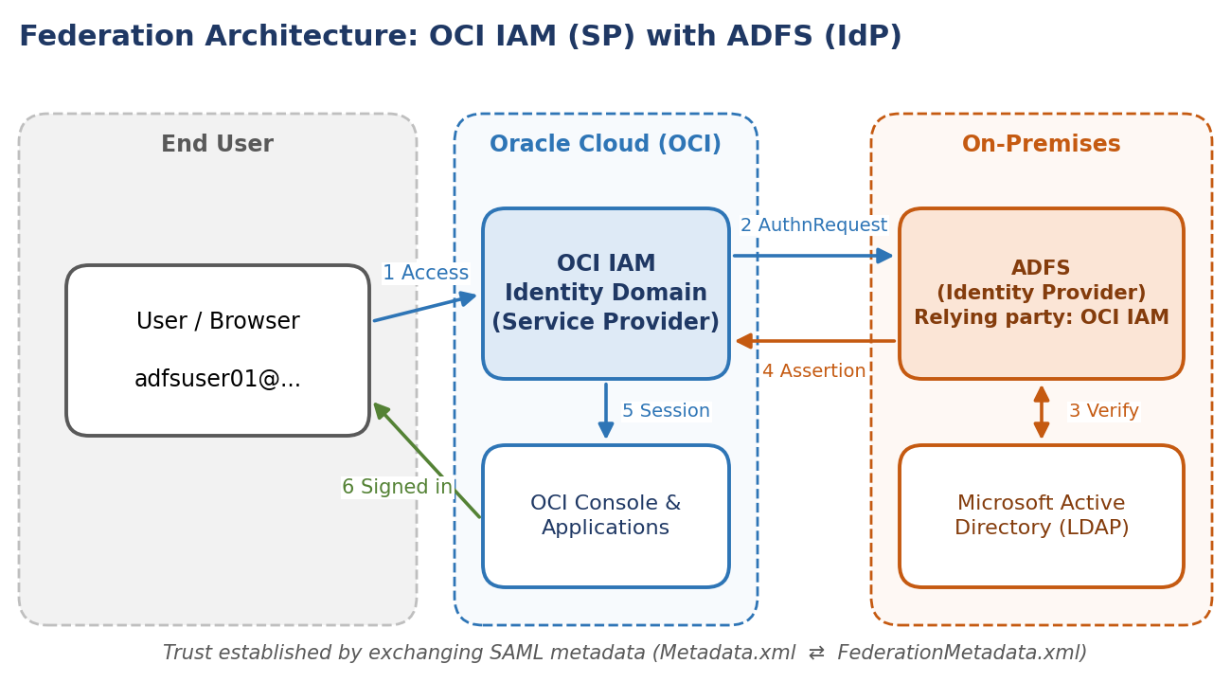
Figure 1: Federation architecture between OCI IAM, ADFS and Active Directory
Component | Role in this integration
OCI IAM identity domain | SAML 2.0 service provider (SP); hosts the ADFS SAML IdP definition, IdP policy and (optionally) JIT provisioning settings.
Microsoft ADFS | SAML 2.0 identity provider (IdP); holds the Relying Party Trust for OCI IAM and the claim issuance rules.
Microsoft Active Directory | Authoritative user store; supplies e-mail, name and group attributes through LDAP.
User / browser | Initiates sign-in to the OCI Console and is redirected between OCI IAM and ADFS.

2. SSO Between OCI and ADFS

2.1 Overview
In this tutorial, configure SSO between the OCI IAM and ADFS, using ADFS as the identity provider (IdP).
This 30-minute tutorial shows you how to integrate OCI IAM, acting as a service provider (SP), with ADFS, acting as an IdP. By setting up federation between ADFS and OCI IAM, you enable users' access to services and applications in OCI using user credentials that ADFS authenticates.
This tutorial covers setting up ADFS as an IdP for OCI IAM. OCI IAM provides integration with SAML 2.0 IdPs. This integration:
- Works with federated Single Sign-On (SSO) solutions that are compatible with SAML 2.0 as an IdP, such as ADFS.
- Let’s users sign in to OCI using their ADFS credentials.
- Let’s users sign in to end applications.
The high-level workflow is:
- First, download the metadata from the OCI IAM identity domain.
- In the next few steps, you create and configure a relying party in ADFS.
- In ADFS, set up SSO with OCI IAM using the metadata.
- In ADFS, edit the Attributes and Claims so that the email name is used as the identifier for users.
- In ADFS, add a user to the app.
- For the next steps, you return to the identity domain to finish the setup and configuration. In OCI IAM, update the default IdP policy to add ADFS.
- Test that federated authentication works between OCI IAM and ADFS.
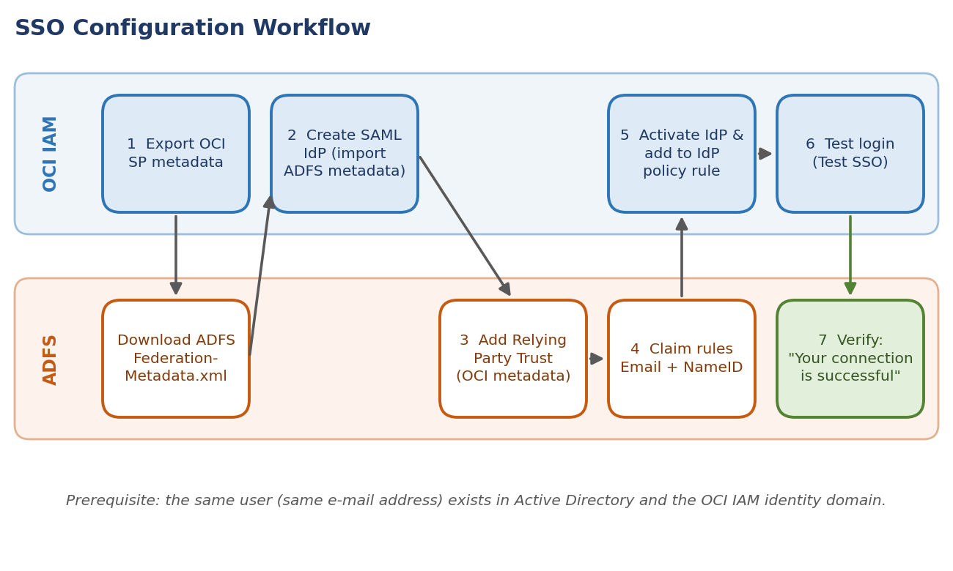
Figure 2: SSO configuration workflow across OCI IAM and ADFS
NOTE
This tutorial is specific to IAM with Identity Domains.

2.2 Before You Begin
To perform this tutorial, you must have the following:
Prerequisite | Details
OCI account | A paid Oracle Cloud Infrastructure (OCI) account, or an OCI trial account. See Oracle Cloud Infrastructure Free Tier.
Administrator role | Identity domain administrator role for the OCI IAM identity domain. See Understanding Administrator Roles.
ADFS | An on-premises ADFS installation.
Matching user | The same user exists in OCI and ADFS (see section 2.3).
ADFS health | ADFS is working (see section 2.4).

NOTE
This tutorial describes using the ADFS software provided with Microsoft Windows Server 2016 R2.

2.3 Create the Same User in Both Systems
Ensure that a user with the same email address exists in both systems.
For SAML SSO to work between ADFS and OCI IAM, there must be a user with the same email address in both the Microsoft Active Directory domain and the OCI IAM identity domain. In this task, you confirm that such a user exists on both systems.
- Open the Microsoft Active Directory Users and Computers utility. In Windows 2016 Server, select Server Manager, then Tools, and then Active Directory Users and Computers.
- In the Employees folder, double-click the user you want to use. Make a note of the user's email address. In this example the ADFS user is adfsuser01@gmail.com.
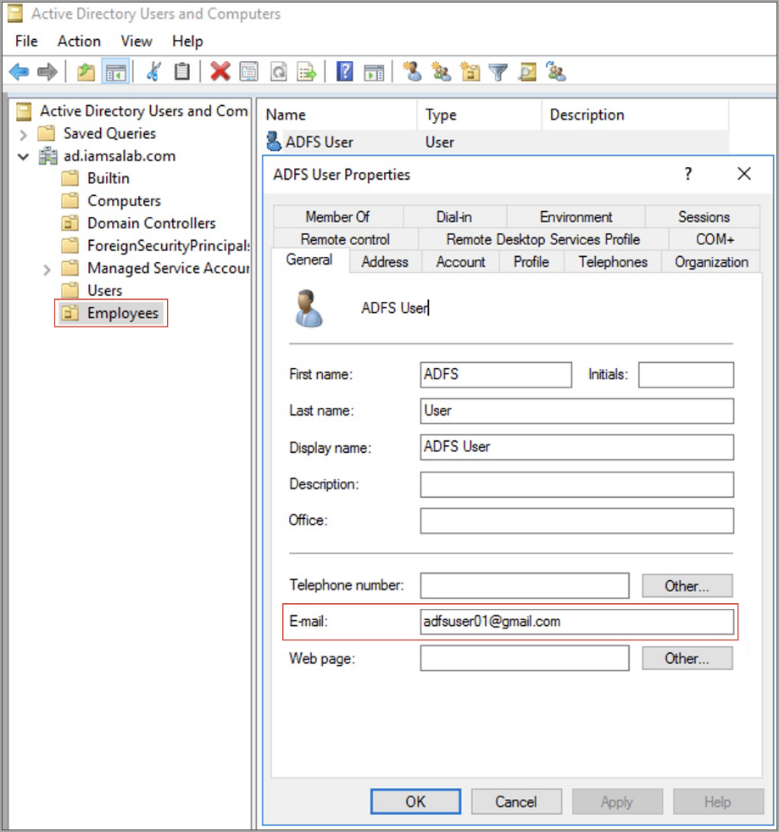
Figure 3: User in the Active Directory Users and Computers utility
IMPORTANT
If more than one user in the OCI IAM domain has the same email address then SAML SSO fails because it's impossible to determine which user is to be signed in.
The user's email address is used to link the user signed in to ADFS with the same user's entry in OCI IAM.
If you don't have an ADFS user to test the connection, you can create one.

- In a browser, enter the Console URL to access the OCI IAM Console:
https://cloud.oracle.com

- Enter your Cloud Account Name, also referred to as the tenancy name, and select Next.
- Sign in with your username and password.
- Select the domain that you are going to use.
- Select Users.
- In the search field, enter the email address you recorded from Microsoft Active Directory.
- In the search results, confirm that a user exists with the same email address as the user in the Microsoft Active Directory.
NOTE
If the user doesn't exist in OCI IAM, select Add and create the user with the same email address as in Microsoft Active Directory.

2.4 Verify ADFS is Running
Verify that ADFS is running, and that you can successfully challenge the user for sign in.
- In the browser, sign in to ADFS using the URL below, where adfs.example.com is your ADFS hostname:
https://adfs.example.com/adfs/ls/IdpInitiatedSignOnPage

- If you need to, select Sign in to this site. Select Sign In.
- Enter the Microsoft Active Directory credentials for a user that exists on both ADFS and OCI IAM (in this example, adfsuser01) and select Sign In.
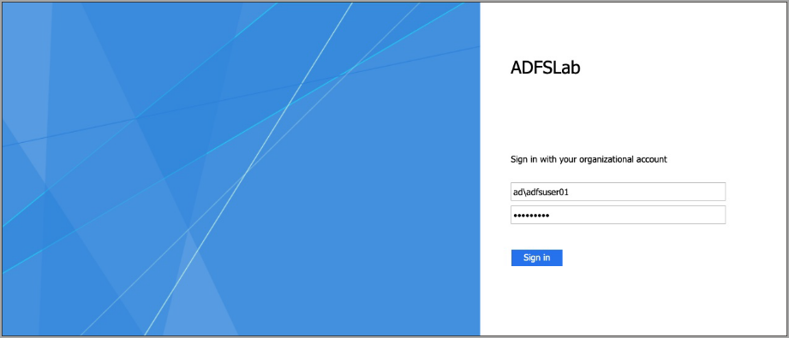
Figure 4: ADFS sign-in page
- You'll see the message You are signed in.

Figure 5: ADFS confirmation that you are signed in

2.5 Task 1: Create ADFS as IdP in OCI IAM
In this task you exchange SAML metadata between the two systems and register ADFS as a SAML identity provider in the OCI IAM identity domain.
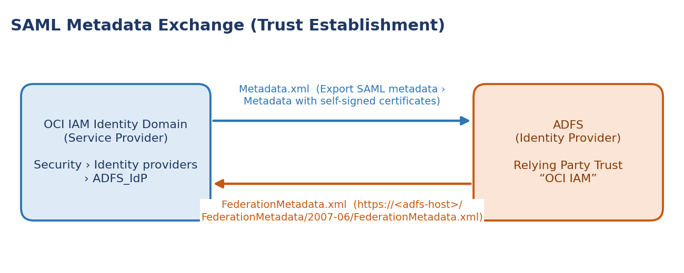
Figure 6: SAML metadata exchange between OCI IAM and ADFS
- In the browser, sign in to ADFS using the URL below, where adfs.example.com is your ADFS hostname:
https://adfs.example.com/FederationMetadata/2007-06/FederationMetadata.xml

- Save the FederationMetadata.xml file. You will use this file to register ADFS with OCI IAM.
- In the OCI Console navigate to the domain you want to work in. You might need to change the compartment to find the domain that you want. Select Security and then Identity providers.
- Select Add IdP, then select Add SAML IdP.
- Enter a name for the SAML IdP, for example ADFS_IdP. Select Next.
- Select Enter IdP metadata.
- Download the OCI IAM Service Provider (SP) metadata by selecting Export SAML metadata.
  - On the Export SAML metadata page under Metadata with self-signed certificates, select Download XML.
NOTE
Use metadata with self-signed certificates when the identity provider performs CRL or OCSP checks on certificates issued by a CA. In this tutorial, ADFS does this during certificate path validation.

  - Save the file to an appropriate location.
  - Transfer the Metadata.xml file to the Windows Server where ADFS is managed. You will use this file to register the OCI IAM domain with ADFS.
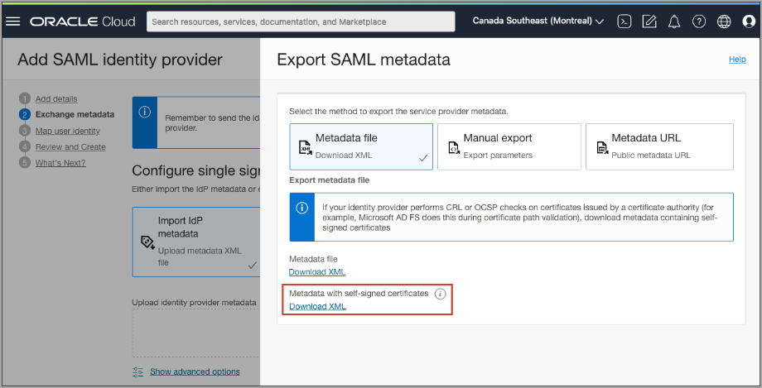
Figure 7: Export SAML metadata for OCI IAM
- Close the Export SAML metadata page.
- Select Import IdP metadata, and then select Upload. Select the FederationMetadata.xml file that you saved earlier from ADFS, select Open, and then select Next.
- In Map user identity, set the following:
Field | Value
Requested Name ID format | Email address
Identity provider user attribute | SAML assertion Name ID
Identity domain user attribute | Primary email address

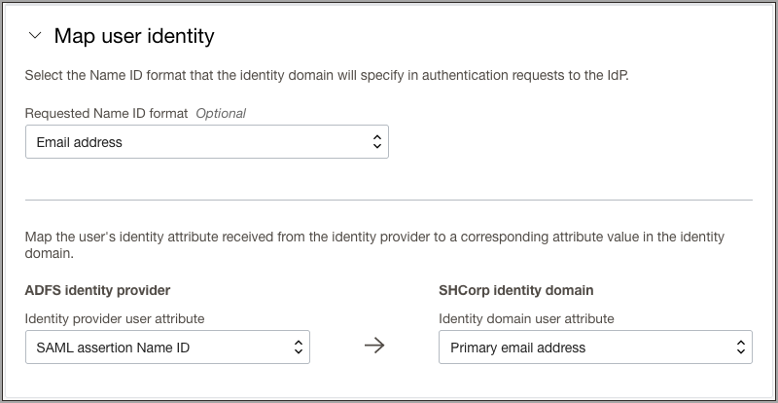
Figure 8: SAML identity provider attribute mapping
- Select Next.
- Under Review and Create verify the configurations, and select Create IdP.
- Select Activate.
- Select Add to IdP Policy Rule. Adding the ADFS IdP to an IdP Policy allows it to be displayed on the OCI IAM sign-in screen.
- Select Default Identity Provider Policy to open it, then select the Actions menu (three dots) for the rule and select Edit IdP rule.
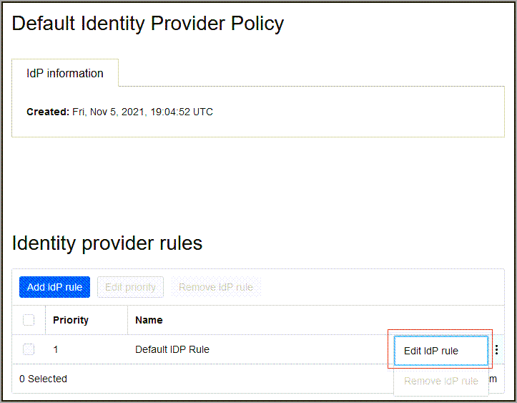
Figure 9: Default Identity Provider Policy context menu showing Edit IdP rule
- Select Assign identity providers and then select ADFS_IdP to add it to the list.
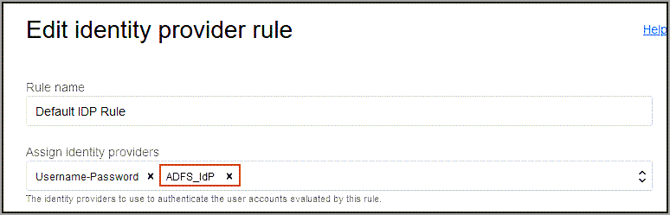
Figure 10: Adding ADFS as an identity provider in the default IdP rule
- Select Save Changes.
Now, ADFS is registered as identity provider in OCI IAM. Next, you register OCI IAM as a trusted relying party in ADFS.

2.6 Task 2: Register OCI IAM as a Trusted Relying Party
First, register OCI IAM as the relying party with ADFS. Then, configure claim rules for OCI IAM as a relying party.

2.6.1 Register the Relying Party
- Open the ADFS management utility. For example, in Windows 2016 Server Manager utility, select Tools, then select Microsoft Active Directory Federation Services Management.
- Select Action, then select Add Relying Party Trust.
- In the Add Relying Party Trust Wizard window, select Start.
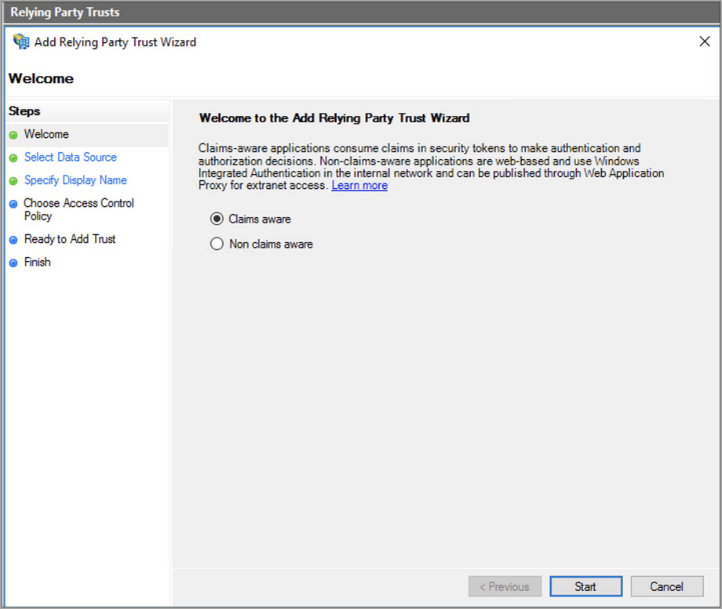
Figure 11: Add Relying Party Trust Wizard in ADFS
- Select Import data about the relying party from a file, and then select Browse.
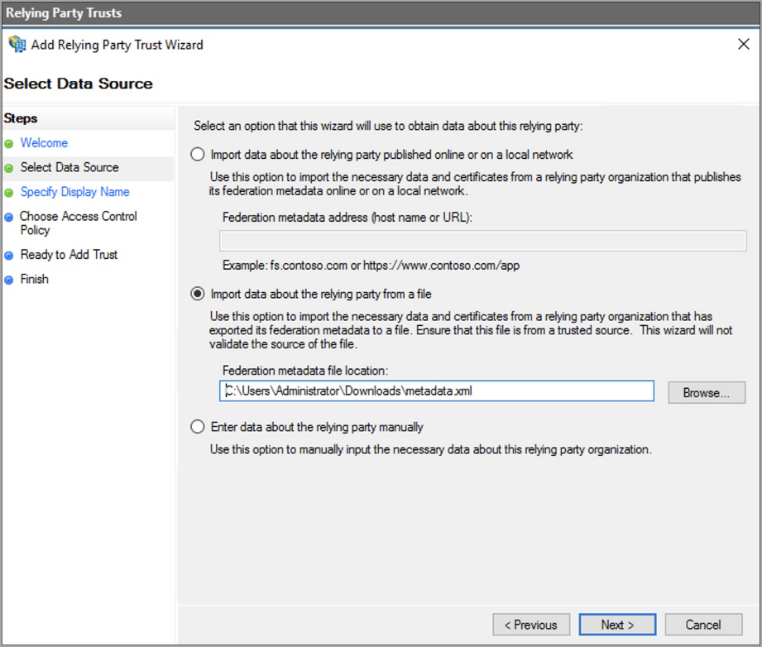
Figure 12: Select data source
- Select Metadata.xml which you downloaded earlier from OCI IAM, and select Next.
- Enter a display name, for example OCI IAM, and optionally enter a description under Notes. Select Next.
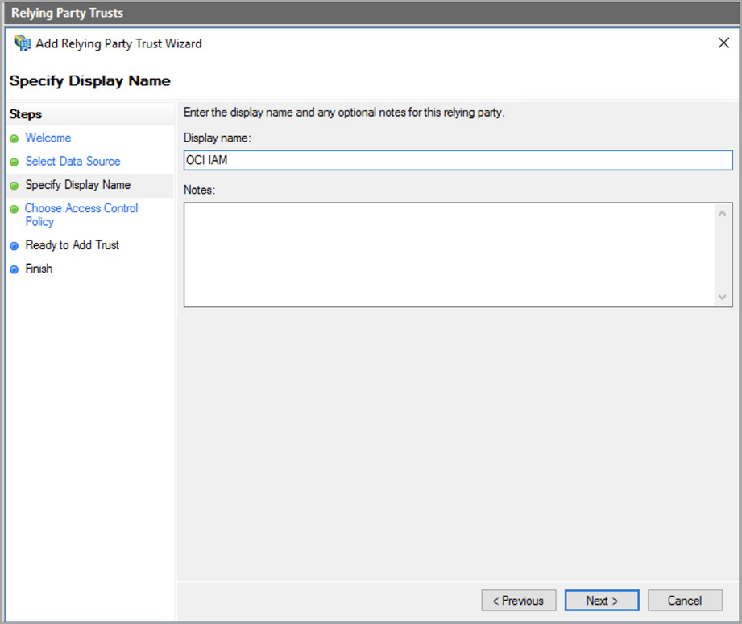
Figure 13: Setting the display name
- Proceed with the default options until you reach the Finish step, and then select Close. The Edit Claim Rules window opens.
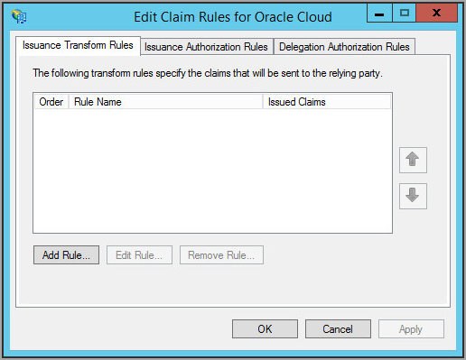
Figure 14: Edit Claim Rules window

2.6.2 Configure Claim Rules
Claim rules define the information about a signed-in user sent from ADFS to OCI IAM after successful authentication. Here, you define two claim rules for OCI IAM to act as a relying party:
- Email: This rule indicates that the user's email address is sent to OCI IAM in the SAML assertion.
- Name ID: This rule indicates that the result of the Email rule is sent to OCI IAM in the Subject Name ID element of the SAML assertion.
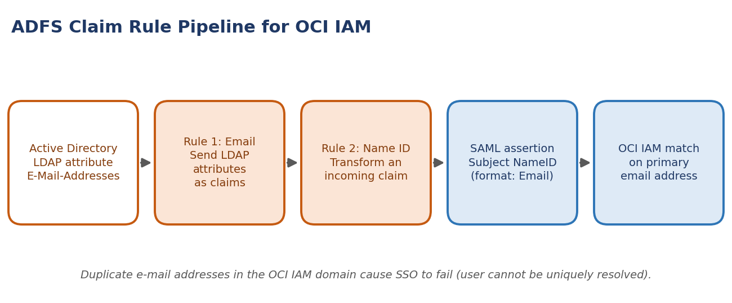
Figure 15: ADFS claim rule pipeline from Active Directory to OCI IAM
Setting | Rule 1: Email | Rule 2: Name ID
Claim rule template | Send LDAP Attributes as Claims | Transform an Incoming Claim
Claim rule name | Email | Name ID
Attribute store | Active Directory | —
LDAP attribute / Incoming claim type | E-Mail-Addresses | E-Mail Address
Outgoing claim type | E-Mail Address | Name ID
Outgoing name ID format | — | Email

- In the Edit Claim Rules window, select Add Rule.
- Select Send LDAP Attributes as Claims as claim rule template, and then select Next.
- In the Choose Rule Type page, provide the following information for the Email rule:
  - Claim rule name: Email
  - Attribute store: Active Directory
  - Mapping of LDAP attributes to outgoing claim types:
    - LDAP Attribute: E-Mail-Addresses
    - Outgoing Claim Type: E-Mail Address
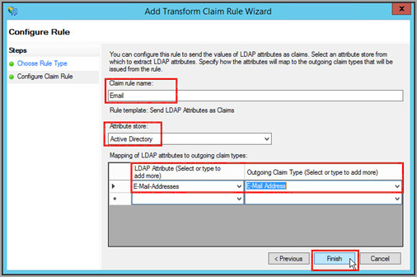
Figure 16: Choose Rule Type page of the Add Transform Claim Rule wizard (Email rule)
- Select Finish.
- In the Edit Claim Rules window, select Add Rule to add the second claim rule.
- Select Transform an Incoming Claim as claim rule template, then select Next.
- In the Choose Rule Type page, provide the following information for the Name ID rule:
  - Claim rule name: Name ID
  - Incoming claim type: E-Mail Address
  - Outgoing claim type: Name ID
  - Outgoing name ID format: Email
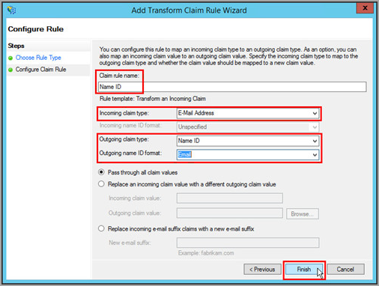
Figure 17: Choose Rule Type page of the Add Transform Claim Rule wizard (Name ID rule)
- Select Finish.
- In the Edit Claim Rules for Oracle Cloud window, check that the Email and Name ID rules have been created.
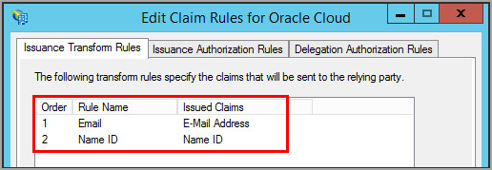
Figure 18: Confirm that both claim rules are present
Now, ADFS and OCI IAM have enough information to establish SSO and you can test the integration.

2.7 Task 3: Test SSO Between ADFS and OCI
In this task, you test the authentication between OCI IAM and ADFS. If the authentication is successful, you enable the identity provider for end-users.
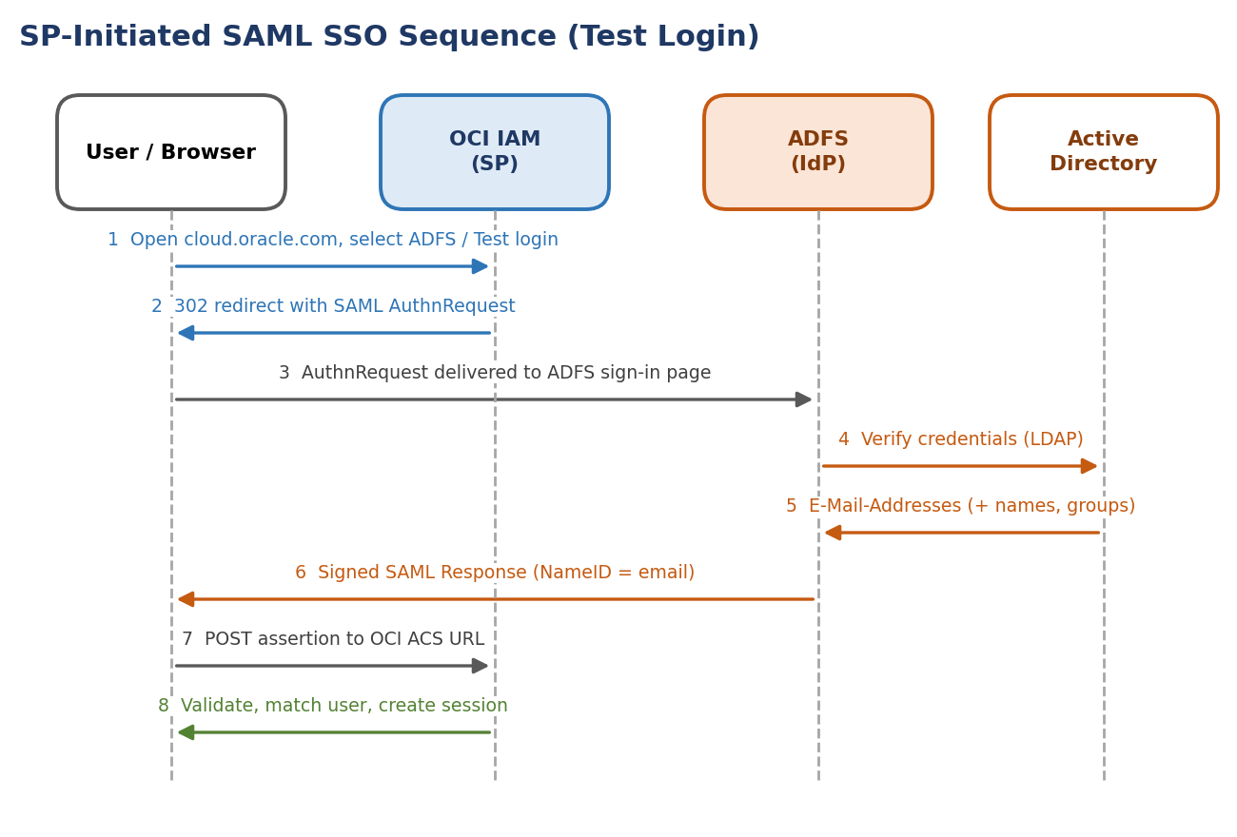
Figure 19: SP-initiated SAML SSO message sequence during Test Login
- Restart your browser, and enter the Console URL to access the OCI IAM Console:
https://cloud.oracle.com

- Enter the Cloud Account Name, also referred to as the tenancy name, and select Next.
- Sign in with your username and password.
- Select the domain that you configured the ADFS IdP for.
- Select Security and then Identity Providers.
- Select the ADFS IdP entry.
- On the details page for the IdP, select More actions then select Test login.
- Scroll to the bottom and select Test Login.
- On the ADFS sign in page, sign in with a user that exists on ADFS and OCI IAM.
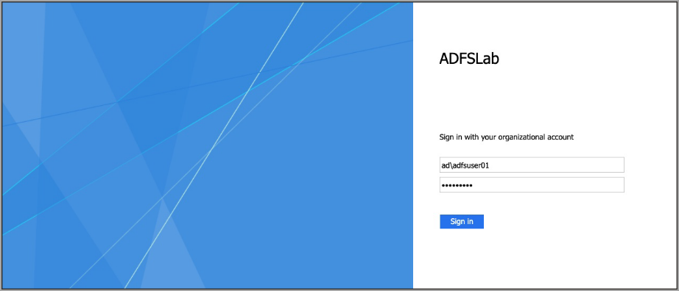
Figure 20: ADFS sign-in page during Test Login
- You see the confirmation message Your connection is successful.
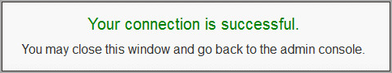
Figure 21: Test Login confirmation message

2.8 What's Next
Congratulations! You have successfully set up SSO between ADFS and OCI IAM.

3. JIT Provisioning from ADFS to OCI IAM

3.1 Overview
In this tutorial, you configure Just-In-Time (JIT) Provisioning between the OCI and Microsoft ADFS, where ADFS acts as the IdP.
You can set up JIT provisioning so that identities can be created in the target system during run time, as and when they make a request to access the target system.
This tutorial covers the following steps:
- Update the Relying Party configurations in ADFS.
- Update the ADFS IdP in OCI IAM for JIT.
- Test that you can provision users from ADFS to OCI IAM.
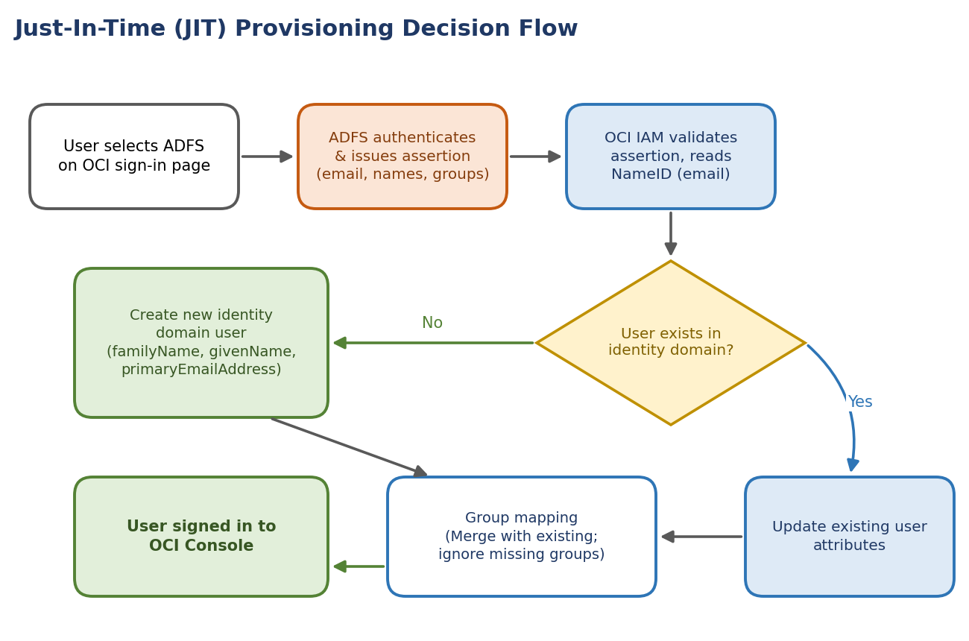
Figure 22: JIT provisioning decision flow at sign-in
NOTE
This tutorial is specific to IAM with Identity Domains.

3.2 Before You Begin
To perform this tutorial, you must have the following:
Prerequisite | Details
OCI account | A paid Oracle Cloud Infrastructure (OCI) account, or an OCI trial account. See Oracle Cloud Infrastructure Free Tier.
Administrator role | Identity domain administrator role for the OCI IAM identity domain. See Understanding Administrator Roles.
ADFS | An ADFS installation.
Completed SSO setup | The same user exists in OCI and ADFS, and ADFS is working (see chapter 2).

NOTE
This tutorial describes using the ADFS software provided with Microsoft Windows Server 2016 R2.

3.3 Task 1: Update the Trusted Relying Party Configurations in ADFS
- Open the ADFS management utility. For example, in Windows 2016 Server Manager utility, select Tools, then select Microsoft Active Directory Federation Services Management.
- Under ADFS, select Relying Party Trusts.
- Right-click the Relying Party Trust you previously configured for OCI called OCI IAM in the tutorial SSO Between OCI and ADFS.
- Choose Edit Claim Issuance Policy.
- Edit the Email claim to add three additional claim rules for First Name, Last Name, and Group:
Attribute | LDAP Attribute | Outgoing Claim Type
First Name | Given-Name | Given Name
Last Name | Surname | Surname
Group | Token-Groups - Unqualified Names | Group

- Select OK on the rules page, then OK again.
You can add additional attributes to suit your business requirements, but you only need these for this tutorial.
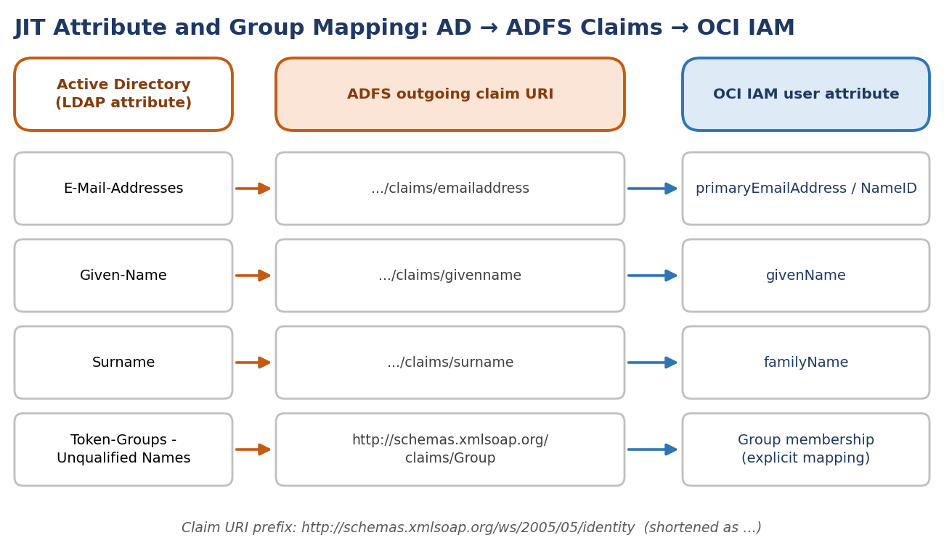
Figure 23: Attribute and group mapping from Active Directory through ADFS claims to OCI IAM

3.4 Task 2: Update the ADFS IdP in OCI IAM
In the OCI IAM Console, configure the ADFS IdP for JIT.
- Open a supported browser and enter the Console URL:
https://cloud.oracle.com

- Enter your Cloud Account Name, also referred to as your tenancy name, and select Next.
- Select the identity domain which will be used to configure SSO.
- Sign in with your username and password.
- Open the navigation menu and select Identity & Security.
- Under Identity, select Domains.
- Select the identity domain in which you have already configured ADFS as IdP in step 1 of the tutorial "SSO Between OCI and ADFS".
- Select Security from menu on the left, and then Identity providers.
- Select the ADFS IdP.
NOTE
This is the ADFS IdP you created as part of the tutorial SSO Between OCI and ADFS.

- On the ADFS IdP page, select Configure JIT.
- On the Configure Just-in-time (JIT) provisioning page:
  - Select Enable Just-In-Time (JIT) provisioning.
  - Select Create a new identity domain user.
  - Select Update the existing identity domain user.
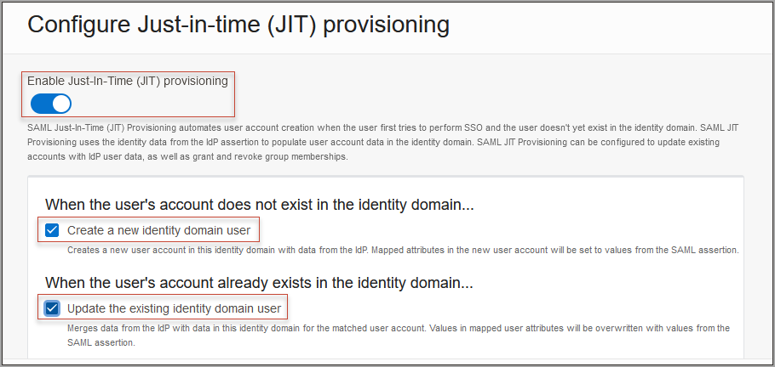
Figure 24: Enable Just-In-Time provisioning
- Under Map user attributes:
  - Leave the first row for Name ID unchanged.
  - For other attributes, under IdP user attribute select Attribute.
  - Provide the IdP user attribute name as shown in the table below.
  - Select Add Row, under IdP user attribute select Attribute, and enter the IdP user attribute name for given Name.
Identity domain attribute | IdP user attribute | IdP user attribute name
Name ID (first row) | (unchanged) | (unchanged)
Family Name | Attribute | http://schemas.xmlsoap.org/ws/2005/05/identity/claims/surname
Primary Email Address | Attribute | http://schemas.xmlsoap.org/ws/2005/05/identity/claims/emailaddress
Given Name (added row) | Attribute | http://schemas.xmlsoap.org/ws/2005/05/identity/claims/givenname

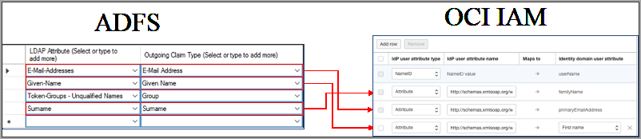
Figure 25: Mapping of attributes between ADFS and OCI IAM
- Select Assign group mapping.
- Enter the Group membership attribute name. Use http://schemas.xmlsoap.org/claims/Group.
- Select Define explicit group membership mappings.
- Under IdP group name maps to identity domain group name, do the following:
  - In IdP Group name, provide the name of the group in ADFS which will be present in the SAML assertion sent by ADFS.
  - In Identity domain group name, in OCI IAM select the group in OCI IAM to be mapped to the corresponding group in ADFS.
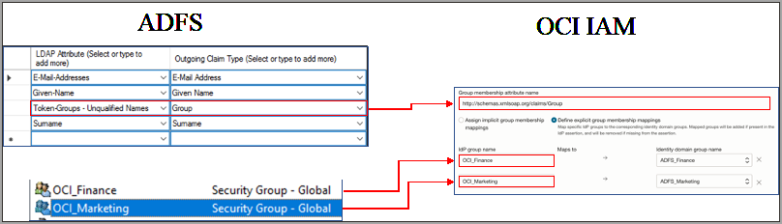
Figure 26: Assign group mappings
- Under Assignment rules, select the following:
Assignment rule | Selection
When assigning group memberships | Merge with existing group memberships
When a group is not found | Ignore the missing group

NOTE
Select options based on your organization's requirements.

- Select Save changes.

3.5 Task 3: Test JIT Provisioning Between ADFS and OCI
In this section, you can test that JIT provisioning works between ADFS and OCI IAM.
- In ADFS, create a user in ADFS which doesn't exist in OCI IAM.
- Restart your browser, and enter the Console URL to access the OCI Console:
https://cloud.oracle.com

- Enter the Cloud Account Name, also referred to as the tenancy name, and select Next.
- Select the identity domain in which JIT configuration has been enabled.
- From the sign in options, select ADFS.
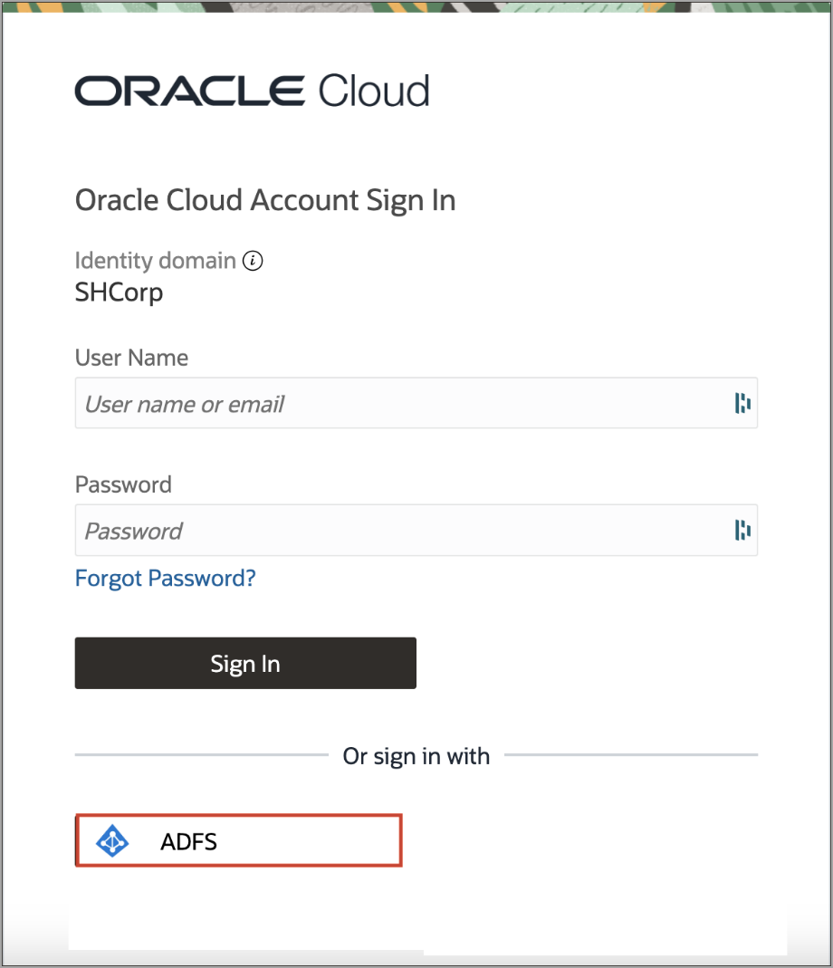
Figure 27: ADFS option on the OCI sign-in page
- On the ADFS login page, provide the newly created user's credentials.
- On successful authentication, an account is created for the user in OCI IAM and the user is signed in to the OCI Console.
You can view the new user in the OCI domain, and verify that it has the same identity attributes and group memberships as you entered.

3.6 What's Next
Congratulations! You have successfully set up JIT provisioning between ADFS and OCI IAM.

Appendix A. References
Reference | Link
SSO Between OCI and ADFS (Oracle tutorial) | https://docs.oracle.com/en-us/iaas/Content/Identity/tutorials/adfs/sso_adfs/adfs_sso.htm
JIT Provisioning from ADFS to OCI IAM (Oracle tutorial) | https://docs.oracle.com/en-us/iaas/Content/Identity/tutorials/adfs/jit_adfs/adfs_jit.htm
Oracle Cloud Infrastructure Free Tier | https://docs.oracle.com/iaas/Content/FreeTier/freetier.htm
Understanding Administrator Roles | https://docs.oracle.com/en-us/iaas/Content/Identity/roles/understand-administrator-roles.htm
Signing in to the Console (supported browsers) | https://docs.oracle.com/iaas/Content/GSG/Tasks/signingin.htm

A.1 Key Endpoints and Values
Item | Value
OCI Console | https://cloud.oracle.com
ADFS IdP-initiated sign-on page | https://<adfs-host>/adfs/ls/IdpInitiatedSignOnPage
ADFS federation metadata | https://<adfs-host>/FederationMetadata/2007-06/FederationMetadata.xml
OCI SAML IdP name (example) | ADFS IdP
ADFS relying party display name (example) | OCI IAM
Group claim URI | http://schemas.xmlsoap.org/claims/Group

