ENTERPRISE — ORACLE CLOUD PROGRAM — VOLUME 11
FDI Strategy, Topology & Design
Oracle Fusion Data Intelligence for the organization's Fusion estate (D20)
Defines how the organization adopts Oracle Fusion Data Intelligence (FDI) as the single governed analytics path from Fusion: the strategy pillars, the two-instance topology inside a dedicated Analytics compartment, the data and semantic architecture (including the landing place for legacy history), identity and security wired to the per-environment identity domain model (D17 / CR-IDN-001 rev 2), the augmentation/ETL design for non-Fusion sources, operations and release management, and the governance register FD-01…FD-09. Draft for Cloud Governance Board review.
Status: v1.0 DRAFT | Author: Enterprise Cloud Architect (OCI) | September 2026 | Classification: Internal

1. Strategy
FDI is Oracle's managed analytics application for Fusion: prebuilt incremental pipelines, a prebuilt warehouse (ADW) and semantic model, and prebuilt ERP/HCM KPIs and dashboards (OAC), maintained by Oracle release-over-release. The strategic choice is to treat FDI as the analytics system of record for everything Fusion-derived, and to make the estate's other analytics needs consume FDI rather than compete with it.
- FD-01 — One extract path: FDI's managed pipelines are the ONLY extract from Fusion. Any other analytics need — Power BI, a future lake, a partner report — consumes FDI/ADW curated schemas, never a second Fusion extract. (Same rule already ratified for multi-cloud: MC-03/§8 of Vol. 9.)
- FD-02 — Prebuilt first: adopt ERP Analytics and HCM Analytics prebuilt content as-is; extend additively via semantic model extensions and custom subject areas. Never fork or modify prebuilt objects — forks break on every FDI release.
- FD-03 — Two instances only: FDI-NP attached to the Fusion test pod (fa-<realm>-test) and FDI-PRD attached to production (fa-<realm>-prod). Dev pods get no FDI — development and validation of extensions happens in FDI-NP. This matches FDI licensing and operational reality: it is environment-attached, not per-developer.
- FD-04 — Security inherited, never duplicated: FDI auto-synchronises users, roles and data security from its source pod. No local grants in FDI/OAC; access is governed upstream (Fusion roles ← Entra groups ← the D17 mapping chain).
- FD-05 — Legacy history lands here, not in Fusion: the legacy ERP retires at go-live and only master data + opening balances migrate to Fusion. Historical legacy-ERP reporting data belongs in the FDI warehouse layer as a modeled, owned schema (DW_HIST) — Fusion stays clean, and historical + current reporting meet in one semantic layer.

What FDI is NOT (guardrails)
Not a transactional system (no writes except pipelines and governed augmentation loads); not an integration hub (OIC owns app-to-app; FDI owns analytics); not an archive dump (DW_HIST is modeled, owned, with retention rules); not open SQL (every non-FDI consumer is a named, read-only account on curated schemas); not per-dev-pod (Dev1–Dev4 validate against FDI-NP).

2. Target Architecture and Topology (D20)
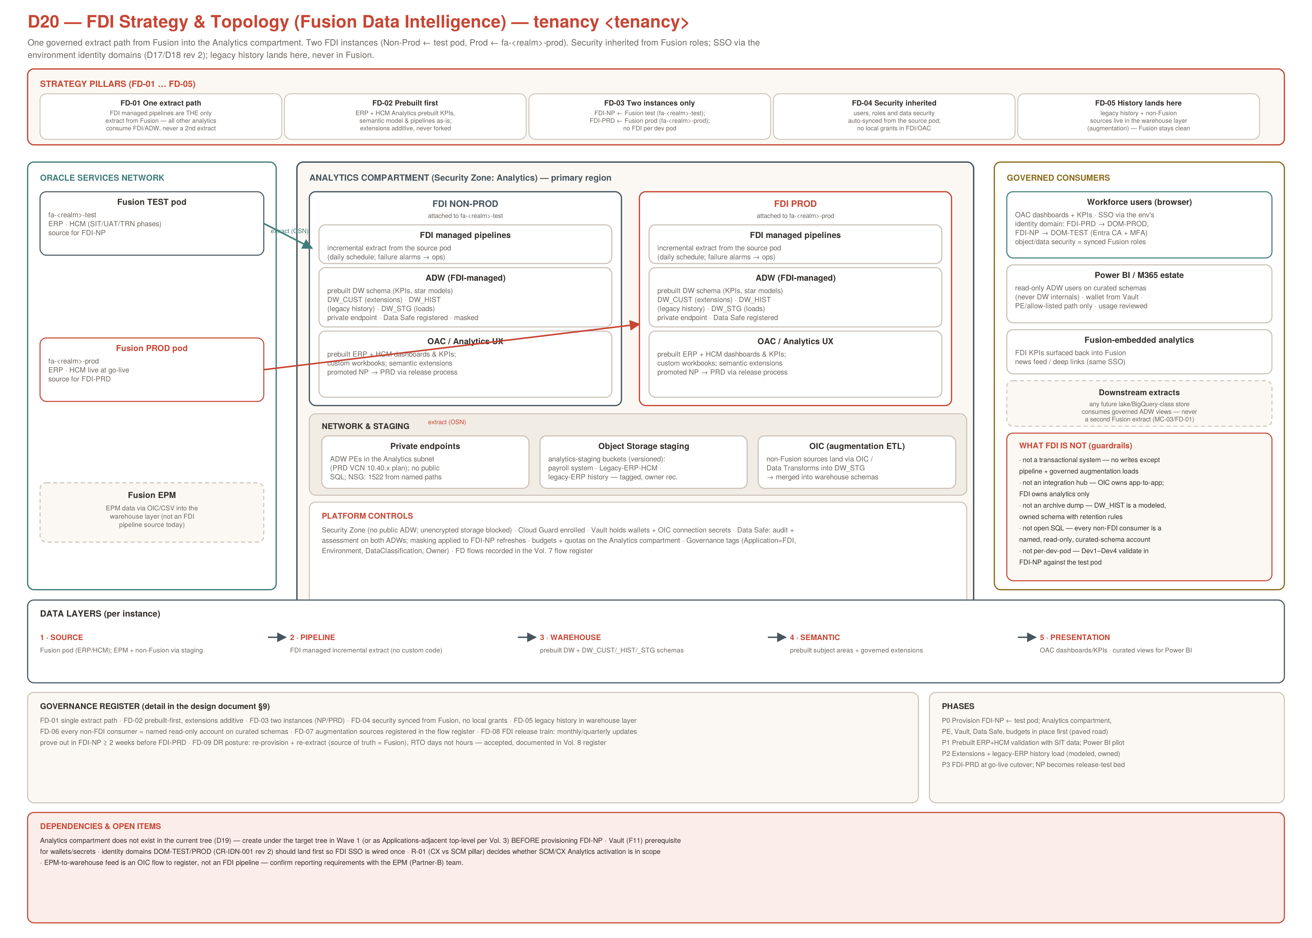

3. Topology and Placement
Element | FDI-NP | FDI-PRD
Source pod | fa-<realm>-test (SIT/UAT/TRN phases) | fa-<realm>-prod (production, from go-live cutover)
Compartment | Analytics (Security Zone: Analytics) — to be created in Wave 1; does not exist in the current tree (D19) | same compartment; separate child compartments Analytics::NonProd / Analytics::Prod if quota/policy separation is wanted
Region | the primary region (with the estate) | the primary region
ADW access | private endpoint in the Analytics subnet; NSG allows 1522 from named consumer paths only; no public SQL; masked on refresh | private endpoint; NSG as NP; Data Safe audit + assessment; no masking
Analytics UX | OAC embedded with the FDI instance; browser access over HTTPS via SSO | same
SSO / identity domain | DOM-TEST (per D17/D18 rev 2) | DOM-PROD (strict CA + PIM for admins)
Sizing (initial) | smallest shape; ECPU auto-scaling capped; grow on evidence | sized from NP observation before go-live; auto-scaling capped; budget alarm on the compartment
Network note: the Analytics subnet lives in the environment VCN plan (PRD VCN 10.40.x per the ratified CIDR plan; NP consumption over the corporate path). The as-built SIT network (172.24.2.0/24 exception) is not a dependency — FDI's own private endpoints are new, governed placements.

4. Data and Semantic Architecture

4.1 Layers
Layer | Content | Rules
Source | Fusion ERP + HCM (pipeline-extracted); EPM and non-Fusion sources via staging (§6) | Fusion is the transactional source of truth; nothing writes back
Pipeline | FDI managed incremental extracts (functional areas activated per module scope) | no custom extract code; activation list is a governed configuration item
Warehouse (ADW) | prebuilt DW schema (star models, KPIs) + custom schemas: DW_CUST (extensions), DW_HIST (legacy history), DW_STG (augmentation landing) | prebuilt schema never modified; custom schemas owned, modeled, documented; STG is transient
Semantic | prebuilt subject areas + governed extensions (joins to DW_CUST/_HIST) | extensions additive; promoted NP → PRD via release process (§7)
Presentation | prebuilt ERP/HCM dashboards + custom OAC workbooks; curated read-only views for Power BI | external consumers see curated views only, never DW internals

4.2 legacy history (the migration-strategy tie-in)
Program rule: no legacy-ERP transactional data migrates into Fusion. The reporting need for that history is met in FDI: a one-time (or few-batch) extract of the legacy ERP reporting entities lands via Object Storage into DW_STG, is transformed into the modeled DW_HIST schema (conformed to FDI dimensions where join-worthy: chart of accounts, projects, suppliers, employees), and is exposed through semantic extensions so users see 'history + current' in one place. DW_HIST has a named owner, a retention rule, and a documented lineage — it is a designed schema, not a dump (guardrail).

5. Identity and Security
- Human access: FDI/OAC sign-in rides the environment identity domain (FDI-PRD → DOM-PROD, FDI-NP → DOM-TEST), i.e. Entra SSO with Conditional Access + MFA per CR-IDN-001 rev 2. FDI application roles (author, consumer, admin) map to CORP-FA-<ENV>-FDI* Entra groups through the standard chain; object and data security inside the analytics content is synchronised from the source pod's Fusion roles (FD-04).
- FDI administrators: service administration (pipeline config, activation, releases) is a named, small group — CORP-FA-<ENV>-FDIAdmin — PIM-eligible for PRD. No standing admin in production.
- Power BI / external SQL consumers: named read-only database users per consumer (not shared), grants only on curated views, wallet stored in Vault and rotated, network path via private endpoint / corporate allow-list. Usage reviewed in the quarterly certification alongside domain groups.
- Platform controls: Analytics Security Zone (no public ADW, encryption enforced), Cloud Guard enrolled, Data Safe registered on both ADWs (audit + assessment; masking applied to FDI-NP data on refresh where required by data classification), Vault for wallets/secrets, Governance tag namespace applied (Application=FDI, Environment, DataClassification, Owner, CostCenter).
- Data classification: HCM content makes FDI-PRD a Confidential-class system by default — access certification includes HCM subject areas explicitly, and any CMMC/FCI-scoped data is excluded from FDI unless the Regulated enclave review approves it (RegulatoryScope tag queryable).

6. Augmentation and ETL (non-Fusion sources)
Source | Path | Target | Notes / flow register
legacy-ERP history (one-time) | controlled export → Object Storage analytics-staging (versioned bucket) → load to DW_STG → transform to DW_HIST | DW_HIST | FD-F1; one-time with re-run capability; lineage documented
EPM (Partner-B) | OIC/CSV extract of planning/consolidation results where reporting needs them beside actuals | DW_CUST | FD-F2; confirm requirement with EPM team — not an FDI pipeline today
the payroll system (payroll, until HCM payroll live) | existing bucket feed → governed load via OIC/Data Transforms | DW_STG → CUST | FD-F3; today's ad-hoc Payroll_Bucket flow is regularised (versioning, owner, tags)
Legacy-ERP-HCM (legacy) | existing bucket feed → governed load | DW_STG → CUST/HIST | FD-F4; disposition with the Partner-A data-conversion team
Future sources | OIC or Data Transforms only; land in STG; register the flow before build | per design | FD-07 rule — an unregistered augmentation flow does not exist
Tooling rule: OIC (or FDI Data Transforms) is the ETL vehicle; no hand-rolled scripts on compute instances. Every augmentation flow gets a flow-register entry (Vol. 7 discipline) with hop-by-hop controls, an owner, and a schedule.

7. Environments, Refresh and Release Management
- Pipeline schedule: daily incremental refresh per instance (off-hours), with per-functional-area activation kept identical between NP and PRD except during release testing. Pipeline failure raises an alarm to the ops queue (not email-only).
- FDI release train: Oracle updates FDI on its own cadence. FDI-NP takes the update first (preview window where offered); prebuilt-content regression and extension compatibility are verified for ≥ 2 weeks before FDI-PRD updates (FD-08). Extensions and custom workbooks promote NP → PRD via export/import with a change record — never rebuilt by hand in PRD.
- Interplay with Fusion P2T refreshes: when the test pod is refreshed from production, FDI-NP is re-pointed/re-extracted per the post-refresh runbook (data reset, masking re-applied, extension smoke test). Add this step to the existing P2T checklist so analytics is never silently stale after a refresh.
- Go-live sequence: FDI-PRD is provisioned against fa-<realm>-prod before cutover but activated for business consumption at go-live +1 refresh cycle; FDI-NP remains the permanent release-test bed afterwards.

8. Operations, Observability and DR Posture
- Monitoring: pipeline status, refresh lag (data currency SLO: business day-1 by 07:00 ET), ADW utilisation/auto-scale events, OAC availability — dashboards + alarms into the standard observability stack; monthly review alongside FinOps.
- Backup: ADW automatic backups apply; custom schemas (CUST/HIST) additionally export-dumped to Object Storage on change milestones (history load, extension releases).
- DR posture (FD-09): FDI is a derived system — the source of truth is Fusion. Posture: re-provision + re-extract in-region (or cross-region if the estate invokes DR), RTO measured in days, RPO bounded by the last Fusion state. This is an accepted, documented posture in the Vol. 8 DR register; the only unique data at risk is DW_HIST/CUST, which is covered by the §8 exports. No Full Stack DR membership for FDI.
- FinOps: budgets + quotas on the Analytics compartment; FDI subscription (per-user + capacity) tracked as a distinct cost line; auto-scaling caps on both ADWs; the 'silent growth' watch item is Power BI extract patterns — curated views keep them cheap and visible.

9. Governance Register and Roadmap
ID | Rule
FD-01 | Single extract path: FDI pipelines are the only Fusion extract; all other analytics consume FDI/ADW curated schemas
FD-02 | Prebuilt first: prebuilt pipelines/model/content adopted as-is; extensions additive; no forks of prebuilt objects
FD-03 | Two instances: FDI-NP ← test pod, FDI-PRD ← prod pod; no per-dev-pod FDI
FD-04 | Security inherited: users/roles/data security synced from the source pod; no local grants in FDI/OAC
FD-05 | Legacy history lives in the warehouse layer (DW_HIST), modeled and owned — never loaded into Fusion
FD-06 | Every non-FDI consumer is a named, read-only account on curated schemas; wallet in Vault; path private/allow-listed
FD-07 | Every augmentation source is flow-registered (owner, schedule, controls) before it is built
FD-08 | Release train: FDI updates and extension promotions prove out in FDI-NP ≥ 2 weeks before FDI-PRD
FD-09 | DR posture: re-provision + re-extract; RTO days; unique schemas protected by exports — accepted and recorded in Vol. 8

Phased roadmap
Phase | Work | Exit criteria
P0 — Foundations | Analytics compartment + Security Zone; Analytics subnet + PEs; Vault, Data Safe, budgets; provision FDI-NP against test pod; wire SSO via DOM-TEST | FDI-NP reachable via SSO; pipelines green on activated areas; controls verified
P1 — Validate | Prebuilt ERP+HCM content validated with SIT/UAT data; data-currency SLO measured; Power BI pilot on one curated view | Business sign-off on prebuilt KPIs; pilot consumer live under FD-06
P2 — Extend | Semantic extensions for organization-specific KPIs; legacy-ERP history extract → DW_HIST; payroll/legacy-ERP feeds regularised | History queryable beside current data; flows FD-F1..F4 registered and green
P3 — Production | Provision FDI-PRD ← fa-<realm>-prod; promote extensions; activate at go-live +1 cycle; NP becomes release-test bed | PRD refresh green; certification includes FDI groups; FD register all green

10. Dependencies, Decisions and Open Items
- Compartment: the Analytics compartment does not exist in the current tree (D19) — created in the Wave-1 Terraform build before FDI-NP provisioning. Do not place FDI in legacy PaaS/Shared_Services branches.
- Identity sequencing: land CR-IDN-001 rev 2 (DOM-TEST/PROD domains) before FDI SSO wiring, so federation is configured once. If FDI-NP must start earlier, wire it to the interim state and re-point with the W3 fan-out.
- Vault (F11): prerequisite for wallets, SCIM and consumer secrets.
- R-01 (CX vs SCM pillar): decides whether SCM/CX Analytics activation enters scope; this design covers ERP + HCM activation and is additive for further pillars.
- EPM reporting requirement: confirm with the EPM (Partner-B) team whether planning results are needed beside actuals (flow FD-F2) — not assumed.
- Module scope note: framework v1.2 lists SCM where the program lists CX — the FDI activation list inherits whatever R-01 resolves; no rework either way.

References: Governance Standard v1.1 · Vol. 3 (compartments) · Vol. 5 LLD (network/CIDR) · Vol. 7 (flow register) · Vol. 8 (DR register) · Vol. 9 (MC-03, §8 data rules) · Vol. 10 + CR-IDN-001 rev 2 (identity domains) · D19 (current compartment tree) · D20 (this volume).

