EbizonCloud
OCI Agentic Security Control Plane
Product Due Diligence, Strategy & Reference Architecture
Working product theme: OCI Agentic Zero Trust

Core promise
No AI, autonomous agent, MCP client or AI-generated infrastructure change should modify an OCI tenancy without attributable identity, deterministic policy authorization, bounded privileges, evidence and—where required—human approval.

Prepared for | EbizonCloud / OCI Core Engineering Practice
Research date | 2 October 2026
Audience | Founders, Product Engineering, OCI Architects, CISOs, Security & Cloud Platform Leaders
Classification | Strategy Draft - Internal / Customer Workshop

Strategic thesis
EbizonCloud should not compete as another generic LLM firewall. The differentiated opportunity is an OCI-native authorization and evidence layer that understands OCI identity, IAM policy semantics, compartments, resource principals, Terraform plans, Security Zones, Cloud Guard events, OCIDs, environment criticality and human change control. The platform should secure the action—not merely the prompt.

Contents
Document structure

1. Executive Summary
2. Market & Technology Due Diligence
3. Problem Definition and Threat Model
4. Product Vision and Positioning
5. Product Design Principles
6. Reference Architecture
7. Core Product Modules
8. Runtime Authorization and Risk Model
9. Terraform / IaC Defense
10. Detection, Audit and Response
11. Deployment & Integration Architecture
12. User Experience and Operations
13. Compliance and Evidence
14. MVP Roadmap and Engineering Plan
15. Commercial Packaging and Go-to-Market
16. Differentiation, Moat and Risks
17. 90-Day Action Plan
- Appendix A. Example Policies
- Appendix B. Research References

1. Executive Summary
Recommendation: build an OCI-specialized agentic security control plane

1.1 Recommendation
Proceed with a focused product initiative under the working name “EbizonCloud OCI Agentic Security Control Plane.” The first design objective is to create a trusted authorization boundary between autonomous AI/agent systems and OCI tenancy-changing operations. This complements EbizonCloud’s OCI engineering, landing zone, IAM, Terraform, Cloud Guard and managed operations competencies [R1].
Positioning
The authorization layer between autonomous AI and your Oracle Cloud tenancy. Discover every agent. Understand what it can access. Control what it can change. Require approval for high-impact actions. Prove every decision.

1.2 Why now
- OCI now exposes more agentic building blocks, including Generative AI Agents, resource-principal authenticated tool calls, remote MCP calling and explicit human-approval signaling for API tools [R6][R7].
- Oracle’s 2026 governed-execution architecture explicitly describes a runtime controller, policy engine, tool gateway, approval binding, budget guardrails and evidence store—validating the architectural direction [R2][R3].
- OWASP released the Agent Control Standard and expanded agentic security guidance in 2026, reflecting a shift from model-only security toward runtime control of autonomous actions [R11][R12].
- Major security vendors now cover AI posture, prompt security, agent/MCP runtime protection and AI BOMs, but they are generally multi-cloud/horizontal rather than optimized around OCI entitlement semantics and OCI change governance [R13]-[R18].

1.3 The non-negotiable security invariant
Security invariant
Production AI agents must not hold unrestricted OCI write credentials. AI should propose a structured action; a deterministic policy layer should authorize, deny, degrade or route the action for human review; a bounded executor identity should perform the approved OCI API call.
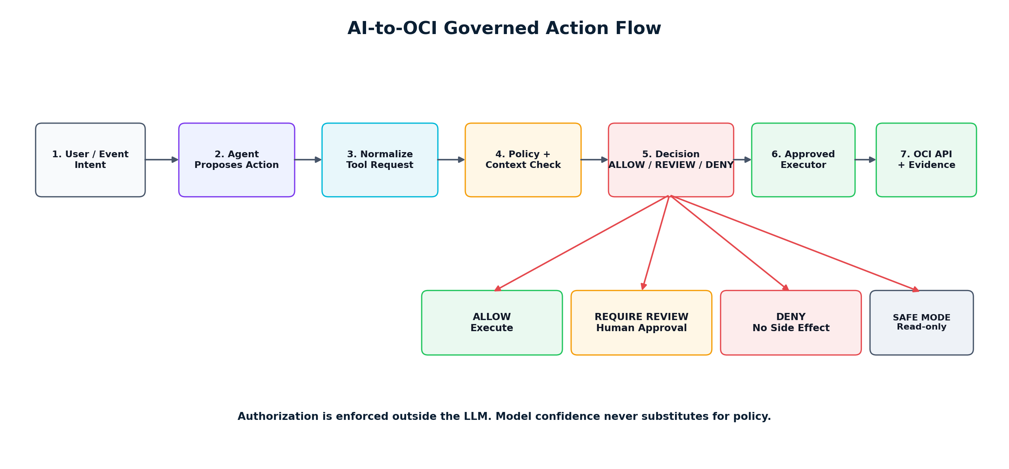
Figure 1 - Governed AI-to-OCI action flow.

1.4 Business opportunity
The proposed platform can be sold first as an “AI Tenancy Security Assessment,” then expanded into governance foundation, runtime enforcement and managed agentic security. This creates a productized extension of EbizonCloud’s existing OCI services instead of requiring a completely new route to market.

2. Market & Technology Due Diligence
What exists, what is missing, and where EbizonCloud should compete

2.1 Oracle-native capabilities
Capability | Oracle capability | Product implication
OCI IAM / Resource Principals | Agents and workloads can authenticate without long-lived user API keys [R6][R7]. | Use as the execution identity substrate; do not reinvent IAM.
OCI GenAI Guardrails | Content moderation, prompt injection detection and PII detection [R5]. | Integrate as model-layer protection; keep action authorization separate.
API Gateway + Authorizer | Request context can be passed to authorizer Functions for custom authorization [R8]. | Strong candidate PEP/ingress for an OCI-native action gateway.
OCI Audit | Records OCI API activity and identity/request metadata [R9]. | Correlate every approved action with actual OCI execution; detect bypass.
Security Zones | Deny operations that violate security-zone policy [R10]. | Treat as hard preventive infrastructure controls under the product.
Oracle Integration MCP Gateway | Centralized governed MCP access, tool filtering and observability [R4]. | Integrate where OIC is present; avoid duplicating Oracle’s integration-layer MCP governance.

2.2 Competitive landscape
Platform | Primary strength | Implication for EbizonCloud
Palo Alto Prisma AIRS | Broad AI security platform covering model/application/runtime and agentic threats [R13]. | Partner/coexist; differentiate on OCI action semantics, tenancy graph and change control.
Cisco AI Defense | AI supply chain, MCP/agent visibility and runtime protection [R14]. | Coexist; provide deeper OCI authorization and OCI-specific remediation.
Microsoft Defender for Cloud AI SPM | AI discovery, AI BOM and posture management [R15]. | Strong posture benchmark; avoid building generic CSPM-only product.
Wiz AI-SPM | Cloud-native AI posture for models, data and pipelines [R16]. | Use as competitive reference for visibility and attack-path UX.
SentinelOne Prompt Security | Agent/MCP discovery, gateway and policy enforcement [R17]. | Prompt/MCP protection can be integrated; do not rely on it for OCI-side authorization.
Check Point AI Security / Lakera | Prompt, data leakage and agent-behavior runtime protection [R18]. | Treat as pluggable model/agent guardrail capability.

Market whitespace hypothesis
Publicly documented offerings show strong horizontal AI-security coverage. The proposed whitespace is an OCI-native policy decision and execution layer that understands OCI IAM entitlements, OCIDs, compartments, tags, Terraform plans, Security Zones, Cloud Guard signals, workload identity and approved change context. This hypothesis should be validated through 8-12 design-partner interviews and competitive POCs before major investment.

2.3 Build / integrate / partner strategy
Area | Recommendation | Rationale
OCI entitlement graph | BUILD | Core differentiated OCI intelligence.
Agent registry / passport | BUILD | Core governance data model.
Action normalization + risk engine | BUILD | Core product IP.
Policy decision / OPA layer | BUILD on open source | Use OPA/Rego or equivalent; product IP is policy packs/context, not expression syntax.
Prompt injection / content safety | INTEGRATE | OCI Guardrails or partner products already address this.
Identity provider | INTEGRATE | Use OCI IAM/Identity Domains, Entra ID, Okta; do not become an IdP.
SIEM / ITSM | INTEGRATE | Splunk, Sentinel, ServiceNow/Jira are systems of record.
Cloud posture | INTEGRATE / AUGMENT | Consume Cloud Guard/Security Zones rather than replicate CSPM.

3. Problem Definition & Threat Model
The security boundary moves from “who can call OCI?” to “should this agent action be allowed now?”

3.1 Trust-boundary change
Traditional cloud security evaluates whether an authenticated principal can call an OCI API. Agentic systems add intent, delegation, tool choice, session context, source content, memory and autonomy. A valid credential may therefore be necessary but no longer sufficient to justify a side effect.
Key question
Should this AI agent be allowed to perform this specific operation, for this human or process, for this purpose, against this OCI resource, at this time, with this blast radius?

3.2 Priority threats
Threat | Example | Risk | Design response
Human credential inheritance | Coding/ops agent reads ~/.oci/config or environment keys | High | Block unrestricted user keys; issue bounded workload identity.
Over-privileged resource principal | Agent gets manage all-resources or broad family permissions | Critical | Entitlement graph + least privilege + action gateway.
Prompt / indirect prompt injection | Web page, document, ticket or log instructs agent to perform harmful action | High | Guardrail inspection + intent/action policy separation.
MCP tool abuse / supply chain | Unknown or compromised MCP server exposes privileged tool | Critical | MCP inventory, tool allowlist, provenance and gateway controls.
IAM privilege escalation | Agent edits IAM policy/dynamic group or creates new credential | Critical | Default deny / dual approval / protected executor separation.
Terraform manipulation | Agent writes IaC that opens ingress or destroys prod resource | Critical | Plan JSON analysis + policy + approval before apply.
Data exfiltration | Agent retrieves Object Storage, DB or Vault data to unapproved destination | Critical | Data classification + destination policy + network controls.
Runaway autonomy / loops | Agent repeatedly creates resources or calls costly tools | High | Budgets, rate limits, circuit breakers and safe mode.
Out-of-band bypass | Principal executes directly outside approved gateway | High | OCI Audit correlation and unmatched-change alerting.
Identity ambiguity | Audit shows a service/user but not the AI/human sponsor | High | Agent passport + delegation chain + execution evidence.

3.3 AGI-resilient design
The design should remain valid even as model capability increases. The stronger the model becomes, the more important it is that irreversible side effects remain behind deterministic, independently administered authorization. The product therefore assumes the agent can be highly capable—or even adversarial—and constrains capability through identity, tools, network reachability, policy, resource scope, approvals, budgets and execution credentials.

4. Product Vision & Positioning
Secure OCI actions, not merely AI conversations

4.1 Working product name
Recommended working name: “EbizonCloud OCI Agentic Security Control Plane.” Market-facing theme: “OCI Agentic Zero Trust.”

4.2 One-sentence value proposition
Value proposition
The OCI-native authorization and evidence layer that discovers autonomous agents, maps their effective cloud permissions, controls what they can change, requires human approval for high-impact operations, and proves every execution.

4.3 Do not position as
- A generic “LLM firewall.”
- A replacement for OCI IAM, Cloud Guard, Security Zones, Vault or SIEM.
- A new identity provider.
- A black-box AI model making security decisions.
- A platform that proxies all customer secrets and production prompts through EbizonCloud SaaS.

4.4 Position as
- An OCI-native AI/agent authorization control plane.
- A deterministic runtime enforcement layer for AI-generated OCI actions.
- An OCI AI-BOM and permission-graph platform.
- A governed execution and evidence layer for CloudOps, IaC and MCP tools.
- A productized extension of OCI landing-zone, security and managed-service engagements.

5. Product Design Principles
Security and architecture guardrails for the product itself

ID | Principle | Implementation consequence
P1 | No unrestricted production write credentials in AI agents | Agents propose; bounded executor identities execute approved actions.
P2 | Authorization outside the model | LLM reasoning may enrich context but may not be the ultimate authorization control.
P3 | Default deny for privilege and destructive actions | IAM, key/vault, security controls and destructive production actions require strong gates.
P4 | Customer-owned enforcement plane | Sensitive credentials, prompts and execution can remain inside customer OCI.
P5 | Every material side effect creates evidence | Decision, approval, executor and OCI request IDs must be linked.
P6 | Read-only discovery first | Customers can gain visibility before enabling blocking.
P7 | Policy-as-code and versioning | Every decision is reproducible against a specific policy version.
P8 | Safe degradation | If policy/approval services fail, privileged write actions fail closed or degrade to read-only.
P9 | Vendor-neutral guardrails | Prompt/model security is pluggable; the core product governs OCI actions.
P10 | Human governance for material risk | Human approval remains a deliberate control, not a UX afterthought.

6. Reference Architecture
Control plane + customer-owned enforcement plane

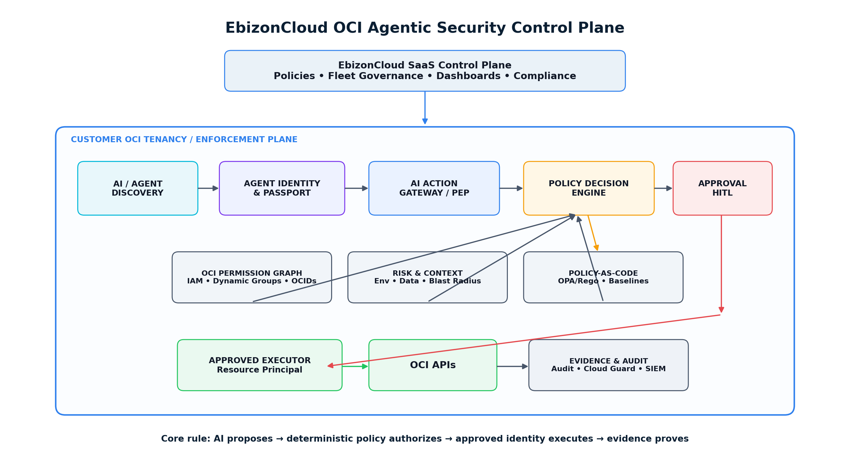
Figure 2 - Recommended logical architecture for OCI agentic security.

6.1 EbizonCloud SaaS control plane
- Tenant and project governance.
- Policy-pack lifecycle and version distribution.
- Fleet posture dashboards and cross-tenancy analytics using metadata only.
- Compliance mappings, reporting and evidence indexes.
- Product configuration, licensing and software update management.

6.2 Customer OCI enforcement plane
- AI/agent discovery collectors and entitlement graph ingestion.
- Agent registry and short-lived identity bindings.
- Action Gateway / Policy Enforcement Point (PEP).
- Policy Decision Point (PDP) with deterministic policy-as-code.
- HITL / change-management integration.
- Approved OCI executor identities using resource principals or short-lived delegated credentials.
- OCI Audit, Cloud Guard, Logging and SIEM correlation.
- Evidence store and immutable event archive.

6.3 Data flow
1. An agent proposes a typed action against an OCI resource or Terraform plan.
2. The action gateway validates agent identity, owner/delegation, tool provenance and request schema.
3. The PDP enriches the request with effective OCI permissions, environment, tags, data classification, resource dependencies, Security Zone status, blast radius and change-ticket context.
4. Policy returns ALLOW, REQUIRE_REVIEW, DENY or SAFE_MODE.
5. If approved, a bounded executor performs the OCI API call and records the OCI request identifier.
6. OCI Audit and Cloud Guard telemetry are correlated to the execution record; unmatched changes become bypass/drift findings.
7. Evidence is retained for incident reconstruction, audit and continuous policy improvement.

7. Core Product Modules
The minimum platform capabilities that create differentiation

ID | Module | Purpose
M1 | AI Asset Discovery | Discover agents, models, MCP servers, tool endpoints, Functions, OKE workloads, CI/CD identities and known AI API integrations.
M2 | OCI AI-BOM | Maintain a bill of materials linking agent, owner, model, framework, identity, tools, data sources, network paths and environment.
M3 | Agent Passport | Purpose, owner, allowed tools/actions, data boundaries, environment and approval requirements.
M4 | OCI Permission Graph | Calculate effective OCI permissions from principals, groups, dynamic groups, policy statements, compartments and resource context.
M5 | Action Gateway / PEP | Normalize agent/MCP/API requests into typed action envelopes; reject malformed or unregistered operations.
M6 | Policy & Risk Engine | Deterministic authorization based on action class, environment, data, blast radius, policy, ticket and approval.
M7 | HITL Approval | Bind an approval to the exact action hash, resource set, policy version and expiration.
M8 | Approved Executor | Perform only the approved operation using least-privilege OCI workload identity.
M9 | Terraform AI Defense | Inspect terraform plan JSON and proposed changes before merge/apply.
M10 | Audit / Bypass Detection | Correlate OCI Audit with approved execution records; detect out-of-band changes.
M11 | Response / Kill Switch | Revoke agent execution, disable tools, force read-only safe mode or isolate integrations.
M12 | Evidence & Compliance | Searchable evidence ledger, reports, policy mappings and incident timeline.

7.1 AI-BOM minimum schema
Domain | Example fields
Identity | agent_id, owner, sponsor, principal_ocid, authentication method, dynamic groups
Runtime | framework, version, model/provider, region, OKE/Function/host, endpoint
Tools | MCP servers, tool name, schema, provenance, destination, approval requirement
Access | IAM policies, effective permissions, compartments, resource types, target OCIDs
Data | sources, sensitivity, PII/regulated flags, egress destinations
Governance | purpose, environment, risk tier, policy pack, approval policy, expiration
Telemetry | last seen, actions, denied actions, incidents, evidence completeness

7.2 Agent Passport example
agent_id: finops-agent-prod
owner: cloud-platform-team
environment: production
purpose: [analyze_cost, recommend_savings]
allowed_actions: [read_compute, read_usage, create_recommendation]
prohibited_actions: [delete_resource, modify_iam, modify_network, retrieve_secret]
approval:
write_operations: required
iam_or_vault: dual_approval
max_session_minutes: 30

8. Runtime Authorization & Risk Model
How the platform makes deterministic decisions

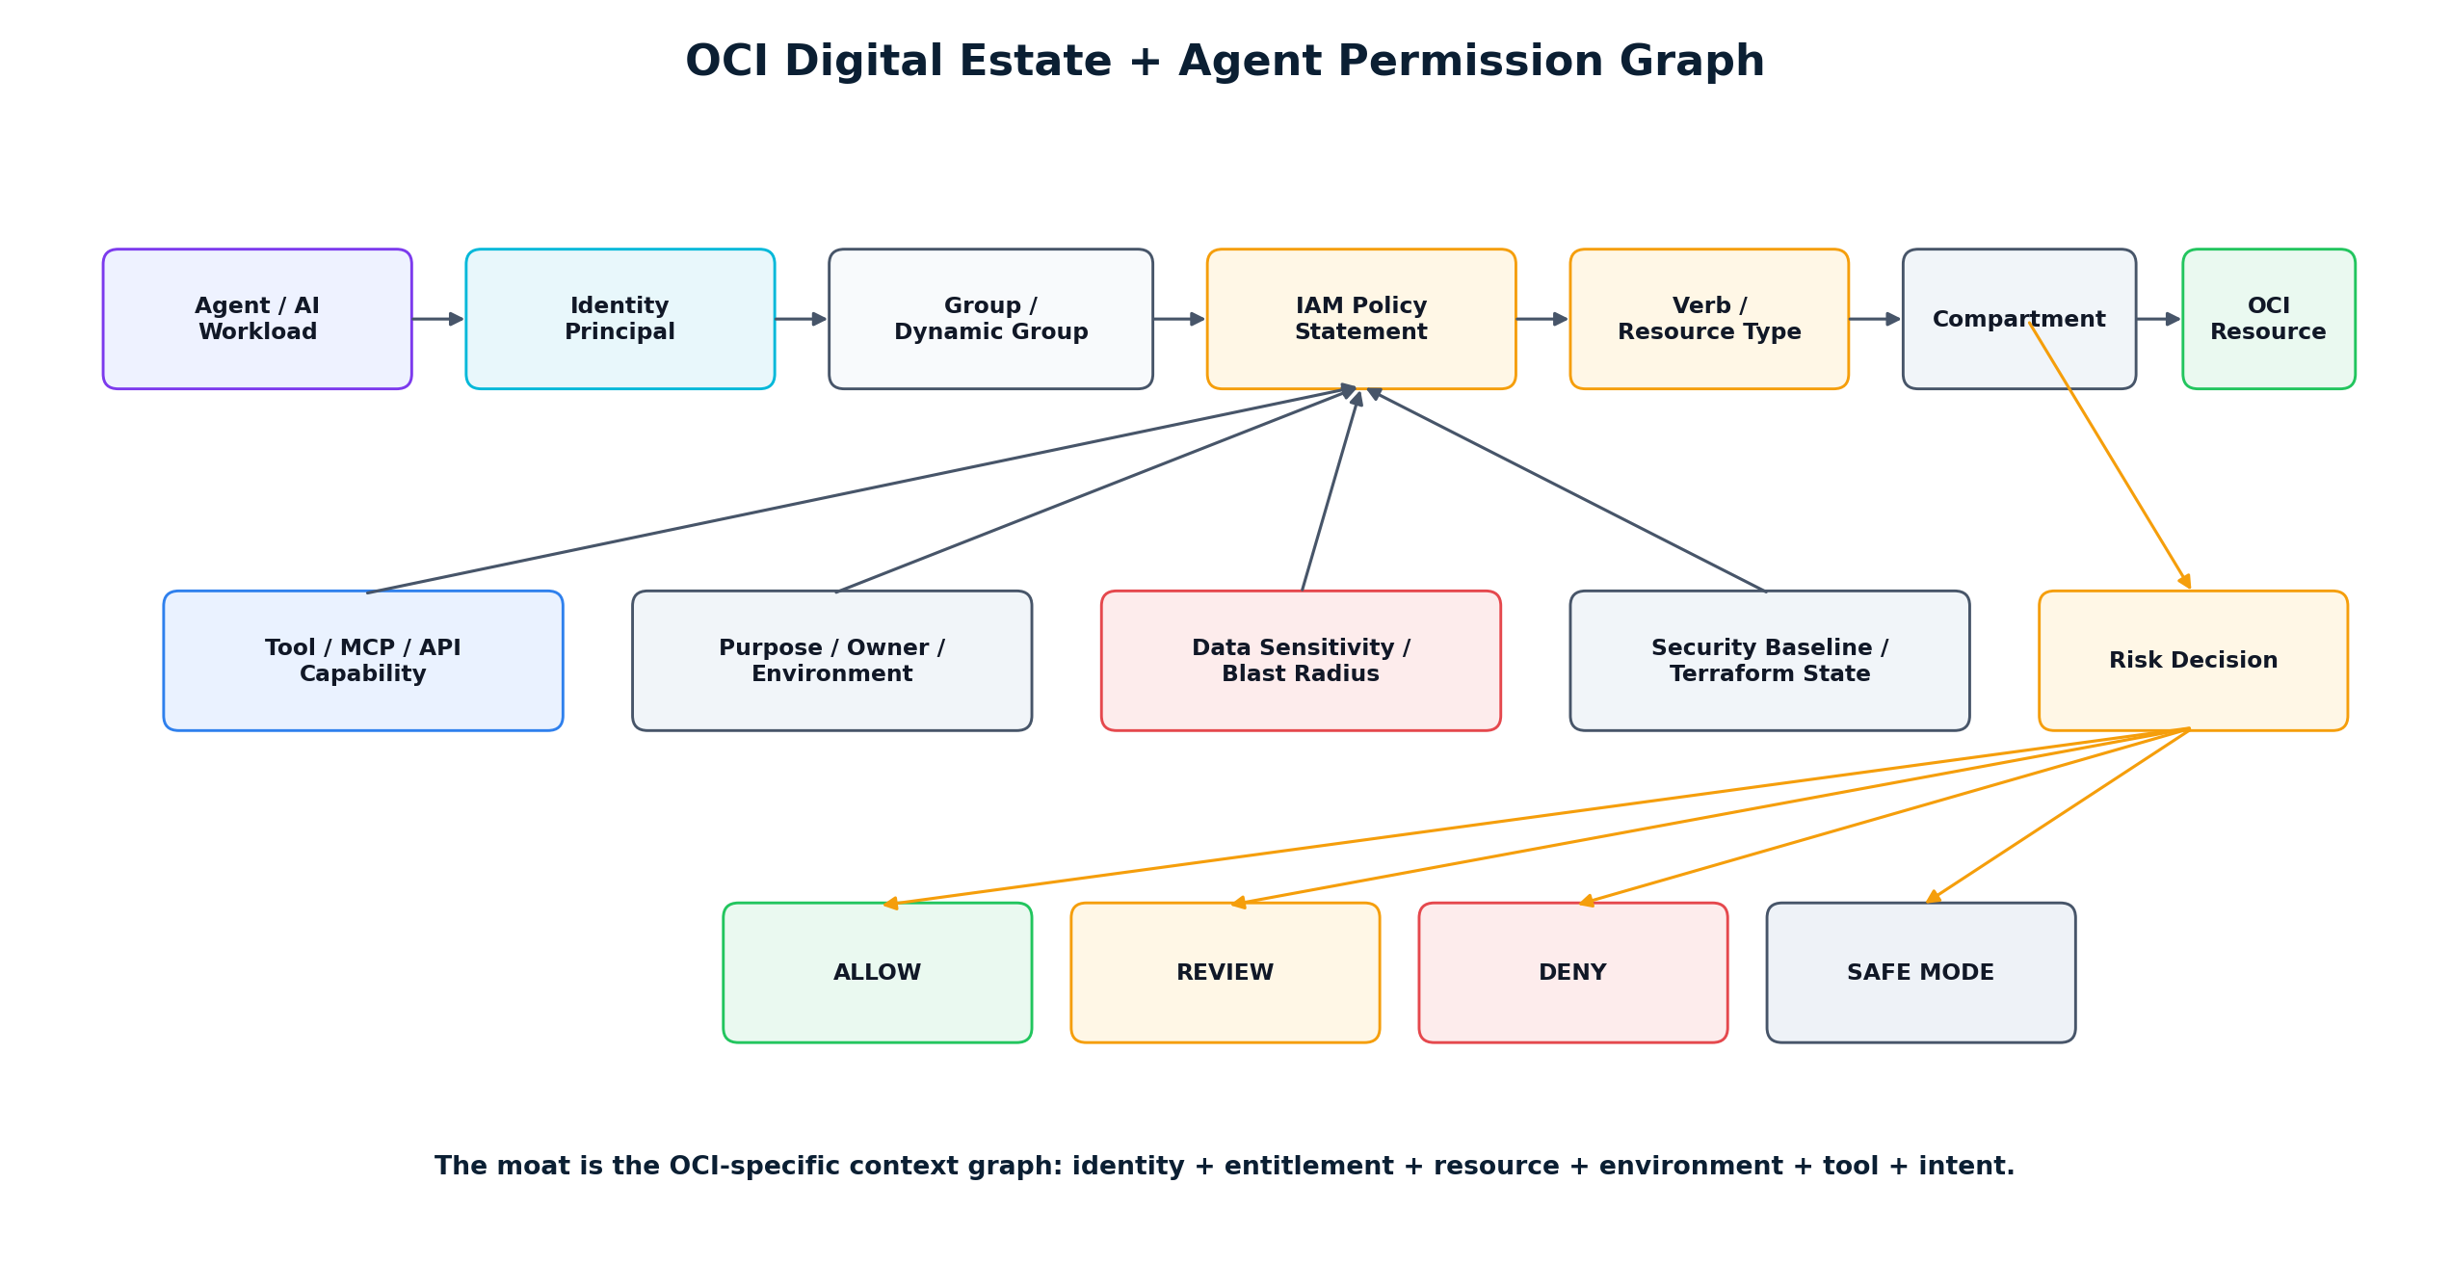
Figure 3 - OCI permission and resource context graph.

8.1 Policy decision envelope
Decision input | Examples
Agent identity | agent_id, owner, trust state, attestation, deployment, last risk assessment
Delegated human/process | requestor, role, ticket, approval authority, session
Tool provenance | registered MCP server, signed tool metadata, allowed schema, tool version
Action | OCI API operation, HTTP method, Terraform resource action, requested side effect
Target | resource OCID, type, compartment, tags, environment, security-zone membership
Effective permission | current OCI IAM permission path and privilege level
Risk context | data sensitivity, internet exposure, destructive change, blast radius, cost impact
Change governance | maintenance window, ServiceNow/Jira record, approval state, emergency flag
Security telemetry | Cloud Guard findings, suspicious session, rate/loop anomaly, guardrail signals

8.2 Decision outcomes
Outcome | Meaning | Example
ALLOW | Execution can proceed through bounded executor. | Read-only list/get or approved low-risk dev operation.
REQUIRE_REVIEW | Action is blocked pending explicit approval. | Production network/database mutation.
DENY | Action is not permitted under policy. | Internet SSH to production; privilege escalation; unapproved secret export.
SAFE_MODE | Agent can continue in reduced capability mode. | Policy service degraded; allow read-only diagnostics only.

8.3 OCI action risk tiers
Tier | Typical action | Default control
R0 | List/Get/Inspect | Allow + log + rate limit.
R1 | Low-risk development operation | Allow if agent passport and environment policy match.
R2 | Create/update non-prod infrastructure | Policy + evidence + bounded executor.
R3 | Production network/database/workload mutation | Human approval; change ticket; blast-radius check.
R4 | IAM, Vault, security-policy, key or identity changes | Dual approval or designated security approver; time-bounded executor.
R5 | Destructive/high-blast-radius action | Default deny for autonomous execution; break-glass human procedure.

9. Terraform / IaC Defense
Make AI-authored infrastructure safe before it becomes OCI infrastructure

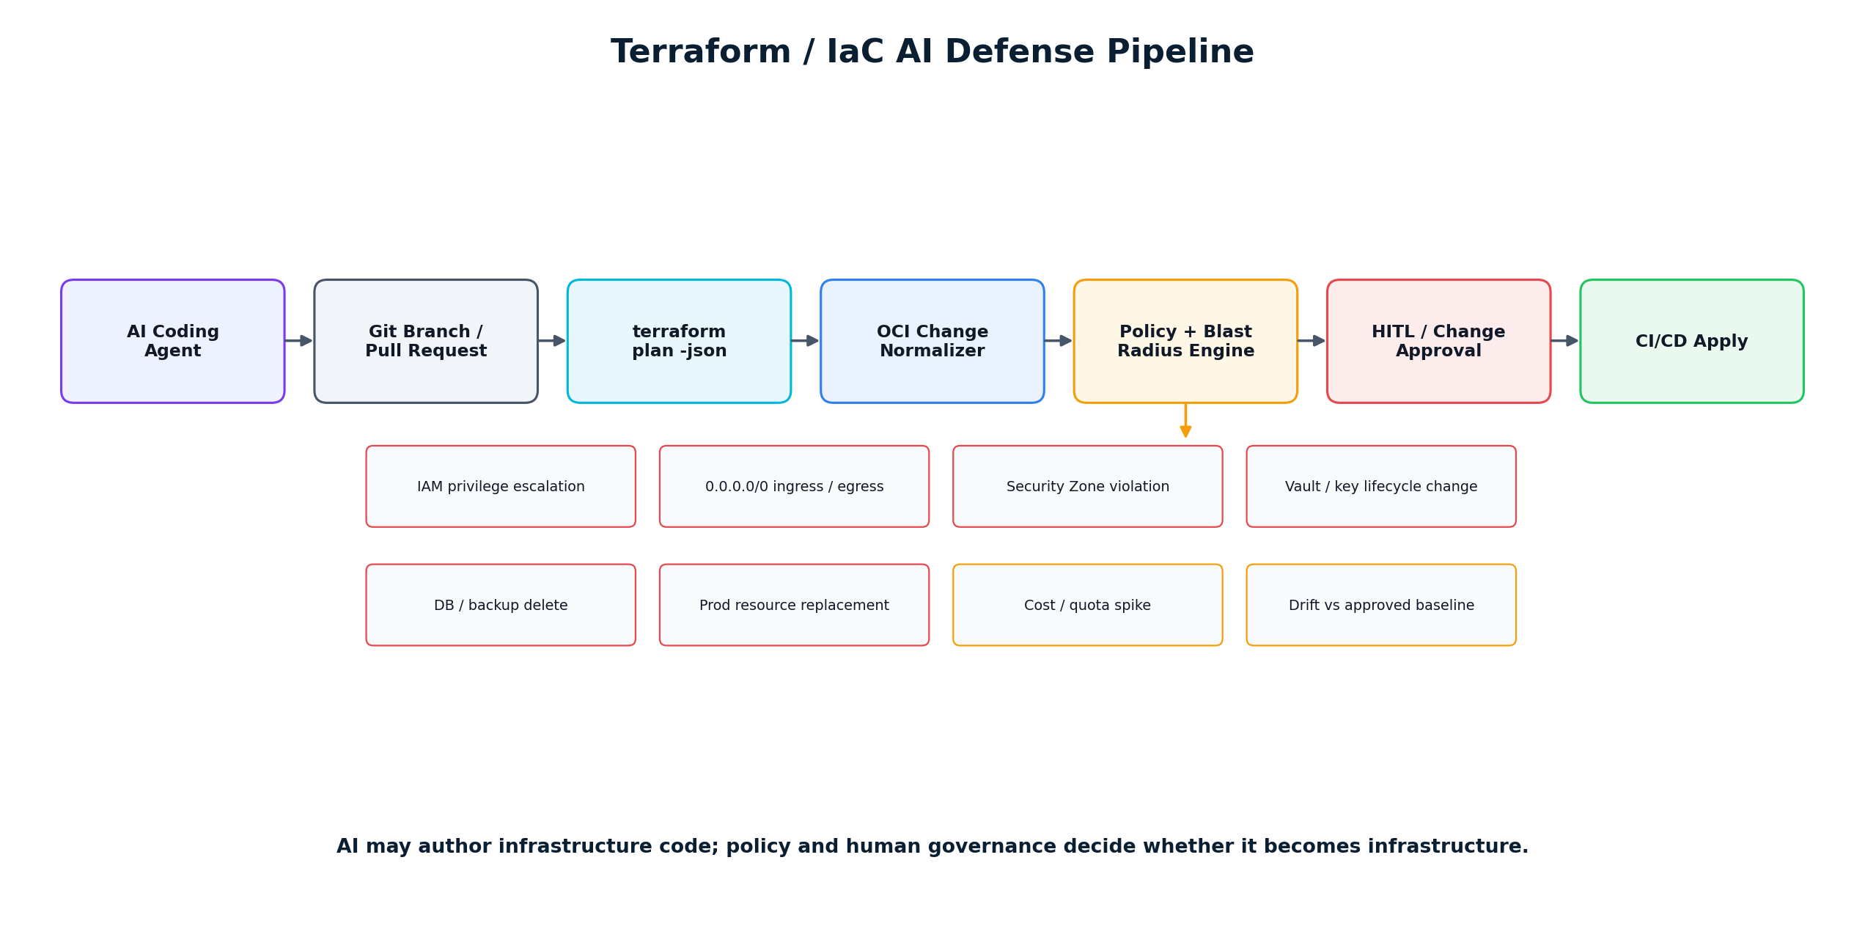
Figure 4 - Terraform / IaC AI defense pipeline.

9.1 Required checks
- IAM policy or dynamic-group privilege expansion.
- Ingress/egress expansion, especially 0.0.0.0/0 and sensitive ports.
- Route, DRG, gateway, NSG or security-list changes that alter trust boundaries.
- Public endpoint enablement for databases or storage.
- Security Zone or encryption baseline violation.
- Vault/key lifecycle changes and secret exposure.
- Destroy/replace operations for production databases, storage, networking and backups.
- Tag/environment mismatches and creation outside approved compartments.
- Blast radius based on graph dependencies, not merely resource count.
- Cost/quota anomalies and resource proliferation.
- Drift from approved landing-zone baseline.

9.2 Git workflow
1. AI agent creates or updates Terraform on a feature branch.
2. CI executes validate, fmt, security scanning and terraform plan -json.
3. Plan is normalized into OCI action objects.
4. Policy engine evaluates each action and aggregate blast radius.
5. High-risk findings block merge or require security/cloud architecture approval.
6. Approved PR merges; protected CI/CD identity applies plan.
7. OCI Audit is correlated back to commit, plan and approval evidence.

10. Detection, Audit & Response
Catch bypasses and contain abnormal agent behavior

10.1 Bypass detection
The runtime gateway is strongest when privileged production write paths are technically constrained to the approved executor. Where direct API access still exists, OCI Audit should be continuously reconciled against execution IDs. An OCI API change with no matching approved action becomes an out-of-band finding [R9].
Signal | Correlation | Response
OCI Audit write event | No execution_id / change_id match | Create high-severity bypass finding; notify SOC/CloudOps.
Cloud Guard critical problem | Agent or executor involved | Freeze agent writes; require investigation.
Repeated policy denials | Same session/agent/tool | Rate-limit, disable tool or safe-mode session.
Unexpected destination / egress | Data classification + network logs | Block egress path; revoke execution token.
Privilege graph expansion | New IAM policy/dynamic-group capability | Require review; compare to baseline; potential rollback.
Budget / loop threshold | High tool-call count or resource creation rate | Circuit-breaker and session termination.

10.2 Agentic OCI kill switch
Kill switch behavior
Deny AI-originated OCI writes, IAM changes, network mutation, data export, secret retrieval and privileged MCP tools; keep approved human break-glass administration available; preserve read-only diagnostics where safe.

10.3 Prompt / model security
Prompt, jailbreak, PII and agent-behavior defenses remain important, but they should be pluggable upstream signals rather than the sole security boundary. OCI GenAI Guardrails can cover content moderation, prompt injection and PII [R5]; third-party platforms can provide additional MCP/agent runtime inspection [R13][R14][R17][R18].

11. Deployment & Integration Architecture
Customer-sensitive execution stays inside OCI

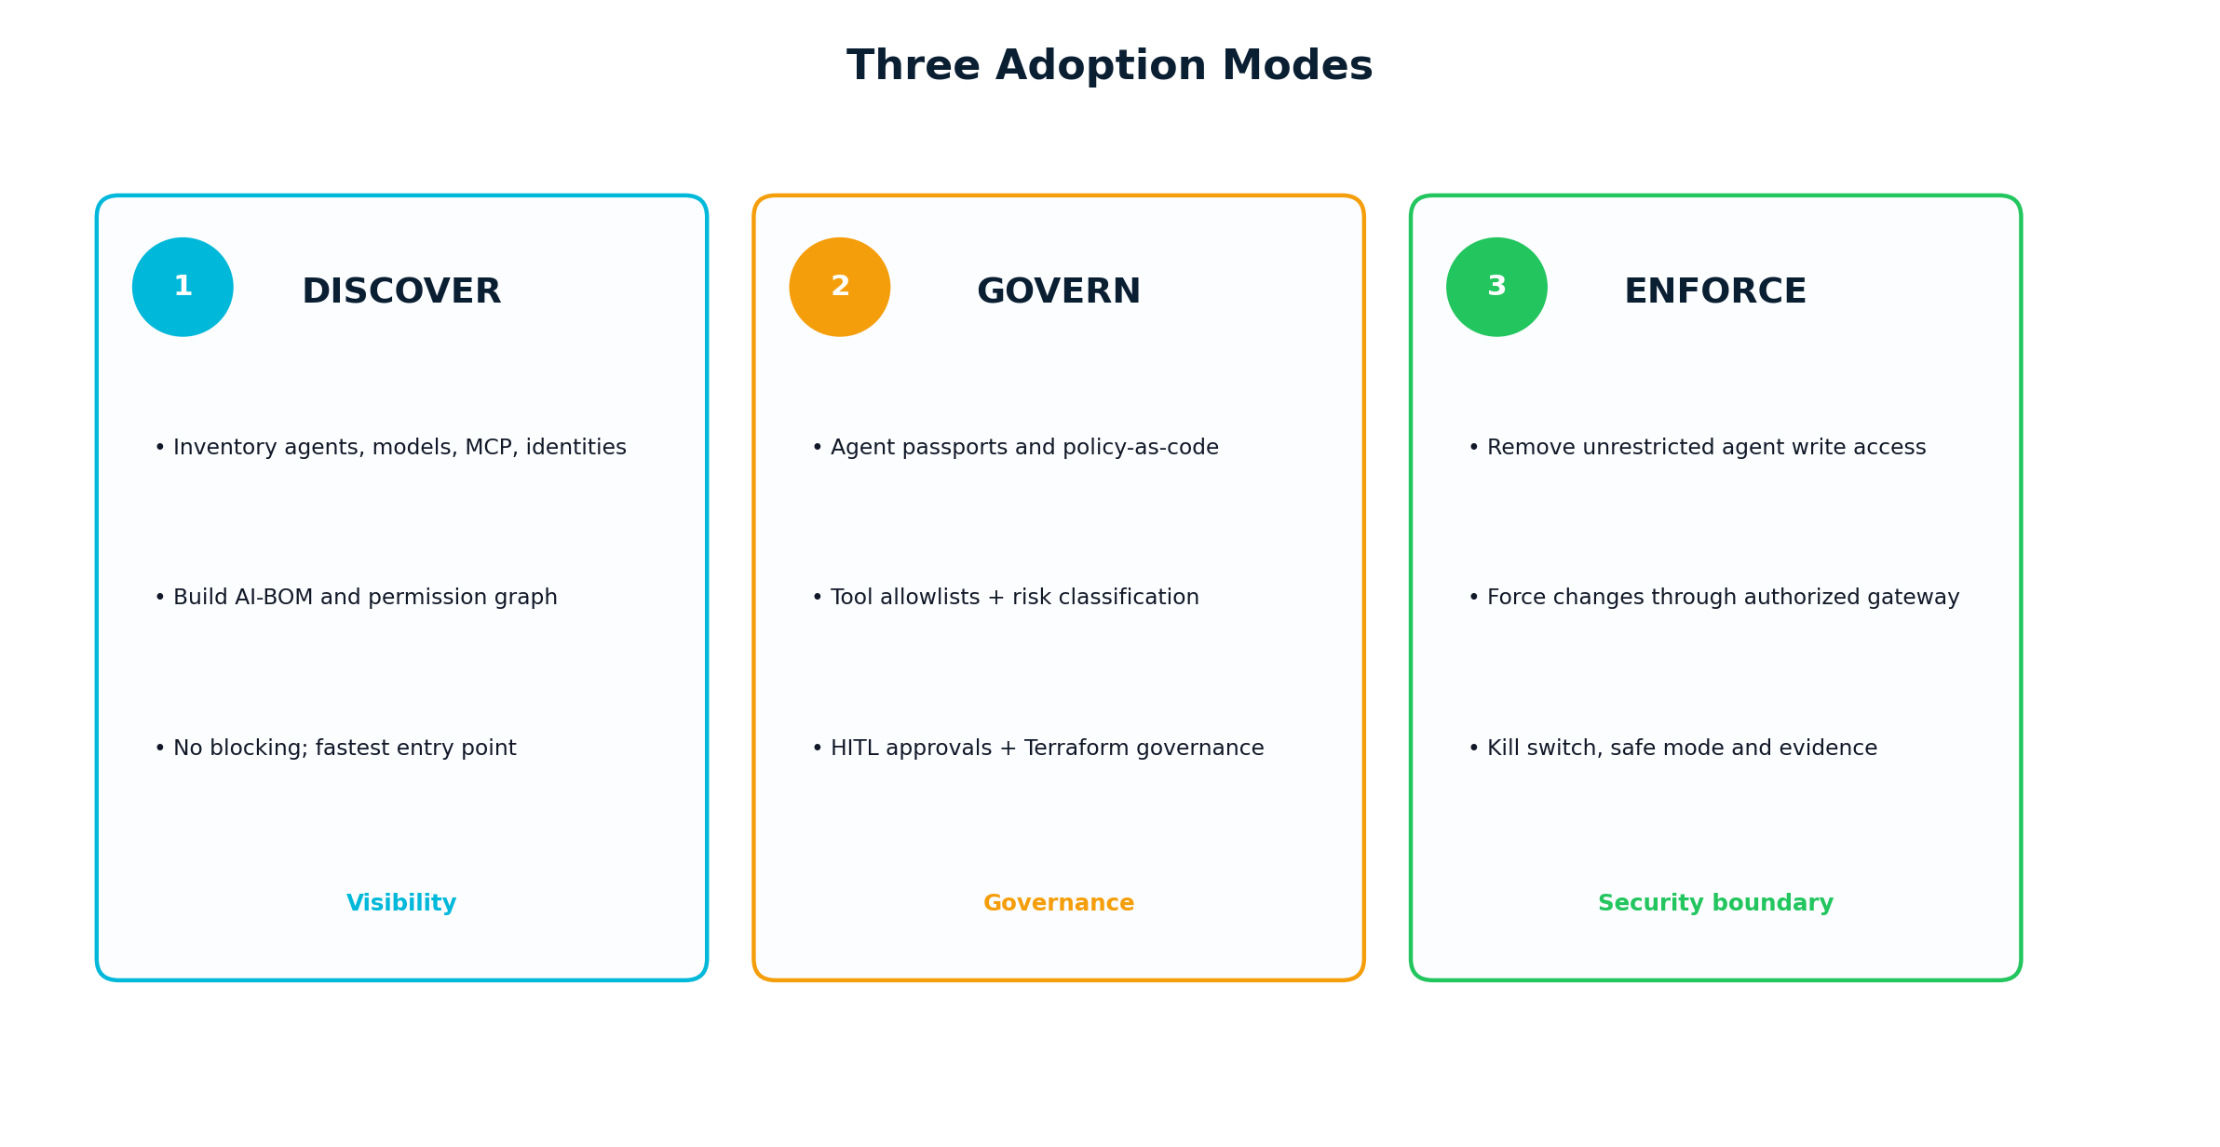
Figure 5 - Adoption model: Discover → Govern → Enforce.

11.1 Recommended deployment pattern
- EbizonCloud SaaS receives configuration metadata, policy versions and summarized posture—not customer OCI private keys.
- Customer OCI tenancy hosts the enforcement gateway, policy cache/PDP, executor, Vault integration, event processing and evidence data as required by policy.
- Use Resource Principals for Functions/OKE workloads wherever possible; avoid long-lived user API keys [R7].
- Use private endpoints, NSGs, Service Gateway/OCI Services Network and ZPR where appropriate to reduce egress and lateral reach.
- Integrate with customer Entra ID/Okta/OCI Identity Domains for human approval identity; do not duplicate enterprise identity.

11.2 Reference technology stack
Layer | Recommended technologies
Web / UX | React / Next.js; role-based views for CISO, CloudOps, SecOps, Platform Engineering.
Service APIs | FastAPI / Node.js; OpenAPI schemas; signed action envelopes.
Policy engine | OPA/Rego or equivalent deterministic policy engine; signed/versioned policy packs.
Graph / metadata | PostgreSQL + graph extension or graph store; object/resource index; Redis cache.
OCI integration | OCI Python/Go SDKs, Search, IAM, Audit, Cloud Guard, Events, Logging, Streaming.
Enforcement | OCI API Gateway, Functions or OKE; optional OIC MCP Gateway integration [R4][R8].
Secrets / identity | OCI Vault, resource principals, Identity Domains, Entra ID, Okta.
Evidence | Autonomous Database/PostgreSQL + Object Storage immutable retention strategy.
DevSecOps | GitHub/GitLab/ADO, Terraform/OpenTofu, Terraform Cloud/Enterprise integration.
SIEM/ITSM | Splunk, Microsoft Sentinel, ServiceNow/Jira via supported APIs/connectors.

12. User Experience & Operations
The dashboard should answer six questions in under one minute

# | Question | UX answer
1 | What AI is operating in my OCI tenancy? | Agent count, shadow/unknown integrations, MCP servers, last-seen status.
2 | What can each agent access? | Permission graph: Agent → Identity → Policy → Resource.
3 | What can it change? | Read/write/delete/administrative capability by OCI service and environment.
4 | Which permissions are dangerous? | Critical/high findings based on effective privilege and context.
5 | What has the agent actually done? | Session/action timeline joined to OCI Audit and approvals.
6 | Can I stop it? | Disable agent execution, revoke tools, safe mode, kill switch.

12.1 Persona views
Persona | Primary view
CISO / Security Leadership | AI estate exposure, critical risks, incidents, policy coverage, evidence completeness.
Cloud Platform / OCI Architect | Effective permissions, OCI resource context, drift, Terraform change risk.
SecOps / SOC | Runtime events, denied actions, bypass alerts, tool anomalies, containment actions.
Application / AI Engineering | Agent passport, approved tools, policy test simulator, integration SDK/MCP guidance.
Auditor / Risk | Immutable evidence, approval chain, policy version, compliance mapping, exportable reports.

13. Compliance & Evidence
Make agentic cloud change auditable by design

13.1 Evidence ledger
- Execution ID
- Agent ID and version
- Model/provider where relevant
- Human sponsor/requestor
- Session / delegation chain
- Prompt/context hash (not necessarily raw prompt)
- Tool / MCP server and version
- Requested OCI operation
- Target OCIDs and compartments
- Environment and data classification
- Policy version and risk tier
- Decision and reason codes
- Approval identity, scope and expiry
- Executor principal
- OCI request ID / Audit correlation
- Outcome / rollback reference
- Timestamp and evidence integrity metadata

13.2 Framework mappings
Framework | How the product contributes
OWASP Agent Control Standard / Agentic Security | Agent identity, tool controls, runtime enforcement, approvals and evidence [R11][R12].
NIST AI RMF / GenAI Profile | Govern/map/measure/manage support via inventory, risk, monitoring and control evidence [R19].
CIS OCI / OCI Landing Zone | Enforce approved infrastructure, network, IAM and security baselines.
SOC 2 / ISO 27001 | Access control, change management, logging, incident evidence and segregation of duties.
PCI / HIPAA / regulated workloads | Data boundary and environment policies, evidence, least privilege and egress controls; customer-specific mapping required.

Important
The product can provide technical control evidence and policy enforcement, but it does not itself make an organization “compliant.” Compliance claims must remain scoped to implemented customer controls, processes and independent assessment.

14. MVP Roadmap & Engineering Plan
Build differentiation first; integrate commodity security functions

Phase | Focus | Scope | Commercial outcome
MVP 1 | OCI AI Security Discovery | OCI onboarding, IAM/policy parser, dynamic groups, principals, GenAI inventory, MCP/agent registry import, initial AI-BOM, permission graph, risk dashboard. | Sellable assessment + design-partner validation.
MVP 2 | Agent & MCP Governance | Agent Passport, tool catalog, tool risk, signed registry, policy simulator, approval matrix. | Governance foundation.
MVP 3 | Runtime Action Gateway | PEP/PDP, action schemas, OPA policies, HITL, bounded executor, evidence ledger, OCI Audit correlation. | True enforcement product.
MVP 4 | Terraform AI Defense | Plan JSON normalization, OCI blast-radius checks, GitHub/GitLab gates, PR evidence. | Cloud engineering differentiation.
MVP 5 | Autonomous Response | Behavior/loop anomaly, kill switch, safe mode, auto-containment playbooks. | Managed security / SOC integration.

14.1 Initial product engineering workstreams
Workstream | Key deliverables
OCI Connector | Tenancy onboarding, compartment/resource inventory, IAM policies, principals, tags, Audit integration.
Permission Graph | Parser, effective privilege evaluation, graph model, blast-radius relationships.
Agent Registry | Agent passport schema, lifecycle, owners, tools, identity mapping, attestations.
Action Contract | Canonical JSON schema for OCI/MCP/Terraform actions and risk metadata.
Policy Engine | Policy packs, reason codes, test harness, simulator, fail-closed/safe-mode logic.
Executor | Bounded resource-principal execution, idempotency, request signing, rollback hooks.
Evidence | Event schema, correlation, retention, integrity, report exports.
UX | Executive posture, permission graph, action timeline, policy simulator, approval inbox.
SDK / MCP | Python/TypeScript SDK, LangGraph middleware, MCP proxy/adapter, CI/CD hooks.

15. Commercial Packaging & Go-to-Market
Lead with assessment, expand into enforcement and managed service

Offer | Commercial form | Outcome
1. AI Tenancy Security Assessment | 2-4 week fixed-scope engagement | AI-BOM, permission graph, excessive agency findings, MCP/tool exposure, credential posture, Terraform/agent risk and target architecture.
2. AI Governance Foundation | Implementation project | Agent registry/passports, identity design, policy packs, approval model, monitoring integrations and landing-zone guardrails.
3. Runtime Enforcement Platform | Subscription + implementation | Action gateway, policy engine, bounded executor, evidence ledger, Terraform gates and kill switch.
4. Managed Agentic Security for OCI | Recurring managed service | 24x7/extended monitoring, policy maintenance, new-agent detection, drift, incident response and quarterly assessments.

15.1 Ideal design-partner profile
- Existing OCI estate with mature IAM and Terraform.
- Beginning to deploy GenAI agents, coding agents, MCP or autonomous CloudOps.
- Has production change-control requirements and a security team willing to co-design policy.
- Needs evidence for regulated or audited operations.
- Willing to run Discover mode before enforcement.

16. Differentiation, Moat & Key Risks
Protect the thesis from commoditization

16.1 Proposed moat
- OCI-specific permission graph and policy semantics.
- OCI Digital Estate Graph linking identity, resources, environment, network, data and dependencies.
- High-quality OCI action-risk catalog and policy packs built from real engineering operations.
- Terraform + OCI runtime correlation in one authorization/evidence model.
- Customer-owned enforcement plane suitable for regulated Oracle estates.
- OCI engineering services and managed operations that shorten enterprise adoption.

16.2 Strategic risks and mitigations
Risk | Impact | Mitigation
Oracle expands governed-execution/MCP security rapidly | High | Integrate and add OCI estate graph / multi-tool action governance rather than competing with Oracle primitives.
Horizontal vendors add deep OCI support | High | Move quickly on OCI-specific entitlement/action semantics and services-led design partners.
Customers resist runtime proxy / latency | Medium | Start Discover/Govern modes; use local policy cache, signed envelopes and fast-path decisions.
Too many false positives | High | Deterministic reason-coded policies, simulation mode, baseline learning, risk tiering and staged enforcement.
Agent identification incomplete | High | Combine explicit registration, workload identity, CI/CD metadata, Audit heuristics and MCP/tool discovery.
Security product itself becomes privileged target | Critical | Customer-owned enforcement, minimal SaaS secrets, hard tenant isolation, signed policies, immutable evidence, independent security review.

17. Recommended 90-Day Action Plan
Validate the category before scaling engineering spend

Window | Workstream | Deliverable
Days 1-15 | Product discovery | Interview 8-12 OCI customers/SIs/CISOs; map AI/agent use cases, authorization pain points and willingness to deploy enforcement. Define top 25 OCI high-risk actions.
Days 16-30 | Technical spike | Build OCI IAM/policy parser, principal inventory and initial permission graph; ingest Audit events; prototype agent passport.
Days 31-45 | Discovery MVP | AI-BOM dashboard, risk scoring, agent/identity/resource views; package a fixed-fee assessment.
Days 46-60 | Policy prototype | Canonical action envelope, OPA/Rego policies, policy simulator; Terraform plan JSON ingestion and two GitHub gates.
Days 61-75 | Runtime POC | API Gateway/Function or OKE PEP, approval flow, bounded executor, execution evidence and Audit correlation.
Days 76-90 | Design-partner pilot | Run in Discover then Govern mode in 1-2 OCI tenancies; measure policy coverage, false positives, latency and customer acceptance.

17.1 Pilot success metrics
- >95% of registered agent actions attributable to a unique agent and human/process sponsor.
- 100% of high-risk OCI write actions receive a deterministic policy decision.
- 100% of enforced executions link to an OCI request/audit record.
- Zero autonomous R4/R5 operations without required approval.
- <100 ms target for cached fast-path policy evaluation (excluding external approval).
- <5% false-positive rate for high-severity policy findings after tuning.
- Demonstrated kill-switch / safe-mode drill and successful incident reconstruction.

Appendix A. Example Policy Patterns
Illustrative policy logic—not production-ready rules

A.1 Production SSH exposure
DENY when:
environment == "PROD"
action in ["CreateSecurityList", "UpdateSecurityList", "UpdateNSG"]
protocol == "TCP"
destination_port == 22
source_cidr == "0.0.0.0/0"
reason: "Public SSH to production is prohibited"

A.2 IAM privilege change
REQUIRE_REVIEW when:
service == "IAM"
action modifies [policy, dynamic_group, group_membership, api_key]
environment in ["PROD", "SHARED"]
approvers: [CloudSecurity, OCIPlatformOwner]
execution_ttl: 15m

A.3 Out-of-band change
ALERT when:
OCI_AUDIT.event is write_operation
AND no matching approved_execution_id exists within correlation_window
actions:
- create_incident
- notify_cloudops_secops
- optionally place affected agent/executor in SAFE_MODE

Appendix B. Research References
Selected primary/official sources reviewed for this strategy

Research basis: public product/documentation information available as of 2 October 2026. Vendor capabilities evolve rapidly; validate licensing, availability, OCI coverage and roadmap through formal vendor RFI/POC before procurement decisions.
[R1] EbizonCloud. OCI engineering, landing zone, managed cloud and AI services positioning. https://www.ebizoncloud.com/
[R2] Oracle - Building Trustworthy AI at Oracle. Governed Execution pattern: runtime controller, policy engine, tool gateway, approvals, budgets and evidence. https://blogs.oracle.com/ai-and-datascience/building-trustworthy-ai-at-oracle
[R3] Oracle - From Model Safety to Runtime Governance. Runtime verification of tool permissions, delegated authority, approvals, budgets and evidence. https://blogs.oracle.com/ai-and-datascience/runtime-governance-enterprise-agentic-ai
[R4] Oracle - Integration MCP Gateway. Governed MCP path with centralized identity, policy, credential, enforcement, observability and tool filtering. https://blogs.oracle.com/integration/introducing-oracle-integration-mcp-gateway-governed-access-for-enterprise-ai-agents
[R5] Oracle OCI Generative AI Guardrails. Content moderation, prompt-injection detection and PII detection. https://docs.oracle.com/en-us/iaas/Content/generative-ai/guardrails.htm
[R6] Oracle OCI Generative AI Agents - API Endpoint Calling Tool Guidelines. OCI resource principal authentication and x-requires-approval human confirmation signal. https://docs.oracle.com/en-us/iaas/Content/generative-ai-agents/api-calling-tool-guidelines.htm
[R7] Oracle OCI Generative AI Authentication. OAuth 2.0 and resource principal authentication without long-lived user API keys. https://docs.oracle.com/en-us/iaas/Content/generative-ai/aurthentication.htm
[R8] Oracle OCI API Gateway Authorizer Functions. Custom authentication/authorization using request context and OCI Functions. https://docs.oracle.com/en-us/iaas/Content/APIGateway/Tasks/apigatewayusingauthorizerfunction.htm
[R9] Oracle OCI Audit. Audit records for OCI API operations and identity/request metadata. https://docs.oracle.com/en-us/iaas/Content/Audit/home.htm
[R10] Oracle OCI Security Zones. OCI prevents create/update operations that violate security-zone policies. https://docs.oracle.com/en-us/iaas/Content/security-zone/using/security-zones.htm
[R11] OWASP Agent Control Standard (ACS). Open control standard for securing agentic systems and runtime enforcement. https://genai.owasp.org/resource/agent-control-standard-acs/
[R12] OWASP Agentic Security Initiative. Agentic AI risks and security guidance including MCP and autonomous agents. https://genai.owasp.org/initiatives/agentic-security-initiative/
[R13] Palo Alto Networks Prisma AIRS. AI application, model, runtime and agentic threat protection. https://www.paloaltonetworks.com/ai-security/prisma-airs
[R14] Cisco AI Defense. AI supply-chain, agentic AI and MCP runtime visibility and control. https://www.cisco.com/c/en/us/products/collateral/security/ai-defense/ai-defense-ds.html
[R15] Microsoft Defender for Cloud - AI Security Posture. AI workload discovery, AI BOM and posture management. https://learn.microsoft.com/en-us/azure/defender-for-cloud/ai-security-posture
[R16] Wiz AI Security Posture Management. AI model, data and pipeline posture across cloud environments. https://www.wiz.io/solutions/ai-spm
[R17] SentinelOne Prompt Security - Agentic AI Security. Agent/MCP discovery, MCP gateway and risk-based policy controls. https://www.sentinelone.com/platform/prompt-security-agentic-ai-security/
[R18] Check Point AI Security / Lakera - AI Agent Security. Runtime prompt, data leakage and agent behavior protection. https://docs.lakera.ai/guard
[R19] NIST AI RMF: Generative AI Profile. Risk-management profile for generative AI. https://www.nist.gov/publications/artificial-intelligence-risk-management-framework-generative-artificial-intelligence

AI proposes. Policy authorizes. Humans govern. OCI executes. Evidence proves.
EbizonCloud OCI Agentic Security Control Plane

