OCI IAM with Microsoft Entra ID
SSO, Lifecycle Management and JIT Provisioning Tutorials
Step-by-step instructions for integrating Oracle Cloud Infrastructure Identity and Access Management (identity domains) with Microsoft Entra ID (formerly Azure AD) for single sign-on, identity lifecycle management and Just-In-Time provisioning.
Service provider | OCI IAM with Identity Domains
Identity provider | Microsoft Entra ID (formerly Azure AD)
Protocols | SAML 2.0 (SSO, JIT); SCIM / app-catalog connectors (provisioning)
Tutorials | SSO; Identity Lifecycle Management (3 methods); JIT Provisioning
Source | Oracle Cloud Infrastructure documentation
Table of Contents
1. Introduction 6
1.1 Tutorials in This Document 6
1.2 Solution Architecture 6
2. SSO Between OCI and Microsoft Entra ID 8
2.1 Overview 8
2.2 Before You Begin 9
2.3 Task 1: Get the Service Provider Metadata from OCI IAM 9
2.4 Task 2: Create an Entra ID Enterprise Application 11
2.5 Task 3: Set Up Single Sign-On for the Entra ID Enterprise App 11
2.6 Task 4: Edit Attributes and Claims 12
2.6.1 Additional Entra ID Configurations 13
2.7 Task 5: Add a Test User to the Entra ID Application 14
2.8 Task 6: Enable Entra ID as IdP for OCI IAM 15
2.9 Task 7: Test SSO Between Entra ID and OCI 16
2.10 What's Next 18
3. Identity Lifecycle Management Between OCI IAM and Entra ID 19
3.1 Overview 19
3.2 Before You Begin 20
4. LCM Tutorial 1: Entra ID as Authoritative Source Using the Entra ID Gallery Application 21
4.1 Overview 21
4.2 Task 1: Create a Confidential Application 21
4.3 Task 2: Find the Domain URL and Generate a Secret Token 24
4.4 Task 3: Create the OCI Application on Entra ID 25
4.5 Task 4: Assign Users and Groups to the Entra ID Application 27
4.6 Additional Configurations for Federated Users 30
4.6.1 Setting Users' Federated Status 31
4.6.2 Disable Notifications for Account Creation or Updates 32
5. LCM Tutorial 2: Entra ID as Authoritative Source Using the OCI IAM Application Catalog 36
5.1 Overview 36
5.2 Task 1: Create an App in OCI IAM for Entra ID 36
5.3 Task 2: Import Users from Entra ID to IAM 38
6. LCM Tutorial 3: OCI IAM as Authoritative Source to Manage Identities in Entra ID 39
6.1 Overview 39
6.2 Task 1: Add MS Office 365 as an App in OCI IAM 39
6.3 Task 2: Assign Users to the MS Office 365 App 40
7. JIT Provisioning from Entra ID to OCI IAM 42
7.1 Overview 42
7.2 Before You Begin 43
7.3 Task 1: Configure SAML Attributes Sent by Entra ID 43
7.3.1 Additional Entra ID Configurations 44
7.4 Task 2: Configure JIT Attributes in OCI IAM 45
7.5 Task 3: Test JIT Provisioning Between Entra ID and OCI 50
7.6 What's Next 52
Appendix A. References 53
A.1 Key Endpoints and Values 53
List of Figures
Figure 1: Integration architecture between OCI IAM and Microsoft Entra ID 7
Figure 2: SSO configuration workflow across OCI IAM and Entra ID 8
Figure 3: SAML metadata exchange between OCI IAM and Entra ID 9
Figure 4: Configure client access on the Domain Settings page 10
Figure 5: Domain information showing the Domain URL 11
Figure 6: The Entra ID SAML-based SSO page 12
Figure 7: Entra ID attributes and claims 13
Figure 8: Filter groups in the Entra ID group claim 14
Figure 9: SAML identity provider attribute mapping 15
Figure 10: Default Identity Provider Policy context menu showing Edit IdP rule 16
Figure 11: Adding Entra ID as an identity provider in the default IdP rule 16
Figure 12: SP-initiated SAML SSO message sequence 17
Figure 13: OCI IAM sign-in page with the Entra ID option 18
Figure 14: Identity lifecycle management methods and authoritative source 19
Figure 15: Provisioning set-up from the OCI confidential app to the Entra ID enterprise app 21
Figure 16: Add a confidential application 22
Figure 17: Configure the application as a client 22
Figure 18: Configure the application for client credentials 22
Figure 19: Token issuance policy 23
Figure 20: Add app roles 23
Figure 21: Domain information showing the Domain URL 24
Figure 22: Client ID and client secret 24
Figure 23: Add an enterprise app 25
Figure 24: Choose Oracle Cloud Infrastructure Console 26
Figure 25: Create the OCI IAM console app 26
Figure 26: Provisioning page for the enterprise application in Entra ID 26
Figure 27: Enter admin credentials 27
Figure 28: Users and groups selection 28
Figure 29: Selected users and groups on the Add Assignment page 28
Figure 30: Users and groups assigned to the app 29
Figure 31: Provisioning log showing a successful status 29
Figure 32: Provisioning status with the number of users provisioned 29
Figure 33: Entra ID users provisioned in OCI IAM 30
Figure 34: Entra ID groups provisioned in OCI IAM 30
Figure 35: Add New Mapping under Attribute Mappings 31
Figure 36: Edit Attribute page (isFederatedUser) 32
Figure 37: User information showing that the user is federated 32
Figure 38: Provision Entra ID Users under Mappings 33
Figure 39: Add New Mapping under Attribute Mappings 34
Figure 40: Edit Attribute page (bypass Notification) 34
Figure 41: Microsoft Entra ID template in the Application Catalog 37
Figure 42: Authorization completed successfully 37
Figure 43: Import users 38
Figure 44: Import has succeeded 38
Figure 45: Microsoft permissions request to access resources 40
Figure 46: Assign a user to the MS Office 365 application 41
Figure 47: New users listed with Active status 41
Figure 48: JIT provisioning decision flow at sign-in 42
Figure 49: Attributes and claims in Entra ID 44
Figure 50: Group details in Entra ID 44
Figure 51: Filter groups in the Entra ID group claim 45
Figure 52: JIT attribute and group mapping from Entra ID claims to OCI IAM 46
Figure 53: Configuration page for the Entra ID identity provider in IAM 47
Figure 54: Enable Just-In-Time provisioning 47
Figure 55: Mapping of user attributes between Entra ID and OCI IAM 48
Figure 56: Assign group mappings 49
Figure 57: Mapping of group attributes between Entra ID and OCI IAM 49
Figure 58: Setting assignment rules 49
Figure 59: Assign the user to groups 50
Figure 60: Microsoft login page 51
Figure 61: My Profile in OCI IAM for the new user 51
Figure 62: Check user properties in OCI IAM 52

1. Introduction
This set of tutorials provides step-by-step instructions to get you working with Microsoft Entra ID (formerly Azure AD) and OCI IAM.
A common requirement for OCI customers is to enable Single-Sign-On (SSO) between multiple cloud providers. Cloud administrators and application users don't want to have to re-authenticate as they move from one cloud platform to another, which is something they might do multiple times throughout a typical day. You can read more about this in the blog post Managing Identity across OCI IAM and Entra ID.
These tutorials cover the details of how to enable Single Sign-On (SSO) between OCI IAM and Microsoft Entra ID. To enable a fully seamless experience, they also cover configuration of identity Lifecycle Management (LCM), which includes provisioning and deprovisioning of accounts, as well as Just-In-Time (JIT) provisioning using SAML.
Be sure to read the Before You Begin sections in each tutorial so that you have everything you need to complete them successfully. You can perform the tutorials in any order.

1.1 Tutorials in This Document
Chapter | Tutorial | Purpose | Source
2 | SSO Between OCI and Microsoft Entra ID | Federate sign-in with SAML 2.0: Entra ID as identity provider (IdP), OCI IAM as service provider (SP). | Oracle docs
3–6 | Identity Lifecycle Management Between OCI IAM and Entra ID | Provision and deprovision accounts using one of three methods. | Oracle docs
7 | JIT Provisioning from Entra ID to OCI IAM | Create or update OCI IAM users and group memberships at sign-in from SAML claims. | Oracle docs

1.2 Solution Architecture
OCI IAM (identity domain) trusts Microsoft Entra ID as a SAML identity provider for SSO and JIT provisioning. Separately, identities can be kept in sync by provisioning, in either direction depending on which system is authoritative.
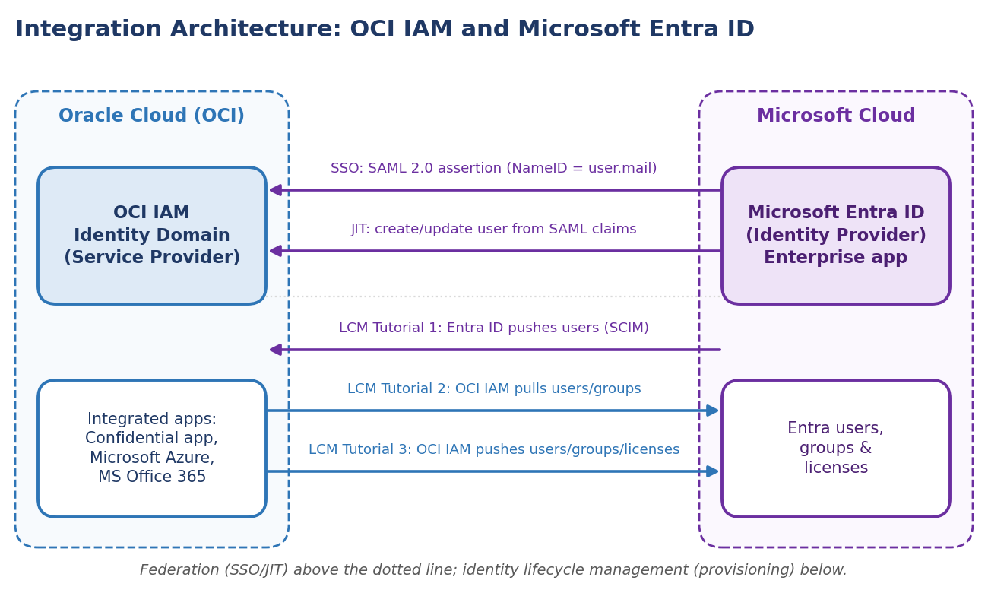
Figure 1: Integration architecture between OCI IAM and Microsoft Entra ID
Component | Role in this integration
OCI IAM identity domain | SAML 2.0 service provider; hosts the Entra ID SAML IdP, the IdP policy, JIT settings and integrated applications (confidential app, Microsoft Azure, MS Office 365).
Microsoft Entra ID | SAML 2.0 identity provider via the Oracle Cloud Infrastructure Console enterprise application; source or target of user provisioning.
User / browser | Initiates sign-in to the OCI Console and is redirected to the Microsoft login page.

2. SSO Between OCI and Microsoft Entra ID

2.1 Overview
In this tutorial, configure SSO between OCI IAM and Microsoft Entra ID, using Entra ID as the identity provider (IdP).
This 30-minute tutorial shows you how to integrate OCI IAM, acting as a service provider (SP), with Entra ID, acting as an IdP. By setting up federation between Entra ID and OCI IAM, you enable users' access to services and applications in OCI using user credentials that Entra ID authenticates.
This tutorial covers setting up Entra ID as an IdP for OCI IAM. The high-level workflow is:
- First, download the metadata from the OCI IAM identity domain.
- In the next few steps, you create and configure an app in Entra ID.
- In Entra ID, set up SSO with OCI IAM using the metadata.
- In Entra ID, edit the Attributes and Claims so that the email name is used as the identifier for users.
- In Entra ID, add a user to the app.
- For the next steps, you return to your identity domain to finish the setup and configuration. In OCI IAM, update the default IdP policy to add Entra ID.
- Test that federated authentication works between OCI IAM and Entra ID.
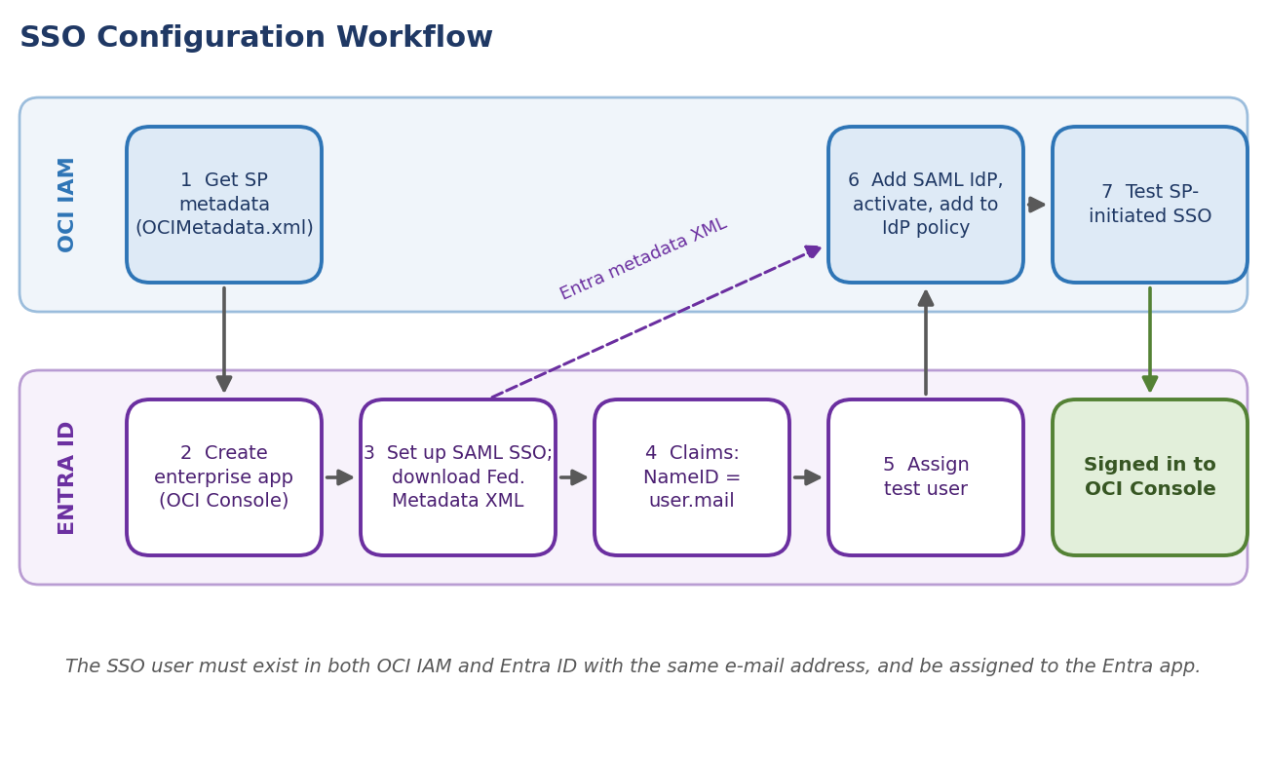
Figure 2: SSO configuration workflow across OCI IAM and Entra ID
NOTE
This tutorial is specific to IAM with Identity Domains.

2.2 Before You Begin
To perform this tutorial, you must have the following:
Prerequisite | Details
OCI account | A paid Oracle Cloud Infrastructure (OCI) account, or an OCI trial account. See Oracle Cloud Infrastructure Free Tier.
OCI administrator role | Identity domain administrator role for the OCI IAM identity domain. See Understanding Administrator Roles.
Entra ID role | An Entra ID account with one of the following Entra ID roles: Global Administrator, Cloud Application Administrator, or Application Administrator.

NOTE
The user used for Single Sign-On (SSO) must exist in both OCI IAM and Entra ID for SSO to work. After you complete this SSO tutorial, there is another tutorial, Identity Lifecycle Management Between OCI IAM and Entra ID (chapters 3–6 of this document), which guides you through how to provision user accounts from Entra ID to OCI IAM or from OCI IAM to Entra ID.

2.3 Task 1: Get the Service Provider Metadata from OCI IAM
You need the SP metadata from your OCI IAM identity domain to import into the SAML Entra ID application you create. OCI IAM provides a direct URL to download the metadata of the identity domain you are using.
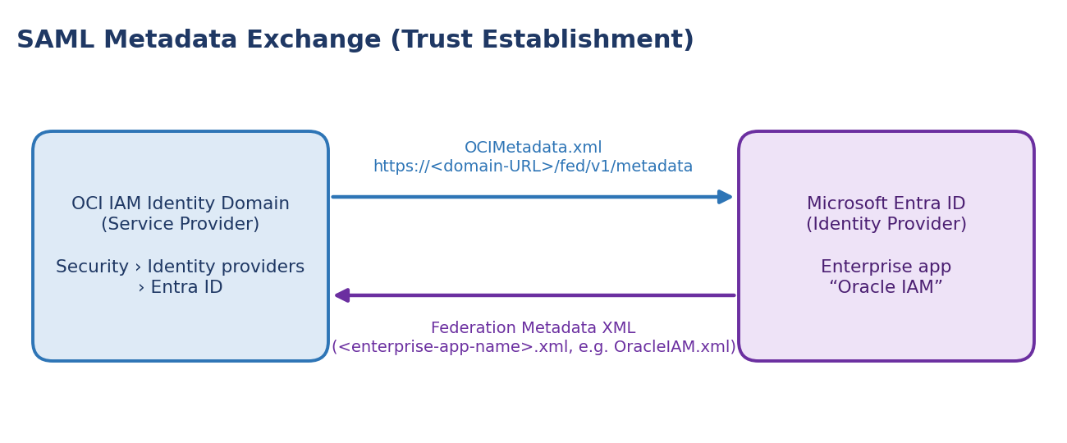
Figure 3: SAML metadata exchange between OCI IAM and Entra ID
To download the metadata, follow these steps:
- Open a supported browser and enter the Console URL:
https://cloud.oracle.com

- Enter your Cloud Account Name, also referred to as your tenancy name, and select Next.
- Select the identity domain to sign in to. This is the identity domain that is used to configure SSO, for example Default.
- Sign in with your username and password.
- Open the navigation menu and select Identity & Security. Under Identity, select Domains.
- Click the name of the identity domain that you want to work in. You might need to change the compartment to find the domain that you want. Then, click Settings and then Domain settings.
- Under Access signing certificate, check Configure client access. This lets a client access the signing certificate for the identity domain without signing in to the domain.
- Select Save changes.
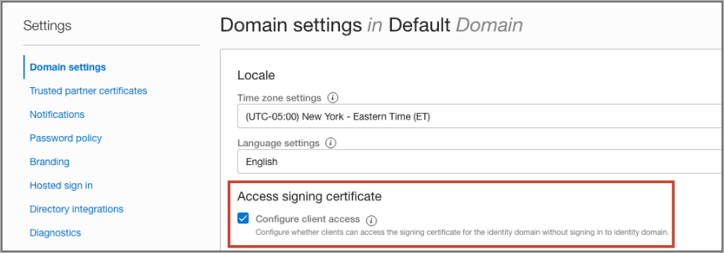
Figure 4: Configure client access on the Domain Settings page
- Return to the identity domain overview by selecting the identity domain name in the breadcrumb navigation trail. Select Copy next to the Domain URL in Domain information and save the URL to an app where you can edit it.
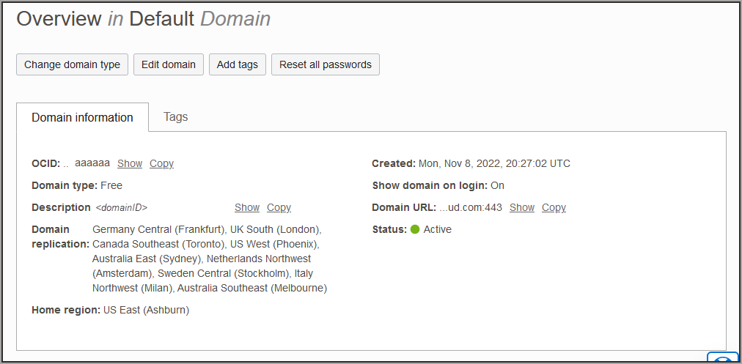
Figure 5: Domain information showing the Domain URL
- In a new browser tab, paste the URL you copied and add /fed/v1/metadata to the end. For example:
https://idcs-<unique_ID>.identity.oraclecloud.com:443/fed/v1/metadata

- The metadata for the identity domain is displayed in the browser. Save it as an XML file with the name OCIMetadata.xml.

2.4 Task 2: Create an Entra ID Enterprise Application
For the next few steps, you are working in Entra ID. Create a SAML enterprise application in Entra ID.
- In the browser, sign in to Microsoft Entra using the URL:
https://entra.microsoft.com

- Select Identity then Applications.
- Select Enterprise applications then New application.
- In Search applications, type Oracle Cloud Infrastructure Console.
- Select the Oracle Cloud Infrastructure Console by Oracle Corporation tile.
- Enter a name for the app, for example, Oracle IAM, and select Create.
The enterprise app is created in Entra ID.

2.5 Task 3: Set Up Single Sign-On for the Entra ID Enterprise App
Set up SSO for the Entra ID SAML application, and download the Entra ID SAML metadata. In this section, you use the OCI IAM SP metadata file you saved in section 2.3.
- In the Getting Started page, select Get started under Set up single sign on.
- Select SAML, then select Upload metadata file (button at the top of the page). Browse to the XML file containing the OCI identity domain metadata, OCIMetadata.xml.
- Provide the Sign on URL. For example:
https://idcs-<domain_ID>.identity.oraclecloud.com/ui/v1/myconsole

- Select Save.
- Close the Upload metadata file page from the X in the upper right. If you are asked whether you want to test the application now, choose not to because you will test the application later in this tutorial.
- In the Set up Single Sign-On with SAML page, scroll down and in SAML Signing Certificate, select Download next to Federation Metadata XML.
- When prompted, choose Save File. The metadata is automatically saved with the default filename <your_enterprise_app_name>.xml, for example OracleIAM.xml.
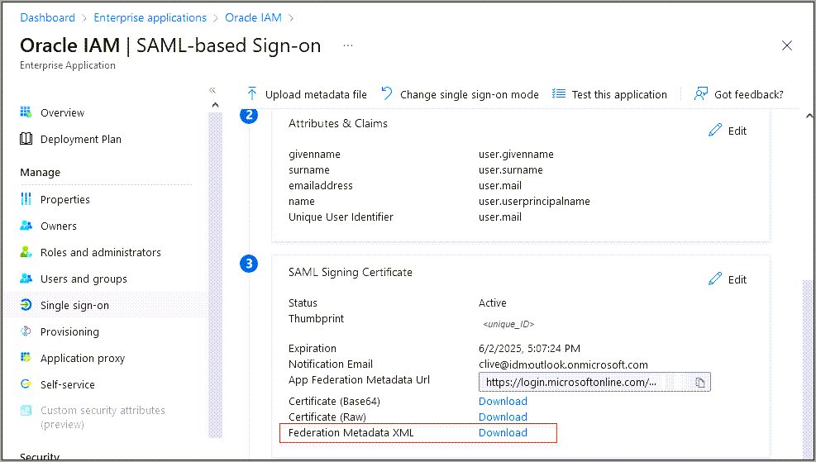
Figure 6: The Entra ID SAML-based SSO page

2.6 Task 4: Edit Attributes and Claims
Edit the Attributes and Claims in your new Entra ID SAML app so that the user email address is used as the user name.
- In the enterprise application, from the menu on the left, select Single sign-on.
- In Attributes and Claims, select Edit.
- Select the required claim:
Unique User Identifier (Name ID) = user.mail [nameid-format:emailAddress]

- In the Manage claim page, change the Source attribute from user.userprincipalname to user.mail.
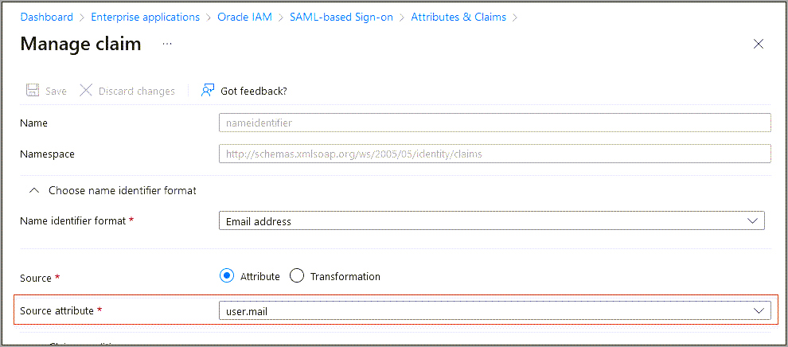
Figure 7: Entra ID attributes and claims
- Select Save.

2.6.1 Additional Entra ID Configurations
In Entra ID, you can filter groups based on the group name, or AM Account Name, attribute. For example, suppose only the Administrators group needs to be sent over using SAML:
- Select the group claim.
- In Group Claims, expand Advanced options.
- Select Filter Groups:
Field | Value
Attribute to match | Display Name
Match with | contains
String | Name of the group, for example Administrators

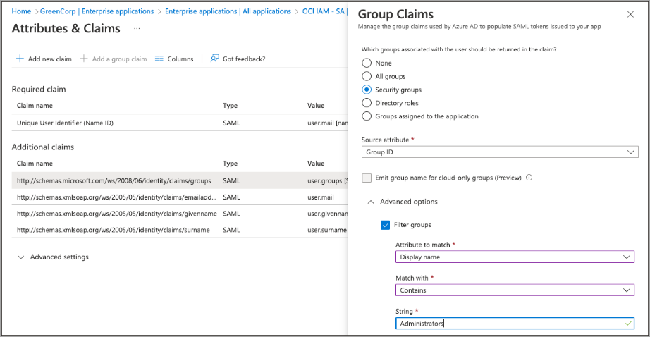
Figure 8: Filter groups in the Entra ID group claim
Using this option, even if the user in the administrator group is part of other groups, Entra ID only sends the Administrators group in SAML.
NOTE
This helps organisations to send only the required groups to OCI IAM from Entra ID.

2.7 Task 5: Add a Test User to the Entra ID Application
Create a test user for your Entra ID application. Later, this user can use their Entra ID credentials to sign in to the OCI Console.
- In the Microsoft Entra admin centre, select Identity then Users, then All users.
- Select New user then Create new user, and create a user and enter their email ID.
NOTE
Ensure that you use the details of a user present in OCI IAM with the same email id.

- Return to the enterprise application menu. Under Getting Started, select Assign users and groups. Alternatively, select Users from under Manage on the menu on the left.
- Select Add user/group, and on the next page under Users select None Selected.
- In the Users page, select the test user you created. As you select it, the user appears under Selected items. Select Select.
- Back on the Add Assignment page, select Assign.

2.8 Task 6: Enable Entra ID as IdP for OCI IAM
For these steps, you are working in OCI IAM. Add Entra ID as an IdP for OCI IAM. In this section, you use the Entra ID metadata file you saved in section 2.5, for example OracleIAM.xml.
- In the OCI Console in the domain you are working in, select Security and then Identity providers.
- Select Add IdP, then select Add SAML IdP.
- Enter a name for the SAML IdP, for example Entra ID. Select Next.
- Ensure that Import identity provider metadata is selected, and browse and select, or drag and drop the Entra ID metadata XML file (OracleIAM.xml) into Identity provider metadata. This is the metadata file you saved in section 2.5. Select Next.
- In Map user identity, set the following:
Field | Value
Requested Name ID format | Email address
Identity provider user attribute | SAML assertion Name ID
Identity domain user attribute | Primary email address

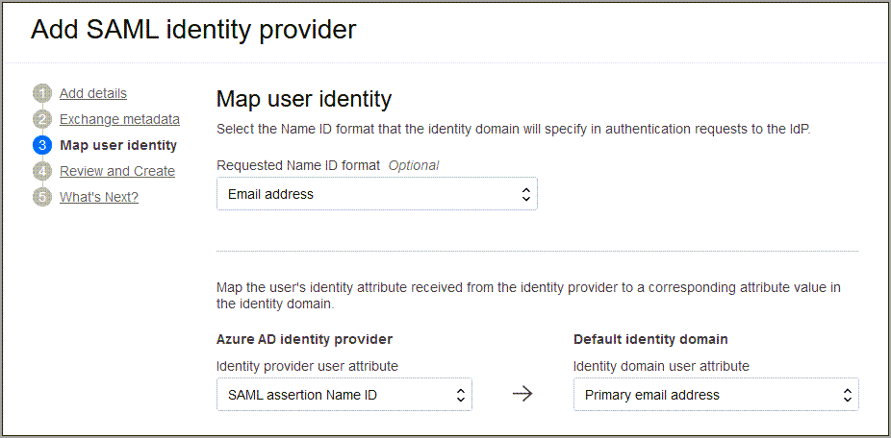
Figure 9: SAML identity provider attribute mapping
- Select Next.
- Under Review and Create, verify the configurations and select Create IdP.
- Select Activate.
- Select Add to IdP Policy Rule.
- Select Default Identity Provider Policy to open it, select the Actions menu (three dots) and select Edit IdP rule.
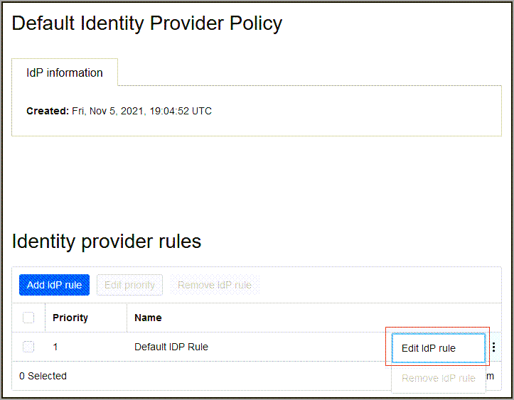
Figure 10: Default Identity Provider Policy context menu showing Edit IdP rule
- Select Assign identity providers and then select Entra ID to add it to the list.
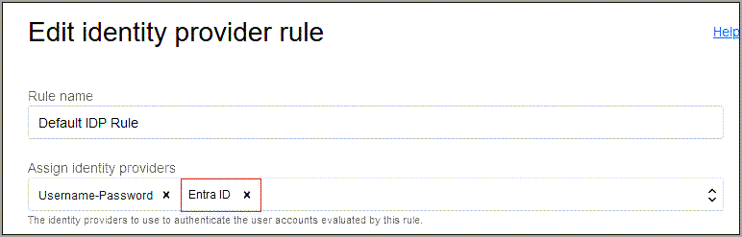
Figure 11: Adding Entra ID as an identity provider in the default IdP rule
- Select Save Changes.

2.9 Task 7: Test SSO Between Entra ID and OCI
In this section, you test that federated authentication works between OCI IAM and Entra ID.
IMPORTANT
For this to work, the user used for SSO must be present in both OCI IAM and Entra ID. Also, the user must be assigned to the OCI IAM application created in Entra ID.

There are two ways to do this:
- You can manually create a test user in both OCI IAM and Entra ID.
- However, if you want to test with a real time user, you should set up provisioning between Entra ID and OCI IAM by following the steps in the tutorial Identity Lifecycle Management Between OCI IAM and Entra ID.
If you haven't set up users to test this tutorial, you see the following error:
Sorry, but we're having trouble signing you in.

AADSTS50105: Your administrator has configured
the application application-name ('<unique_ID>')
to block users unless they are specifically granted
('assigned') access to the application.

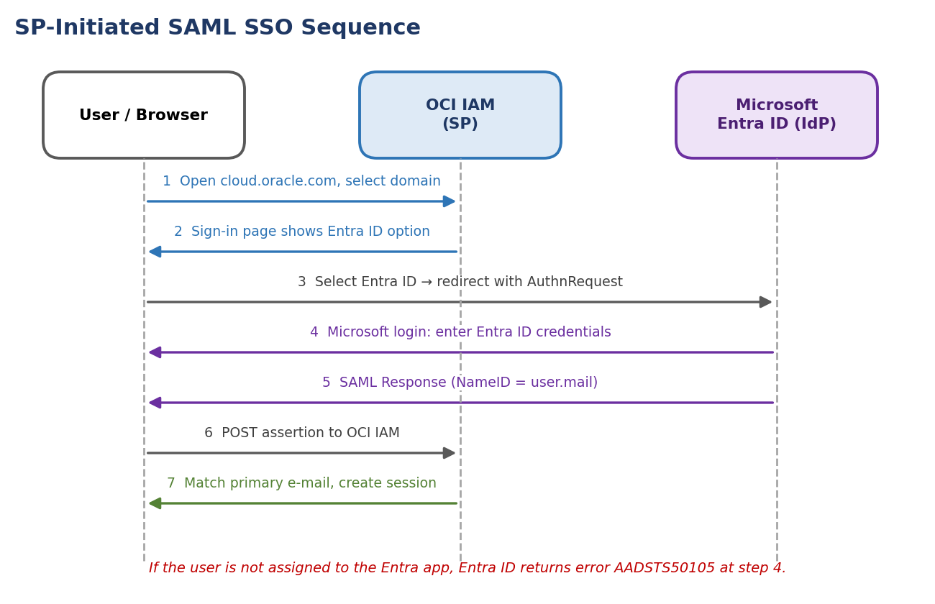
Figure 12: SP-initiated SAML SSO message sequence
Test the SP-initiated SSO:
- Open a supported browser and enter the Console URL:
https://cloud.oracle.com

- Enter your Cloud Account Name, also referred to as your tenancy name, and select Next.
- Select the identity domain in which Entra ID federation has been configured.
- On the sign-in page, you can see an option to sign in with Entra ID.
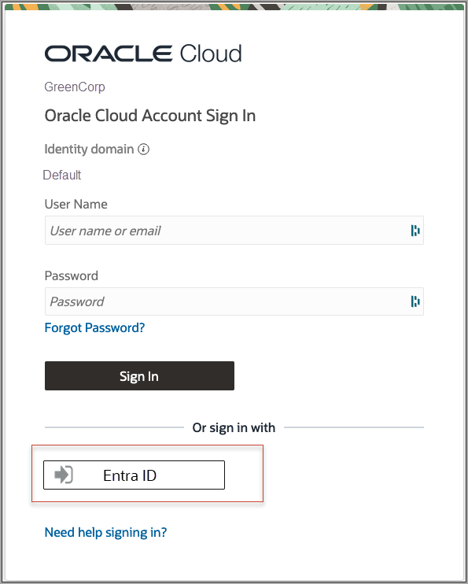
Figure 13: OCI IAM sign-in page with the Entra ID option
- Select Entra ID. You are redirected to the Microsoft login page.
- Provide your Entra ID credentials.
- On successful authentication, you are logged in to the OCI Console.

2.10 What's Next
Congratulations! You have successfully set up SSO between Entra ID and OCI IAM.
If you already had a user created in Entra ID and assigned to the application, that had been provisioned to OCI IAM, you were able to test that federation authentication works between OCI IAM and Entra ID. If you didn't have such a user, you can create one by following one of the Identity Lifecycle Management Between OCI IAM and Entra ID tutorials.
To explore more information about development with Oracle products, check out the Oracle Developers Portal and Oracle Cloud Infrastructure.

3. Identity Lifecycle Management Between OCI IAM and Entra ID

3.1 Overview
Configure provisioning between OCI IAM and Entra ID using three different methods. This set of tutorials will take around 30 minutes. Use the following scenarios to determine which method to use:
Tutorial | Scenario | Direction
Tutorial 1 | Configure Entra ID as the authoritative identity store to manage identities in OCI IAM using an application template from the Entra ID gallery. User accounts are pushed from Entra ID to OCI IAM. | Entra ID → OCI IAM (push)
Tutorial 2 | Configure Entra ID as the authoritative identity store to manage identities in OCI IAM using the app template from the OCI IAM Application Catalog. OCI IAM pulls users, groups, and group membership from Entra ID into OCI IAM. | Entra ID → OCI IAM (pull)
Tutorial 3 | Configure OCI IAM as the authoritative identity store to manage identities. OCI IAM pushes users, groups, and licenses to Entra ID. | OCI IAM → Entra ID (push)

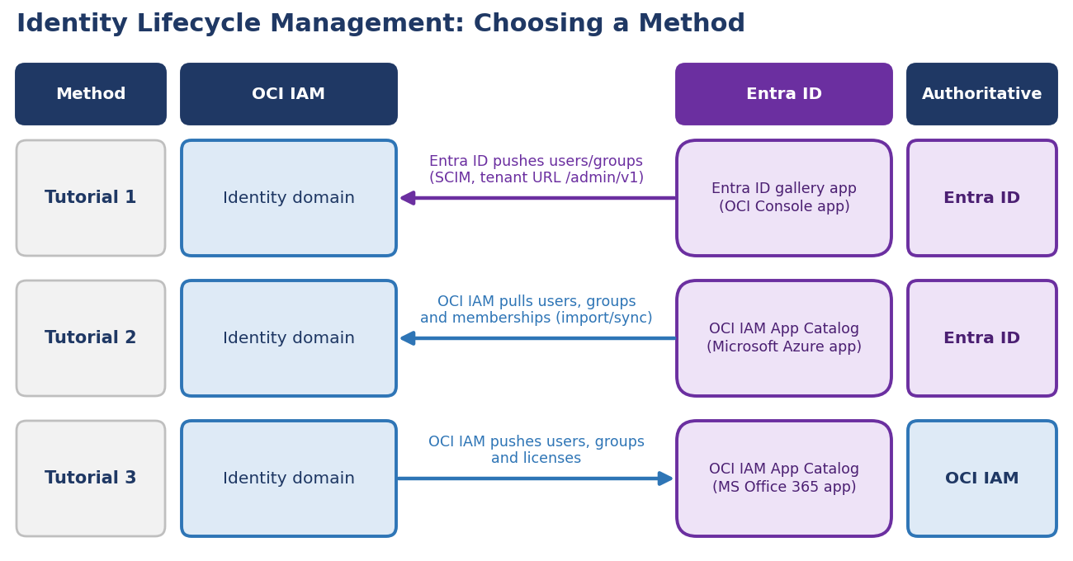
Figure 14: Identity lifecycle management methods and authoritative source
NOTE
These tutorials are specific to IAM with Identity Domains.

3.2 Before You Begin
To perform this set of tutorials, you must have the following:
Prerequisite | Details
OCI account | A paid Oracle Cloud Infrastructure (OCI) account, or an OCI trial account. See Oracle Cloud Infrastructure Free Tier.
OCI administrator role | Identity domain administrator role for the OCI IAM identity domain. See Understanding Administrator Roles.
Entra ID role | An Entra ID account with one of the following Entra ID roles: Global Administrator, Cloud Application Administrator, or Application Administrator.

4. LCM Tutorial 1: Entra ID as Authoritative Source Using the Entra ID Gallery Application

4.1 Overview
Configure Entra ID as the authoritative identity store to manage identities in OCI IAM using an application template from Entra ID Gallery.
- Configure OCI IAM so that Entra ID is the identity store to manage identities in OCI IAM. In OCI IAM, create a confidential application.
- Generate a secret token from the OCI IAM identity domain's client ID and client secret. Use this, along with the domain URL, in Entra ID.
- Create an app in Entra ID and use the secret token and identity domain URL to specify the OCI IAM identity domain, and prove that it works by pushing users from Entra ID to OCI IAM.
- Assign the users and groups which you want to provision to OCI IAM to the Entra ID application.
In addition, there are instructions on how to set users' federated status so that they're authenticated by the external identity provider, and how to stop users getting notification emails when their account is created or updated.
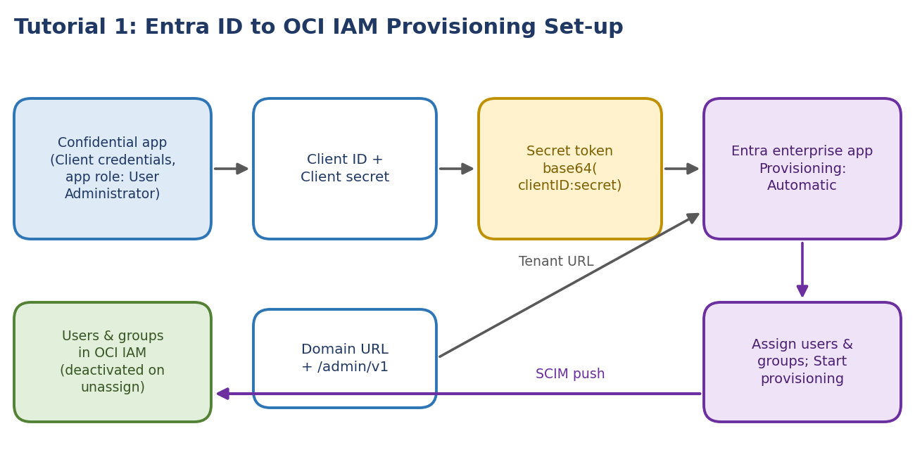
Figure 15: Provisioning set-up from the OCI confidential app to the Entra ID enterprise app

4.2 Task 1: Create a Confidential Application
In this section, you configure Entra ID to act as the identity manager so that user accounts are synchronized from Entra ID to OCI IAM.
- In the identity domain you are working in, select Applications.
- Select Add Application, choose Confidential Application and select Launch workflow.
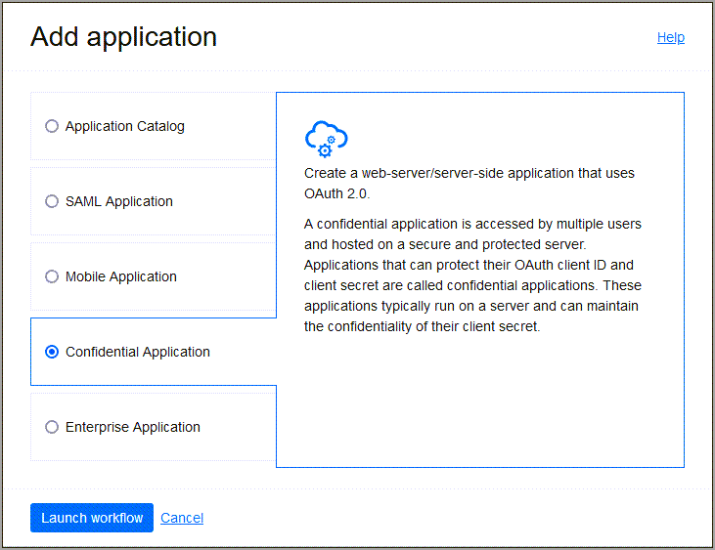
Figure 16: Add a confidential application
- Enter a name for the application, for example Entra ID, and select Next.
- Under Client configuration, select Configure this application as a client now.
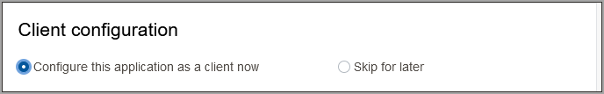
Figure 17: Configure the application as a client
- Under Authorization, check Client credentials.
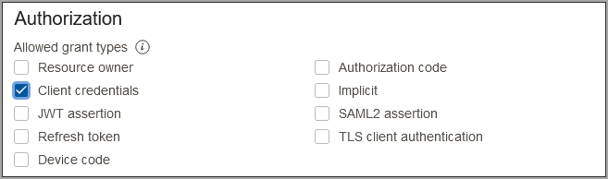
Figure 18: Configure the application for client credentials
- Under Client type select Confidential.
- Scroll down, and in the Token issuance policy section, set Authorized resources to Specific.
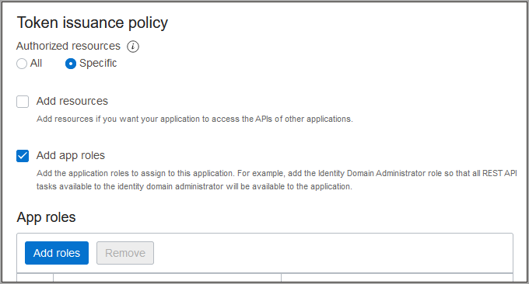
Figure 19: Token issuance policy
- Select Add app roles.
- In the App Roles section, select Add roles, and in the Add app roles page select User Administrator then select Add.
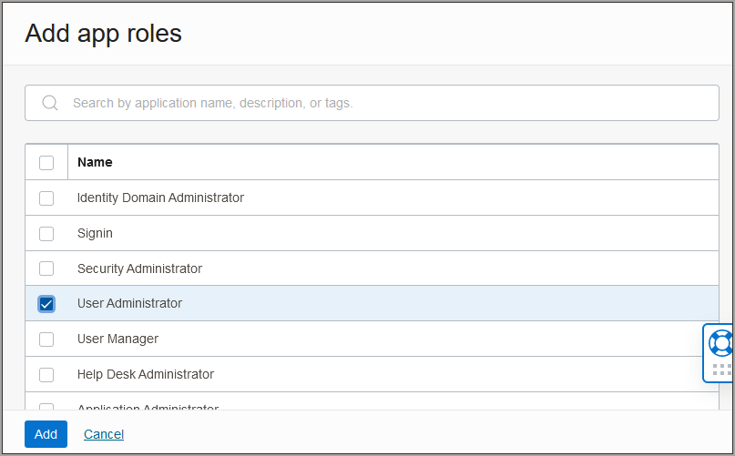
Figure 20: Add app roles
- Select Next, then Finish.
- On the application overview page, select Activate and confirm that you want to activate the application.
The confidential application is activated.

4.3 Task 2: Find the Domain URL and Generate a Secret Token
You need two pieces of information to use as part of the connection settings for the enterprise app you create in Entra ID: the domain URL, and a secret token generated from the client ID and client secret.
- Return to the identity domain overview by selecting the identity domain name in the breadcrumbs. Select Copy next to the Domain URL in Domain information and save the URL to an app where you can edit it.
Figure 21: Domain information showing the Domain URL
- In the confidential app in OCI IAM, select OAuth configuration under Resources.
- Scroll down, and find the Client ID and Client secret under General Information.
- Copy the client ID and store it.
- Select Show secret and copy the secret and store it.
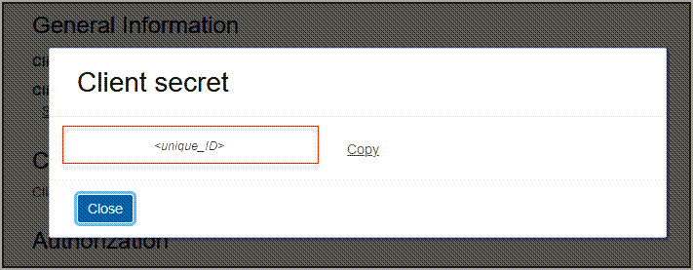
Figure 22: Client ID and client secret
The secret token is the base64 encoding of <clientID>:<clientsecret>, that is base64(<clientID>:<clientsecret>). These examples show how to generate the secret token on Windows, Linux, or macOS:
Platform | Command
Windows (PowerShell) | [Convert]::ToBase64String([System.Text.Encoding]::Unicode.GetBytes('client_id:secret'))
Linux | echo -n <clientID>:<clientsecret> | base64 --wrap=0
macOS | echo -n <clientID>:<clientsecret> | base64

The secret token is returned. For example:
$ echo -n 392357752347523923457437:3454-9853-7843-3554 | base64
Nk0NzUyMzcyMzQ1NzMTc0NzUyMzMtNTQzNC05ODc4LTUzNQ==

IMPORTANT
Make a note of the secret token value. Treat it as a credential: anyone holding it can call the identity domain with the confidential app's User Administrator role.

4.4 Task 3: Create the OCI Application on Entra ID
Configure Entra ID to enable Entra ID to be the authoritative identity store to manage identities in IAM.
- In the browser, sign in to Microsoft Entra ID using the URL:
https://portal.azure.com

- Select Identity then Applications.
- Select Enterprise applications.
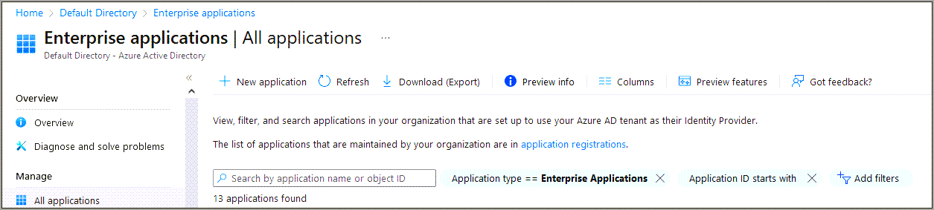
Figure 23: Add an enterprise app
- On the Enterprise applications page, select New application then Oracle.
- Select Oracle Cloud Infrastructure Console.
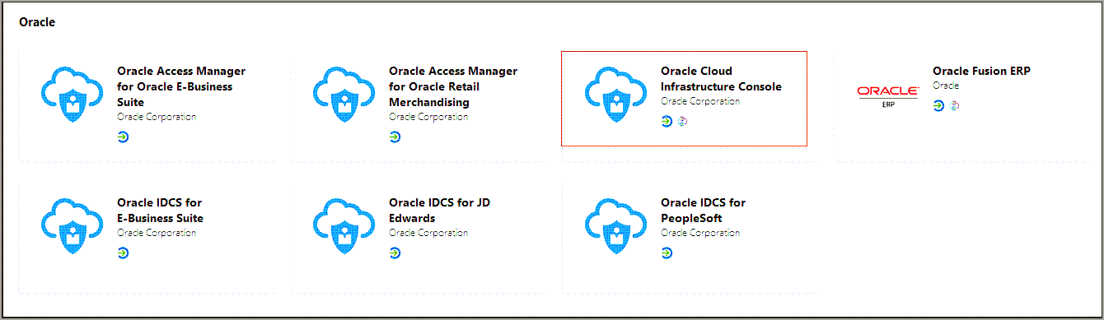
Figure 24: Choose Oracle Cloud Infrastructure Console
- Enter a name, or accept the default of Oracle Cloud Infrastructure Console.
- Select Create.
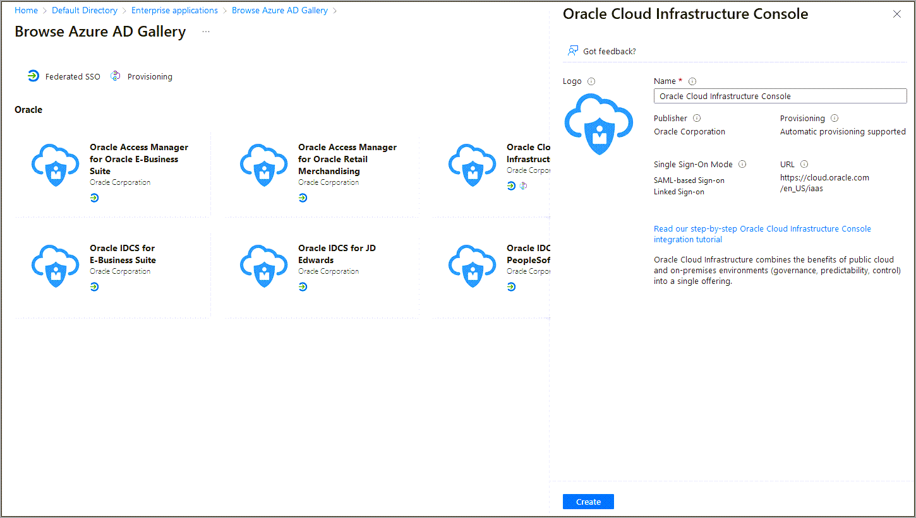
Figure 25: Create the OCI IAM console app
- Choose Provisioning from the left menu under Manage.
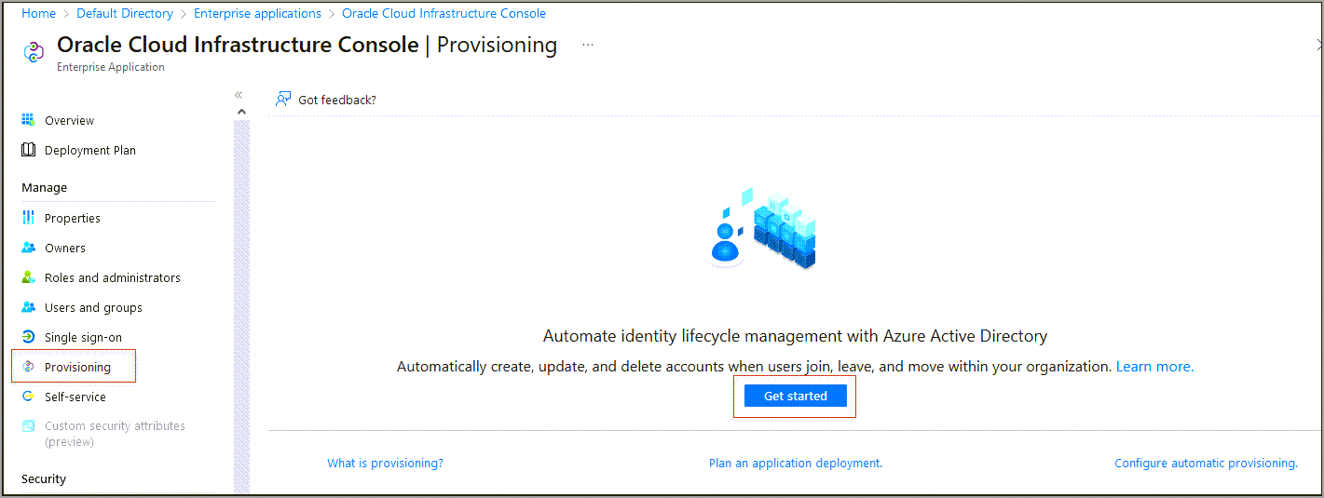
Figure 26: Provisioning page for the enterprise application in Entra ID
- Select Get started, and change Provisioning Mode to Automatic.
- In Tenant URL, enter the OCI IAM Domain URL from section 4.3 followed by /admin/v1. That is, the tenant URL is:
https://<domainURL>/admin/v1

- Enter the secret token you generated in section 4.3.
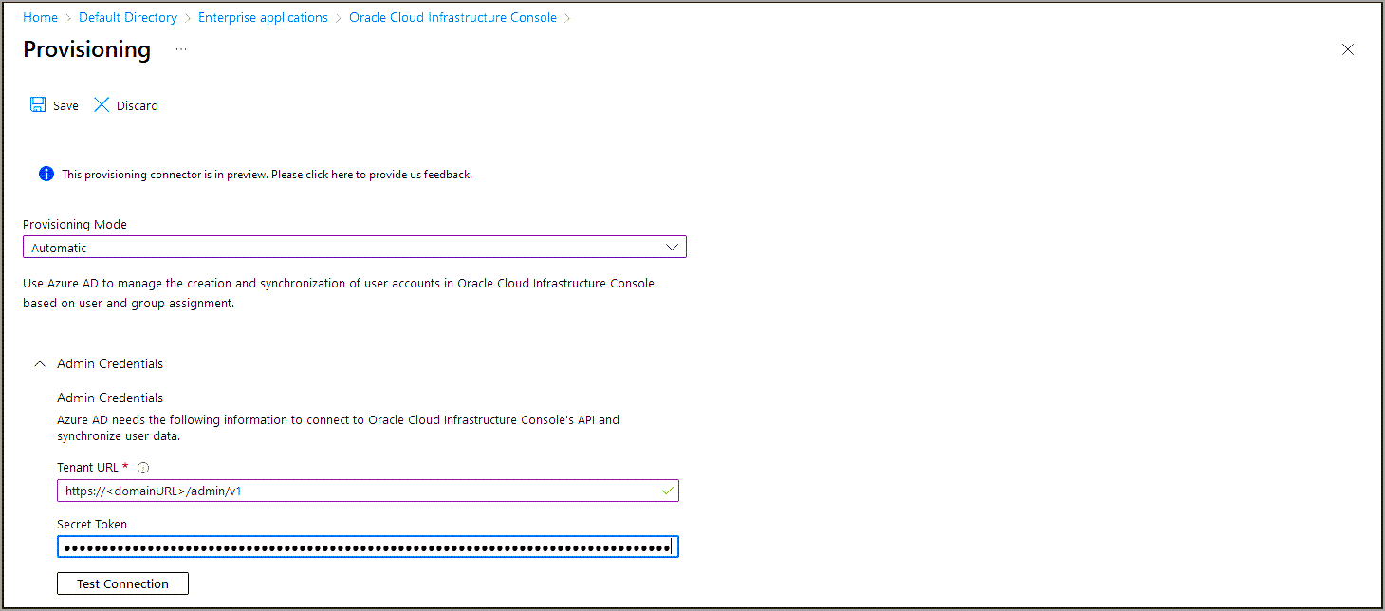
Figure 27: Enter admin credentials
- Select Test Connection. When this message appears, the connection is successful:
Testing connection to Oracle Cloud Infrastructure Console
The supplied credentials are authorized to enable provisioning

- Choose Provisioning from the left menu under Manage and select Start provisioning. The provisioning cycle starts, and the status of provisioning is displayed.

4.5 Task 4: Assign Users and Groups to the Entra ID Application
Assign the users which you want to provision to OCI IAM to the Entra ID application.
- In Entra ID, in the left menu select Enterprise applications.
- Select the application you created earlier, Oracle Cloud Infrastructure Console.
- In the left menu under Manage, select Users and groups.
- In the Users and groups page, select Add user/group.
- In the Add Assignment page, on the left under Users and groups, select None Selected. The Users and groups page opens.
- Select one or more users or groups from the list by selecting on them. The ones you select are listed under Selected items.
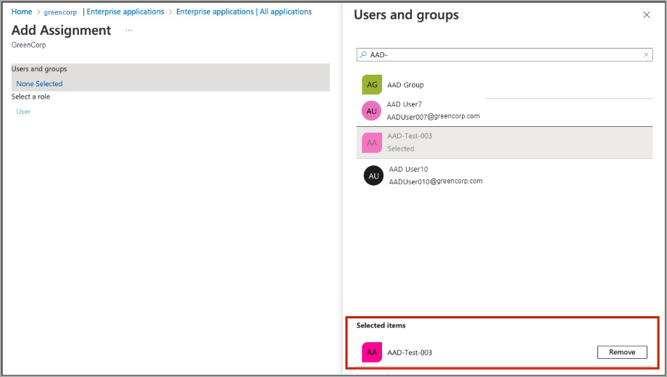
Figure 28: Users and groups selection
- Select Select. The number of users and groups selected are shown on the Add Assignment page.
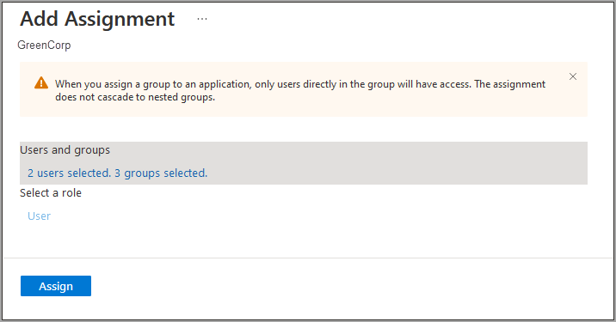
Figure 29: Selected users and groups on the Add Assignment page
- On the Add Assignment page, select Assign. The Users and groups page now shows the users and groups you have chosen.
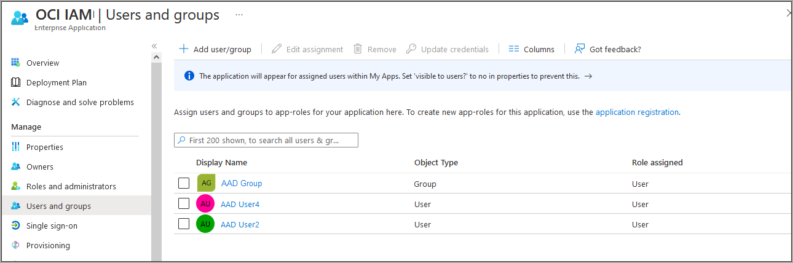
Figure 30: Users and groups assigned to the app
- Select Provisioning in the left menu to provision the groups and users. The provisioning log shows the status.
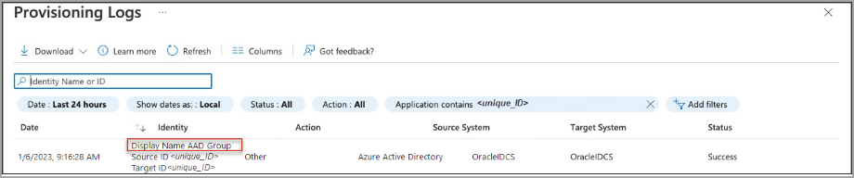
Figure 31: Provisioning log showing a successful status
- When provisioning has been successful, the Current cycle status shows that the incremental cycle has completed and the number of users provisioned to OCI IAM is shown.
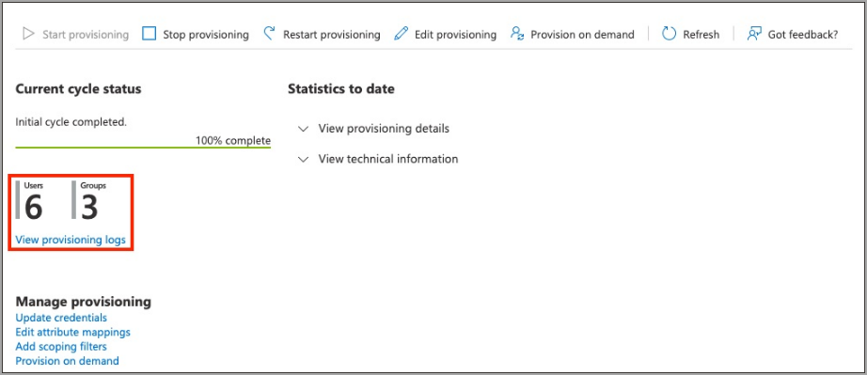
Figure 32: Provisioning status with the number of users provisioned

In OCI IAM, you can now see the users and groups provisioned from Entra ID.
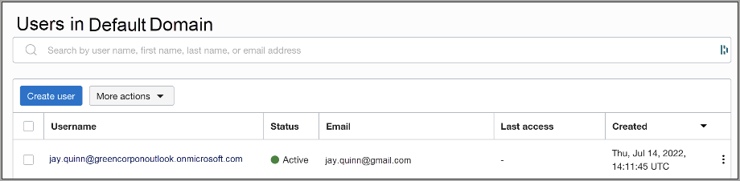
Figure 33: Entra ID users provisioned in OCI IAM
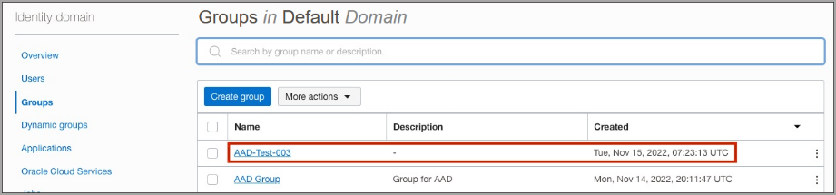
Figure 34: Entra ID groups provisioned in OCI IAM
NOTE
When you remove users from the Oracle Cloud Infrastructure Console app on Entra ID, the user is only deactivated in OCI IAM.

4.6 Additional Configurations for Federated Users
You can set users' federated status so that they're authenticated by the external identity provider, and you can disable notification emails being sent to the user when their account is created or updated. Both use an expression mapping on the Entra ID provisioning attribute mappings:
Setting | Mapping type | Expression | Target attribute
Federated status | Expression | CBool("true") | urn:ietf:params:scim:schemas:oracle:idcs:extension:user:User:isFederatedUser
Bypass notification | Expression | CBool("true") | urn:ietf:params:scim:schemas:oracle:idcs:extension:user:User:bypassNotification

4.6.1 Setting Users' Federated Status
Federated users don't have credentials to sign in directly to OCI. Instead they're authenticated by the external identity provider. If you want users to use their federated accounts to sign in to OCI, set the federated attribute to true for those users. To set the user's federated status:
- In the browser, sign in to Microsoft Entra ID using the URL:
https://portal.azure.com

- Select Identity then Applications.
- Select Enterprise applications.
- Select the application you created earlier, Oracle Cloud Infrastructure Console.
- In the left menu under Manage, select Provisioning then select Edit Provisioning.
- In the Provisioning page, select Mappings.
- Under Mappings, select Provision Entra ID Users.
- Under Attribute Mappings, scroll down and select Add New Mapping.
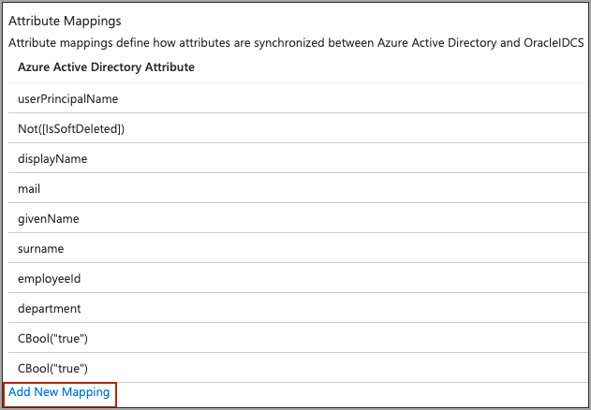
Figure 35: Add New Mapping under Attribute Mappings
- In the Edit Attribute page:
  - For Mapping type, choose Expression.
  - For Expression, enter CBool("true").
  - For Target Attribute, choose urn:ietf:params:scim:schemas:oracle:idcs:extension:user:User:isFederatedUser.
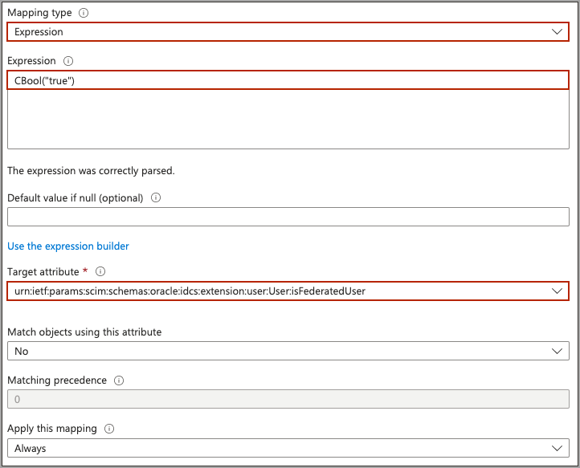
Figure 36: Edit Attribute page (isFederatedUser)
- Select Ok.
- In the Attribute Mapping page, select Save.
Now, when the users are provisioned from Entra ID to OCI, their federated status is set to true. You can see this in the user's profile page: in the OCI Console, navigate to the identity domain you are using, select Users, and select the user to show the user information. Federated is shown as Yes.
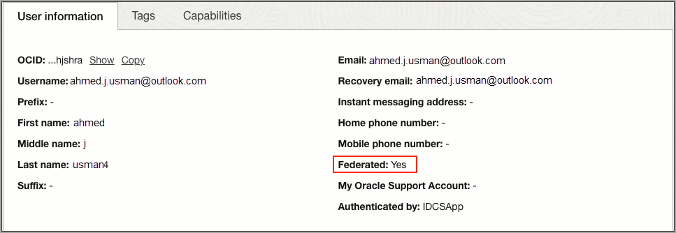
Figure 37: User information showing that the user is federated

4.6.2 Disable Notifications for Account Creation or Updates
The bypass notification flag controls whether an email notification is sent after creating or updating a user account in OCI. If you don't want users to be notified that accounts have been created for them, then set the bypass notification flag to true. To set the bypass notification flag:
- In the browser, sign in to Microsoft Entra ID using the URL:
https://portal.azure.com

- Select Identity then Applications.
- Select Enterprise applications.
- Select the application you created earlier, Oracle Cloud Infrastructure Console.
- In the left menu under Manage, select Provisioning then select Edit Provisioning.
- In the Provisioning page, select Mappings.
- Under Mappings, select Provision Entra ID Users.
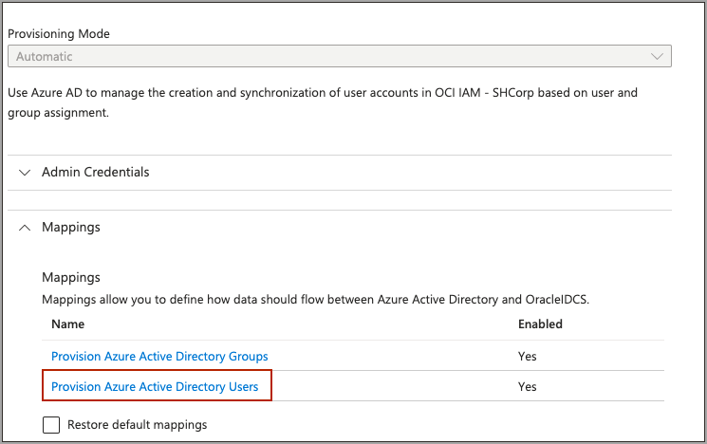
Figure 38: Provision Entra ID Users under Mappings
- Under Attribute Mappings, scroll down and select Add New Mapping.
Figure 39: Add New Mapping under Attribute Mappings
- In the Edit Attribute page:
  - For Mapping type, choose Expression.
  - For Expression, enter CBool("true").
  - For Target Attribute, choose urn:ietf:params:scim:schemas:oracle:idcs:extension:user:User:bypassNotification.
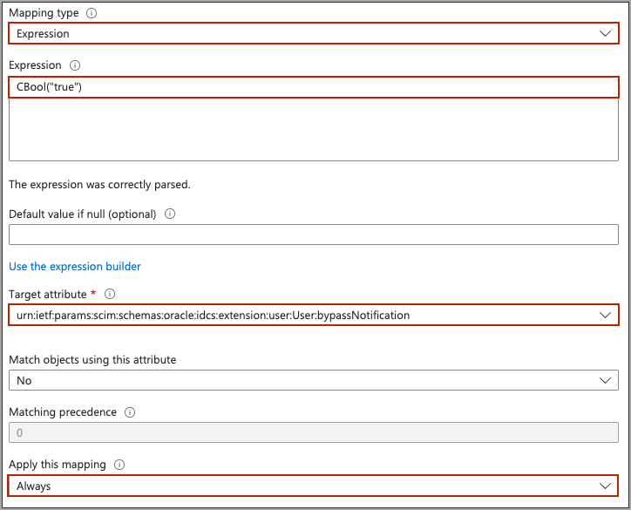
Figure 40: Edit Attribute page (bypassNotification)
- Select Ok.
- In the Attribute Mapping page, select Save.

5. LCM Tutorial 2: Entra ID as Authoritative Source Using the OCI IAM Application Catalog

5.1 Overview
Configure Entra ID as the authoritative identity store to manage identities in OCI IAM and pull users, groups, and group membership from Entra ID into OCI IAM.
IMPORTANT
This tutorial takes you through the steps to synchronize all users from Entra ID into OCI IAM. Before you begin, ensure that you understand the limits on users so that you avoid any additional licensing costs. See IAM Identity Domain Object Limits.

- Configure Entra ID to use OCI IAM as the identity store. Create an app in OCI IAM for Entra ID, and in this app you add OCI IAM as an IdP.
- Prove that it works by pulling users, groups, and group memberships from Entra ID into the Entra ID app in OCI IAM, and enable synchronization.
- Validate that it works by pulling users, groups, and group memberships from Entra ID, and confirm that the same users and groups have been populated in OCI IAM.

5.2 Task 1: Create an App in OCI IAM for Entra ID
Set up Entra ID (formerly Azure) so IAM is the identity store to manage identities in OCI IAM.
- In the identity domain you are working in, select Integrated applications.
- Select Add Application, choose Application Catalog and select Launch app catalog.
- Search for the Microsoft application template by entering the string Microsoft.
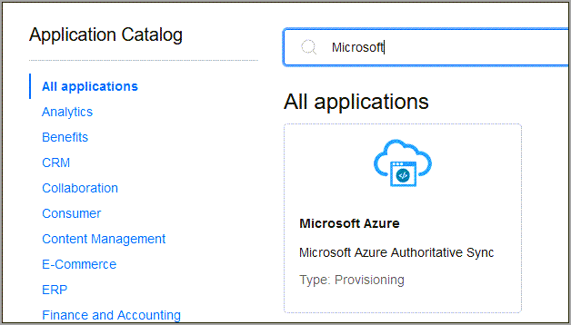
Figure 41: Microsoft Entra ID template in the Application Catalog
- Select the Microsoft Azure tile.
- Enter a name for the application, or use the default Microsoft Entra ID.
- Select Next, and on the Configure provisioning page, enable provisioning, and confirm that you want to enable provisioning.
- Configure connectivity by selecting Authorize with Microsoft Azure.
- A browser instance opens showing the Microsoft Entra ID login page. Sign in using your Microsoft Entra ID credentials, and in the Permissions requested dialog select Accept.
- The Console displays the message Authorization completed successfully.
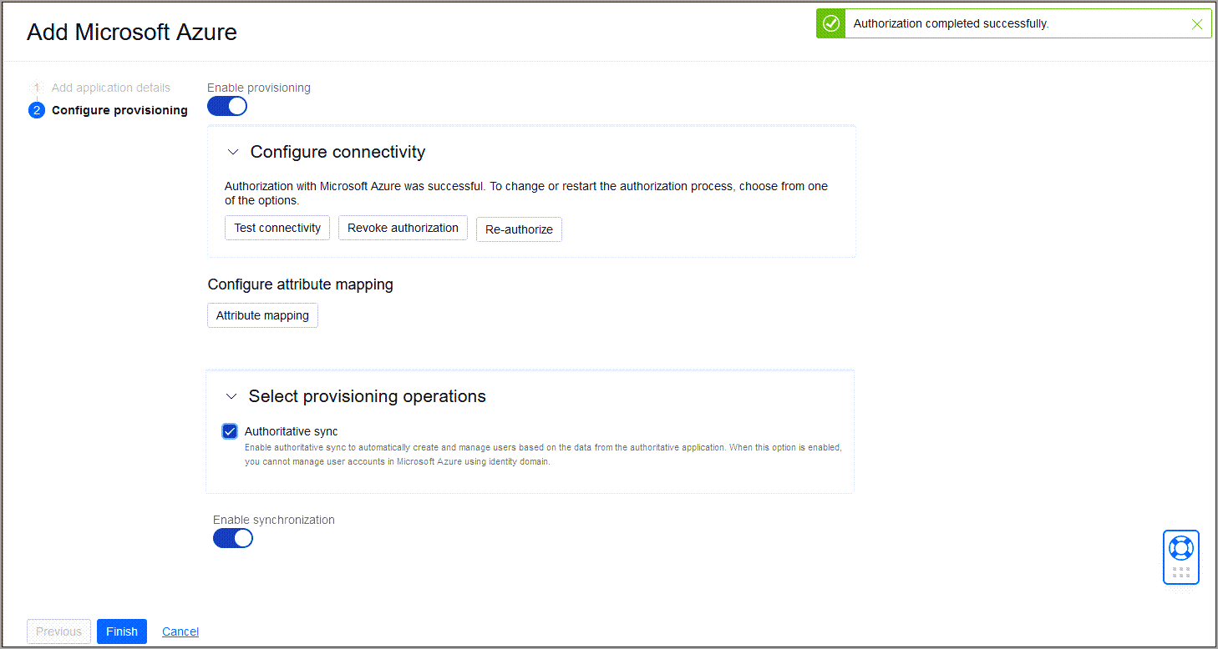
Figure 42: Authorization completed successfully
- Choose Enable synchronization so that users are synchronized between OCI IAM and Microsoft Entra ID.
- Select Finish.
- On the application overview page, select Activate and confirm that you want to activate the application.

5.3 Task 2: Import Users from Entra ID to IAM
Import Entra ID users into the Entra ID app in OCI IAM.
- In the Microsoft Entra ID app in OCI IAM, select Import under Resources.
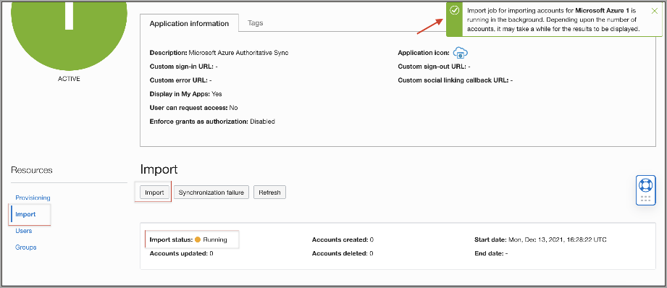
Figure 43: Import users
- The Console displays Import job for importing accounts for Microsoft Azure is running in the background. Depending upon the number of accounts, it may take a while for the results to be displayed.
- Check the import status. When the status changes to Succeeded, a list of users is displayed.
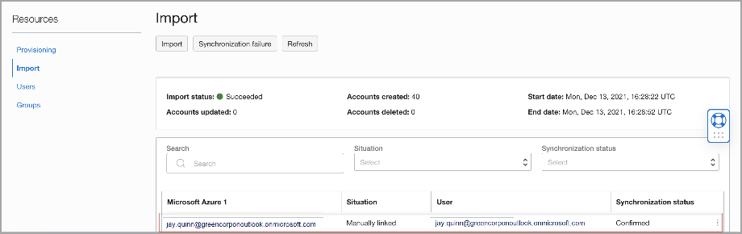
Figure 44: Import has succeeded
You have successfully created an Entra ID application in OCI IAM to use as an identity store, and imported users from Entra ID to OCI IAM.

6. LCM Tutorial 3: OCI IAM as Authoritative Source to Manage Identities in Entra ID

6.1 Overview
Configure OCI IAM as the authoritative identity store to manage identities, along with entitlements, in Entra ID. In this scenario, OCI IAM acts as the identity manager. OCI IAM pushes users, groups, and licenses to Entra ID.
- First, configure OCI IAM to enable IAM as the authoritative identity store to manage identities in Entra ID. Create an app in OCI IAM for MS Office 365 using IAM's App Catalog, which provides pre-built integrations with major cloud services.
- Assign a user to the MS Office 365 application in OCI IAM, and assign the groups and roles you want the user to be provisioned to MS Office 365.

6.2 Task 1: Add MS Office 365 as an App in OCI IAM
Use OCI IAM's App Catalog to create an app which uses MS Office 365.
- Open a supported browser and enter the Console URL:
https://cloud.oracle.com

- Enter your Cloud Account Name, also referred to as your tenancy name, and select Next.
- Select the identity domain to sign in to. This is the identity domain that you will configure user lifecycle management in.
- Sign in with your username and password.
- Open the navigation menu and select Identity & Security. Under Identity, select Domains.
- Click the name of the identity domain that you want to work in. You might need to change the compartment to find the domain that you want. Then, click Integrated applications.
- Select Add Application, choose Application Catalog and select Launch app catalog, which contains pre-configured application templates.
- Search for the MS Office 365 application template by entering the string MS Office, then select the tile to create an MS Office 365 application.
- Enter a name for the application, or use the default MS Office 365.
- Select Next and then Next again, and on the Configure provisioning page enable provisioning, and confirm that you want to enable provisioning.
- Configure connectivity by selecting Authorize with MS Office 365. Microsoft opens a new browser window.
- Log in using your MS Office 365 credentials. On the Permissions requested dialog, select Consent on behalf of your organization, and select Accept.
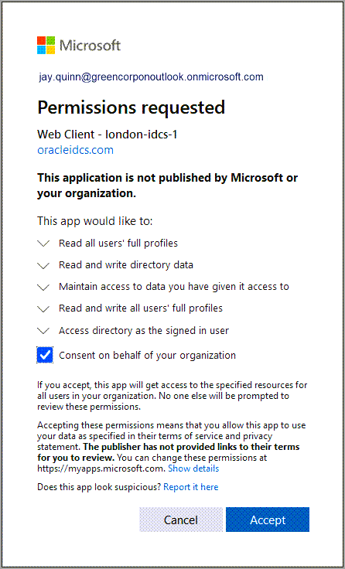
Figure 45: Microsoft permissions request to access resources
- The new browser closes and you are returned to the Add MS Office 365 page. A message pops up to say that the connection has been successful.
- Select Finish.
- On the application overview page, select Activate and confirm that you want to activate the application.
The MS Office 365 application is now active. You have successfully created an MS Office 365 application in OCI IAM, and configured it to connect to MS Office 365.

6.3 Task 2: Assign Users to the MS Office 365 App
Assign a user to the MS Office 365 application, and assign it to the Office roles and groups the user will have when provisioned to MS Office 365.
- In the MS Office 365 application, select Users on the left under Resources.
- Select Assign users.
- Search for the user you want to assign, then select the Actions menu (three dots) for that user and select Assign.
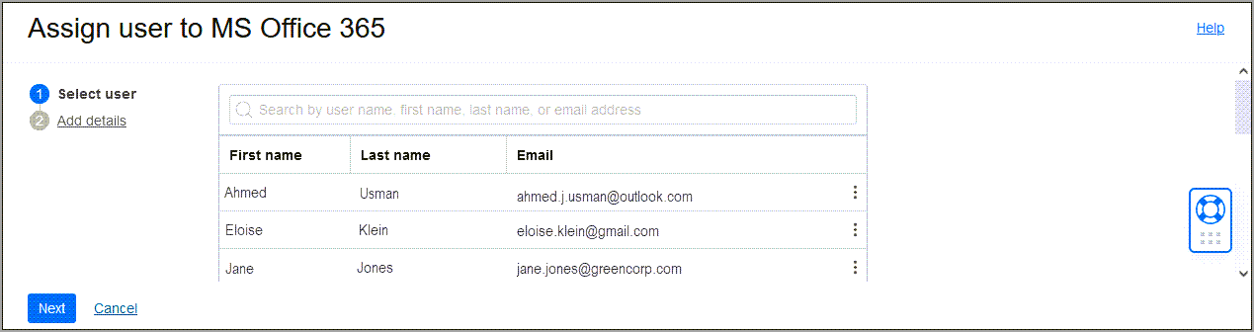
Figure 46: Assign a user to the MS Office 365 application
- Select Next.
- On the Add Details page, scroll down, and under Licenses, select Add and assign the licences you want the user to be provisioned with on MS Office 365.
- Under Roles, select Add and assign the roles you want the user to be provisioned with.
- Under Groups, select Add and assign the groups you want the user to be provisioned with.
- Select Assign User.
You can see the new user in the User List with Active status.
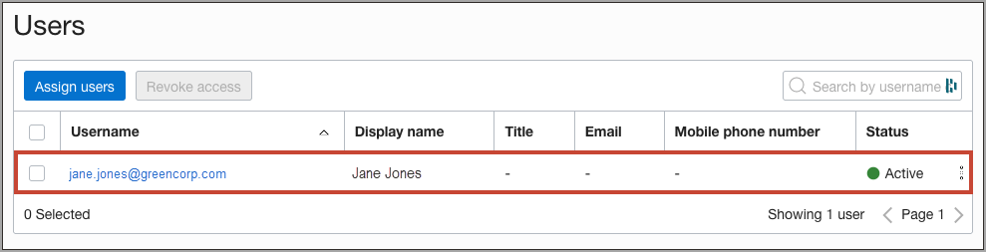
Figure 47: New users listed with Active status

7. JIT Provisioning from Entra ID to OCI IAM

7.1 Overview
In this tutorial, you configure Just-In-Time (JIT) Provisioning between the OCI Console and Entra ID, using Entra ID as the IdP.
You can set up JIT provisioning so that identities can be created in the target system during run time, as and when they make a request to access the target system. This tutorial covers the following steps:
- Configure the Entra ID IdP in OCI IAM for JIT.
- Update the OCI IAM app configuration in Entra ID.
- Test that you can provision from Entra ID to OCI IAM.
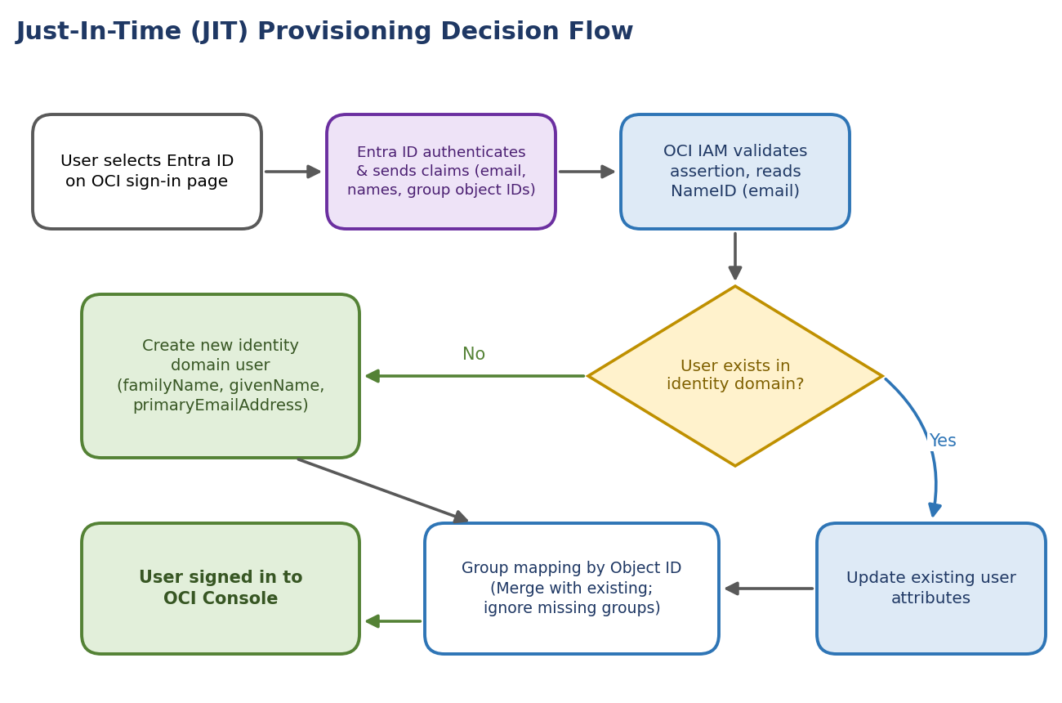
Figure 48: JIT provisioning decision flow at sign-in
NOTE
This tutorial is specific to IAM with Identity Domains.

7.2 Before You Begin
To perform this tutorial, you must have the following:
Prerequisite | Details
OCI account | A paid Oracle Cloud Infrastructure (OCI) account, or an OCI trial account. See Oracle Cloud Infrastructure Free Tier.
OCI administrator role | Identity domain administrator role for the OCI IAM identity domain. See Understanding Administrator Roles.
Entra ID role | An Entra ID account with one of the following Entra ID roles: Global Administrator, Cloud Application Administrator, or Application Administrator.
Completed SSO setup | You must have completed the tutorial SSO Between OCI and Microsoft Entra ID (chapter 2).
Group object IDs | The object IDs of the Entra ID groups which you are going to use for JIT provisioning.

7.3 Task 1: Configure SAML Attributes Sent by Entra ID
For JIT provisioning to work, the appropriate and required SAML attributes have to be configured, which will be sent in the SAML assertion to OCI IAM by Entra ID.
- In the browser, sign in to Microsoft Entra ID using the URL:
https://entra.microsoft.com

- Navigate to Enterprise Applications.
- Select the Oracle Cloud Infrastructure Console application.
NOTE
This is the app you created as part of SSO Between OCI and Microsoft Entra ID.

- In the left menu, select Single sign-on.
- In the Attributes and Claims section, select Edit.
- Verify that the attributes are properly configured: Name ID, Email Address, First Name, and Last Name. If you require new claims, add them.
- Make a note of all the configured claim names. For example, this is the claim name for First Name:
http://schemas.xmlsoap.org/ws/2005/05/identity/claims/givenname

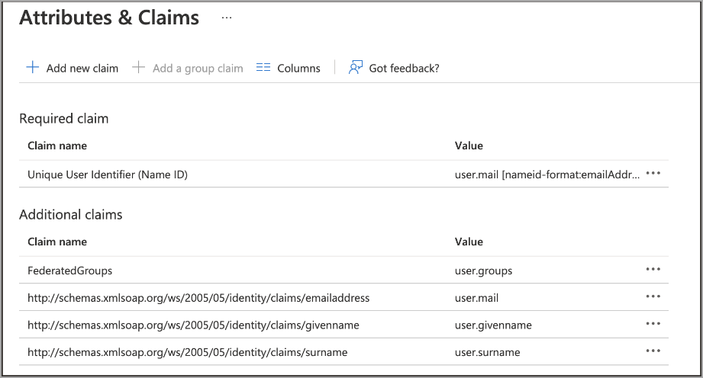
Figure 49: Attributes and claims in Entra ID
- Navigate to Groups. You'll see all the groups available in Entra ID.
- Make a note of the Object IDs of the groups you want to make part of SAML to send to OCI IAM.
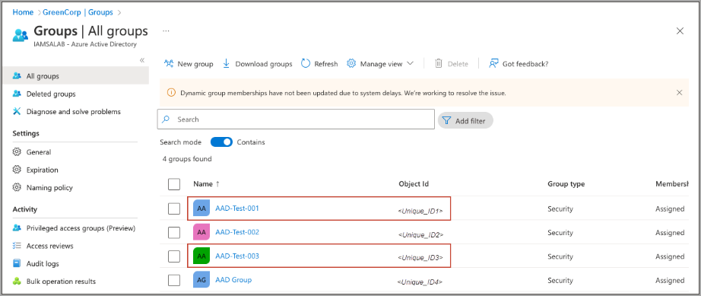
Figure 50: Group details in Entra ID

7.3.1 Additional Entra ID Configurations
In Entra ID, you can filter groups based on the group name, or sAMAccountName, attribute. For example, suppose only the Administrators group needs to be sent over using SAML:
- Select the group claim.
- In Group Claims, expand Advanced options.
- Select Filter Groups:
Field | Value
Attribute to match | Display Name
Match with | contains
String | Name of the group, for example Administrators

Figure 51: Filter groups in the Entra ID group claim
Using this option, even if the user in the administrator group is part of other groups, Entra ID only sends the Administrators group in SAML.
NOTE
This helps organisations to send only the required groups to OCI IAM from Entra ID.

7.4 Task 2: Configure JIT Attributes in OCI IAM
In OCI IAM, update the Entra ID IdP for JIT.
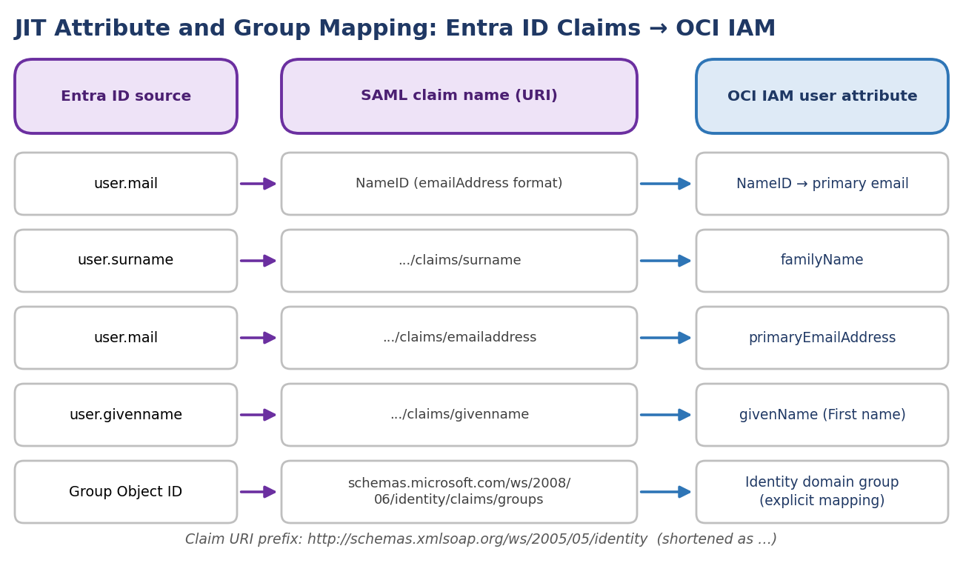
Figure 52: JIT attribute and group mapping from Entra ID claims to OCI IAM
- Open a supported browser and enter the Console URL:
https://cloud.oracle.com

- Enter your Cloud Account Name, also referred to as your tenancy name, and select Next.
- Select the identity domain which will be used to configure SSO.
- Sign in with your username and password.
- Open the navigation menu and select Identity & Security.
- Under Identity, select Domains.
- Select the identity domain in which you have already configured Entra ID as IdP.
- Select Security from the menu on the left, and then Identity providers.
- Select the Entra ID IdP.
NOTE
This is the Entra ID IdP you created as part of SSO Between OCI and Microsoft Entra ID.

- On the Entra ID IdP page, select Configure JIT.
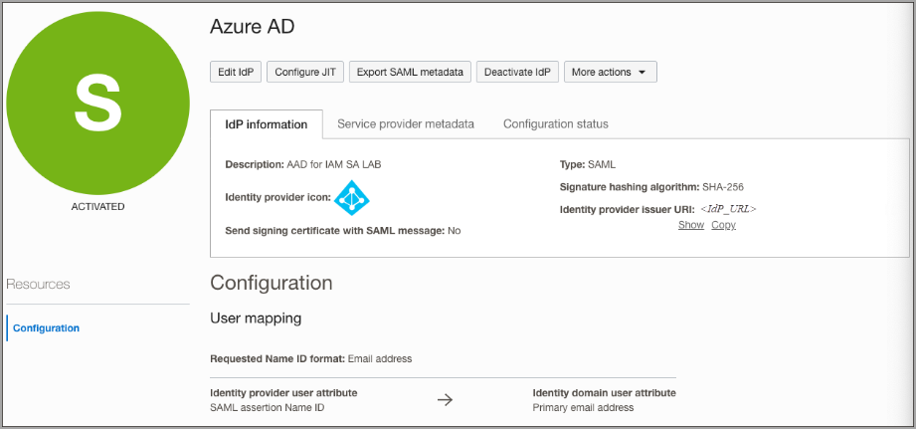
Figure 53: Configuration page for the Entra ID identity provider in IAM
- On the Configure Just-in-time (JIT) provisioning page:
  - Select Just-In-Time (JIT) provisioning.
  - Select Create a new identity domain user.
  - Select Update the existing identity domain user.
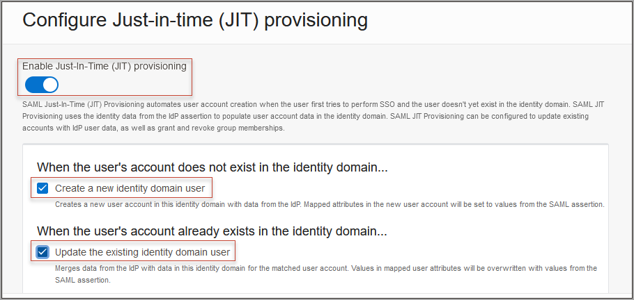
Figure 54: Enable Just-In-Time provisioning
- Under Map user attributes:
  - Leave the first row for NameID unchanged.
  - For other attributes, under IdP user attribute select Attribute.
  - Provide the IdP user attribute name as shown in the table below.
  - Select Add Row and enter the givenname claim. For the identity domain user attribute, choose First name.
Identity domain attribute | IdP user attribute | IdP user attribute name
NameID (first row) | (unchanged) | (unchanged)
familyName | Attribute | http://schemas.xmlsoap.org/ws/2005/05/identity/claims/surname
primaryEmailAddress | Attribute | http://schemas.xmlsoap.org/ws/2005/05/identity/claims/emailaddress
First name (added row) | Attribute | http://schemas.xmlsoap.org/ws/2005/05/identity/claims/givenname

NOTE
The fully qualified claim names come from section 7.3.

- The following shows what the user attributes in OCI IAM should look like (on the right), and the mapping of user attributes between Entra ID and OCI IAM.
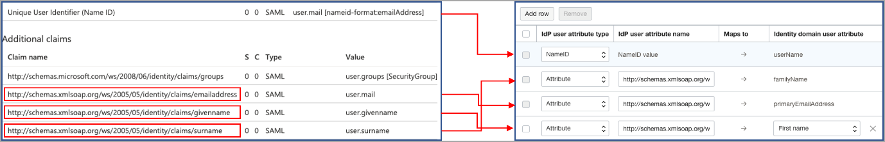
Figure 55: Mapping of user attributes between Entra ID and OCI IAM
- Select Assign group mapping.
- Enter the Group membership attribute name:
http://schemas.microsoft.com/ws/2008/06/identity/claims/groups

- Select Define explicit group membership mappings.
- In IdP Group name, provide the Object ID of the group in Entra ID from the previous step.
- In Identity domain group name, select the group in OCI IAM to map the Entra ID group to.
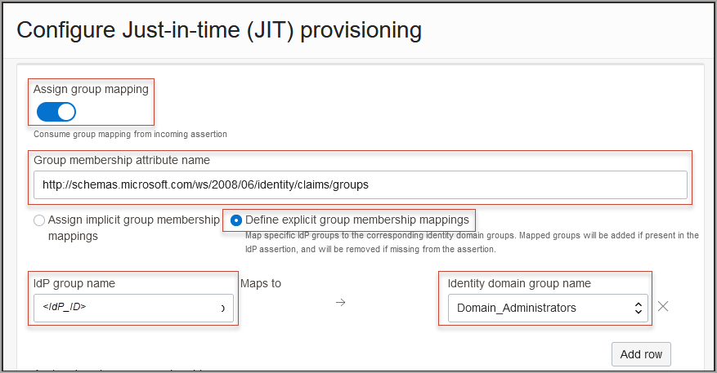
Figure 56: Assign group mappings
The following shows what the group attributes in OCI IAM should look like (on the right), and the mapping of group attributes between Entra ID and OCI IAM.
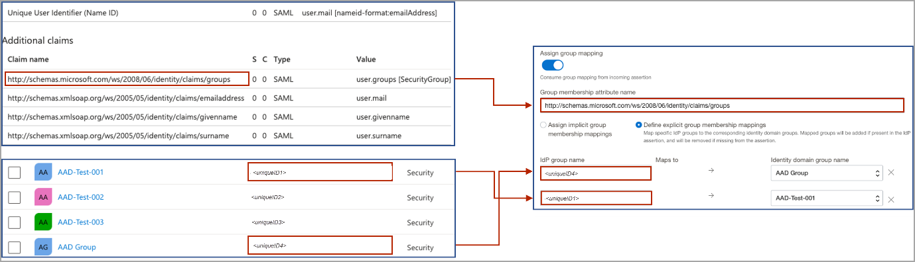
Figure 57: Mapping of group attributes between Entra ID and OCI IAM
- Under Assignment rules, select the following:
Assignment rule | Selection
When assigning group memberships | Merge with existing group memberships
When a group is not found | Ignore the missing group

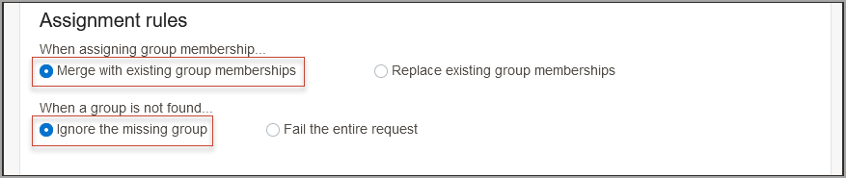
Figure 58: Setting assignment rules
NOTE
Select options based on your organization's requirements.

- Select Save changes.

7.5 Task 3: Test JIT Provisioning Between Entra ID and OCI
In this section, you test that JIT provisioning works between Entra ID and OCI IAM.
- In the Entra ID console, create a new user with an email ID which is not present in OCI IAM.
- Assign the user to the required groups.
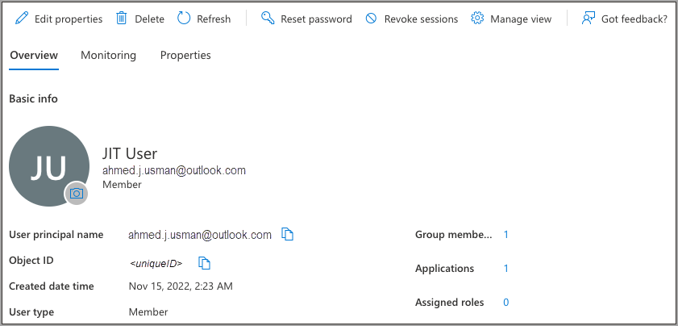
Figure 59: Assign the user to groups
- In the browser, open the OCI Console.
- Select the identity domain in which JIT configuration has been enabled.
- Select Next.
- From the sign on options, select Entra ID.
- On the Microsoft login page, enter the newly created user id.
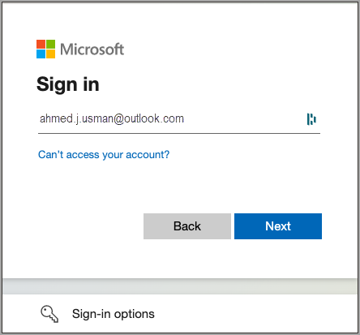
Figure 60: Microsoft login page
- On successful authentication from Microsoft, the user account is created in OCI IAM and the user is logged into the OCI Console.
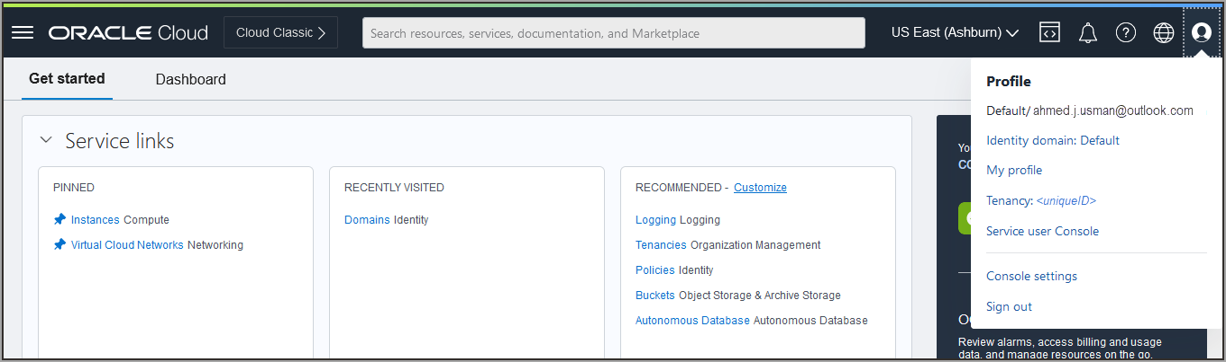
Figure 61: My Profile in OCI IAM for the new user
- In the navigation menu, select the Profile menu (user avatar icon) and then select User settings. Check the user properties such as email id, first name, last name, and associated groups.
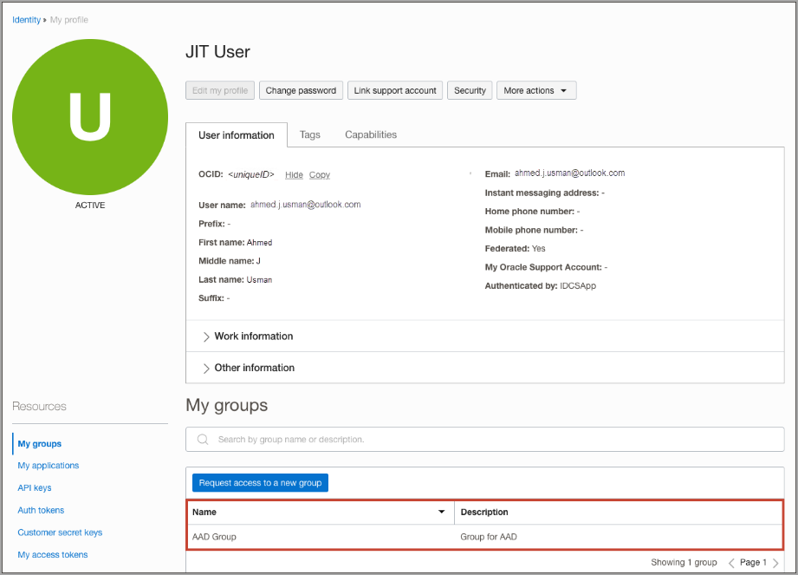
Figure 62: Check user properties in OCI IAM

7.6 What's Next
Congratulations! You have successfully set up JIT provisioning between Entra ID and OCI IAM.
To explore more information about development with Oracle products, check out the Oracle Developers Portal and Oracle Cloud Infrastructure.

Appendix A. References
Reference | Link
SSO Between OCI and Microsoft Entra ID | https://docs.oracle.com/en-us/iaas/Content/Identity/tutorials/azure_ad/sso_azure/azure_sso.htm
Identity Lifecycle Management Between OCI IAM and Entra ID | https://docs.oracle.com/en-us/iaas/Content/Identity/tutorials/azure_ad/lifecycle_azure/azure_lifecycle.htm
LCM Tutorial 1 (Entra ID gallery app) | https://docs.oracle.com/en-us/iaas/Content/Identity/tutorials/azure_ad/lifecycle_azure/01-config-azure-template.htm
LCM Tutorial 2 (OCI IAM App Catalog) | https://docs.oracle.com/en-us/iaas/Content/Identity/tutorials/azure_ad/lifecycle_azure/02-config-azure-iam-template.htm
LCM Tutorial 3 (MS Office 365) | https://docs.oracle.com/en-us/iaas/Content/Identity/tutorials/azure_ad/lifecycle_azure/03-config-iam.htm
JIT Provisioning from Entra ID to OCI IAM | https://docs.oracle.com/en-us/iaas/Content/Identity/tutorials/azure_ad/jit_azure/azure_jit.htm
Managing Identity across OCI IAM and Entra ID (blog) | https://blogs.oracle.com/cloudsecurity/post/managing-identity-across-oci-iam-and-azure-ad
IAM Identity Domain Object Limits | https://docs.oracle.com/en-us/iaas/Content/Identity/sku/overview.htm#iam-object-limits
Oracle Cloud Infrastructure Free Tier | https://docs.oracle.com/iaas/Content/FreeTier/freetier.htm
Understanding Administrator Roles | https://docs.oracle.com/en-us/iaas/Content/Identity/roles/understand-administrator-roles.htm
Signing in to the Console (supported browsers) | https://docs.oracle.com/iaas/Content/GSG/Tasks/signingin.htm

A.1 Key Endpoints and Values
Item | Value
OCI Console | https://cloud.oracle.com
Microsoft Entra admin center | https://entra.microsoft.com
Azure portal | https://portal.azure.com
OCI SP metadata | https://<domain-URL>/fed/v1/metadata
OCI sign-on URL (Entra app) | https://idcs-<domain_ID>.identity.oraclecloud.com/ui/v1/myconsole
SCIM tenant URL (LCM Tutorial 1) | https://<domainURL>/admin/v1
Secret token | base64(<clientID>:<clientsecret>)
NameID claim | user.mail [nameid-format:emailAddress]
Group claim (JIT) | http://schemas.microsoft.com/ws/2008/06/identity/claims/groups
Common AADSTS error | AADSTS50105 – user not assigned to the Entra enterprise app

