ENTERPRISE — ORACLE CLOUD PROGRAM — VOLUME 6
End-State Architecture
Full-Landscape Solution / Logical Architecture (D9) · Technical / Infrastructure Topology (D10)
The two capstone views of the organization's Oracle Cloud estate at steady state, consolidating volumes 1–5 and the governance corpus: Fusion (ERP · EPM · HCM · CX/SCM) as system of record, OIC/ATP/FDI/VBS on OCI, the legacy ERP retired, governed under the Governance Framework v1.2 and OCI Governance Standard v1.1.
Status: v1.0 DRAFT | Author: Enterprise Cloud Architect (OCI) | August 2026 | Classification: Internal

1. End-State Solution / Logical Architecture (D9)
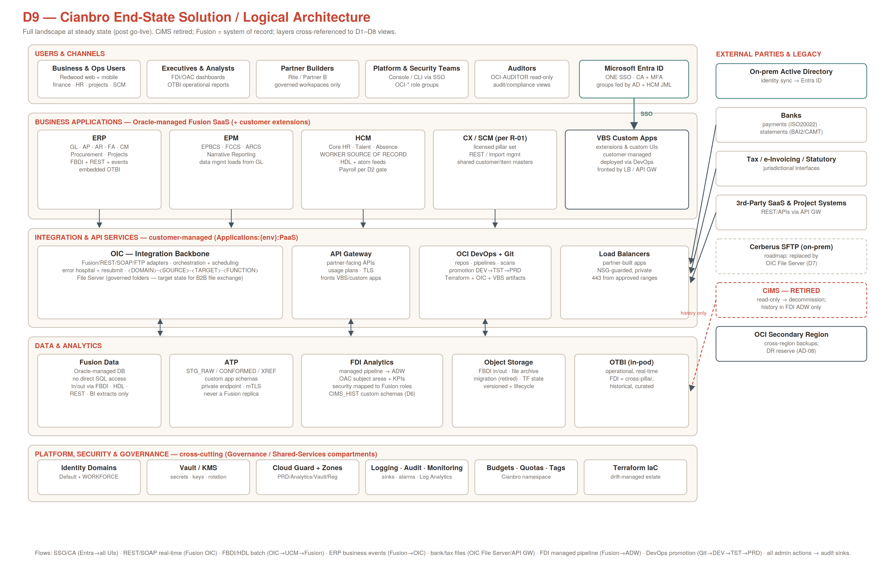
Reading the view: five horizontal layers — users/channels, business applications, integration/API, data/analytics, and cross-cutting platform & governance — with external parties and legacy on the right. Everything a user touches authenticates once through Entra ID (Conditional Access + MFA); everything a builder deploys lands in a governed compartment; every data movement uses one of the eight catalogued flows below. The legacy ERP appears only as a retired node whose history lives in FDI's ADW; legacy MFT/SFTP appears as a roadmap replacement target, not a dependency.

2. Logical Flow Catalog
Flow | Path | Pattern / protocol | Security | Notes
F1 | All user channels → Entra → Fusion / OIC / FDI / Console | SSO — SAML 2.0/OIDC | CA + MFA; federated groups; no local accounts | One sign-on across both control planes
F2 | Fusion ↔ OIC | Real-time REST (SOAP legacy) | TLS over OSN; svc accounts from Vault | Default for queries/updates/events-driven calls
F3 | OIC → Object Storage/UCM → Fusion | Batch FBDI (ERP/SCM) / HDL (HCM) | Checksummed manifests; Confidential class | Bulk loads incl. steady-state interfaces
F4 | Fusion → OIC | ERP Business Events subscription | OSN; event payload validation | Outbound triggers (invoice approved, worker hired…)
F5 | Banks/tax/3rd parties ↔ OIC File Server / API GW | Files (ISO20022, BAI2/CAMT) + REST | SFTP keys in Vault; allow-listed; usage plans | File exchange standard = OIC File Server (legacy MFT/SFTP replacement per roadmap D7)
F6 | Fusion PRD → FDI ADW → OAC | Oracle-managed incremental pipeline | BI-extract roles only; RLS mapped to Fusion roles | Re-baselined after each P2T refresh
F7 | Git → DEV → TST → PRD | DevOps pipeline promotion | PR review + scans; CAB gate for PRD | Terraform, OIC artifacts, VBS apps
F8 | All admin/user actions → Governance sinks | Audit + service + flow logs | Log deletion not grantable; max retention | Feeds Log Analytics, Cloud Guard, (D9 gate) SIEM

3. Technical / Infrastructure Architecture Topology (D10)
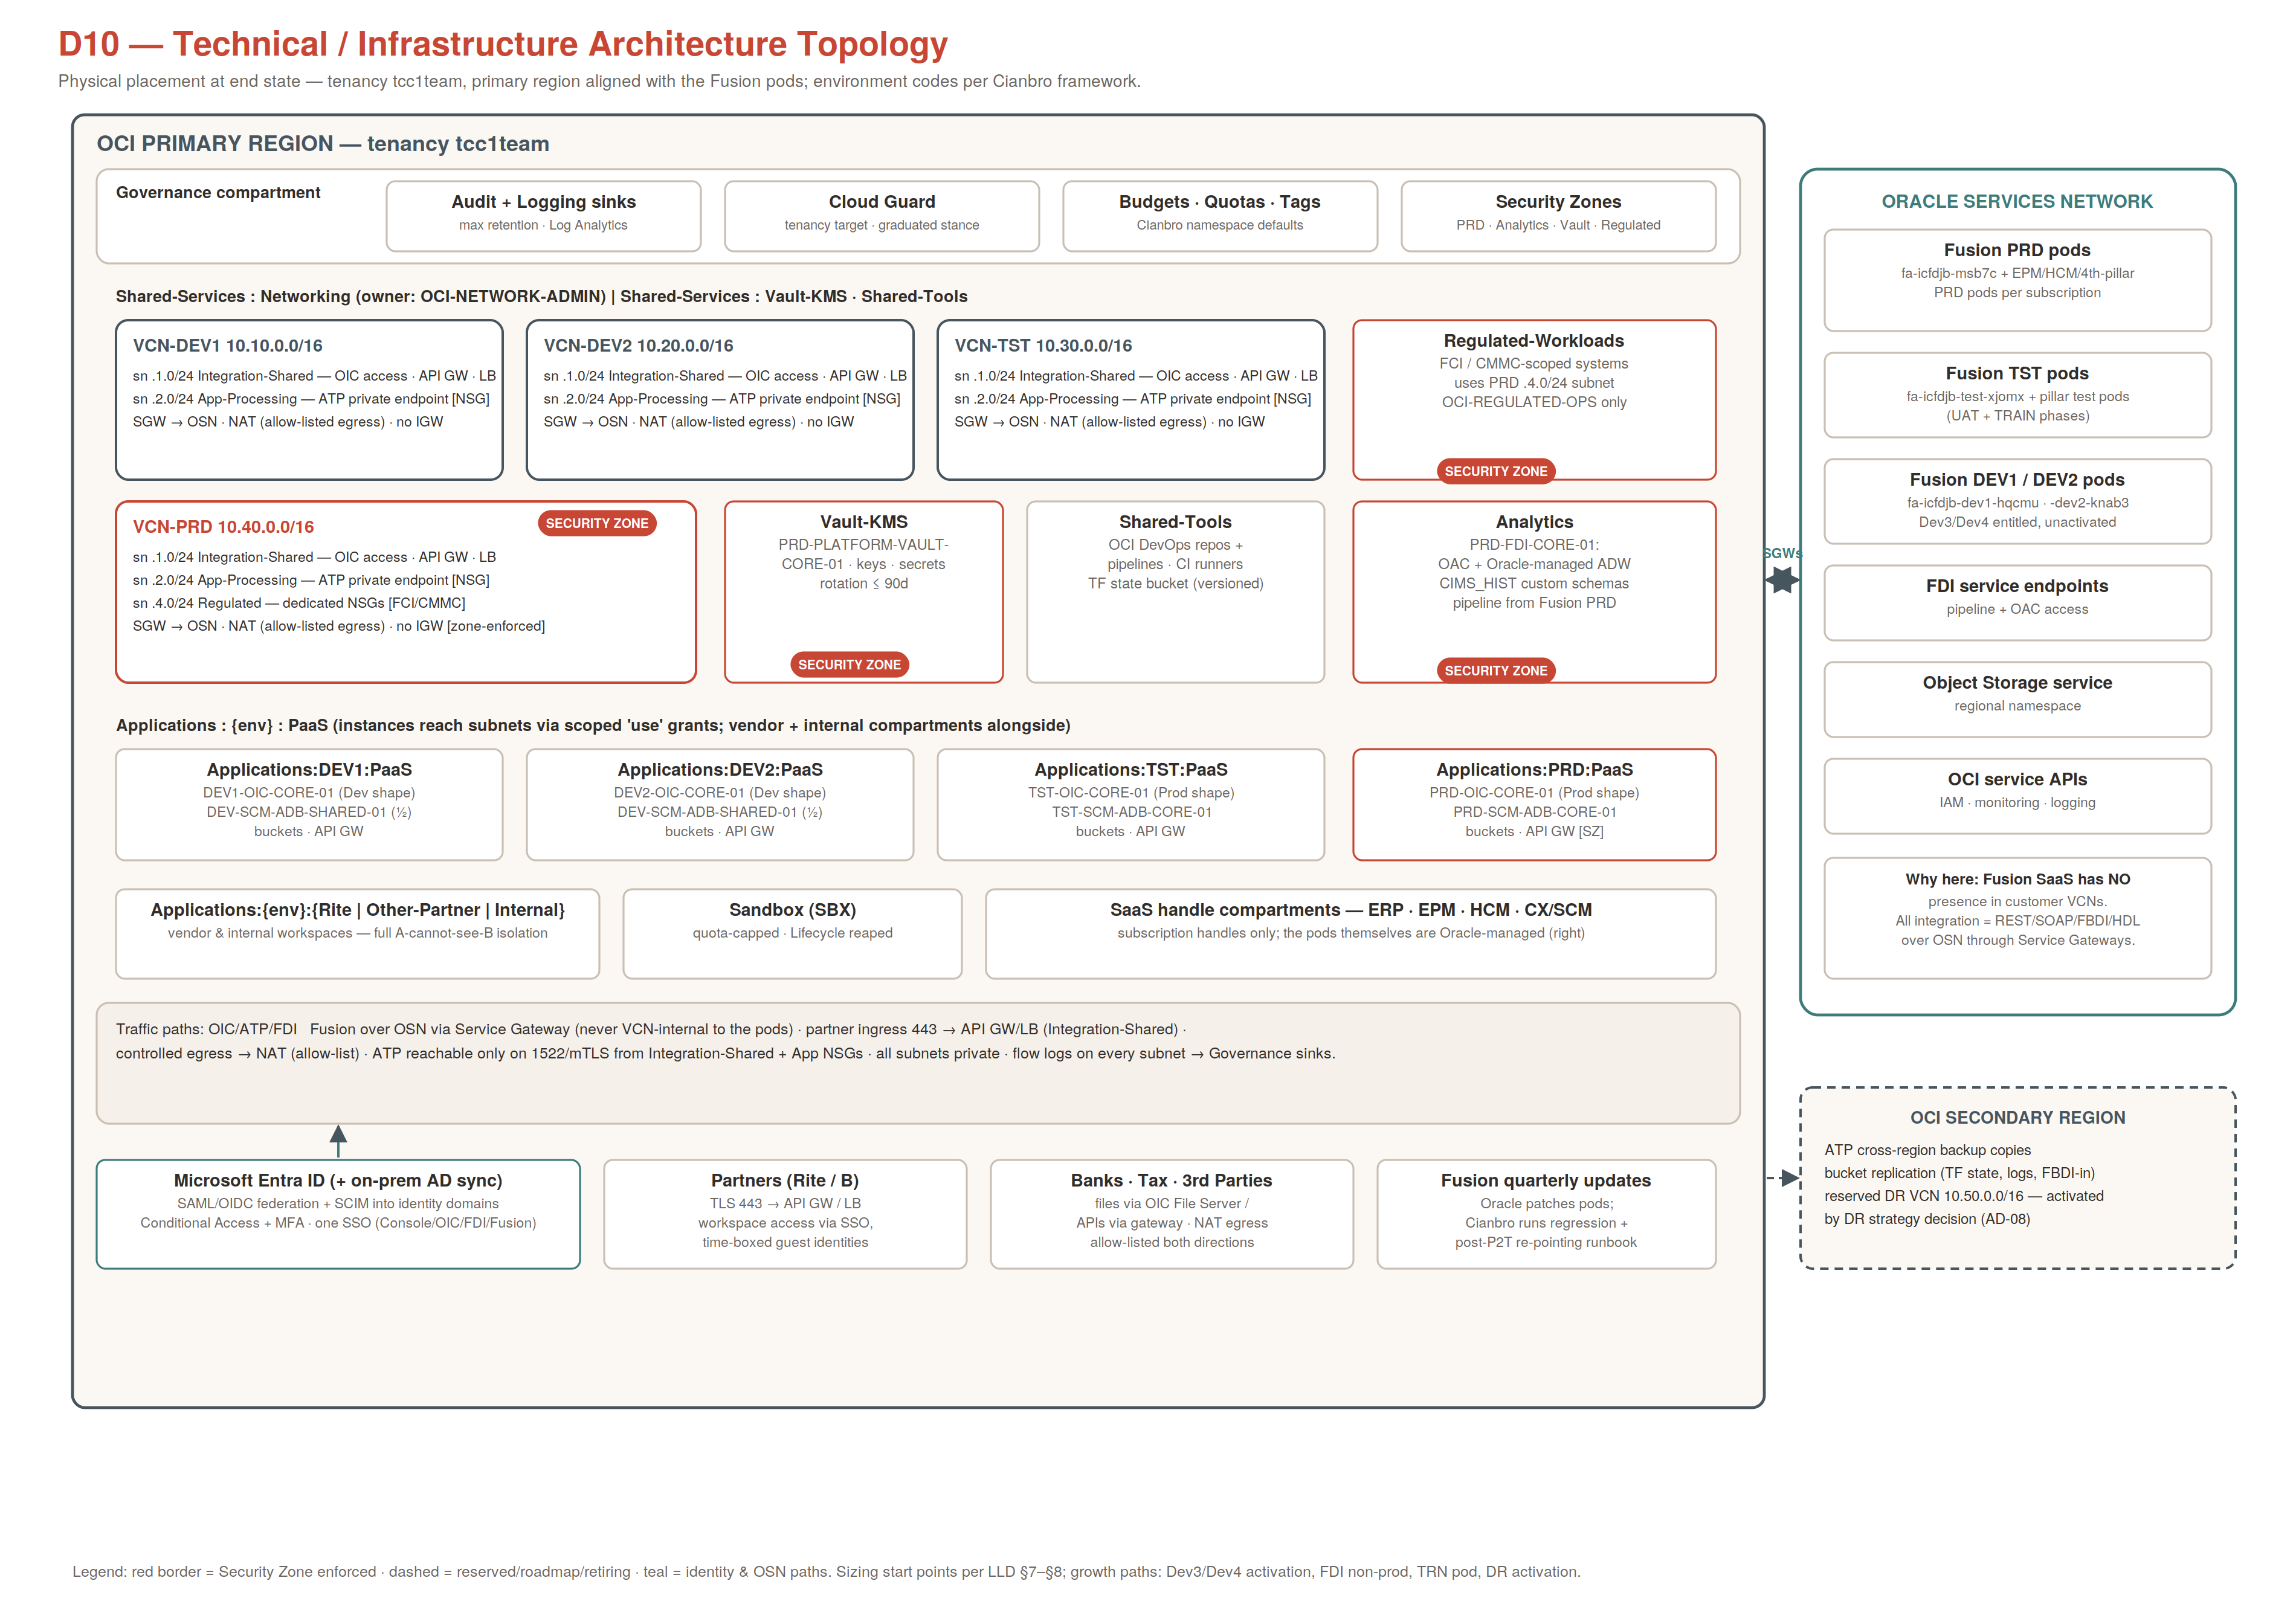
Reading the view: one tenancy in the primary region (aligned to the Fusion pods), four environment VCNs plus the PRD Regulated subnet, per-environment PaaS compartments consuming shared subnets via scoped grants, Security-Zoned crown jewels (PRD, Analytics, Vault, Regulated), the OSN column carrying everything Oracle manages, and the secondary region holding backup copies plus the reserved DR footprint. Fusion pods are deliberately drawn outside the tenancy's VCNs — the single most common misreading this diagram exists to prevent.

4. Infrastructure Inventory by Environment
Env | Network | Integration | Data | Fusion pods served | Notes
DEV1 | VCN-DEV1 10.10.0.0/16; 2 subnets; SGW+NAT | DEV1-OIC-CORE-01 (Dev shape, 1 pack) | DEV-SCM-ADB-SHARED-01 (shared, schema-isolated) | fa-<realm>-dev1 + pillar dev1 pods | Relaxed NSGs; auto-remediate stance
DEV2 | VCN-DEV2 10.20.0.0/16; mirror | DEV2-OIC-CORE-01 | shared ADB (½) | fa-<realm>-dev2 + pillar dev2 pods | Parallel build stream
TST | VCN-TST 10.30.0.0/16; PRD-equivalent rules | TST-OIC-CORE-01 (Prod shape) | TST-SCM-ADB-CORE-01 | fa-<realm>-test + pillar test pods | SIT + UAT + TRAIN phases; selective auto-remediate
PRD | VCN-PRD 10.40.0.0/16; + .4.0/24 Regulated; Security Zone; no IGW | PRD-OIC-CORE-01 (sized post-Mock-2) | PRD-SCM-ADB-CORE-01 (2 ECPU auto×3; cross-region backup) | fa-<realm>-prod + pillar PRD pods | Alert+escalate only; CAB-gated change
Analytics | service endpoints (no own VCN) | — | PRD-FDI-CORE-01: OAC + managed ADW + LEGACY_HIST | sources Fusion PRD | Security Zone; non-prod FDI later (D4)
SBX / DR | — / reserved 10.50.0.0/16 | — | quota-capped / backup copies only | — | DR activation per AD-08

5. Connectivity Matrix (authoritative allowed paths)
Source | Destination | Port / proto | Path | Control
OIC (any env) | Fusion pods, Object Storage, FDI | 443 TLS | OSN via Service Gateway | Allow-listed OIC network access; svc accounts from Vault
OIC / partner apps (App-Processing) | ATP private endpoint | 1522 mTLS | intra-VCN | NSG-{ENV}-ATP-01 ingress from .1.0/24 + app NSG only
Partners (internet) | API GW / LB (Integration-Shared) | 443 TLS | allow-listed ingress | Approved CIDR list; usage plans; no other inbound
Any subnet | Internet | 443 (named) | NAT gateway | Egress allow-list; no route = no path; none by default in PRD
Banks/counterparties | OIC File Server | SFTP/443 | File Server endpoint / NAT | Keys in Vault; per-counterparty folders
Entra ID | Identity domains / Fusion pods | 443 SAML/OIDC/SCIM | public federation endpoints | CA + MFA; SCIM provisioning; break-glass excluded
Fusion pods | anything in customer VCNs | — | — | NO PATH EXISTS — by design (GOV-NE-02)
Primary region | Secondary region | Oracle backbone | backup copy / replication | ATP cross-region backups; bucket replication; DR reserve

6. End-State Qualities and Growth Paths
- Resilience: managed-PaaS SLAs end to end; platform RPO ≤ 24h / RTO ≤ 8h via cross-region backups + IaC rebuild; formal DR tiering and exercise regime activate with AD-08; Fusion DR is Oracle's obligation with the organization owning regression and BC validation.
- Security posture: one SSO with CA/MFA; structural SoD; Security Zones on all crown jewels; default-deny everywhere (network and IAM); FCI/CMMC isolation ready in Regulated-Workloads with CUI escalation path (R-04).
- Operability: everything governed is Terraform-managed and drift-checked; alarms route by SupportGroup tag; error hospital gives integration incidents one front door; environment calendar synchronizes Fusion quarterly updates, P2T refreshes, and FDI re-baselining.
- Cost & attribution: budgets and quotas per compartment; every resource attributable to BusinessUnit/CostCenter/Partner; monthly variance review with vendor showback.
- Growth without redesign: Dev3/Dev4 pod activation extends the environment matrix; TRN pod slots into the same pattern; FDI non-prod attaches to TST; DR region activates from the reserved CIDR and IaC; legacy MFT/SFTP retirement completes the file-exchange consolidation onto OIC File Server; additional partners get pattern-stamped compartments and groups in a day.
Related views: D1–D8 (Vols 2–5) provide the per-domain detail behind both capstones; the LLD carries every parameter shown here.

